

RSE/PSHE

We believe that PSHE plays a vital part in primary education. As such, we go beyond the statutory RSHE elements so that wider life issues can be explored; these include economic education, environmental and community issues, right and responsibilities. We follow SCARF for our PSHE scheme as it provides a comprehensive scheme of work for PSHE provision, covering all the statutory requirements for Relationships Education and Health Education. It also covers the learning opportunities within the PSHE association’s programme of study, therefore providing for elements such as the rights of the child, caring for the environment, economic education and children’s spiritual, moral, spiritual and cultural education.
Our PSHE education, including statutory Relationships and Health education, provides a framework through which key skills, attributes and knowledge can be developed and applied. This promotes positive behaviour, good mental health and wellbeing, resilience and achievement, helping children to stay safe online, have the skills and attributes to negotiate and assert themselves now and in the future and form positive relationships.

Our PSHE provision supports our aims of developing confident citizens and successful learners who are creative, resourceful and able to identify and solve problems. At Rose Wood, we follow a planned thematic PSHE program, built around a spiral curriculum of recurring themes, designed to:
  - Give pupils the knowledge and develop the self-esteem, confidence and self-awareness to make informed choices and decisions;
  - Encourage and support the development of social skills and social awareness;
  - Enable pupils to make sense of their own personal and social experiences;
  - Promote responsible attitudes towards the maintenance of good physical and mental health, supported by a safe and healthy lifestyle;
  - Enable effective interpersonal relationships and develop a caring attitude towards others;
  - Encourage a caring attitude towards and responsibility for the environment;
  - Help our pupils understand and manage their feelings, build resilience and be independent, curious problem solvers;
  - Understand how society works and the laws, rights and responsibilities involved.

The Early Years Foundation Stage
In the Early Years Foundation Stage, PSHE education is about making connections; it’s strongly linked to child-led activities, including play. PSHE is taught through activities that are part of topics, as well as on an individual basis to develop personal skills such as dressing, feeding and toileting. Positive experiences are built through daily opportunities, to share and enjoy a range of different activities. Children are given the opportunity to engage in social activities, as members of a small group or occasionally during whole-school activities.
KS1 and KS2
The SCARF programme divides the year into 6 themed units:
- Me and My Relationships: includes content on feelings, emotions, conflict resolution and friendships;
- Valuing Difference: a focus on respectful relationships and British values;
- Keeping Myself Safe: looking at keeping ourselves healthy and safe
- Rights and Responsibilities: learning about money, living the wider world and the environment;
- Being My Best: developing skills in keeping healthy, developing a growth mindset (resilience), goal-setting and achievement;
- Growing and Changing: finding out about the human body, the changes that take place from birth to old age and being safe.

RSE
We have developed our curriculum in consultation with parents, pupils and staff, taking into account the age, needs and feelings of the pupils.

RSE is taught within the personal, social, health and economic (PSHE) education curriculum. Biological aspects of RSE are taught within the science curriculum, and other aspects are included in religious education (RE). Relationships education focuses on teaching the fundamental building blocks and characteristics of positive relationships including:
Families and people who care for me
Caring friendships
Respectful relationships
Online relationships
Being safe
At Rose Wood Academy, we will include sex education within the statutory content of the science curriculum and health education curriculum. If issues occur beyond this, individuals may be taught additional content in consultation with their parents.

Mental Wellbeing
At Rose Wood Academy, we are fully committed to an approach to Mental Health and Wellbeing covering children, staff and the wider community.

We consider the development of our children's mental health and wellbeing to be as important as we do their physical well-being and we promote its importance both within our curriculum and through the support we offer our children and their families. We recognise that children’s mental health is a crucial factor in their overall well-being and can affect their learning and achievement. The Department for Education recognises that: “in order to help their pupils succeed; schools have a role to play in supporting them to be resilient and mentally healthy”. We take the view that positive mental health is everybody’s responsibility in our school and that we all have a role to play.

Mental health and wellbeing is not just the absence of mental health problems. We want all children to:

• feel confident in themselves;
• be able to express a range of emotions appropriately;
• be able to make and maintain positive relationships with others;
• cope with the stresses of everyday life;
• manage times of stress and be able to deal with change;
• learn and achieve.

We also know that everyone experiences challenges in life and that these can make us vulnerable at certain times. We know that anyone may need additional emotional support.

We therefore have a universal offer towards supporting the wellbeing of all, alongside a targeted offer to meet the needs of specific children who need it, when they need it. We believe it is the role of all staff in school to recognise when a targeted offer is required.

Universal Mental Wellbeing Support

The skills, knowledge and understanding needed by our children to keep themselves and others physically and mentally healthy and safe are included as part of our SCARF PSHE and RSE curriculum. Children learn the social and emotional skills that will help them to be more resilient, understand about mental health and be less affected by the stigma of mental health problems.

As well as discrete lessons, through this curriculum, we also have a focus on ‘The Five Steps to Wellbeing’. The ‘Five Steps to Wellbeing’ programme is an evidence-based approach as researched by NEF (The New Economics Foundation.) This research identified five behaviours that can lead to improved mental health and wellbeing. They are the five aspects below:

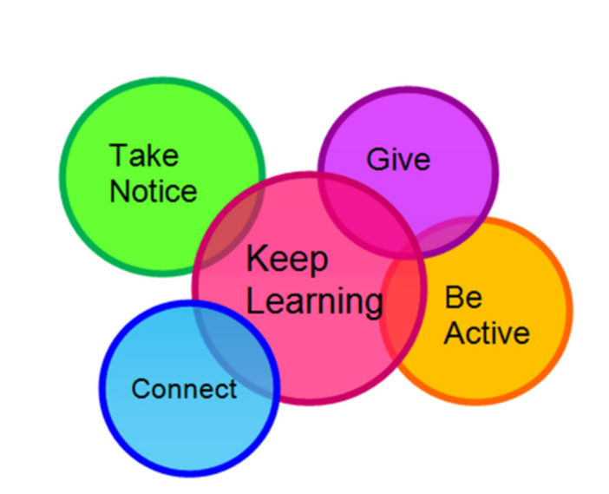

Why the Five Ways work:

• Connect: Strengthening relationships with others and feeling close to and valued by others is critical to boosting wellbeing.
• Keep Learning: Being curious and seeking out new experiences more generally positively stimulates the brain.
• Be Active: Being physically active improves physical health and can improve mood and wellbeing and decrease stress, depression and anxiety.
• Give: Carrying out acts of kindness, whether small or large, can increase happiness, life satisfaction and general sense of wellbeing.
• Take Notice: Paying more attention to the present moment, to thoughts and feelings and to the world around, boosts our wellbeing.

The Five Ways in action:

• Connect with the people around you.
• Keep Learning. Try something new. Rediscover an old interest. Take on a new responsibility.
• Be Active. Take opportunities to move more
• Give. Do something nice for others. Notice and appreciate those around us
• Take Notice. Notice and appreciate what is around us. Savour the moment.

What does this look like at Rose Wood?

Five Steps to Wellbeing at Rose Wood
Connect | School Values – Be Kind and REAP the Rewards  Team Tables  Collaborative Independence  School Council  Assemblies  Positive Relationships Adult/Child, Child/Child, Adult/Adult  Class Dojo and Class Rewards  Volunteering  Teamwork in PE etc.  Headstarters  PSHE conversations
Keep Learning | Educational Visits/Visitors  Memorable Experiences  Quality Texts  High Quality Enquiry Driven Curriculum  Outdoor Learning Linked to Enquiry Driven Curriculum  Clubs  Celebrations of Work  SMSC Calendar  Roles and Responsibilities  Developing Cultural Capital
Be Active | PE Curriculum  Active Learning  Clubs  Playtime and Lunchtime Games/Activities  Brain Breaks  Active Learning
Give | School Values – Be Kind and REAP the Rewards  Celebration of Kindness  Community work such as litter picks, community performances  Fundraising
Take Notice | Noticing the Positives  Strong relationships between school community  Yoga/Mindfulness  Praise  Visits  Memorable Experiences

We also promote wellbeing across the year through themed events such as children’s mental health week, Mental ‘Elf run at Christmas through MIND, mental health assemblies etc.

Targeted Mental Wellbeing Support

We also offer targeted mental health support. This could be for those who may have short term needs and those who may have been made vulnerable by life experiences such as bereavement. Or it may be for children and families who need more differentiated support and resources or specific targeted interventions.

Parent Support Advisor/Wellbeing Champion/Mental Health First Aider
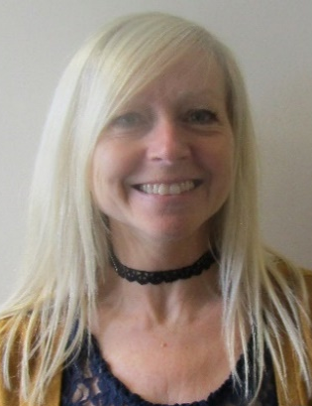

Miss Jackson

Miss Jackson is our ‘wellbeing champion’ and is trained as a mental health First Aider. She supports our children and families through planned interventions and informal support when needed.

Miss Jackson has received the following training to support with wellbeing:

Mental Health First Aid MHFA England
ELSA Programme Middlesbrough Psychology Services
Attachment and Trauma The Bungalow Partnership
Bereavement Forget Me Not Teesside Hospice
Responses to Self-Harm The Bungalow Partnership
Impact of Domestic Abuse on Children The Bungalow Partnership
Neurodiversity The Bungalow Partnership
Resilience Headstart Mental Health Network
Headstarters Headstart Mental Health Network
Impact of Parental Mental Illness PSA Network
Online Safety (Grooming) PSA Network
Safeguarding Level 3 South Tees Safeguarding Children Partnership

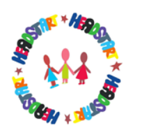
Headstart

‘Giving all Middlesbrough’s children and young people the necessary support to build resilience to achieve good emotional health’
We work in partnership with HeadStart. The aim of this partnership is to increase emotional resilience and well-being in our pupils. In 2015 the Government’s Future in Mind report was published, providing national recognition of the need to make dramatic improvements in children’s mental health services. The HeadStart programme has been developed in response to the needs highlighted in the report. HeadStart aims to introduce support within school, home, the community and on-line taking on a preventative and early intervention approach to equip young people to cope better with difficult circumstances.

CAMHS
Rose Wood Academy work closely with CAMHS. If you think your child may benefit from a referral, please speak to Miss Tyerman (SENDCO) or Miss Jackson.
For more details on what CAMHS offer please use the following link:
https://fis.middlesbrough.gov.uk/kb5/middlesbrough/fsd/service.page?id=B15SAr6HAkQ

The Link
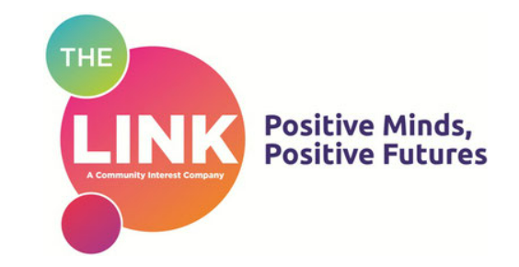

The Link is a professional mental health and wellbeing provider, providing therapeutic services to children identified as needing additional support. The aim of the service is to offer integrated provision with a range of individual, group and parent-led evidence based interventions for children and families. School identify children in need of the service, liaising with the Link’s children’s psychological well-being practitioner, and school refer them into the service. Referrals are then assessed and appropriate support offered. Types of support that have been offered are family systemic support, pathways to wellness for emotional literacy, parent led conduct and low intensity CBT.

The Bungalow Partnership

We also work with the Bungalow Partnership. The Bungalow partnership provide therapeutic services for our children experiencing periods of uncertainty, distress and anxiety through a team of highly qualified and experienced Play Therapists, Psychotherapists, Counsellors and Family Mentors. The Bungalow supports the emotional wellbeing of children by providing a range of support aimed at improving mental health, emotional regulation and resilience.

Other Useful Documents and Websites

Mind – To provide advice and support to empower anyone experiencing a mental health problem. We campaign to improve services, raise awareness and promote understanding. | View
Family Lives – Provides targeted early intervention and crisis support for families | View
CAHMS Resources – Resources to support mental health and wellbeing. | View
Childline – A counselling service for children and young people. | View
BBC Bitesize – PSHE and citizenship videos to help children’s understanding. | View
NSPCC – Information and support for child abuse | View
NCPCC’s Pantosaurus – A video to help children stay safe and keeping their private parts private. | View
Pop ‘n’ Olly – LGBT+ education for primary school | View
Young People’s Mental Health Resources | View
Every Mind Matters – NHS (www.nhs.uk) | View
Sleep hygiene in children and young people | View
Toolbox | Childline | View

