Rose Wood Academy

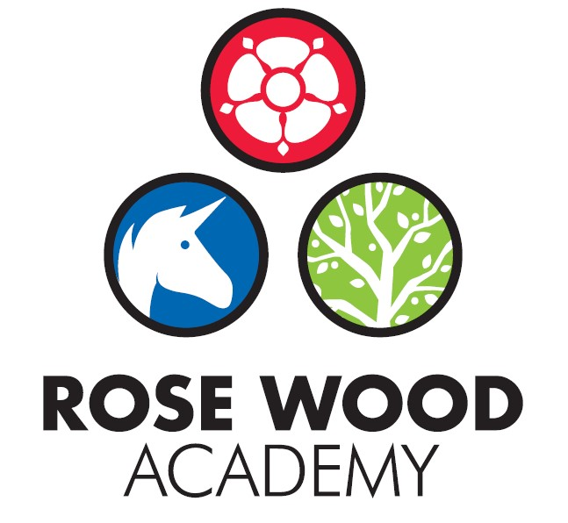

Subject Statement for RE

Contents

Curriculum Aims 3
Subject Content and Organisation 3
Embedding Knowledge 4
Leadership Activities 5
Assessment 6
Appendices 7

RE Overview Document

Subject Statement for RE

Curriculum Aims

At Rose Wood Academy, we aim to deliver a high-quality Religious Education curriculum, which inspires pupils to be tolerant, respectful members of the wider community and celebrates the culture and diversity of people in Middlesbrough, Britain and the wider world.
For many people, religion forms a crucial part of their culture and identity. Our Religious Education curriculum prepares our children for life in modern day Britain so that they can make a positive contribution to the multicultural society in which we live.
At Rose Wood Academy, we intend to:
- develop pupils’ knowledge and understanding of Christianity, Islam, Hinduism, Judaism and non-religious worldviews
- allow pupils to explore the big questions about life, in order to find out what people believe, how they express their faith and what difference this makes to how they live
- allow pupils to reflect on their own ideas and ways of living
- contribute to the development of pupils’ cultural capital
- prepare pupils for life in modern day Britain, to live as part of a multicultural society
- give pupils an awareness of religion in Britain and particularly the North East of England
- promote a positive and inclusive school ethos that champions democratic values and human rights
- provoke challenging questions, encourage pupils to explore their own beliefs whilst enabling pupils to develop respect and understanding for others and challenging stereotypes
- prompt pupils to consider their rights and responsibilities to society.

Subject Content and Organisation

Our Religious Education curriculum provides pupils with a positive context within which the diversity of cultures, beliefs and values can be celebrated and explored. The teaching of Religious Education is a statutory requirement for all maintained schools across England. Rose Wood Academy’s RE curriculum has been developed in line with the Middlesbrough locally agreed syllabus for 2020-2025. We build on statutory content already outlined in the locally agreed syllabus and follow the ‘RE Today’ scheme of work to provide consistency and progression throughout our school.
Our curriculum is implemented through three ‘Big Ideas’, which are constantly revisited throughout teaching sequences in EYFS, Key Stage 1 and Key Stage 2:
- Believing: religious beliefs, teachings, sources; questions about meaning, purpose and truth
- Expressing: religious and spiritual forms of expression; questions about identity and diversity
- Living: religious practices and ways of living; questions about values and commitments

The agreed syllabus requires that Christianity is taught in each Key Stage. To reflect the national and local context, at Rose Wood we teach Christianity in each year group. As the demographic of Middlesbrough is that Islam is the most common religion after Christianity, this is the other major religion we focus on in KS1. This demographic is mirrored in our own school context. In KS2, we broaden this to include Judaism, Hinduism and other world views such as Humanism.

We use a ‘key question’ approach, in line with our wider curriculum approach of using an enquiry question to inform the learning that follows. These key questions allow children to investigate the big questions about life and encourage discussion and debate. Each unit takes the form of an overarching question and each lesson within it is a question which contributes towards answering this question. At the culmination of a unit, children use the learning they have gained throughout the unit to answer the main question through a POP (proof of progress) task.

There are clear end of key stage outcomes, which are identified on the RE overview. Milestones are identified for each unit which are intended to enable children to meet these end of key stage expectations. These milestones are stuck into books at the beginning of each unit. These milestones identify the expectations for ‘emerging’, ‘expected’ and ‘exceeding’. This helps staff ensure that work is pitched at the correct level, provides appropriate challenge and ensures that children are on track to meet the end of key stage expectations.

Our RE curriculum follows a progressive model, with learning carefully sequenced. Children are taught the basic tenets of each religion before looking at the wider religious questions that affect society. Our curriculum enables children to compare and contrast religious beliefs with others and with non-religious worldviews. The substantive knowledge that is taught is identified on a RE overview document which also includes the prior learning which underpins the new learning. This helps staff to revisit prior learning and ensure that it is embedded. This document also gives a brief explanation for the curriculum choices which we have made.
Religious Education is taught for 36 hours in Key stage 1 and 45 hours in Key Stage 2, usually in a weekly lesson. Parents have the right to request to withdraw their child from the RE curriculum. Parents themselves then become responsible for the alternative education.

Embedding Knowledge

At Rose Wood, we recognise that learning is only successful if children can securely draw upon it and build upon it. We know that scientific research states that the act of retrieving prior learning strengthens memory and helps ensure that children leave school secure in the knowledge and skills mapped out in the curriculum. We also know that learning is generative – new learning is embedded far more successfully if it accumulates around prior learning. Our approach to securing knowledge and is therefore threefold:

- Learning is reviewed regularly
- The curriculum is designed to build on previous learning. These links are explicit and revisiting is built in so that children can make clear connections and learning is embedded.
- Retrieval practice is built in to the curriculum to help children recall information from their memory
In RE, we use a range of retrieval approaches, which are deliberately varied in design to allow students to explore their schemata in different ways, strengthening future recall.
The RE overview document provides staff with information about prior learning in order to support them with revisiting and therefore help embed learning. Key content such as religious books and sacred places for each religion are revisited regularly in our curriculum, ensuring that children leave school with good substantive knowledge about the four religions studied.

Leadership Activities

As with all subjects, the quality of teaching and learning for RE is every leader’s responsibility and all leaders will have an oversight of the quality of teaching and learning for RE. There is also a designated RE lead who has ownership of certain aspects of the curriculum. As well as supporting the leadership team to ensure the highest standards of teaching and learning for RE are maintained, the RE lead will also be the ‘subject champion’ and will keep abreast of all the new developments that are happening within the subject as well as ensuring high levels of subject knowledge which they will use to support others. They are also in charge of maintaining and acquiring the appropriate resources and supporting staff with their use. The RE lead will deliver some subject specific CPD or will identify appropriate external CPD for staff. The RE lead will also perform monitoring and evaluation on an ongoing basis and feedback their findings to the SLT.

  - Monitoring and Evaluation
Monitoring and evaluation is ongoing throughout the year. The monitoring will be carried out by the RE lead but other senior leaders will monitor the subject at certain points throughout the year. The main activities that make up the monitoring process are:
Learning Walks and Enquiries
Work Scrutinies
Pupil Voice
Teacher Voice
Planning and Content Coverage Checks
The RE lead and the SLT will evaluate the outcomes from these monitoring activities. This evaluation will be used to inform next steps for development such as identifying CPD for staff, supporting with subject knowledge or improving use of or access to resources. The evaluation will be used to produce subject specific action plans and inform the evidencing for subject specific causal chains.
These activities will take place throughout the year but there will be at least one ‘deeper dive’ activity that takes an in depth look at the quality of history in the school. Some deeper dives will be supported by other members of the trust.

  - CPD
The RE lead will lead some CPD for staff. This will be to support subject knowledge or could be to introduce new material, resources or ideas. They will also organise external CPD as appropriate to support whole school or individual development.

  - Resourcing
The subject lead is responsible for ensuring that the school is appropriately resourced to allow teaching staff to deliver high quality RE lessons and to ensure that pupils get the best experience they can. The RE lead should be regularly assessing the quality of the resources but should also be keeping informed about new developments and innovations that could further enhance and improve the quality of the subject within our school.

Assessment

Teachers at Rose Wood use assessment regularly to support them with their planning and task design. It underpins the principles for learning and ensures that all children make progress and face the appropriate level of challenge. It allows staff to know which children need greater challenge and which children need scaffolding and support to allow them to continue to make progress.
In RE, children are assessed against the milestones which are designed to enable children to meet the end of key stage expectations. These milestones are identified for each unit and stuck in books. At the end of a unit, children complete a POP (Proof of Progress) task, which allows staff to judge how children have performed against the milestones. This is then recorded in the child’s RE book.
In addition, the RE lead and SLT can use these milestones to ensure that staff are setting work at the appropriate level of expectation. Pupils will produce high standards of work which demonstrate their knowledge and skills.

Appendices

