2020/2021

2020/2021

PROSPECTUS
Contents
Welcome from the Head 4
Aims and Values 5
School Organisation
Teaching and Support Staff 6
Governing Body 7

Admissions
Catchment area 8
Admissions Policy 8
Arrangements for an initial visit to the school 8
Nursery Admissions Policy 8
The School Day
Punctuality and Attendance 9
Holidays in term time 9
School times 10
Before and After School Activities 12
Charging Policy 12
Meal Arrangements
Universal Free School Meals 13
Packed Lunches 14
Healthy Schools 14
Payment and Cash Handling 14
Curriculum
Sex Education 15
Religious Education 16
Homework 16
Welfare and Behaviour
Code of Conduct 16
Bullying 17
Uniform 17/18
Safeguarding
Safeguarding Statement 19
Medicines in School 19
Pastoral Care 20
Child Protection 20
Photograph Policy 20
School Crossing Patrol 20
Parking 21
Special Educational Needs 21
External Support 22
Communication 22
How to get in touch 22
Documents Held In School …….. 22

Welcome to Rose Wood Academy
This Prospectus has been put together to share some basic information about our school. We hope it helps you gain an understanding of how our school is organised, and to appreciate the exciting opportunities on offer to children in our care. All schools have their own distinctive ‘feel’ which makes each one unique. We believe that the ‘special feel’ at Rose Wood Academy is to do with our caring, friendly atmosphere. Our school continues to develop in many exciting ways, providing a rich and quality experience for our pupils. We are always striving to improve the quality of education and experience within the school. Our latest Ofsted report reflects this and our latest set of outcomes demonstrates the great impact of our teaching and learning. We are very proud of the positive comments across the report and the outstanding judgement for our Early Years provision. Throughout my career, I have been fortunate to have worked in schools that believe that education is about developing the whole person: socially, emotionally, spiritually as well as academically. These are the beliefs that I uphold at Rose Wood Academy. I want to ensure that we work closely with staff and families to ensure that pupils continue to enjoy their time here, make excellent progress and leave school equipped with the skills for lifelong learning. My expectations of the pupils, in terms of their achievement and behaviour, are very high. I expect all members of the school community to uphold the values of respect, tolerance, courtesy and cooperation. Your support in reinforcing high expectations is very much valued. As you’re the most precious person in your child’s life, it’s really important that we support each other in making sure your child gets the best education possible. I will strive to maintain and build upon the unique strengths of Rose Wood. My aim is that in partnership we can ensure Rose Wood provides excellent teaching and learning experiences in a happy and caring environment.
I look forward to meeting you in the near future.

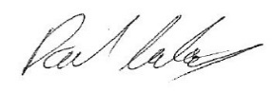
Mr P Cowley
Head Teacher

Aims and Values
We aim to:
- Enable all children to achieve their full potential, by providing high quality teaching, matched to the needs of the individual;
- Provide a safe, stimulating and caring learning environment which enriches children’s learning and motivates them to become active, successful and independent learners;
- Develop a sense of wellbeing, confidence and responsibility so that children can become well rounded members of society;
- Develop a feeling of respect for themselves and others

We believe:
- That all children are equally important, regardless of race, gender, background or ability;
- That children should be listened to, respected and treated fairly;
- That it is our duty to protect and care for our pupils;
- That parents and carers are partners in their child’s education and development;
- That bullying should not be tolerated;
- That good behaviour is essential if children are to learn;
- That everyone is a learner and everyone can be successful in their own way;
- That adults in school should provide excellent role models for children

SCHOOL ORGANISATION

Teaching and Support Staff
Our staff work very hard to provide an excellent education for your child. We have good adult to pupil ratios and well trained support staff. This is the current staff in school for the 2019-2020 academic year.
Mr Cowley (Head Teacher) |  |  | Miss Carney (Deputy Head Teacher)
Mrs Danks  (EYFS Team Leader) | Mrs Bould  (KS1 Team Leader) |  | Mrs Tierney  (LKS2 Team Leader) |  | Mrs Shields  (UKS2 Team Leader and SENDCo)
Teachers  Mrs Phillips  Miss Rose  Mr Millward  Miss Tyerman (SEND Lead)  Mr Downing  Mrs Kadar  Miss Marr  Miss Dismore  Miss Shepherd  Mrs Watson |  |  | Other teaching staff  Mrs Seaman  (Higher Level Teaching Assistant)  Mrs Clarkson  (Higher Level Teaching Assistant)  Mrs Smith  (Higher Level Teaching Assistant)  Mrs Welford (Teaching Assistant)  Mr Mazfari (Teaching Assistant& Sports Coach)  Mrs Murray (Teaching Assistant)  Mrs Kidby (Teaching Assistant)  Mrs Cockerill (Teaching Assistant)  Miss Da Silva (Teaching Assistant)  Miss Cummings (Teaching Assistant)  Miss Pattinson (Teaching Assistant Apprentice)

Other Staff
- Mrs Morris (Business Manager)
- Miss Jackson (Parental Support Advisor)
- Mrs Abrol (Office Manager)
- Mr Martin (Caretaker)

Governing Body
Governor’s plan the school’s future direction making decisions on the school’s budget and staffing. They make sure the National Curriculum is taught and that the school provides for all its pupils, including those with special educational needs. Governors also make decisions on how the school can encourage pupils’ spiritual, moral and cultural development.
Head Teacher

- Mr Paul Cowley

Chair of Governors

- Dave Elliott

Appointed Governors

- Mrs Helen Malbon
- Mrs Jill Patterson

Parent Governor

- Mrs Sarah Slater

ADMISSIONS

Our catchment area is:
- North - the south side of Coulby Farm Way (including Swallowfields, Crossfields and Dewberry)
- East - the west side of Marton West Beck
- West - the east side of Stokesley Rd (B1365)
- South - the boundary between Middlesbrough and North Yorkshire

Admissions Policy
In Middlesbrough, children can begin full time education when they are 4 years old. At Rose Wood, we admit all children who are 5 between 1st September and the end of the school year in August, in September.

Parents will be sent an application form in the term before their child is due to start full time school, requesting preferences for full time education, by the Local Authority.

Arrangements for an initial visit to the school
Parents are encouraged to visit the school before admission. Parents of new starters in Reception will be invited to a “Welcome “meeting before their child actually begins school.

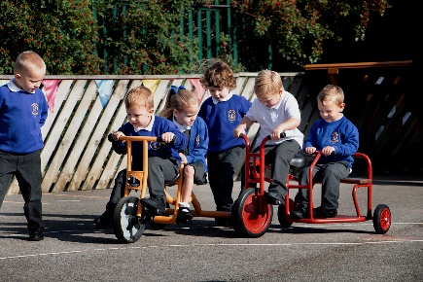
Nursery Admissions Policy
Children are admitted to nursery as soon as possible after their third birthday. Older children wanting a Nursery place can be admitted by arrangement with the Head Teacher, although this is dependent upon places in the Nursery.

Parents will be contacted in the term before their child starts Nursery, and will be invited to a “Welcome to Nursery” meeting at school.

There are two Nursery sessions:
- Morning Session 8.45 am – 11.45am
- Afternoon Session 12.30pm – 3.30pm

For further details about admissions, please refer to our admissions policy.

THE SCHOOL DAY

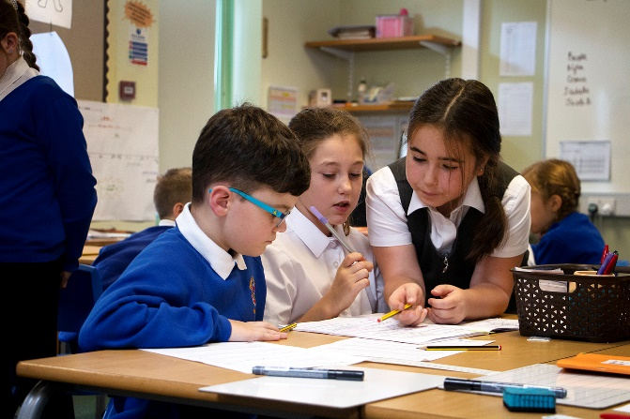
Punctuality and Attendance
It is very important that children arrive at school on time and attend regularly. The legal requirements for attendance are set out in Section 7 of the Education Act 1996.

Please keep your child‘s absences to a minimum so that they miss as little as possible of their learning time in school. If your child is absent, please ring to let us know, or send a note with your child on their return. If a child has a medical appointment, they should not miss the whole day but return to school straight after the appointment.

Please note that attendance is carefully monitored, and we will contact parents if a child’s attendance and/or punctuality falls below a minimum level. This may also trigger a visit from the school’s attendance officer and may result in a fine being imposed.

Rewards are given to all children with 100% attendance throughout the year.

Lateness

Children will be classed as having an unauthorised absence if they arrive at school after 9.15am.

Holidays in term time
Holidays in term time must be avoided except in exceptional circumstances. All such holidays must be sanctioned by the Head Teacher. Local Authority policy indicates that parents may be fined if they fail to bring their child to school. No holidays will be authorised during term time.

School Times
Key Stage 1 (Years 1 and 2)

8.50am: Doors open
We open the doors at 8.50 am for children to come straight inside and get a prompt start with the school day. We have tasks in class ready for them and register is taken at 9.00am. A member of staff is available in each area at 8.50am, if you need to pass on a message.

Children may come to school on bikes and scooters, which should be left in the bike racks, locked. For safety reasons, we ask that these are pushed rather than ridden once children are on the school premises. Parents are asked not to bring buggies etc. into school for safety reasons.

Late arrivals
Doors are locked at 9.00am. Parents arriving late will need to come to the main entrance. The security gates are locked at around 9.30am and unlocked just before home time.

10.30am: Morning break
Children have a fifteen minute break each morning. They are given a piece of fruit at this time. Two members of staff supervise playtimes.

12.00 – 12.45: Lunchtime
Children are supervised by lunchtime supervisors. There is a first aider on duty at all times.

3pm: Home time
Children are brought on to the yard at 3pm, where they will stand with the teacher until a parent or carer arrives to collect them. Reception children will be kept in the classroom and let out of the classroom door when teachers see the person collecting them.

If you are unable to collect your child, or another adult is collecting them for you, please let the school know as soon as possible. Children are always told not to go until an adult is there to collect them. Children are not allowed to go with a teenage sibling. Children attending after school clubs will be let out through the front entrance, where parents should meet them.

Key Stage 2 (Years 3, 4, 5 and 6)

8.50am: Doors open
We open the doors at 8.50 am for children to come straight inside and get a prompt start with the school day. We have tasks in class ready for them and register is taken at 9.00am. A member of staff is available in each area at 8.50am, if you need to pass on a message.

Children may come to school on scooters or bikes. These should be locked and left in the KS2 bike racks. For safety reasons, we ask that these are pushed rather than ridden once children are on the school premises.

Late arrivals
Doors are locked at 9.00am. Any child arriving after this time should come to the front entrance. Please note that if children arrive late after registration they will be marked absent for their morning session. Children should not arrive at school earlier than 8.45am unless they are attending a before-school club.

10.30am – 10.45am: Morning break Y3/Y4
10.45am – 11.00am: Morning break Y5/Y6

Children are able to buy a healthy snack from the tuck shop. They should bring no more than 20p per day.

12.00 – 12.45pm: Lunchtime Y3/Y4
12.15 – 1.00pm: Lunchtime Y5/Y6

Children are supervised by lunchtime staff. There is a first aider on duty at all times.

3.10pm: Home time

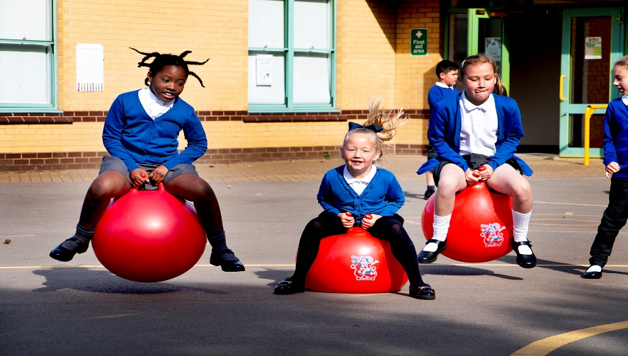

Before and After School Activities

We have a range of before and after school activities, which includes the following:

Breakfast Club
Breakfast starts at 8am and the club operates every day. There is a daily charge of £2.20 which includes a range of cereals, toasted items, fruit, milk and fruit juices. If you would like a place, please contact the school office.

After school Club ‘Wrap Around Care’
This club is run by Rose Wood staff and provides care for pupils between 3.00pm to 5.45pm. There is a charge of £6.00 per session. For siblings to attend the cost would be £5.00 for each child.

School run a range of clubs before and after school, such as street dance, football, homework club. Please note: clubs may change through the year. Some clubs may incur a small charge. Please refer to the school website and the School Office for current information and availability

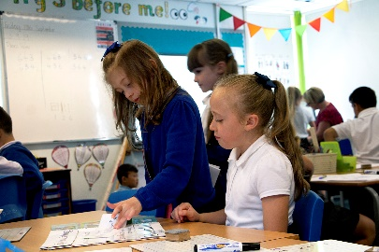
Charging Policy
The Governors have decided that because of the wide range of provision for clubs the school will have to charge for some clubs.

MEAL ARRANGEMENTS
Rose Wood is a ‘healthy’ school. This means that we try to encourage our children to eat healthily, take exercise and be aware of how to keep themselves well, both physically and emotionally. We recognise that a healthy diet contributes to children’s ability to learn and develop well.
Rose Wood provides excellent school meals, providing our children with nutritious menus that include a range of hot meals and salads every day. Our school cook tries very hard to offer meals that the children enjoy which are also nutritionally sound and children are rewarded for making healthy choices. For a typical two week menu cycle please contact the School Office.

Lunchtime supervisors help children with their choices and supervise behaviour in the dining hall and on the yard. Children who do not behave well at lunchtime may be sent to the “Lunchtime Reflection Room” where they are supervised, and where they must reflect on their behaviour.

Free School Meals (FSM) / Universal Infant Free School Meals

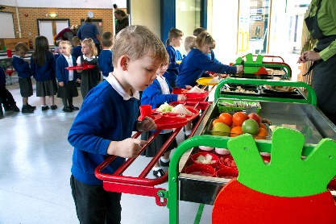
Parents/carers you can check your own eligibility on https://www.cloudforedu.org.uk/ofsm/sims or alternatively you can speak to Mrs Abrol in the school office for more information.

Government legislation means that all children in Reception, Year 1 and Year 2 are entitled to free school meals. Meal choices can only be changed half termly so please inform the school office before the start of the new term in order for the kitchen staff to plan the correct number of meals for the coming term.

For Key Stage 2 Children, school lunches cost £2.30 per day and dinner money must be paid for the week in advance on Mondays, or the first day of the week if this is not Monday. If you wish to pay for a number of weeks (e.g. for a half or full term) you are welcome to do so. All payments for lunches must be made using Parentpay- an online payment service. Please speak to Mrs Abrol in the school office for any support you may need to use this service.

Payment arrears are closely monitored. Please ensure that dinner money does not fall any more than two weeks in arrears. If you are in receipt of certain benefits, you may qualify for free school meals. You can check your own eligibility on https://www.cloudforedu.org.uk/ofsm/sims or alternatively you can speak to Mrs Abrol in the school office for more information. We are aware that all children in key stage one are entitled to universal free school meals, but please still complete the online free school meals application as your child can still benefit by confirmation of eligibility. Every child entitled to a free school meal receives ‘pupil premium’ funding, which is used to support their learning.

Packed Lunches
Some parents may wish to give their child a packed lunch. We always encourage healthy packed lunches but don’t want to be too prescriptive with extensive guidelines. We recommend a balanced approach. We would ask though that you don’t include fizzy drinks or chocolate bars of the type that you would buy in a sweet shop. We are fine with a biscuit or a cake bar etc. We are a strictly nut free school and this includes ‘Nutella’ and other chocolate spreads that contain hazelnuts.
Please see Mrs Abrol in the School Office if you wish to change from packed lunches to school dinners or vice versa. This is done on a half termly basis.

Healthy Schools

The school aims to encourage healthy eating, exercise, emotional wellbeing and understanding about safety issues.

We participate in the National Fruit Scheme, which provides Foundation Stage and Key Stage 1 with a piece of fruit each day.

The children in Key Stage 2 have a healthy tuck shop, which provides a healthy snack each day for around 20 pence.

The school also offers many sporting activities and clubs which encourage healthy lifestyles.

Payment and Cash Handling Policy

ParentPay – Parents/Carers are able to pay securely online for a range of items and activities through Parentpay. Paying online gives you the peace of mind that comes with knowing that your money has reached the school safely and is used for its intended purpose. To activate your account please request an activation letter from the school office.

The cost of school visits is £20 for the year. This is then further subsidised by school to cover the cost of a range of trips and visits throughout the year.
Debt Policy
The Governors have approved a debt policy for the Academy. This is available on the school website www.rosewoodacademy.co.uk under key information/policies.

CURRICULUM
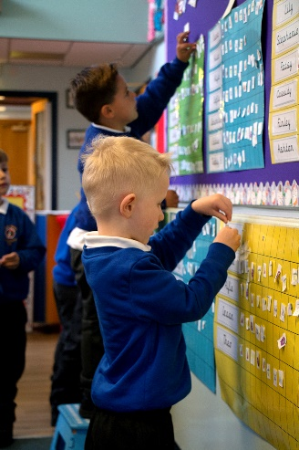
Pupils in the Foundation Stage follow a curriculum based on the Early Years Foundation Stage. This involves a stimulating range of indoor and outdoor learning, including opportunities for learning in the community, which helps develop the knowledge, understanding and skills for the seven areas of learning outlined in the document.

In Key Stage 1 and 2, the school offers an exciting and stimulating cross curricular curriculum which follows the Department for Education frameworks for English and Maths. Topics are well planned and resourced, match children’s interests and abilities well, and where possible involve a visit or visitor to stimulate interest. ICT is used to support the children’s learning in all subjects.

The school teaches its pupils about Citizenship issues, and develops social, personal and emotional skills. Key Stage 2 children learn a modern foreign language.

Our curriculum is fully inclusive. All children have access to the full range of curriculum activities.

Sex Education
The Governing Body have agreed that Sex Education will not be taught as a separate subject to younger children. However, if the subject arises, for example through children’s questions, the subject will be dealt with in a manner appropriate to the age and maturity of the child concerned.

Older pupils in UKS2 will be shown animations which aim to prepare them for the physical and emotional changes which they will experience during puberty. Parents will be informed that these talks are about to take place, and may withdraw their child if they wish (although we hope that they will not do so). Parents may also view the animations in advance.

The teaching in this area is intended to support parents, and recognises that the main responsibility for sex and relationships education lies with the parents.

Religious Education
In accordance with the 1988 Education Reform Act, parents have the right to withdraw their children from attendance at Religious Education lessons, and Religious Worship and alternative provision will be made for these pupils. Parents wishing to do so should contact the Head Teacher. The School follows the local RE syllabus.

Homework
In response to parents’ feedback, we changed our approach to homework. We identified the key aspects that we felt would have the biggest impact on children’s attainment and ask that parents focus on these. These are regular reading (a minimum of three times per week), practising spellings, learning times tables and learning key mathematical knowledge from the year group’s curriculum.

WELFARE AND BEHAVIOUR

Code of Conduct
Standards of behaviour at Rose Wood are very high. We achieve this through establishing clear boundaries and guidelines, and by the use of rewards and sanctions.

Our behaviour policy is shared with all parents and children on entry to the school, and this outlines expected behaviour and consequences if children do not adhere to these expectations.

Children are awarded bronze, silver and gold stickers for earning 100, 200 or 300 dojos, Children who behave well receive rewards, including:
- Stickers
- Praise/Dojos
- Pupil of the Week award
- Child of Achievement award
- Head Teacher’s award

Children who do not behave as we expect could receive one or more of the following sanctions:
- Removal of dojos
- Time out in their own or another teacher’s class
- Missed playtimes
- Time in the “Lunchtime Reflection Room” for poor behaviour at lunchtime
- Sent to the head teacher or other senior member of staff
- Letter home to parents
- Report

Children who need additional support to conform to behaviour expectations may have a sticker chart or Individual Behaviour Plan or Care Plan drawn up by the Special Educational Needs Coordinator (SENDCo)

We aim to work in partnership with parents where behaviour causes concern.

Bullying
Most schools experience incidents of bullying from time to time. At Rose Wood all reported bullying is dealt with speedily and thoroughly. All allegations of bullying are dealt with seriously. Where children need support (either victim or bully) it will be provided, sometimes by the Parent Support Adviser.
We define bullying as:
- The persistent abuse of a position of power to intimidate or threaten another person;
- The persistent use of name calling/verbal abuse or physical violence to intimidate another person;
- The intimidation of one person by a group of people

The school has a bullying policy which is available to parents on the school website.

UNIFORM

The school has a dress code which should be followed by all pupils from reception to Year 6. In nursery, many parents also choose to dress their children in uniform, however this is not compulsory.

Uniform can be purchased from:
Elizabeth’s Embroidery www.elizabethsembroidery.co.uk tel: 01642 674973
Lollipops 01642 225827 www.lollipops-middlesbrough.co.uk tel: 01642 225827

You can add the school logo or your child’s initials if required.

Everyday wear:
- Royal blue sweatshirt or cardigan
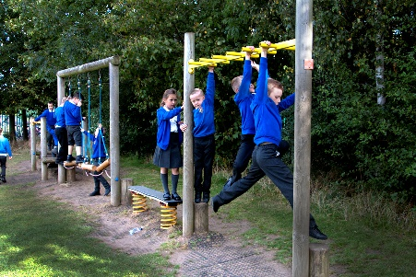
- White polo shirt or plain white school shirt
- Grey trousers or skirt (knee length, grey shorts may be worn in warm weather)
- Blue gingham dress in Summer
- Plain grey pinafore dress
- Black shoes or plain all black trainers (including a dark sole). Trainers must NOT have a coloured sports logo. Shoes must be flat shoes.
- Girls may wear white, flat sandals in summer. Plain black, flat ankle boots can be worn in winter.

Items may have the school’s logo if wished, but this is not compulsory.

So that the year six children stand out as school ambassadors, they are allowed to wear a red sweatshirt. Year 6 children can also wear black or grey trousers or skirts.

Indoor PE:
- Navy blue shorts
- Short sleeved, white T shirt of appropriate length

Outdoor PE:
- Navy blue shorts
- Short sleeved, white T shirt
- Trainers or outdoor plimsolls
- Navy or grey jogging trousers and sweatshirts may be worn in cold weather

General requirements:
- No jewellery except watches or small ear studs (ear studs to be worn at own risk; for health and safety reasons these must not be worn for PE or swimming and cannot be removed by staff)
- No nail varnish, make up or tattoos
- Appropriate hairstyles (e.g. no colours, tramlines or elaborately shaved hairstyles. Long hair should be tied back.)
- Bows and other adornments in hair should be small and in line with the school uniform colours.

Sun Awareness
On sunny days where there is a high risk of sunburn we try to keep children in the shade as much as possible. There is a shelter in the KS1 yard. Parents can assist by ensuring children wear loose, long sleeved tops and wear high factor sunscreen and a hat.

SAFEGUARDING
Safeguarding statement
The school has rigorous systems in place which help safeguard the pupils. The school has many safeguarding policies including the following:
- Access
- Whistle blowing
- Use of mobile phones and cameras
- Acceptable Use (ICT)
- Bullying
- Safe recruitment
- Confidentiality
- Emotional health and Wellbeing
- Child Protection etc
- Staff code of conduct

Staff are well trained in safeguarding matters and place the safety of the children at the top of their priorities. Our designated safeguarding lead is Mr Cowley and the deputy safeguarding leads are Miss Carney and Miss Jackson.

Policies can be found on the school’s website, or hard copies can be made available on request.

Medicines in school

Medicines can be administered by a First Aid qualified member of staff provided that medicine has been prescribed by a doctor and is labelled with your child’s name. We are unable to administer non-prescription medicines but parents are welcome to come in to school to give medicines such as Calpol.

Pupils needing inhalers must keep one in the classroom labelled with their name.
Parents must identify their child’s medical/dietary needs (including allergies) on the medical information form and it is parents’ responsibility to inform school of any changes.

Pastoral Care
Your child’s teacher is responsible for the pastoral care of the children in their class. If a teacher feels that there is concern over a child (academic, emotional, social or behavioural) the teacher will discuss this concern with the Head Teacher. This could result in a discussion with the child’s parents or referral to an appropriate outside agency. It might also trigger involvement from the school’s Parent Support Adviser (Miss Jackson).

Child Protection
All staff have a duty of care towards the children in our school. We will take all reasonable action to ensure the health, safety and wellbeing of children in our care.

Where staff have cause to suspect that a child may be subject to ill-treatment, neglect or other forms of abuse, they will discuss that concern with the Designated Person for Child Protection (the Head Teacher). Guidelines laid down in the school’s Child Protection policies will be strictly followed. These guidelines conform with the LSCB regulations. Concerns may result in a referral being made to Family Services.

Photograph Policy
The school seeks a range of permissions on an annual permissions form. These permissions include being able to take and use photographs of pupils for school use. Photographs of children may be used in school, on the school website, in displays or in other school publications. Children’s names will not be used in these photographs.

Parents are allowed to take video footage of their child at performances such as the Nativity, but we ask that these images are not shared on social media. Where photographs of children appear in the Evening Gazette names may be used, but names will not appear in an electronic version on their website. Any parent who wishes their child to be exempt from this policy should write to the Head Teacher.

School Crossing Patrol
We have a school crossing just outside the school, which is supervised by a Warden. Children needing to cross over Coulby Farm Way should always use this facility.

Parking
Parents must not park in the staff car park when delivering and collecting children for the school day. This is a safety hazard. There are lay-bys at the front and rear of the school. School gates are shut at key times. Parents may use the car park (with caution) when delivering children to breakfast club before 8.30am and collecting children from after school clubs. Please park responsibly around the school!

SPECIAL EDUCATIONAL NEEDS AND DISABILITIES (SEND)
Mrs Shields is the Special Educational Needs Co-ordinator (SENDCo) for the school, supported by Miss Tyerman as SEND Lead. Within the Code of Practice, the school has a policy for dealing with Special Educational Needs. This policy is available to parents on request.

Rose Wood is an inclusive school. We are committed to providing an excellent education for all the children who attend. In order to provide for each child’s needs, we have well trained teaching and support staff who support children in a variety of ways. This may be through a differentiated curriculum, intervention programmes for learning, behaviour programmes, and individual or small group help.

Our school offer for SEND appears on the school’s website in accordance with current legislation.

External Support

The school employs a specialist teacher (Mrs Croft) who provides assessment for pupils with specific needs. We have access to an Educational Psychologist (who provides advice and assessment) and other specialist schools e.g. Beverley School and Holmwood School.
We identify any difficulties as early as possible through our pupil tracking and assessment system, and we fully involve parents, welcoming their support. Parents can request an assessment of their child’s needs by contacting the Head Teacher via the School Office.

COMMUNICATION

How to get in touch

Rose Wood Academy
The Garth
Coulby Farm Way
Coulby Newham
Middlesbrough
TS8 0UG

Tel. 01642 595353 Website: www.rosewoodacademy.co.uk

Making an appointment with your child’s teacher: Please ask your child’s teacher, the Head Teacher or telephone the School Office. Please ensure that you are signed up for class dojos, as messages will be sent out using this platform. It is of the utmost importance that any changes in telephone numbers are given to the school office
Information and Updates

For information on what is happening in school we suggest you check the school website as well as Class Dojo.

Documents Held In School
Documents outlining the Department for Educations statutory requirements, National Curriculum, schemes of work and minutes of Governor’s meetings are available on request.

Other Formats
This document is available in other formats for parents with a visual disability. Please contact the Head Teacher for further information.

