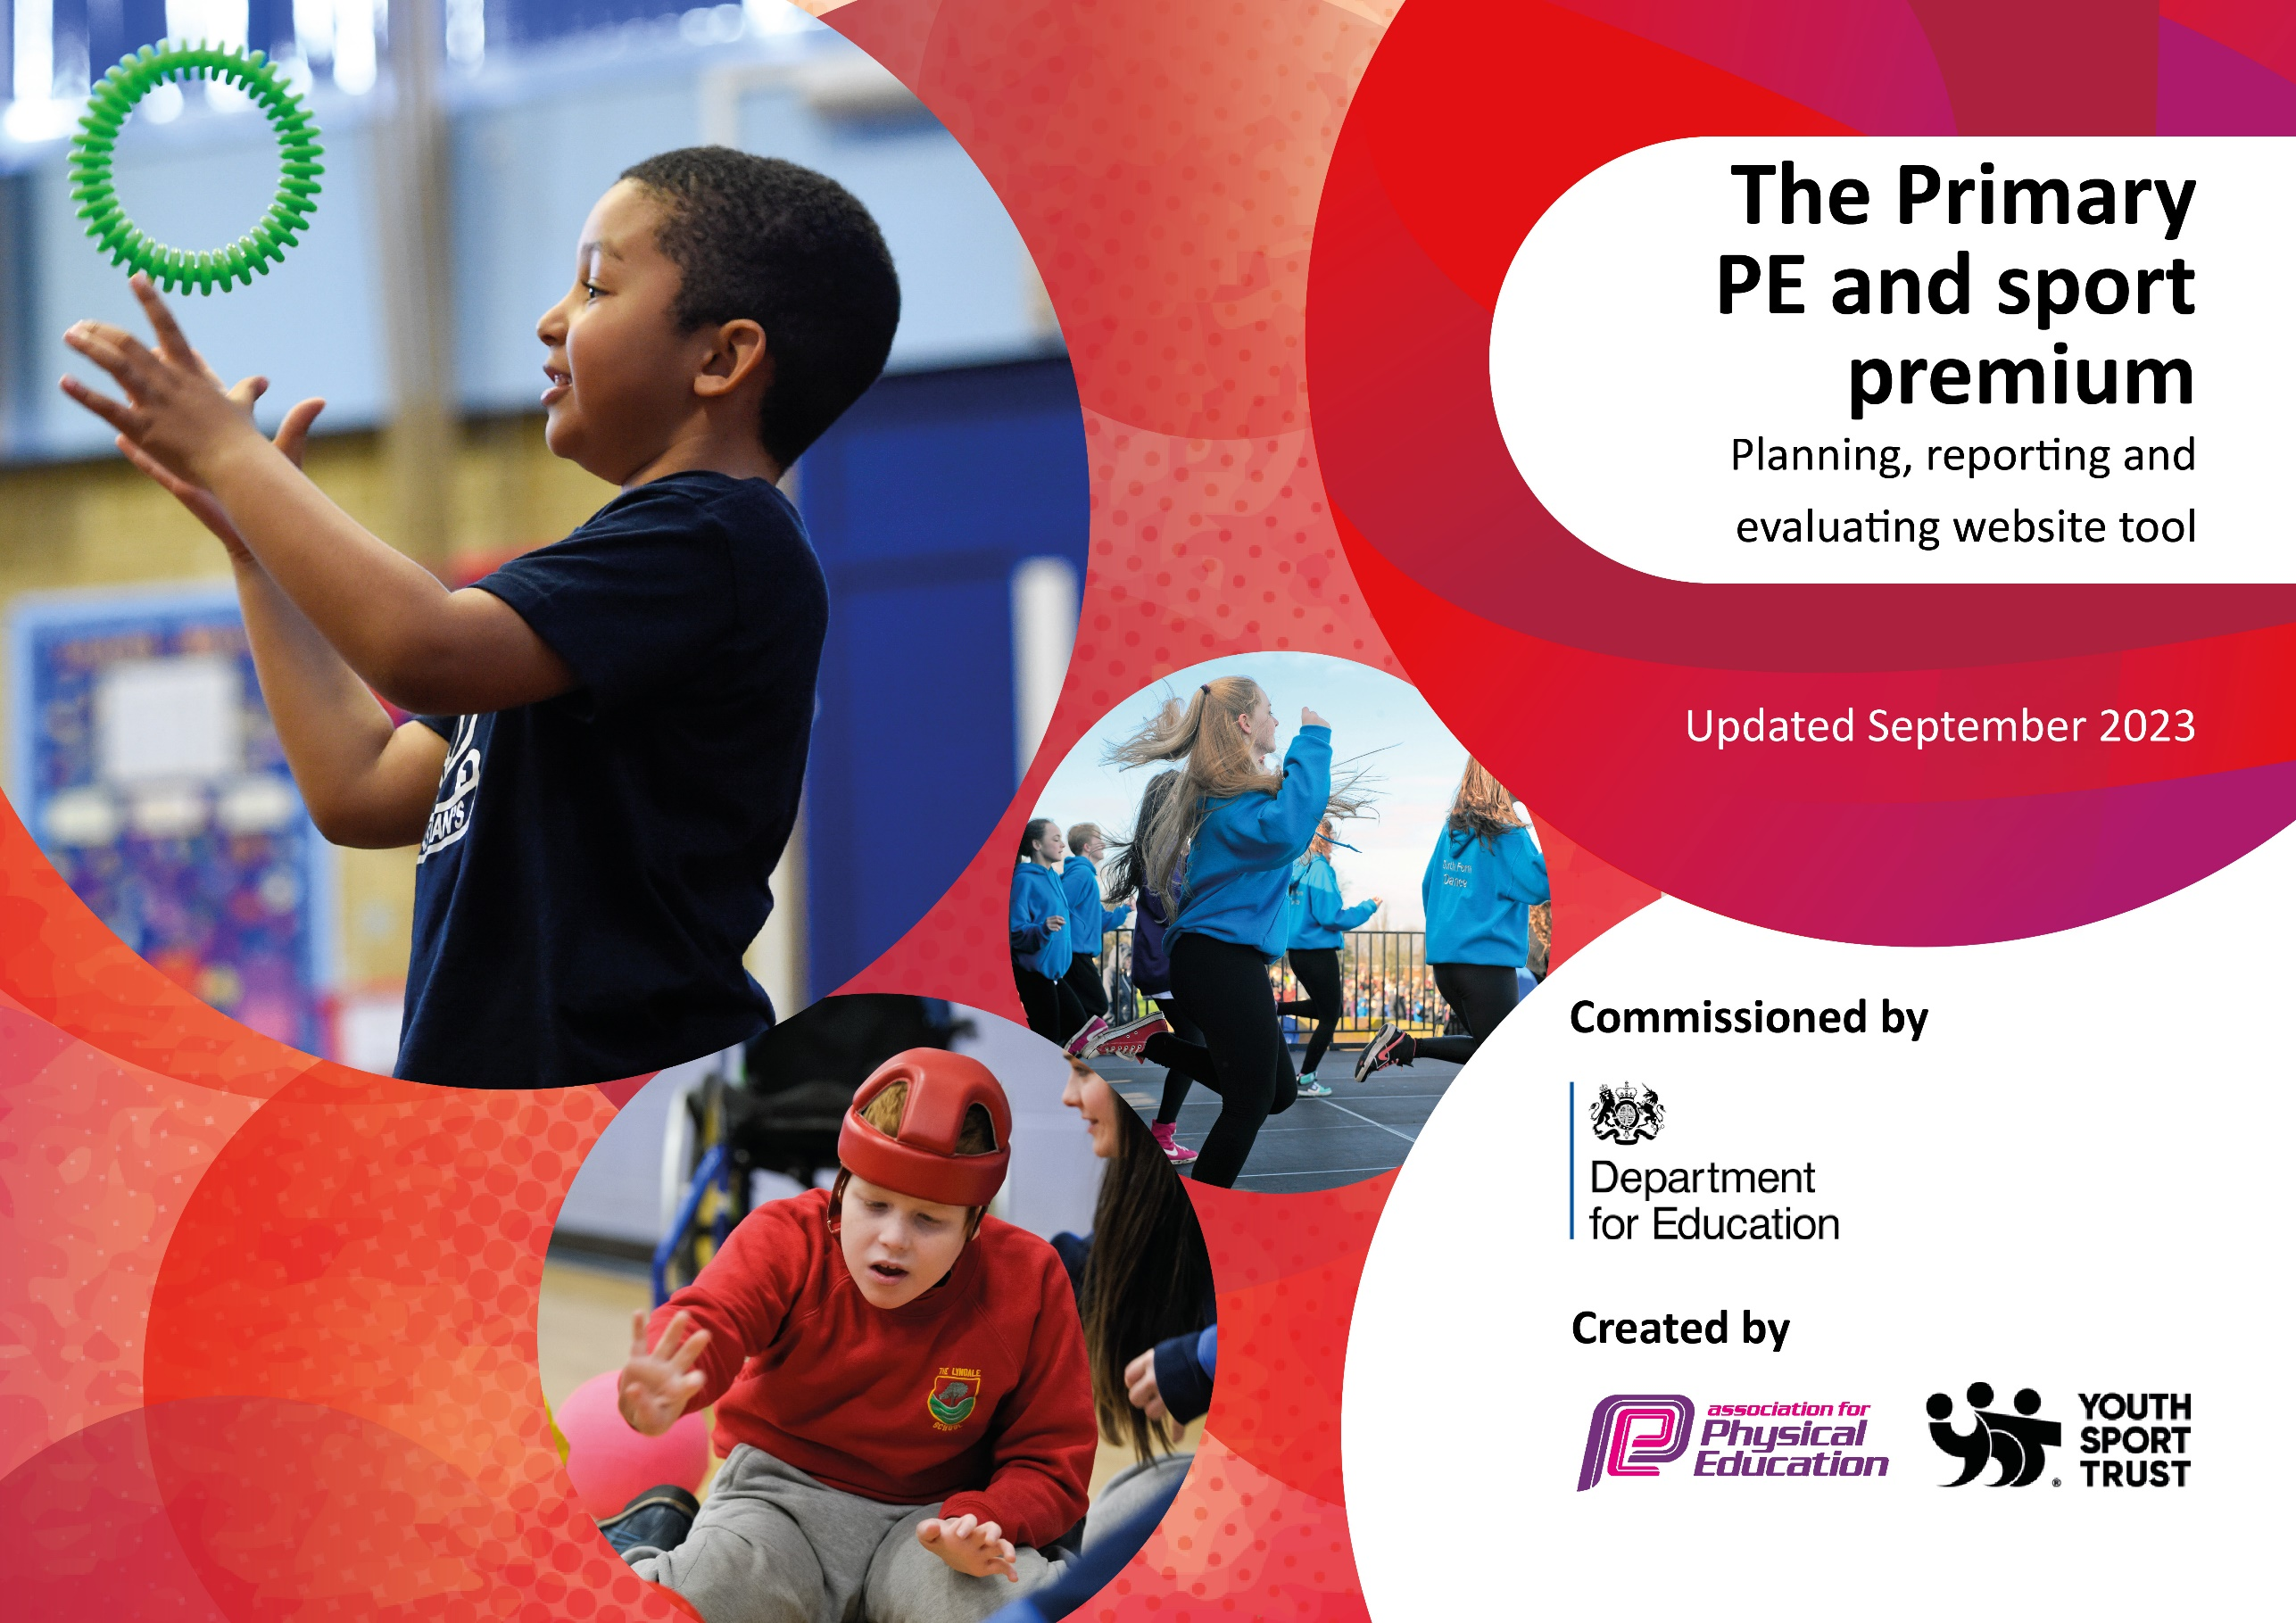

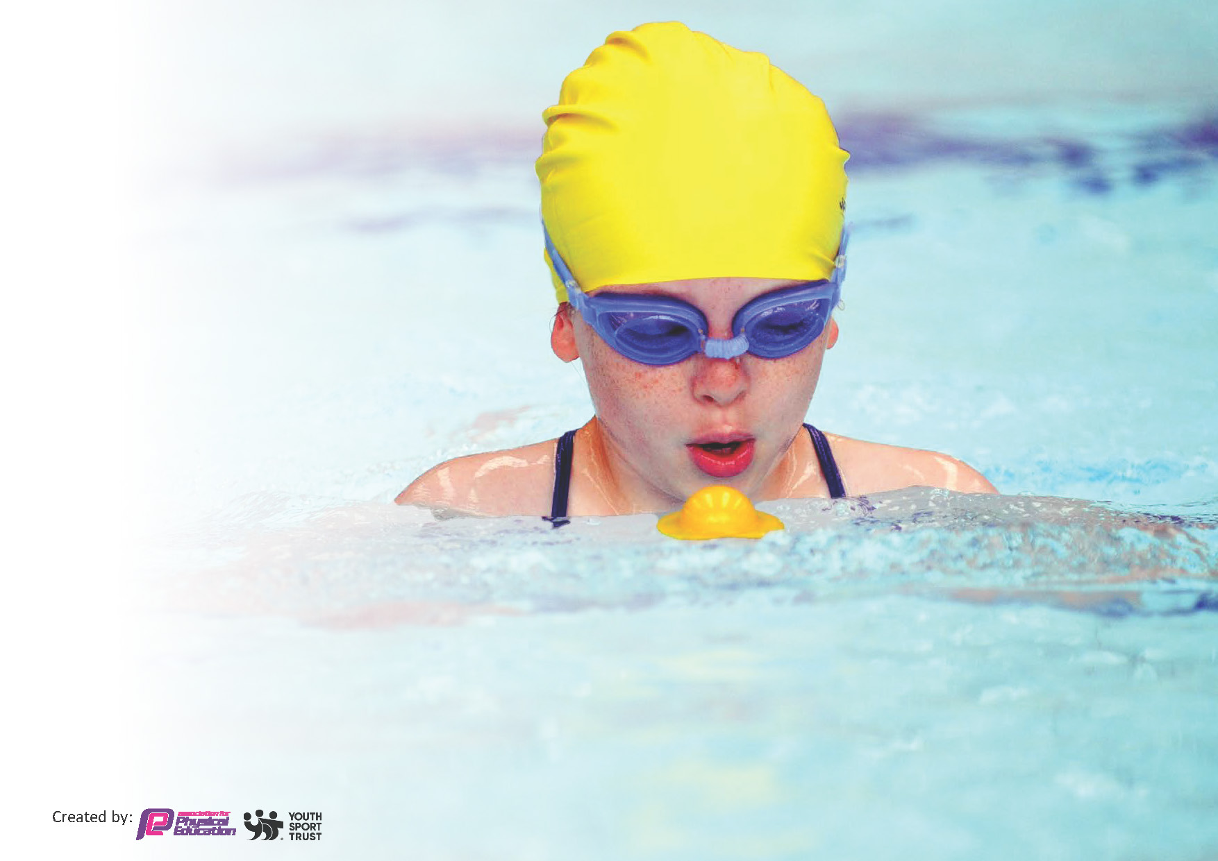
This template can be used for multiple purposes:
by:
- It enables schools to effectively plan their use of the Primary PE and sport premium
- It helps schools to meet the requirements (as set out in guidance) to publish information on their Primary PE and sport premium
- It will be an effective document to support Ofsted inspections enabling schools to evidence progress in Physical Education (PE) and evidence swimming attainment, which forms part of the PE National Curriculum. We would recommend schools consider the Intent, Implementation and Impact of any spend, as examined within the Education Inspection Framework.

It is important that your grant is used effectively and based
on school need.

Schools must use the funding to make additional and sustainable
improvements to the quality of the PE, School Sport and Physical Activity (PESSPA)
they offer. This means that you should use the Primary PE and sport premium to:

- Build capacity and capability within the school to ensure that improvements made now will benefit pupils joining the school in future years
- Develop or add to the PESSPA activities that your school already offers.

The Primary PE and sport premium should not be used to fund capital spend projects; the school’s core budget should fund these. Further detail on capital expenditure can be found in the updated Primary PE and sport premium guidance.

The Primary PE and sport premium guidance, outlines 5 key priorities that funding should be used towards. It is not

necessary that spending has to meet all the key priorities, you should select the priorities that you aim to use any funding towards.

Although completing this template is not a requirement for schools, schools are required to publish details of how they spend this funding. Schools must also outline what the impact this funding has had on pupils’ PE and sport participation and attainment and how any spending will be sustainable in the future. All funding must be spent by 31st July 2024.

The Department for Education has worked closely with the Association for Physical Education (afPE) and the Youth Sport Trust (YST) to develop this template and encourages schools to use it. This template is an effective way of meeting the reporting requirements of the Primary PE and sport premium.
Review of last year’s spend and key achievements (2022/2023)

We recommend you start by reflecting on the impact of current provision and reviewing your previous spend.

Activity/Action | Impact | Comments
Increase physical activity opportunities during break times.  Increase the number of before and after school clubs.  MFC Foundation to provide sports coach expertise for the children and staff in school.  Provide staff with a long-term overview of the year.  Provide the KS2 children with the opportunity to attend a sports competition. | Children’s physical activity levels increased during the school day.  Children had a wider range of before and after school clubs throughout the year.  Staff continue to develop their confidence and ability to teach PE. Children received high-quality PE lessons.  Tailored PE overview developed to ensure revisiting of skills.  More children attending sports competitions. | The Year 6 children who were trained as ‘Play Leaders’ have now moved to secondary school.  The new cheerleading club was very popular with the children.  Suit the children’s interests by asking them what clubs they would like to see before and after school via pupil voice and school council.  Renew contract with MFC Foundation to continue supporting the teaching of PE.  Renew Complete PE subscription as supports staff in teaching PE and makes them feel more confident.  Track which children are attending a sports competition and target where necessary.

Key priorities and Planning
This planning template will allow schools to accurately plan their spending.

Action – what are you planning to do? | Who does this action impact? | Key indicator to meet | Impacts and how sustainability will be achieved? | Cost linked to the action
Increase the number of children participating in a before and after school club.  Offer a wide range of activities.  Ask the children what activities they would like to see before and after school.  Provide every child with the opportunity to participate in an extracurricular activity.  Re-introduce Year 5 and 6 ‘Play Leaders’ at lunch times. | The children will take part in the before and after school clubs.  The school council representatives will ask their peers what clubs they would like to see in school and report back to the PE subject lead.  The PE subject lead will ask the children what clubs they would like to see in school when conducting pupil voice.  The PE subject lead, PE specialist in school and external agencies will lead the clubs.  The PE subject lead will monitor the children who are participating in clubs and target children where necessary. | Key indicator 2: Engagement of all pupils in regular physical activity.  Key indicator 4: Broader range of sports and activities offered to all pupils. | The children will have the opportunity to participate in a range of different activities and sports.  The children’s physical activity levels will increase during the school day. | £2,830
Ensure all children in KS2 have the opportunity to attend a sporting competition. | The PE subject lead to organise the competition calendar and sign the school up for the competitions in advance.  The children will take part in the sporting competitions.  The PE specialist in school will take the children to the sporting competitions.  The PE subject lead and PE specialist will monitor which children are attending sporting competitions and target children where necessary. | Key indicator 5: Increased participation in competitive sport. | The children will be exposed to competitive sport beyond school and in the local community. | £3,060
Increase staff confidence in teaching PE by offering CPD.  Increase the PE subject leaders confidence in leading the subject by attending CPD. | The PE subject lead will send out a staff voice form to establish where staff feel less confident.  Teachers and TAs will work alongside the PE specialist in school and external agencies.  Teachers and TAs will participate in PE CPD.  The PE subject lead will offer and suggest PE CPD to staff.  The PE subject lead will attend subject leadership CPD. | Key indicator 1: Increased confidence, knowledge and skills of all staff in teaching PE and sport. | The children will participate in a high-quality PE lesson.  Staff will feel more confident teaching a PE lesson.  The subject leader will feel more confident supporting staff. | £12,058
Provide staff with the planning for PE from the Complete PE scheme. | The PE subject lead will set out the long-term plan for the year.  Teachers, with the support of the PE specialist in school and external agencies, will teach the PE lessons from the planning from the Complete PE scheme. | Key indicator 1: Increased confidence, knowledge and skills of all staff in teaching PE and sport. | Staff will feel more confident teaching a PE lesson by using the planning provided by the Complete PE scheme.  A more thought through long term curriculum plan will allow children to re-visit skills and progress throughout the year and across year groups. | £252
Organise the PE cupboard and order high-quality equipment needed to teach PE lessons. | The PE subject leader will audit what equipment needs ordering.  The head teacher will authorize the order.  The business manager will process the order. | Key indicator 4: Broader range of sports and activities offered to all pupils. | All equipment will be of a high standard and accessible to teach each lesson.  The children will be using high-quality equipment in their PE lessons. | £500

Key achievements 2023-2024
This template will be completed at the end of the academic year and will showcase the key achievements schools have made with their Primary PE and sport premium spending.

Activity/Action | Impact | Comments

Swimming Data
Meeting National Curriculum requirements for swimming and water safety.
Priority should always be given to ensuring that pupils can perform safe self-rescue even if they do not fully meet the first two requirements of the National Curriculum programme of study

Question | Stats: | Further context  Relative to local challenges
What percentage of your current Year 6 cohort can swim competently, confidently and proficiently over a distance of at least 25 metres? | 92% | The children who have not achieved this objective are currently attending additional swimming lessons.
What percentage of your current Year 6 cohort can use a range of strokes effectively [for example, front crawl, backstroke, and breaststroke]? | 92% | The children who have not achieved this objective are currently attending additional swimming lessons.

What percentage of your current Year 6 cohort are able to perform safe self-rescue in different water-based situations? | 100%
If your schools swimming data is below national expectation, you can choose to use the Primary PE and sport premium to provide additional top-up sessions for those pupils that did not meet National Curriculum  requirements after the completion of core lessons. Have you done this? | Yes/No | The Year 4, 5 and 6 children who have not met the National Curriculum requirements for swimming and water safety are currently attending additional swimming lessons with the Year 3 children who are attending their core swimming lessons.
Have you provided CPD to improve the knowledge and confidence of staff to be able to teach swimming and water safety? | Yes/No | The swimming teachers at the leisure center support the teachers before, during and after the lessons.

Signed off by:

Head Teacher: | Paul Cowley
Subject Leader or the individual responsible for the Primary PE and sport premium: | Holly Peacock  Year 2 Teacher and PE Subject Lead
Governor:
Date: | 28.11.23

