Rose Wood Academy

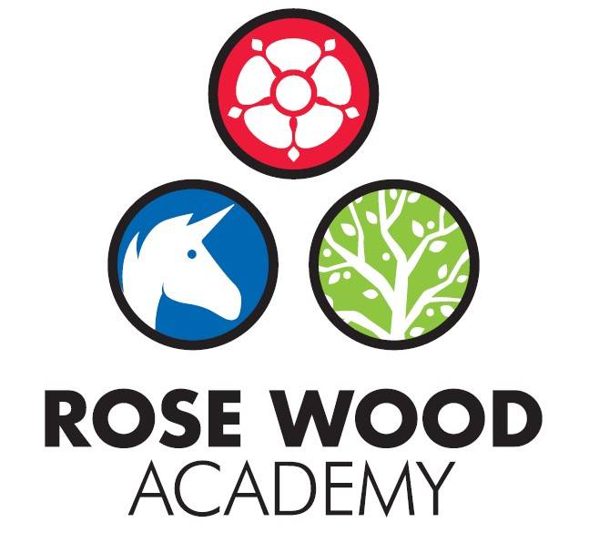

Subject Statement for Art

Contents
Curriculum Aims 3
Subject Content and Organisation 3
Embedding Knowledge 4
Leadership Activities 4
Assessment 6
Appendices 7

Artists Covered
Art Overview

Subject Statement for Art

Curriculum Aims

At Rose Wood Academy, we want every pupil to learn and develop the knowledge and skills they need to experiment, invent and create their own works of art, craft and design. We believe that art and design is integral to developing imaginative, creative, culturally aware citizens who have a lifelong appreciation of the highest forms of human creativity.
Our pupils will learn how to critically engage with a diverse range of ancient, traditional, modern and contemporary artists through the most significant periods in art, understanding the key concepts behind them.
As they progress through our curriculum, pupils will accumulate properly embedded, sequenced knowledge and skills that help them to develop as confident practitioners of art who understand their position in the learning journey and what they need to do to improve. They will understand that improvement is relative to themselves, as they develop the confidence to express their creative voice in ways that suit their own artistic tastes and preferences.

Subject Content and Organisation

We teach art through four curriculum attainment areas, which correspond to the National Curriculum for art and design, and closely relate to the NSEAD’s four attainment targets.
Our four curriculum attainment areas are:
Skills – acquiring skills sequentially and reinforcing these skills through regular practice.
Knowledge & Understanding – developing their knowledge of significant art through time and understanding the concepts behind it. Also, to develop their knowledge of key subject vocabulary in order to critically engage with works of art.
Creativity – opportunities to execute the knowledge and skills they learn in appropriate, imaginative and creative ways.
Reflection – developing the pupil’s metacognitive ability to critically engage with their own and others work, so that they understand their position in the learning process and know what they need to do in order to improve.
Art is divided into unit plans across each year group. The unit plans are designed to cover the above areas and to ensure that the children get to experience the different strands of:
- Painting
- Drawing
- Sculpture
- Design
The children will revisit these strands and the associated skills several times throughout their time in school. This allows children to revisit skills, use prior learning and progress. Where relevant, the units of work are aligned to the ‘Enquiry Driven Curriculum’. This supports the children with their stimulus for creativity.
The children study the work of different artists as part of the art curriculum. This allows the children to appreciate different forms of art as well as giving them a stimulus for their own creativity. The Rose Wood art curriculum covers a diverse range of artists from various backgrounds who demonstrate a range of styles using a range of mediums. The artists chosen also cover the periods of art: Ancient, Traditional, Modern and Contemporary. The list of artists can be seen in the appendices.
All children have an art book from the start of KS1. The books are specific to art. They are high quality art books containing cartridge paper to promote high quality valued artwork. The books allow the children to practise, develop and revisit skills. The books can be used for painting, drawing and to create designs. The children will use the books during their work on the main art units but will also use them to practise their art skills during half terms when art is not the main focus. The books stay with the children throughout school and remain as a stimulus to the children as well as a record of progression. The teachers also have an art book which supports their own subject knowledge and skills development as well as supporting their modelling when teaching the class.

Embedding Knowledge

At Rose Wood, we recognise that learning is only successful if children can securely draw upon it and build upon it. We know that scientific research states that the act of retrieving prior learning strengthens memory and helps ensure that children leave school secure in the knowledge and skills mapped out in the curriculum. We also know that learning is generative – new learning is embedded far more successfully if it accumulates around prior learning. Our approach to securing knowledge and is therefore thwofold:
- Learning is reviewed regularly
- The curriculum is designed to build on previous learning. These links are explicit and revisiting is built in so that children can make clear connections and learning is embedded.
In art, the ‘Art, Craft & Design Knowledge & Skills Progression’ document provides the staff with the prior knowledge that children have to allow them to build the revisits into the curriculum and to use that prior knowledge as the base for new learning. In addition, art books are used for retrieval and to revisit prior knowledge. Children will be encouraged to revisit their previous art and the skills they practised within their art books and then use this as a stimulus when creating new art or developing their skills.

Leadership Activities

As with all subjects, the quality of teaching and learning for art is every leader’s responsibility and all leaders will have an oversight of the quality of teaching and learning for art. There is also a designated art lead who has ownership of certain elements of the curriculum. As well as supporting the leadership team to ensure the highest standards of teaching and learning for art are maintained, the art lead will also be the ‘subject champion’ and will keep abreast of all the new developments that are happening within the subject as well as ensuring high levels of subject knowledge which they will use to support others. They are also in charge of maintaining and acquiring the appropriate resources and supporting staff with their use. The art lead will deliver some subject specific CPD or will identify appropriate external CPD for staff. The art lead will also perform monitoring and evaluation on an ongoing basis and feedback their findings to the SLT.

  - Monitoring and Evaluation
Monitoring and evaluation is ongoing throughout the year. The monitoring will be carried out by the art lead but other senior leaders will monitor the subject at certain points throughout the year. The main activities that make up the monitoring process are:
Learning walks and enquiries
Work scrutinies, evaluation of artwork and the content of art books
Pupil voice
Teacher voice
Planning and content coverage checks
The art lead and the SLT will evaluate the outcomes from these monitoring activities. This evaluation will be used to inform next steps for development such as identifying CPD for staff, supporting with subject knowledge or improving use of or access to resources. The evaluation will be used to produce subject specific action plans and inform the evidencing for review.
These activities will take place throughout the year but there will be at least one ‘deeper dive’ activity that takes an in depth look at the quality of art in the school. Some deeper dives may be supported by other members of the trust.
  - CPD
The art lead will lead some CPD for staff. This will be to support subject knowledge or could be to introduce new material, resources or ideas. They will also organise external CPD as appropriate to support whole school or individual development.
  - Resourcing
The subject lead is responsible for ensuring that the school is appropriately resourced to allow teaching staff to deliver high quality art lessons and to ensure that pupils get the best experience they can. This could be in the form of physical resources such as paint brushes, art pencils, oil pastels, clay, sculpting tools etc. It also includes online resources such as video links that demonstrate specific skills or gallery sites that show the work of studied artists. The art lead should be regularly assessing the quality of the resources but should also be keeping informed about new developments and innovations that could further enhance and improve the quality of the subject within our school.

Assessment

Teachers at Rose Wood use assessment regularly to support them with their planning and task design. It underpins the principles for learning and ensures that all children make progress and face the appropriate level of challenge. It allows staff to know which children need greater challenge and which children need scaffolding and support to allow them to continue to make progress. For art, staff make regular assessments to determine understanding of the key knowledge and skills. The unit plans documentation and the ‘Art, Craft & Design Knowledge & Skills Progression’ document provides the expectations that support staff to do this. It gives examples of outcomes to expect for each area of art across all year groups. By using this to support task design, the staff can assess the outcomes of children and make judgements about their attainment and the next steps. The artwork that is completed by the children in each year group is designed to give the pupils the opportunity to show their creativity as well as demonstrate their skills and knowledge.

Appendices

Artists studied
Jill Murphy – contemporary female British illustrator
AA Milne – traditional male British illustrator
Stanley Spencer – modern male British artist
Diane Ibbitson – contemporary female British artist
Kenyan Flip Flop art - contemporary black, African artists
Gabriel Ugueto – contemporary male American illustrator
Vicky Woodgate - contemporary female British illustrator
Johnny Warangkula Tjupurrula - Aboriginal male artist
Emily Kame Kngwarreye - Aboriginal female artist
Georgia O’Keeffe - modern female American artist
Rachel Ruysch – traditional female European artist
Edward Wilson – botanical British male illustrator
Penny Gould - contemporary female British artist
Emma Stibbons - contemporary female British artist
Ancient Egyptian art
Roman art
Wassily Kandinsky - modern male European artist
Albrecht Durer - traditional male European artist
Kath Kollwitz - modern female European artist
Musah Yussif - contemporary male Black Muslim artist
William Pattison - traditional male British artist
Fernand Leger - modern male French artist
Hokusai – Japanese traditional male artist
Viking art
Hoeydonck - traditional male European artist
Fourth Plinth artists - contemporary British artists
Henry Moore - modern male British artist
Paul Nash - modern male British artist
Laura Knight - modern female British artist
Street Artists - contemporary artists
Shamsia Hassani - contemporary female Muslim artist,
Jean-Michele Basquiat - contemporary male black artist
Mayan, Guatemalan art

Long Term Overview of ART
 | Autumn 1 | Autumn 2 | Spring 1 | Spring 2 | Summer 1 | Summer 2
Early Years | At Rose Wood the art and design curriculum for EYFS is designed to develop the children’s skills and expression to allow the children to meet the Early Learning Goals for Expressive Arts and Design Creating with Materials. This is achieved through guiding and teaching specific skills as well as exposing the children to a range of media on a daily basis via continuous provision. Children are encouraged to be expressive and develop a range of skills including mark making, painting, sculpting, model making using a wide range of materials and techniques. The creative opportunities are linked to the EYFS topics and Power of reading texts throughout the year and help children to consolidate their understanding as well as develop skills, be creative and express themselves.
POR Focus Nursery | Main Focus  Naughty Bus | Main Focus  Oh No, George | Main Focus  Anna Hibiscus Song  The Growing Story | Main Focus  The Very Hungry Caterpillar  Jack and the Beanstalk | Main Focus  What the Ladybird Heard Next | Main Focus  Billy’s Bucket  Happy in our Skin
POR Focus Reception | Main Focus  The Everywhere Bear and Leaf Man | Main Focus  No Dinner | Main Focus  Dear Zoo  +  Tanka Tanka Skunk  Blue Penguin | Main Focus  Hansel and Gretel  (including mixed up fairy tales)  Poetry (A Great Big Cuddle)  (including creating their own and performing) | Main Focus  Yucky Worms  Farm animals | Main Focus  Wild  The Day the Crayons Quit
Year 1 | How have toys changed over time?  Design a Bear  Drawing/Design/Digital |  | How did the Great Fire affect London?  Great Fire  Mixed Media Print |  | Kenya Savannah  Should animals live in the zoo?  Kenyan Animals  Drawing/Printing/Sculpture
Year 2 | Dinosaurs- What can we learn from them?  Dinosaurs  Mixed Media |  | Captain Cook – Was it worth the Endeavour?  Aboriginal Animals  Drawing/Painting/Digital |  |  | How does your garden grow?  Gardens  Mixed Media
Year 3 |  | Will polar bears survive if the ice caps melt?  Antarctic  Drawing & Sculpture |  |  | Why were the Ancient Egyptians so successful?  Ancient Egypt  Drawing & Painting | What will happen to the world if the rainforest disappears?
Year 4 |  | What happened to Britain when the Romans left?  Roman Coin  Drawing & Design | From source to sea Where does the water come from?  Abstract Music  Drawing & Painting |  | What can we learn from the Titanic Disaster?  Shipbuilding  Draw & Design
Year 5 |  | Humans v Nature Which is more disastrous?  Mountains  Drawing/Painting/Mixed Media/Design |  | Vikings – Ruthless killers or peaceful settlers?  Vikings  Drawing & Painting | What else is there to discover about Earth and Space?  Earth & Space  Design & Make
Year 6 |  | Does war steal childhood?  WW2  Drawing/Painting/Design |  | The Highway Man – Is wrong ever right?  Graffiti!  Drawing/Sculpture |  | Mayans – What will our Historical Footprint be?  Mayan Masks  Design & Make

