Rose Wood Academy

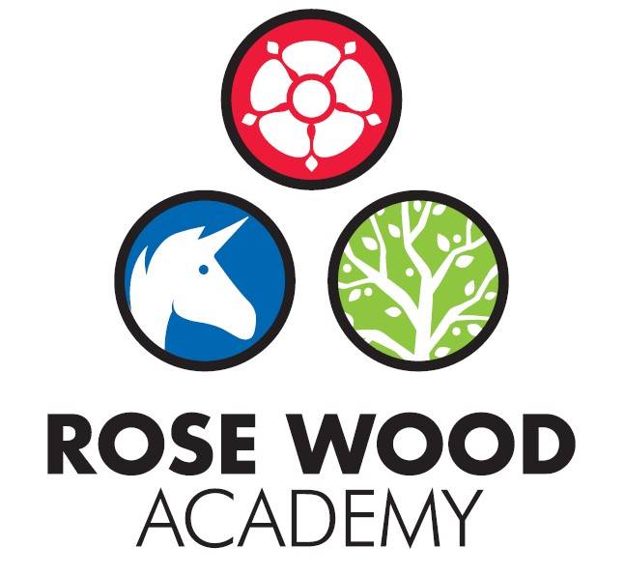

Subject Statement for DT

Contents
Curriculum Aims 3
Subject Content and Organisation 3
Embedding Knowledge 4
Leadership Activities 5
Assessment 6
Appendices 7

DT Overview

Subject Statement for Design and Technology

Curriculum Aims

At Rose Wood we aim for Design and Technology (DT) education to involve two important elements. They are:
- learning about the designed and made world and how things work
- learning to design and make functional products for particular purposes and users.
Children will acquire and apply knowledge and understanding of materials and components, mechanisms and control systems, structures, existing products, quality and health and safety. They will understand the principles of design and the importance of evaluating products and improving them.
The skills learned in DT will also help with learning across the curriculum. Knowledge about the properties of materials will help in science and the practice of measuring accurately will support the learning in maths. Aspects of DT will also help in IT through the children’s use of computer control and, naturally, in art and design.

Subject Content and Organisation

DT education helps develop children’s skills through collaborative working and problem-solving, and knowledge in design, materials, structures, mechanisms and electrical control. They are encouraged to be creative and innovative, and are actively encouraged to think about important issues such as sustainability and enterprise.
There are three core activities children engage with in DT:
- Activities which involve investigating and evaluating existing products
- Focused tasks in which children develop particular aspects of knowledge and skills
- Designing and making activities in which children design and make 'something' for 'somebody' for 'some purpose'
These three activities are combined in sequence to create a DT project.
The curriculum is based upon and supported by the ‘Projects on a Page’ from the DT association. ‘Projects on a Page’ break each key aspect of DT down into easy to follow expectations that allow teachers to plan projects that ensure all elements of the DT curriculum are covered at the appropriate level with progression and challenge is built in. They are organised into the following projects that ensure full coverage of the national curriculum:

Age group | Focus | Title
Year 1/2 | Mechanisms | Sliders and levers
Year 1/2 | Structures | Freestanding structures
Year 1/2 | Food | Preparing fruit and vegetables
Year 1/2 | Textiles | Templates and joining techniques
Year 1/2 | Mechanisms | Wheels and axles
Year 3/4 | Textiles | 2-D shape to 3-D product
Year 3/4 | Food | Healthy and varied diet
Year 3/4 | Mechanical Systems | Levers and linkages
Year 3/4 | Structures | Shell structures
Year 3/4 | Electrical Systems | Simple circuits and switches
Year 5/6 | Food | Celebrating culture and seasonality
Year 5/6 | Textiles | Combining different fabric shapes
Year 5/6 | Structures | Frame structures
Year 5/6 | Electrical Systems | More complex switches and circuits
Year 5/6 | Mechanical Systems | Pulleys or gears

Further details can be found at data.org.uk
The projects are distributed across the key stages so that there is an opportunity to revisit skills and knowledge as well as learn new skills. The choice of projects in each year group has been aligned to the main Enquiry Driven Curriculum so that there is a greater purpose for the products that are created. The long term overview can be seen in the appendix.

Embedding Knowledge

At Rose Wood, we recognise that learning is only successful if children can securely draw upon it and build upon it. We know that scientific research states that the act of retrieving prior learning strengthens memory and helps ensure that children leave school secure in the knowledge and skills mapped out in the curriculum. We also know that learning is generative, new learning is embedded far more successfully if it accumulates around prior learning. Our approach to securing knowledge and is therefore threefold:
- Learning is reviewed regularly
- The curriculum is designed to build on previous learning. These links are explicit and revisiting is built in so that children can make clear connections and learning is embedded.
In DT the skills are progressive. As the children move through the school they will revisit and reapply skills learnt previously as they complete new projects. This allows the children to develop the skills and improve. They will advance as designers and makers through this process. The knowledge of successful designs will be built upon and their prior knowledge will be applied to new projects to ensure that their understanding of key design features becomes embedded.

Leadership Activities

As with all subjects, the quality of teaching and learning for DT is every leader’s responsibility and all leaders will have an oversight of the quality of teaching and learning for DT. There is also a designated DT lead who has ownership of certain elements of the curriculum. As well as supporting the leadership team to ensure the highest standards of teaching and learning for DT are maintained, the DT lead will also be the ‘subject champion’ and will keep abreast of all the new developments that are happening within the subject as well as ensuring high levels of subject knowledge which they will use to support others. They are also in charge of maintaining and acquiring the appropriate resources and supporting staff with their use. The DT lead will deliver some subject specific CPD or will identify appropriate external CPD for staff. The DT lead will also perform monitoring and evaluation on an ongoing basis and feedback their findings to the SLT.

  - Monitoring and Evaluation
Monitoring and evaluation is ongoing throughout the year. The monitoring will be carried out by the DT lead but other senior leaders will monitor the subject at certain points throughout the year. The main activities that make up the monitoring process are:
Learning walks and enquiries
Work scrutinies, evaluation of projects
Pupil voice
Teacher voice
Planning and content coverage checks
The DT lead and the SLT will evaluate the outcomes from these monitoring activities. This evaluation will be used to inform next steps for development such as identifying CPD for staff, supporting with subject knowledge or improving use of or access to resources. The evaluation will be used to produce subject specific action plans and inform the evidencing for review.
These activities will take place throughout the year but there will be at least one ‘deeper dive’ activity that takes an in depth look at the quality of DT in the school. Some deeper dives will be supported by other members of the trust.
  - CPD
The DT lead will lead some CPD for staff. This will be to support subject knowledge or could be to introduce new material, resources or ideas. They will also organise external CPD as appropriate to support whole school or individual development.
  - Resourcing
The subject lead is responsible for ensuring that the school is appropriately resourced to allow teaching staff to deliver high quality DT lessons and to ensure that pupils get the best experience they can. This could be in the form of physical resources such as tools, control technology or pneumatic systems or information texts. It also includes online resources such as ‘The Design and Technology Association’. The DT lead should be regularly assessing the quality of the resources but should also be keeping informed about new developments and innovations that could further enhance and improve the quality of the subject within our school.

Assessment

Teachers at Rose Wood use assessment regularly to support them with their planning and task design. It underpins the principles for learning and ensures that all children make progress and face the appropriate level of challenge. It allows staff to know which children need greater challenge and which children need scaffolding and support to allow them to continue to make progress. For DT, staff make regular assessments to determine understanding of the key knowledge and skills. The projects on a page documentation and the skills progression provides the expectations that support staff to do this. It gives examples of outcomes to expect for each area of DT across all year groups. By using this to support task design, the staff can assess the outcomes of children and make judgements about their attainment and the next steps. The projects that are completed by the children in each year group are designed to give the pupils the opportunity to show their understanding and level of knowledge on a certain subject and allow the assessment of deeper knowledge.

Appendices

Long Term Overview of Design Technology and ART
 | Autumn 1 | Autumn 2 | Spring 1 | Spring 2 | Summer 1 | Summer 2
Early Years | At Rose Wood the art and design curriculum for EYFS is designed to develop the children’s skills and expression to allow the children to meet the Early Learning Goals for Expressive Arts and Design Creating with Materials. This is achieved through guiding and teaching specific skills as well as exposing the children to a range of media on a daily basis via continuous provision. Children are encouraged to be expressive and develop a range of skills including mark making, painting, sculpting, model making using a wide range of materials and techniques. The creative opportunities are linked to the EYFS topics and Power of reading texts throughout the year and help children to consolidate their understanding as well as develop skills, be creative and express themselves.
Year 1 |  | What is so great about the outdoors?  Mechanisms  Sliders and Levers  (Growing Plant) |  |  |  | What does Home mean to you?  Textiles  Templates and joining  Rapunzel Puppets.
Year 2 |  | How have powerful women changed History?  Structures  Free Standing Structures  (Memorial Park) |  | What did they exhibit at the Great Exhibition  Mechanisms | What’s so great about India?  Food?  Preparing Fruit and Veg?
Year 3 | How did life in Britain change from iron age to the stone age? |  | How did metal make Middlesbrough mighty?  Mechanical Structures Pneumatics
 | Food and Nutrition: Making flatbread and veg soup | Shell Structures Christmas Decs
Year 4 | The Empire Strikes  How did the Romans become so successful?  Mechanical Structures (Levers) |  |  | Plastic Pollution: What’s all the fuss about?  Textiles  (Bag for life) |  | What’s so great about the USA?  Shell Structures and Electrical Structures
Year 5 |  |  | Humans v Nature Which is more disastrous?  Emergency Shelters  Nutrition |  |  | What would you include in a Great British Theme Park?  Mechanical Structures Pulleys and Gears  Plus Crumble Control
Year 6 | Is death the only consequence of war?  Electrical Systems  More complex switches and Circuits  (Early Warning Systems) |  | Shackleton – Was it worth the risk?  Textiles Combining Different Shapes  Hats?

