Rose Wood Academy

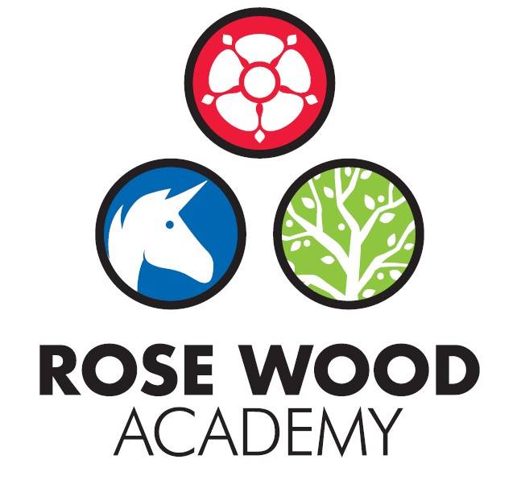

Subject Statement for History

Contents

Curriculum Aims 3
Subject Content and Organisation 3
Embedding Knowledge 4
Leadership Activities 5
Assessment 6
Appendices 8

Rationale
Matrices
Key Knowledge Documents

Subject Statement for History

Curriculum Aims

The key aim for our history curriculum is to ensure that children leave Rose Wood with a coherent knowledge and understanding of Britain’s past and that of the wider world. This begins in the Early Years where children begin to understand the concept of chronology by looking at changes in their own lifetimes. The aim of our KS1 history curriculum is to build on this early knowledge and understanding. Children will develop the language of history and extend their understanding of chronology to beyond their own lifetimes. Children will gain an early understanding of how we can use historical sources to develop knowledge of life beyond living memory, an aspect which will be developed further within the key stage two curriculum. Children will learn about some significant people and events, including opportunities to look at aspects which are relevant locally.
The aim of the KS2 history curriculum is largely driven by the expected knowledge outlined within the National Curriculum. The aim is to embed identified key knowledge and historical skills that build on prior knowledge. To develop the children’s sense of chronology, children will be made aware of where the period studied relates in time to other periods of historical significance. Each year group in KS2 will study an early civilisation and these will be compared when children have learnt about all of these civilisations, with a focus on their legacy on society today. Our curriculum aims to give children a strong grounding in British history chronologically from the first settlements through to Roman Britain, the Anglo Saxons and the Vikings, culminating in World War 2 in Year 6. Woven through these is the concept of invasion and its impact on Britain. These units are supplemented with additional units to reinforce children’s historical skills, support learning in other subjects and foster a love of learning about the past. Our history curriculum also offers some opportunities beyond the national curriculum to further consolidate the skills taught, broaden the children’s knowledge and enhance engagement. Throughout the curriculum, pupils are taught the substantive content which defines each period - knowledge which is carefully planned and regularly revisited to ensure that it is fully embedded. The skills of how to be a historian are also carefully planned for and run through all history units.

Subject Content and Organisation

The Rose Wood history curriculum is driven by key knowledge and skills. The knowledge and skills are organised in two ways – through our key knowledge documents and our history matrix. The key knowledge documents contain the substantive knowledge that children are expected to know and retain about each specific aspect or period of history studied and include identified historical vocabulary and definitions. We also have the history matrix which contains more generic historical knowledge but also outlines the procedural knowledge/skills and concepts that the children need to be successful within the subject.
In addition to these documents, we have a history rationale. This rationale provides an overview of the key knowledge that the children learn throughout their time at Rose Wood and explicitly identifies prior learning.
In addition, as part of the learning of each historical period or event, the children are taught to think about three aspects that they will revisit throughout their time in school to support their learning. These are:
What changed during this period or due to this event?
What caused that change?
Why is that change so significant that we are learning about it today?

  - Key Knowledge Documents
Each of the key knowledge document underpins a unit of work. They are organised in a simple format that is consistent across each period or event in history that is covered. They contain the key knowledge to be taught. The knowledge that is taught within a unit of work does not have to be restricted to the content within the key knowledge document but it must contain that identified knowledge and this knowledge should be the focus of retention and revisit to ensure that it is embedded. In addition, the document contains the key vocabulary that is needed for the unit. This is vocabulary that is specific to the aspect of history covered but also more generic vocabulary that is needed to study the aspects of history covered. Definitions of the vocabulary are provided to ensure that we have consistency across the school. The key knowledge documents also include a brief timeline if there are other significant historical events that happened nationally or internationally during the same time period. This provides context and supports with making links and revisiting where appropriate.
  - History Matrix
The history matrix is designed to provide support for staff with what procedural knowledge and concepts they should include within their history planning. These ‘aspects’ are standardised across KS1 and KS2 to allow for revisiting and to help build schema. To ensure progression, progression statements are attached to each aspect by phase and exemplification of what working towards the standard, meeting the standard and exceeding expectations look like is included. The matrix supports staff with planning and expectation and also provides the information staff need to make assessment judgements. In addition, the matrix support leadership activities as leaders can check that there is coverage and that the children are using and applying the skills and knowledge as well as understanding the concepts at an appropriate standard. To support understanding and to increase retention, a dual coding approach has been adopted and each aspect of a skill, knowledge or concept has a symbol associated with it. The symbols are displayed when covering each aspect and stickers stuck in to books to support children as well as staff.

Embedding Knowledge

At Rose Wood, we recognise that learning is only successful if children can securely draw upon it and build upon it. We know that scientific research states that the act of retrieving prior learning strengthens memory and helps ensure that children leave school secure in the knowledge and skills mapped out in the curriculum. We also know that learning is generative – new learning is embedded far more successfully if it accumulates around prior learning. Our approach to securing knowledge and is therefore threefold:
- Learning is reviewed regularly
- The curriculum is designed to build on previous learning. These links are explicit and revisiting is built in so that children can make clear connections and learning is embedded.
- Retrieval practice is built in to the curriculum to help children recall information from their memory
We use a range of retrieval approaches, which are deliberately varied in design to allow students to explore their schemata in different ways, strengthening future recall.
In history, the rationale document provides staff with information about prior learning and how that can be revisited and built upon. Tasks are designed to draw on prior knowledge when making comparisons or by following key strands of history such as invasion. Time lines are used as an essential part of both recall and revisit. When revisiting key periods or events, children are encouraged to focus on the three areas of:
What changed during this period or due to this event?
What caused that change?
Why is that change so significant that we are learning about it today?

Graphic organisers will be produced for each period or event studied. These will be used for recall, revisits and elaboration to support a deepening of knowledge.

Leadership Activities

As with all subjects, the quality of teaching and learning for history is every leader’s responsibility and all leaders will have an oversight of the quality of teaching and learning for history. There is also a designated history lead who has ownership of certain aspects of the curriculum. As well as supporting the leadership team to ensure the highest standards of teaching and learning for history are maintained, the history lead will also be the ‘subject champion’ and will keep abreast of all the new developments that are happening within the subject as well as ensuring high levels of subject knowledge which they will use to support others. They are also in charge of maintaining and acquiring the appropriate resources and supporting staff with their use. The history lead will deliver some subject specific CPD or will identify appropriate external CPD for staff. The history lead will also perform monitoring and evaluation on an ongoing basis and feedback their findings to the SLT.

  - Monitoring and Evaluation
Monitoring and evaluation is ongoing throughout the year. The monitoring will be carried out by the history lead but other senior leaders will monitor the subject at certain points throughout the year. The main activities that make up the monitoring process are:
Learning walks and enquiries
Work Scrutinies
Pupil Voice
Teacher Voice
Planning and content coverage checks
The history lead and the SLT will evaluate the outcomes from these monitoring activities. This evaluation will be used to inform next steps for development such as identifying CPD for staff, supporting with subject knowledge or improving use of or access to resources. The evaluation will be used to produce subject specific action plans and inform the evidencing for subject specific causal chains.
These activities will take place throughout the year but there will be at least one ‘deeper dive’ activity that takes an in depth look at the quality of history in the school. Some deeper dives will be supported by other members of the trust.

  - CPD
The history lead will lead some CPD for staff. This will be to support subject knowledge or could be to introduce new material, resources or ideas. They will also organise external CPD as appropriate to support whole school or individual development.

  - Resourcing
The subject lead is responsible for ensuring that the school is appropriately resourced to allow teaching staff to deliver high quality history lessons and to ensure that pupils get the best experience they can. This could be in the form of physical resources such as artefacts or information texts. It also includes online resources such as ‘The History Association’ and ‘Key Stage History’. The history lead should be regularly assessing the quality of the resources but should also be keeping informed about new developments and innovations that could further enhance and improve the quality of the subject within our school.

Assessment

Teachers at Rose Wood use assessment regularly to support them with their planning and task design. It underpins the principles for learning and ensures that all children make progress and face the appropriate level of challenge. It allows staff to know which children need greater challenge and which children need scaffolding and support to allow them to continue to make progress. For history, staff make regular assessments to determine understanding of the key aspects and to ensure children are gaining and retaining the appropriate knowledge. The History Matrix provides the expectations that support staff to do this. It gives examples of outcomes to expect for each aspect across all year groups. By using this to support task design, the staff can assess the outcomes of children and make judgements about their attainment and the next steps. In addition, the history lead and SLT can use the matrix to ensure that staff are setting work at the appropriate level of expectation.

Appendices

