Rose Wood Academy

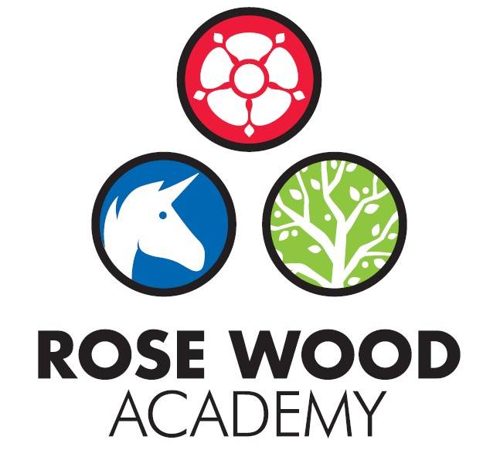

Subject Statement for Music

Contents

Curriculum Aims 3
Subject Content and Organisation 3
Embedding Knowledge 4
Leadership Activities 5
Assessment 6
Appendix 8

Music Overview
Musical Progression

Subject Statement for Music

Curriculum Aims

At Rose Wood we aim for children to experience the joys of music and understand musical concepts through a repetition-based approach to learning. We encourage all children, no matter ability, to participate in a variety of musical experiences through which we aim to build their confidence through practice and performance. We aim to develop the children’s ability to understand rhythm and follow a beat and through singing songs aim for children to learn about the structure and organisation of music. We teach them to listen and to appreciate different forms of music. Children develop descriptive language skills in music lessons when learning about how music can represent different feelings, emotions and narratives. We also teach technical vocabulary such as volume, pitch, beat and rhythm and encourage children to discuss music using these terms.

Subject Content and Organisation

The Rose Wood Music curriculum is delivered through the use of the Charanga Music scheme. The music is planned to be incorporated into our Enquiry Driven Curriculum projects where it can be linked to or complement the key focus. At other times units of music may be stand alone. The content focusses on skills development and progression but does incorporate subject specific knowledge and technical vocabulary. Each unit of work studied follows the format below:
- Listening and Appreciating
- Musical Activities
  - Warm up games
  - Optional flexible games
  - Singing
  - Playing instruments
  - Improvisation
  - Composition
- Performing

Embedding Knowledge

The curriculum is designed in a way that supports progression and allows children to revisit their skills and knowledge. Learning about the same musical concept through different musical activities enables a more secure, deeper learning and mastery of musical skills. The curriculum is mapped through each strand of musical learning from Reception to Upper Key Stage 2 in order for teachers to plan for and to see the opportunity to embed a deeper learning, knowledge, understanding and skills. Musical teaching and learning is not neat or linear. Learning is designed to be in the form of a spiral rather than linear. Over time, children can both develop new musical skills and concepts, and re-visit established musical skills and concepts. Repeating a musical skill doesn’t necessarily mean their progress is slowing down or their development is moving backwards. It's just shifting within the spiral. Mastery means both a deeper understanding of musical skills and concepts and learning something new.

Leadership Activities

As with all subjects, the quality of teaching and learning for Music is every leader’s responsibility and all leaders will have an oversight of the quality of teaching and learning for music. There is also a designated music lead who has ownership of certain aspects of the curriculum. As well as supporting the leadership team to ensure the highest standards of teaching and learning for music are maintained, the music lead will also be the ‘subject champion’ and will keep abreast of all the new developments that are happening within the subject as well as ensuring high levels of subject knowledge which they will use to support others. They are also in charge of maintaining and acquiring the appropriate resources and supporting staff with their use. The music lead will deliver some subject specific CPD or will identify appropriate external CPD for staff. The music lead will also perform monitoring and evaluation on an ongoing basis and feedback their findings to the SLT.

  - Monitoring and Evaluation
Monitoring and evaluation is ongoing throughout the year. The monitoring will be carried out by the music lead but other senior leaders will monitor the subject at certain points throughout the year. The main activities that make up the monitoring process are:
Learning walks and enquiries
Work Scrutinies/performance observation/video evidence
Pupil Voice
Teacher Voice
Planning and content coverage checks
The music lead and the SLT will evaluate the outcomes from these monitoring activities. This evaluation will be used to inform next steps for development such as identifying CPD for staff, supporting with subject knowledge or improving use of or access to resources. The evaluation will be used to produce subject specific action plans and inform the evidencing for subject specific causal chains.
These activities will take place throughout the year but there will be at least one ‘deeper dive’ activity that takes an in depth look at the quality of music in the school. These deeper dives may be supported by other members of the trust.
  - CPD
The music lead will lead some CPD for staff. This will be to support subject knowledge or could be to introduce new material, resources or ideas. They will also organise external CPD as appropriate to support whole school or individual development.

  - Resourcing
The subject lead is responsible for ensuring that the school is appropriately resourced to allow teaching staff to deliver high quality music lessons and to ensure that pupils get the best experience they can. This could be in the form of physical resources such as Musical instruments or audio equipment. It also includes online resources such as ‘Charanga’. The music lead should be regularly assessing the quality of the resources but should also be keeping informed about new developments and innovations that could further enhance and improve the quality of the subject within our school.

Assessment

Teachers at Rose Wood use assessment regularly to support them with their planning and task design. It underpins the principles for learning and ensures that all children make progress and face the appropriate level of challenge. It allows staff to know which children need greater challenge and which children need scaffolding and support to allow them to continue to make progress. For music, staff make regular assessments to determine understanding of the key aspects and to ensure children are gaining and retaining the appropriate knowledge. The Charanga music scheme provides the assessment information needed to support staff with their judgments and to ensure that children are working at the appropriate standard and progressing through school.

Appendix

