Rose Wood Academy

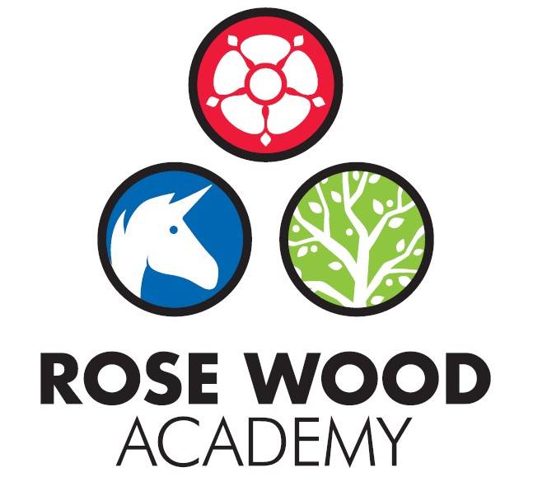

Subject Statement for Science

Contents

Curriculum Aims 3
Subject Content and Organisation 3
Embedding Knowledge 5
Leadership Activities 5
Assessment 6
Appendices 8

Overview
Rationale
Matrices
Key Knowledge Documents
‘Working Scientifically’ Document

Subject Statement for Science

Curriculum Aims

Science is how we understand the world around us and we aim that our science curriculum is the tool through which children’s understanding of the world around them is developed. We want the children to develop a sense of excitement and curiosity about natural phenomena, through having a secure understanding of scientific knowledge and practices. Our curriculum celebrates the work of scientists and their impact on the world in which we live. We want our children to leave school equipped with the foundational skills of a scientist and aspirations towards this in later life. Our approach to science is threefold:

- Develop knowledge and understanding through the disciplines of chemistry, biology and physics
- Develop understanding by working scientifically across the disciplines
- Support the understanding of the importance of science in everyday life in the past, present and future, including the study of some key influential scientists

Subject Content and Organisation

The Rose Wood science curriculum is driven by the key knowledge of the subject and the disciplinary knowledge of working scientifically. The knowledge and skills are organised in two ways – through our key knowledge documents and our science matrix. The key knowledge documents contain the substantive knowledge that children are expected to know and retain about each unit of science and include identified scientific vocabulary and definitions. We also have the science matrix which breaks the disciplines of chemistry, biology and physics and working scientifically down into its ‘aspects’. In addition to these documents, we have a science rationale. This rationale provides a brief explanation of how the Rose Wood curriculum has been sequenced. Our curriculum is organised so that as pupils progress through the science curriculum, new knowledge gets systematically integrated into pre-existing knowledge in order to deepen understanding. Substantive knowledge is broken down into small steps and introduced sequentially to secure children’s understanding. Teachers plan each unit of work with a revisit of the knowledge needed from previous units.
Opportunities to work scientifically are articulated and sequenced in the curriculum. This disciplinary knowledge is taught alongside the substantive knowledge and staff have identified the best context through which to teach it. For example, the skill of observing when identifying the parts of a plant and not planning a fair test when studying the phases of the moon. The ability to work scientifically is used and developed in a range of different substantive concepts to fully embed it. Science planning also ensures that there are opportunities for children to answer science questions using the different types of scientific enquiry:

- Comparative and Fair Tests
- Seeking Patterns
- Grouping and Classifying
- Observing Over Time
- Researching
We also know that it is important that children understand the impact scientists have made on the world in which we live and that children know how disciplinary knowledge has helped to provide us with the body of substantive knowledge that we have. We therefore identify scientists for each year group to study and learn about their work and how it links to what we know today.
We have a shared definition for each science discipline. These definitions are included on each key knowledge document and shared with the children in lessons. We use the following definitions:
Chemistry: learning about matter and the changes that take place with that matter
Biology: learning about living things
Physics: learning about movement, forces and magnets and their effect

  - Key Knowledge Documents
Each of the key knowledge documents underpin a unit of work. They are organised in a simple format that is consistent across school. They contain the key knowledge to be taught; the prior learning which the unit builds upon and identify the misconceptions that often occur so that these can be explicitly taught correctly. The knowledge that is taught within a unit of work does not have to be restricted to the content within the key knowledge document but it must contain that identified knowledge and this knowledge should be the focus of retention and revisit to ensure that it is embedded. In addition, the document contains the key vocabulary that is needed for the unit. Definitions of the vocabulary are provided to ensure that we have consistency across the school. There is a separate ‘working scientifically’ guidance document with the key vocabulary for working scientifically and the different types of scientific enquiry.

  - Science Matrix
The science matrix breaks down each science discipline into smaller ‘aspects’ to support with planning and assessment. These ‘aspects’ are standardised across KS1 and KS2 to allow for revisiting and to help build schema. To ensure progression, progression statements are attached to each aspect by phase and exemplification of what working towards the standard, meeting the standard and exceeding expectations look like is included. The matrix supports staff with planning and expectation and also provides the information staff need to make assessment judgements. In addition, the matrix support leadership activities as leaders can check that there is coverage and that the children are using and applying the skills and knowledge at an appropriate standard.

Embedding Knowledge

At Rose Wood, we recognise that learning is only successful if children can securely draw upon it and build upon it. We know that scientific research states that the act of retrieving prior learning strengthens memory and helps ensure that children leave school secure in the knowledge and skills mapped out in the curriculum. We also know that learning is generative – new learning is embedded far more successfully if it accumulates around prior learning. Our approach to securing knowledge and is therefore threefold:
- Learning is reviewed regularly
- The curriculum is designed to build on previous learning. These links are explicit and revisiting is built in so that children can make clear connections and learning is embedded.
- Retrieval practice is built in to the curriculum to help children recall information from their memory
We use a range of retrieval approaches, which are deliberately varied in design to allow students to explore their schemata in different ways, strengthening future recall.
Prior learning is identified on the key knowledge documents and there is an expectation that each unit of work starts with coverage of the previous objectives which underpin the new learning.
Graphic organisers will be produced for science units where appropriate. These will be used for recall, revisits and elaboration to support a deepening of knowledge.

Leadership Activities

As with all subjects, the quality of teaching and learning for science is every leader’s responsibility and all leaders will have an oversight of the quality of teaching and learning for science. There is also a designated science lead who has ownership of certain aspects of the curriculum. As well as supporting the leadership team to ensure the highest standards of teaching and learning for science are maintained, the science lead will also be the ‘subject champion’ and will keep abreast of all the new developments that are happening within the subject as well as ensuring high levels of subject knowledge which they will use to support others. They are also in charge of maintaining and acquiring the appropriate resources and supporting staff with their use. The science lead will deliver some subject specific CPD or will identify appropriate external CPD for staff. The science lead will also perform monitoring and evaluation on an ongoing basis and feedback their findings to the SLT.

  - Monitoring and Evaluation
Monitoring and evaluation is ongoing throughout the year. The monitoring will be carried out by the science lead but other senior leaders will monitor the subject at certain points throughout the year. The main activities that make up the monitoring process are:
Learning Walks and Enquiries
Work Scrutinies
Pupil Voice
Teacher Voice
Planning and Content Coverage Checks
The science lead and the SLT will evaluate the outcomes from these monitoring activities. This evaluation will be used to inform next steps for development such as identifying CPD for staff, supporting with subject knowledge or improving use of or access to resources. The evaluation will be used to produce subject specific action plans and inform the evidencing for subject specific causal chains.
These activities will take place throughout the year but there will be at least one ‘deeper dive’ activity that takes an in depth look at the quality of science in the school. Some deeper dives will be supported by other members of the trust.

  - CPD
The science lead will lead some CPD for staff. This will be to support subject knowledge or could be to introduce new material, resources or ideas. They will also organise external CPD as appropriate to support whole school or individual development.

  - Resourcing
The subject lead is responsible for ensuring that the school is appropriately resourced to allow teaching staff to deliver high quality science lessons and to ensure that pupils get the best experience they can. The science lead should be regularly assessing the quality of the resources but should also be keeping informed about new developments and innovations that could further enhance and improve the quality of the subject within our school.

Assessment

Teachers at Rose Wood use assessment regularly to support them with their planning and task design. It underpins the principles for learning and ensures that all children make progress and face the appropriate level of challenge. It allows staff to know which children need greater challenge and which children need scaffolding and support to allow them to continue to make progress. Teachers will include a summative assessment at the end of each unit. This may be in the form of a written test or may be a more open-ended assessment, designed to assess the objectives taught. There is also on-going formative assessment throughout the units where staff make regular assessments to determine children’s understanding of the key aspects and inform next steps.
The science matrix provides the expectations in the subject. It gives examples of outcomes to expect for each aspect across all year groups. By using this to support task design, the staff can assess the outcomes of children and make judgements about their attainment and the next steps. In addition, the science lead and SLT can use the matrix to ensure that staff are setting work at the appropriate level of expectation.
Children’s progress is tracked on our ‘Management Information System’. Formative judgements are recorded against the National Curriculum objectives and used to inform a termly summative judgement.

Appendices

