The Garth
Coulby Farm Way
Coulby Newham
Middlesbrough TS8 OUG
Telephone: 01642 595353

Web: www.rosewoodacademy.co.uk

Headteacher: Mr Paul Cowley

Dear Parent/Guardian

Thank you for your continued feedback and suggestions regarding school drop off and collection. We have looked again at the system in place. From observation and feedback, I can see that the mornings are working better than the evenings so we are going to emulate some of our approach to morning drop offs by introducing a window of time in which to collect children from our Reception, Year 1 and Year 2 classes at the end of the day. All other times will stay the same. The new end times are shown on the table included. We have had some suggestions of a one-way system. I have looked at this as a solution but feel that it will result in a lot of families trying to get out through one gate or in through one gate and may make the congestion worse. We are therefore suggesting some specific entrances to try to spread you about a bit more. The plan attached shows these suggestions. In addition, we are having the gate at the layby entrance widened. Thank you to those who suggested this. I hope this will improve things for everyone. We will see how it goes and tweak again if needed.

Many thanks

Mr Cowley

Suggested routes into and from school.
Red route is suggested for Year 3, Year 4 and Year 6
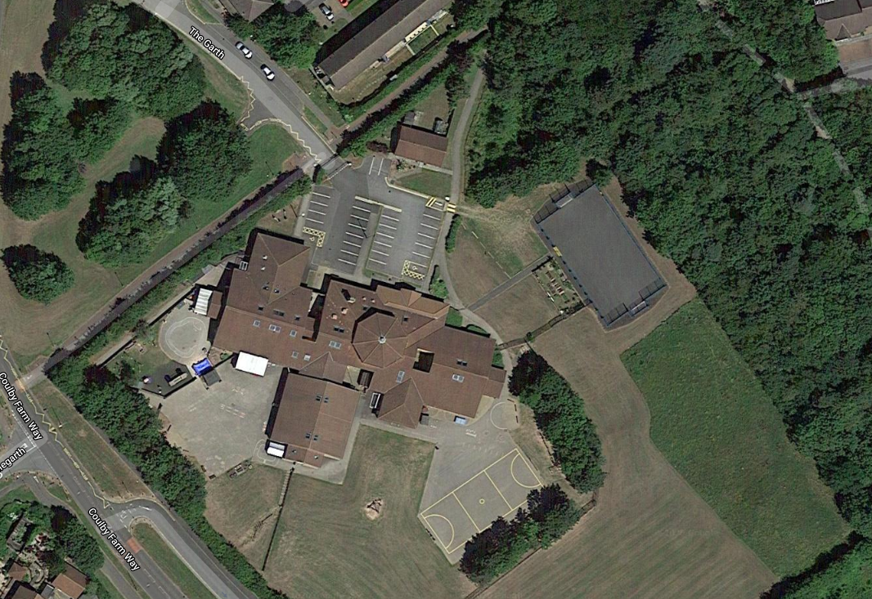
Blue route is suggested for Reception, Year 1, Year 2 and Year 5
Nursery can use either route.

Year Group | Beginning of Day | Morning Break |  | Lunch Time |  |  | End of Day
 |  | Time | Location | Timings | Location when outdoors | Hall Time for Lunch
Nursery am | 8:40 | Flexible |  | 11.50 –12.20 |  |  | 11.40
Nursery pm | 12.30 |  |  |  |  |  | 15.30
Reception | 8:50-9.00 | Flexible |  | 11:30 – 12:15 | Reception Playground | 11.30 | 14.50 -15:00
Year 1 | 8:45-8.55 | 10:30 – 10:45 | KS1 Playground | 11.50 – 12:35 | KS1 Playground | 11:50* | 14.45 -14.55
Year 2 | 8:45-8.55 | 10:30 – 10:45 | KS1 Playground | 11:50 – 12:35 | KS1 Playground | 11.50* | 14.45 -14.55
Year 3 | 8.40-8.50 | 10:30 – 10:45 | KS2 Playground/MUGA | 12:15 – 13.00 | KS2 Playground ** | 12:15 | 15.00
Year 4 | 8.45-8.55 | 10:30 – 10:45 | KS2 Playground/MUGA | 12:15 – 13:00 | KS2 Playground ** | 12:25 | 15:05
Year 5 | 8.55-9.05 | 10:45 – 11.00 | KS2 Playground/MUGA | 12:35 – 13:20 | KS1 Playground prior to lunch them KS2 playground after lunch ** | 12:50 | 15:15
Year 6 | 8.55-9.05 | 10:45 – 11:00 | KS2 Playground/MUGA | 12:40 – 13:25 | KS2 Playground ** | 12.40 | 15:15

