Easter Activities



Twinkle Activity Pack – Free for a month
Step 1: Go to twinklhq.twinkl.co.uk/offer
Step 2: Enter the code you have received, or CVDTWINKLHELPS if you have not yet been given a code.
https://www.twinkl.co.uk/resource/t2-t-18001-ks2-top-10-easter-activities-resource-pack
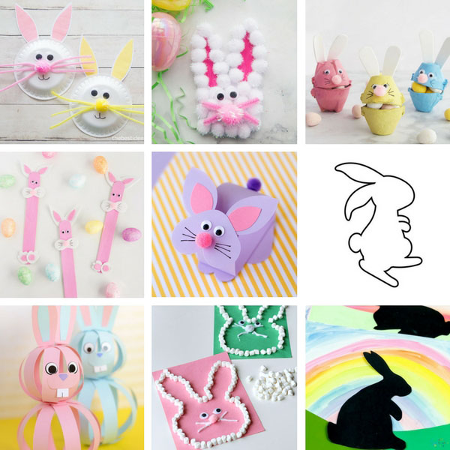

Lots of brilliant crafts here:
https://www.thebestideasforkids.com/easter-crafts-for-kids/
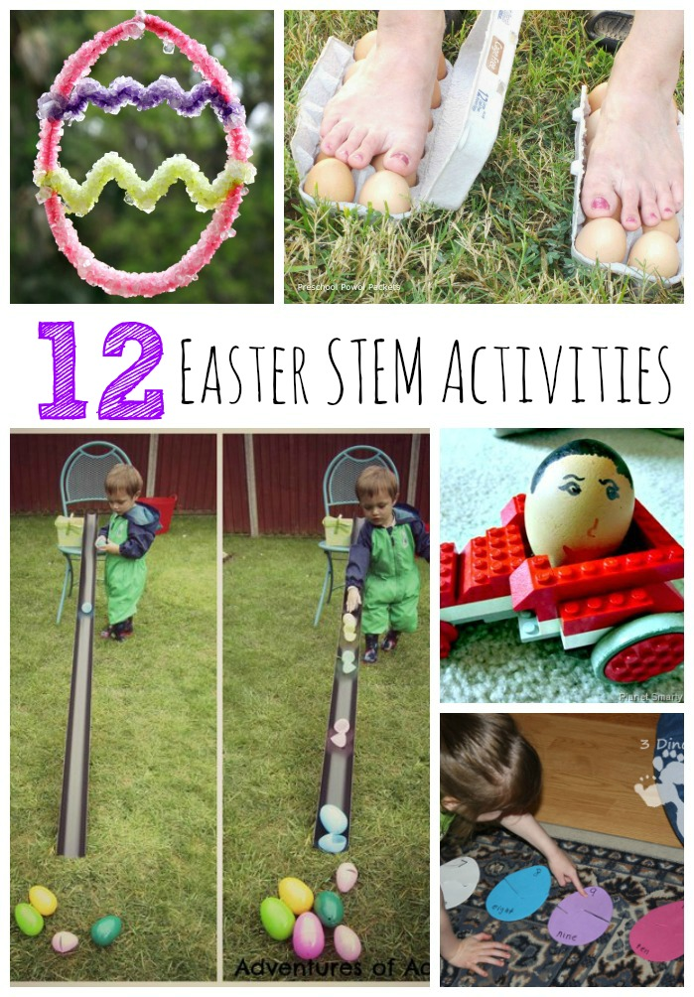

Science, Math, Design and technology activities:
https://theeducatorsspinonit.com/12-easter-stem-activities-for-kids

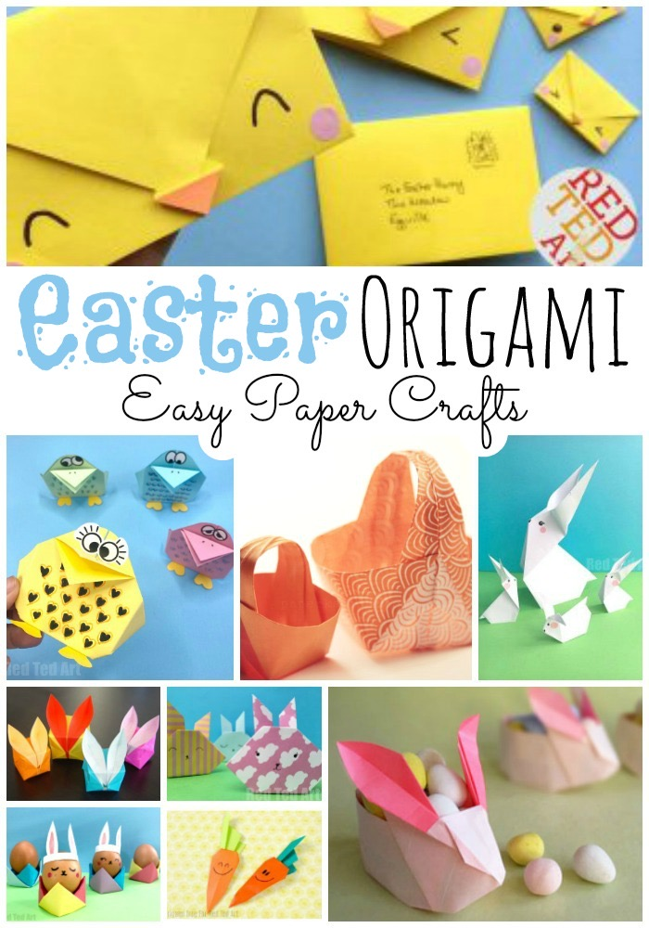
Easter Baking:
https://www.bbcgoodfood.com/howto/guide/fun-easter-projects-kids

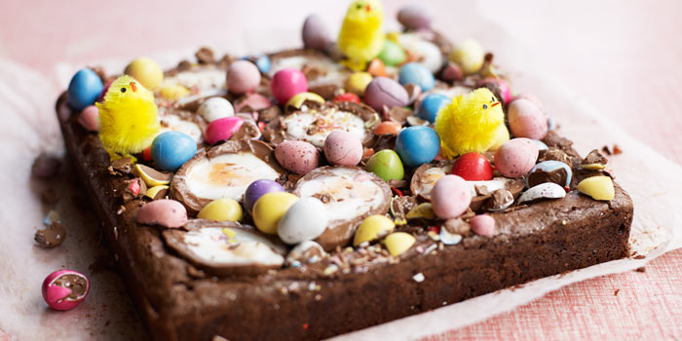
Easter Origami:
https://www.redtedart.com/easy-easter-origami-for-kids/
https://www.redtedart.com/paper-easter-crafts/

