- Outlook.com and click on sign into office365
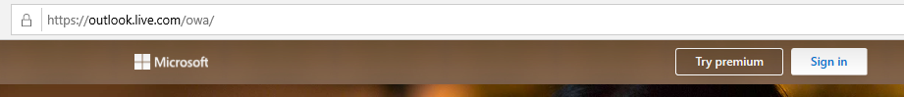
- Login in with school email
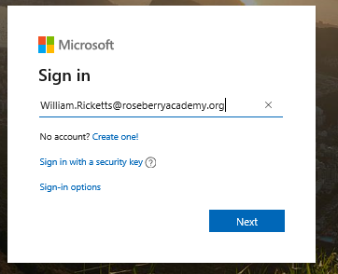
- Click on 9 dots in outlook
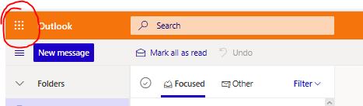
- Choose teams or if its not there go to All apps and type it into the search
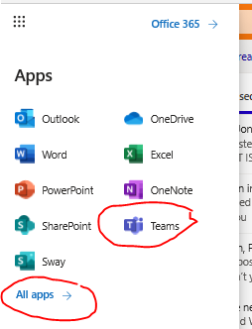
- Choose Activities
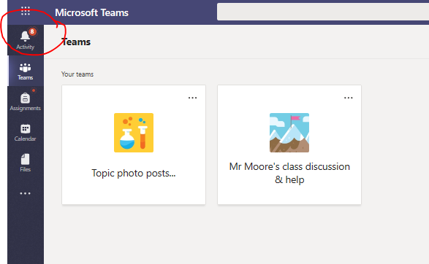
- Choose topic or Mr Moore’s class (there are assignments under both)
- Choose assignments at the top of the page.
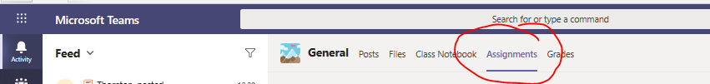
- Work is under the assigned heading and it is dated.
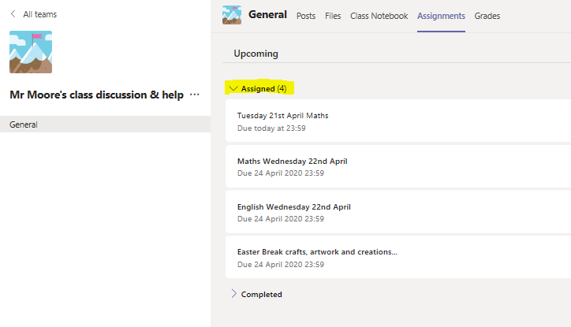
- Click on the assignment you want to do

- Choose your lesson
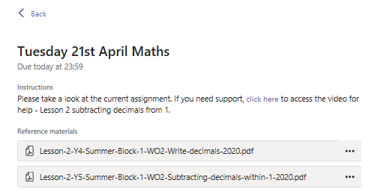
- It should open up your question sheet
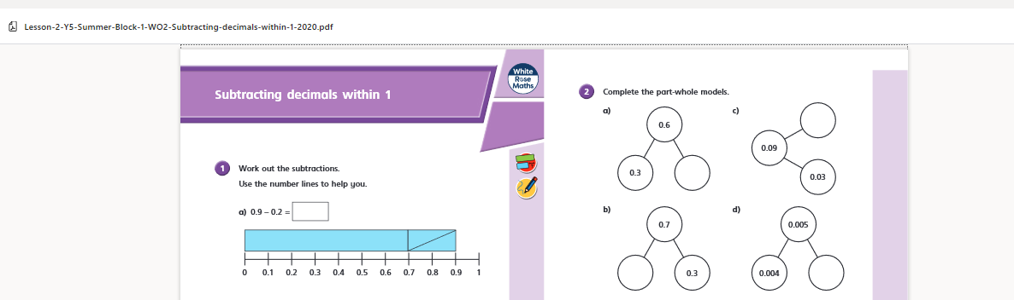
12.a. You can answer the questions in a Microsoft word or notebook file on your device and save to your device to upload later, (remember where you saved it or save to your desktop to make it easier to find)
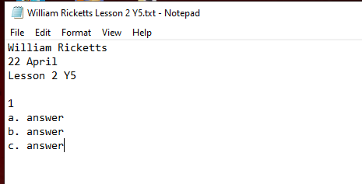
OR
12.b. you can go to the 9 dots and choose Word
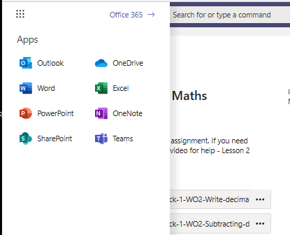
This will open word in Microsoft Office 365 in a new tab on your browser
Check on where new documents are saved - this should be your personal OneDrive
Click on New blank document
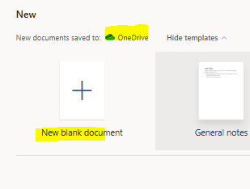
- This will open a new browser window with a word document
Click on the file name to change it and type your answers
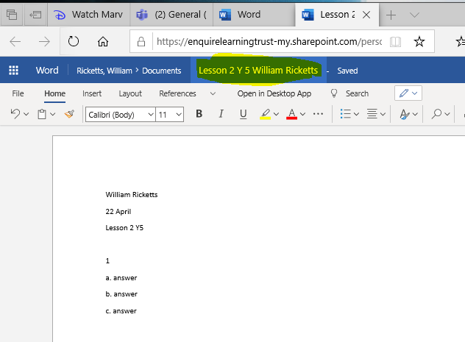
- When you are done you can save (if not on o365) or close O365 doc (it will autosave)
Close the assignment
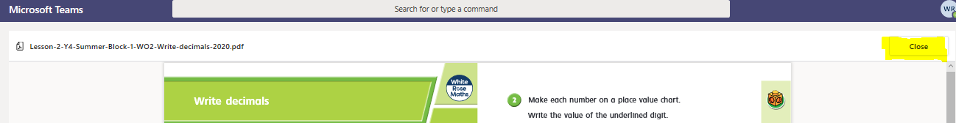

- If you are ready to hand in your work then you can upload it to teams to hand in
Click on +Add work at the bottom of the screen
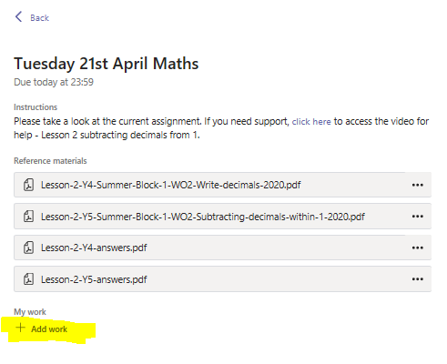
And you can either go to your one drive and choose from your list of documents, which to attach OR
You can upload from your device if that is where you saved it.
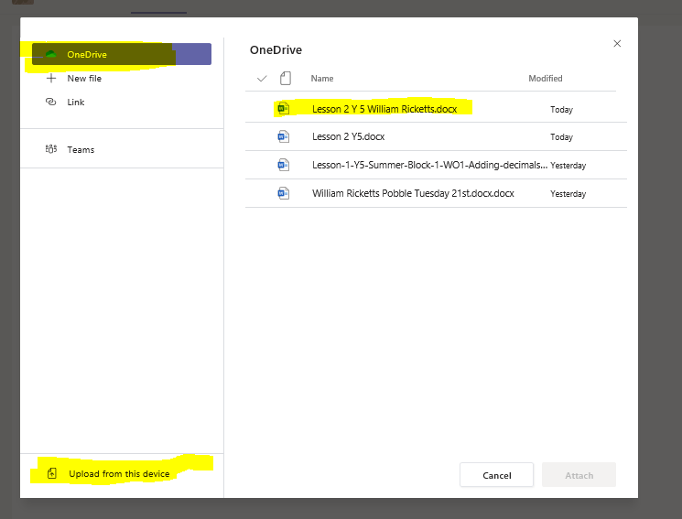

- When you have chosen your file from OneDrive or uploaded the file to Teams from your device, you click on
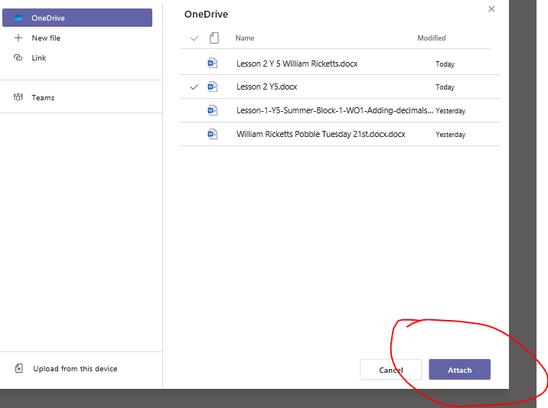

- Your answer sheet will now be under the “My Work” section and you can click on Hand in to hand in your assignment
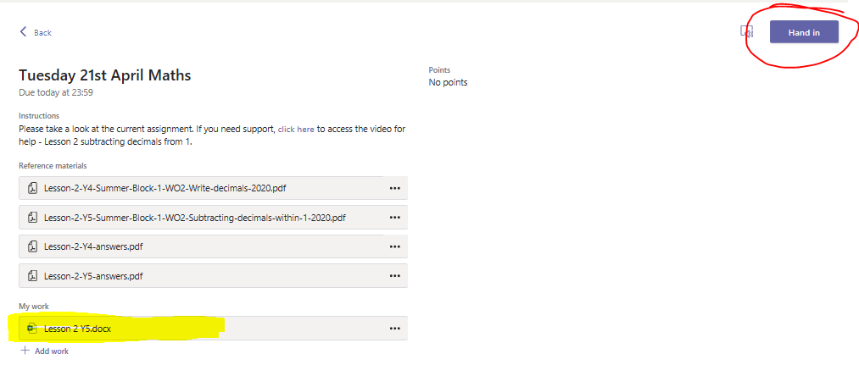If you have uploaded the wrong assignment you can click on the 3 dots next to the file name and “remove” before you click hand in.

