Microsoft Teams – The Basics

Downloading and Installing Microsoft Teams

To download and install Microsoft Teams on a laptop, simply go to https://www.microsoft.com/en-gb/microsoft-365/microsoft-teams/download-app and download the version for your device – Windows or Mac. If you’re using Teams on an iPad, iPhone (iOS device) or another type of Tablet (Android only), go to the App Store/Play Store and search for Microsoft Teams and download this for free and install as per any other app you would.

Logging into Microsoft Teams

Once you’ve installed Microsoft Teams, on whichever device you’re using, the first time you open it, it will ask you to login to using your Microsoft Account. Every student has been setup with a Microsoft Account through our O365 platform. These accounts are what have been linked to various Teams in order for you to gain access to the online learning. Using another Microsoft Account other than the one provided by the school won’t work. All pupils have a computer logon in school and this provides the base to your email logon. If you’re computer logon in school is joe.bloggs, with a password of Password1 then your email is joe.bloggs@roseberryacademy.org and the password is in sync so will also be Password1. For any issues logging onto Teams using these credentials, please contact the school who will liaise with IT Support to have them reset for your child.

Menu Items

Once you’ve logged into Teams, whether that be on a laptop, computer, phone or tablet, the menu structure is uniform across them all. The 4 sections you need to use are Activity, Teams, Assignments and possibly Calendar (if your teachers are giving online remote video lessons).

The Activity feed simply shows you anything that a Teacher has ‘tagged’ you in. This could be an Assignment, Feedback, Discussion, or Files shared with you. In the Activity feed all these type of notifications will be displayed with further detail on what to do to access them. They are in date order with the newest at the top.

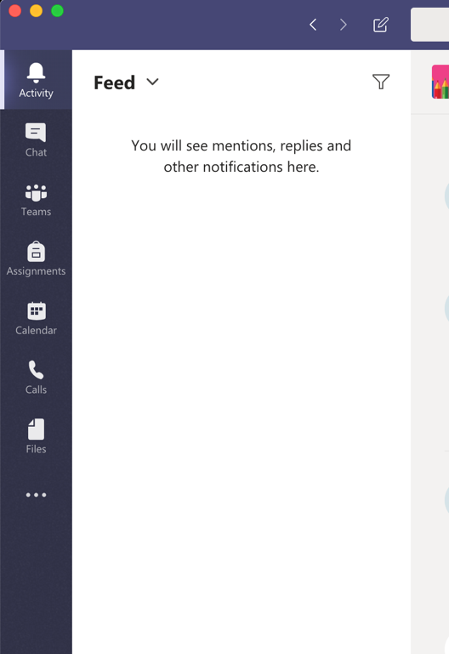

Teams show you which Teams you’re a part of. Teachers create the Teams and invite you into them for Remote Learning. The structure of the Team itself will be different per teacher but in the main there would be a Discussion board, Files, and Resources.

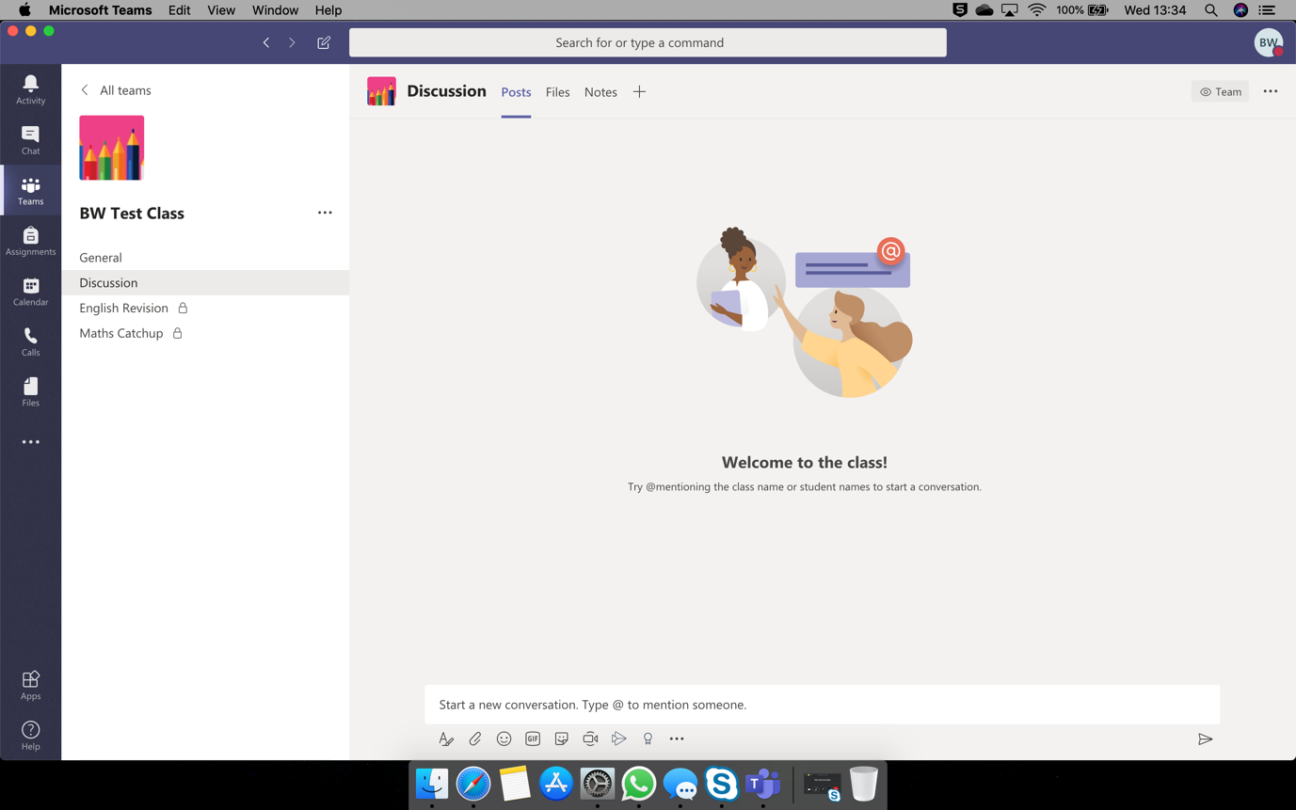

Assignments shows you all the ‘lessons’ that Teachers have set with work they have set for you to complete. Each Assignment is contained within itself so there will be a Title, Description, Resources, Files, and Due Dates set for each. There’ll also be clear sections within this to ‘Hand in’ completed work.

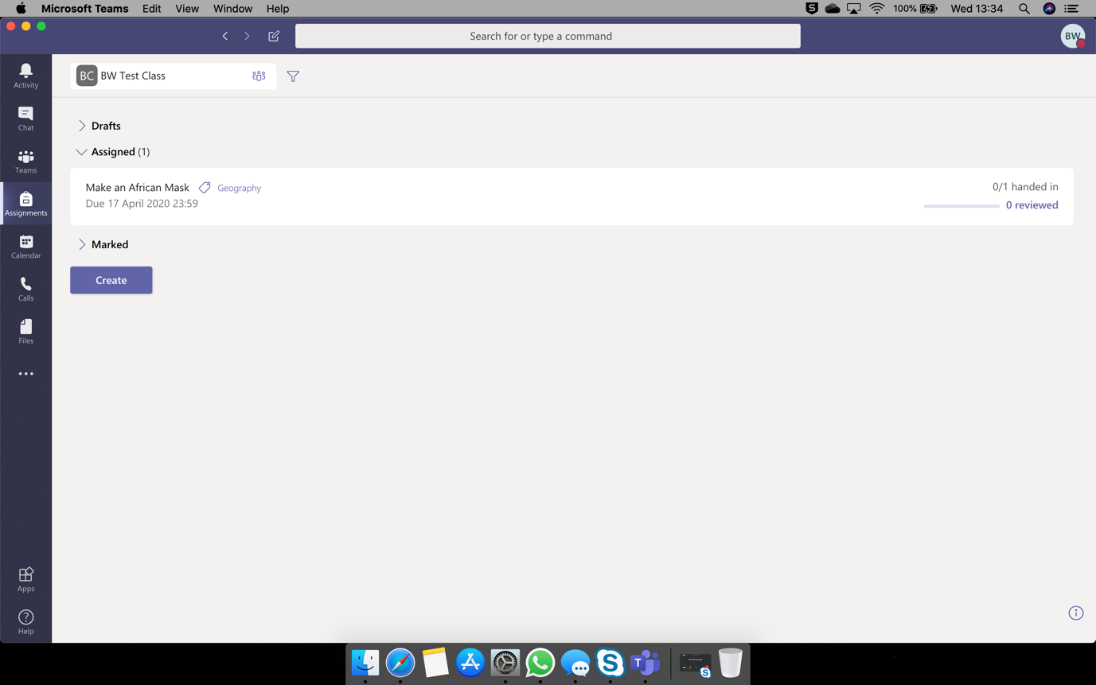

Office 365 Apps & Integration

Some of the work created and assigned may be on Word, Excel or PowerPoint. You can download these apps for tablet and phone devices, for free, and login to them with the same email address and password as shown in the ‘Logging into Microsoft Teams’ section, and will all link seamlessly. What I mean by this is that if you have an Assignment set that asks you to edit a Word document, you can click on this, the Word app will open, allow you to do the work, and save automatically back to Teams. On a Windows or Mac device, you can do the same but via the Internet Browser you use. So if that be Chrome, Internet Explorer, Edge, Safari or otherwise, simply login to outlook.office.com with the same email and password and within here you can access Word, Excel or PowerPoint online and link into Teams in the same way as you can on a handheld device.

Teachers may also communicate directly with a child via email which you can access at outlook.office.com and login again with the same credentials as above.

All of the tools mentioned above are underpinned by the same O365 credentials.

