RUSHEY GREEN
PRIMARY SCHOOL

COMPLAINTS POLICY

Reviewed by: | Resources Committee | Date: 8 November 2023
Signed: | Ratified by Governors
Last reviewed on: | November 2023
Next review due by: | November 2024

Rushey Green School Mission Statement
We aim to work in partnership with parents to provide an education of the highest quality, which celebrates everyone’s success in a happy, caring, creative environment where all our differences are valued.
At Rushey Green School we work in partnership with parents to provide an education of the highest quality, which celebrates everyone’s success in a happy, caring environment, where all our differences are valued.

At Rushey Green School we want all our children to do well and be happy. An important part of this is to provide as many opportunities to keep parents and carers informed about the school and involved in their child’s progress as we possibly can. Regular reports, newsletters, open evenings and visits, all help in this process. We aim to deal with issues and concerns before they become a ‘complaint’. However, we recognise there are times when things go wrong, when concerns continue and differences of opinion develop. These can usually be resolved by speaking to the right person.

This policy describes the response the school will make to complaints relating to the application of school procedures and the actions of staff where they affect individual pupils. Complaints about areas where the L.A. has the lead role and for which different procedures must be followed will not be dealt with under this policy. These areas are:
- The national curriculum
- collective worship
- religious education
- temporary withdrawal of pupils from all or part of the national curriculum
- pupil admissions
- pupil exclusions
Issues related to child protection must also be handled separate from this policy and are covered in the child protection policy.

General Principles:
- To allow for a proper investigation, complaints should be brought to the attention of the school as soon as possible. Any matter raised more than 3 months after the event will only be considered in exceptional circumstances.
- Investigation of any complaint will begin within five school days of being received, except in exceptional circumstances. The investigation will be completed as soon as reasonably practicable.
- An anonymous complaint will not be investigated using these procedures unless there are exceptional circumstances.

COMPLAINTS ABOUT THE ACTIONS OF A MEMBER OF STAFF (other than the Headteacher)

INFORMAL STAGE
A person with a complaint should normally arrange to communicate directly with their child’s class teacher. This may be by letter (or complete and send the form attached at appendix 1), by telephone or in person. (Sometimes it may be necessary to make an appointment). Many complaints can be resolved by simple clarification or the provision of information and it is expected that most will be resolved during this informal stage. (In the case of serious complaints, it may be appropriate to address them directly to the Headteacher or Deputy Head).

This informal stage usually takes place first and the school may not be prepared to consider the matter further if this has not happened.

FORMAL STAGE
If the complaint is not resolved at the informal stage, the person bringing the complaint should write to or make an appointment with the Headteacher or the Deputy Head, who will be responsible for dealing with the complaint. (or complete and send the form attached at appendix 1). The person bringing the complaint may be accompanied by a friend or representative if a meeting is arranged.

The Headteacher or Deputy Head will gather as much information as they feel necessary to resolve the issue. If the complaint is against a member of staff and it becomes necessary for him or her to be interviewed, the member of staff may be accompanied by a friend or representative if they wish.
At this stage, the Head or Deputy should make written notes of their investigation. When the investigation has been concluded, the person with the complaint and the member of staff concerned will be informed of the outcome. This may be in person or in writing or both, depending on the circumstances. Possible outcomes and conclusion will be that:-

- There is insufficient evidence to reach a conclusion, so the complaint cannot be upheld.
- The complaint is not substantiated by the evidence
- The complaint was substantiated in part or fully. (Some details can then be given about the action the school might take to improve its procedures, etc but details of the investigation or of any disciplinary procedures will not be released)
- The matter has been fully investigated and strictly confidential procedures are being followed

If the person with the complaint is not satisfied with the way the matter has been dealt with or considers that the outcome is unreasonable, they may request that the Governing Body review the process that has been followed in handling the matter. A request of this sort must be made in writing to the Chair of Governors within two weeks of the outcome having been reported.

COMPLAINTS ABOUT THE ACTIONS OF THE HEADTEACHER

INFORMAL STAGE
A person with a complaint should normally arrange to communicate directly with the Headteacher. This may be by letter (or complete and send the form attached at appendix 1), by telephone or in person. (Sometimes it may be necessary to make an appointment). The person bringing the complaint may be accompanied by a friend or representative if a meeting is arranged. Many complaints can be resolved during this informal stage. (In the case of serious complaints, it may be appropriate to address them directly to the Chair of Governors).

This informal stage should usually take place first and the school may not be prepared to consider the matter further if this has not happened.

FORMAL STAGE
If the complaint is not resolved at the informal stage, the person bringing the complaint should write (or complete and send the form attached at appendix 1) to the Chair of Governors, who will then be responsible for dealing with the complaint. The person making the complaint should include as much detail as possible which might assist with the investigation, such as times and dates of events and who was involved

The Chair of Governors may invite the person bringing the complaint to meet with him/her to clarify the nature of the complaint. The person bringing the complaint may be accompanied by a friend or representative if a meeting is arranged. The Chair of Governors will gather as much they feel necessary to resolve the issue. This may include talking with others who may provide relevant information.

The Headteacher will be provided with a copy of the complaint and any information gathered by the Chair of Governors. Once the Headteacher has the opportunity to consider this, he or she will meet with the Chair of Governors to present a response. During this meeting, the Headteacher may be accompanied by a friend or representative.
When the investigation has been concluded, the person with the complaint and the Headteacher, will be informed of the outcome in writing. Possible outcomes and conclusions will be that:
- There is insufficient evidence to reach a conclusion, so the complaint cannot be upheld
- The complaint is not substantiated by the evidence
- The complaint was substantiated in part or full, but the procedural failure did not affect the outcome significantly so the matter is now closed
- The complaint was substantiated in part or full and the Governing Body will take steps to prevent recurrence or to rectify the situation where this is practicable

If the person with the complaint is not satisfied with the way the matter has been dealt or considers that the outcome is unreasonable, they may request that the Governing Body review the handling of the complaint by the Chair. A request of this sort must be made in writing to the Vice Chair of the Governing Body within two weeks of the outcome having been reported and should include a statement which specifies any perceived failures.

THE REVIEW PROCESS
Any review of the process followed by the Headteacher or the Chair of Governors will be conducted by a panel made up of 3 members of the Governing Body.

The review panel will normally only consider written submissions from the person bringing the complaint, although they may ask or agree to speak with him or her. The panel will consider the complaint first and will then invite the Headteacher or the Chair of Governors as appropriate to make a response to the complaint. The panel may also ask to see any records kept of the process.

The person bringing the complaint and the Headteacher or Chair of Governors, as appropriate, will be informed in writing of the outcome of the review.

This may be that:-
- There is insufficient evidence to reach a conclusion, so the complaint cannot be upheld
- The complaint is not substantiated by the evidence
- The complaint was substantiated in part or in full, but any procedural failure did not affect the outcome significantly so the matter is now closed
- The complaint was substantiated in part or in full and the Governing Body will take steps to prevent a recurrence or to rectify the situation where this is practicable

If the issue is still not resolved, the complainant would need to refer the matter via Lewisham Authority Complaints Procedure.

The flowchart (Appendix 2) illustrates the school’s procedures for dealing with complaints. Further advice for staff and governors is available from the DfES document.

Appendix 1 - Complaint Form
Please complete and return to the complaints coordinator who will acknowledge receipt and explain what action will be taken.

Your name:
Pupil’s name (if relevant):
Your relationship to the pupil (if relevant):
Address:

Postcode:
Day time telephone number: Evening telephone number:
Please give details of your complaint.
What action, if any, have you already taken to try and resolve your complaint.
(Who did you speak to and what was the response)?
What actions do you feel might resolve the problem at this stage?
Are you attaching any paperwork? If so, please give details.
Signature:

Date:
Official use
Date acknowledgement sent:
By who:
Complaint referred to:
Date:

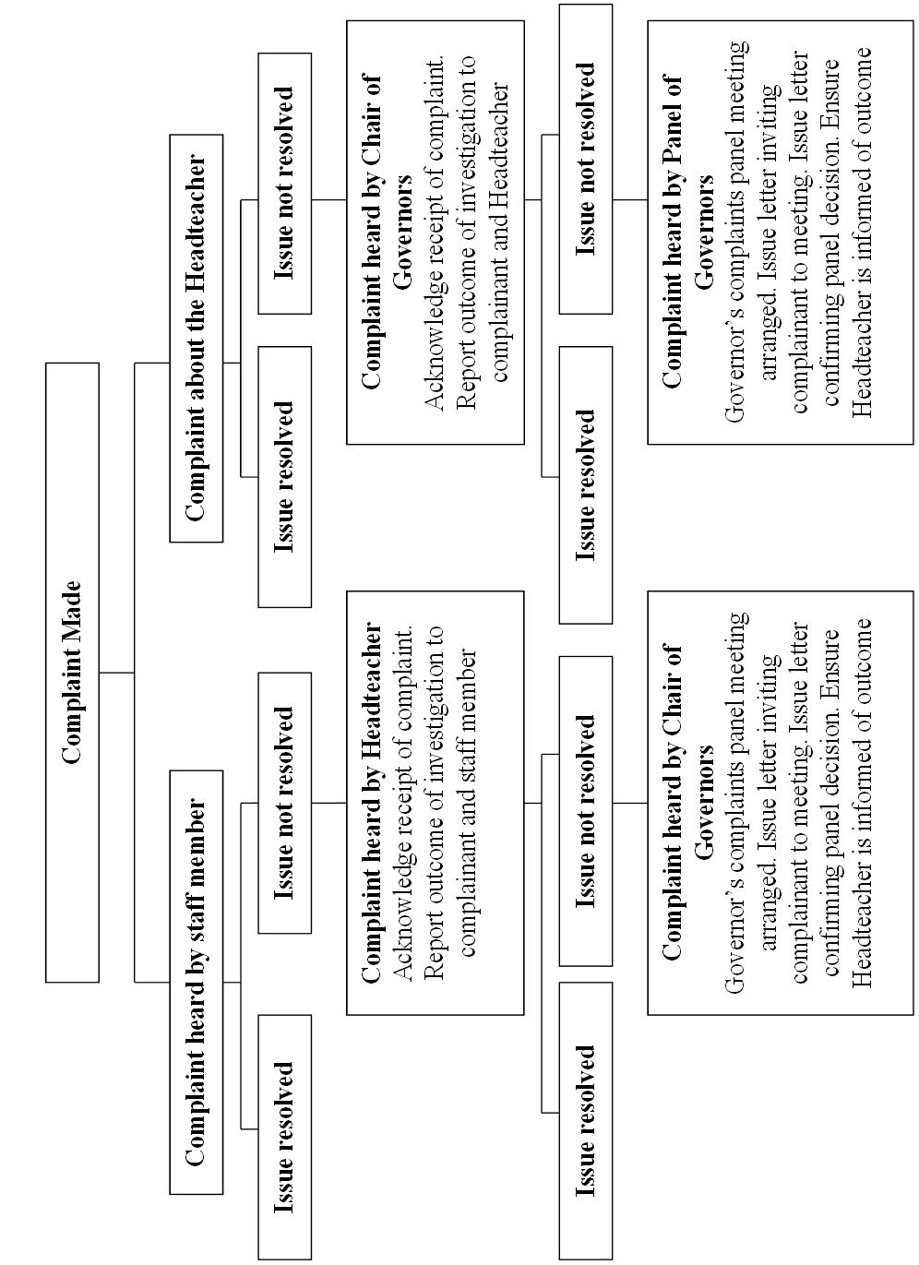
Appendix 2 - Flowchart

