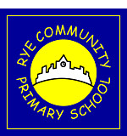
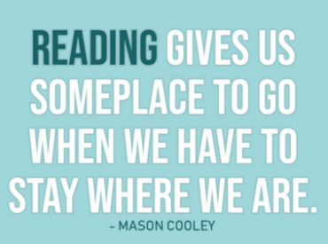
Rye Community Primary School
Reading Newsletter Issue 6
Summer Term 2 2021
Welcome back to the next edition of our reading newsletter dedicated only to inspiring children to read and improving reading standards.
Reading Eggs (EYFS and KS1) Summary for Term 5
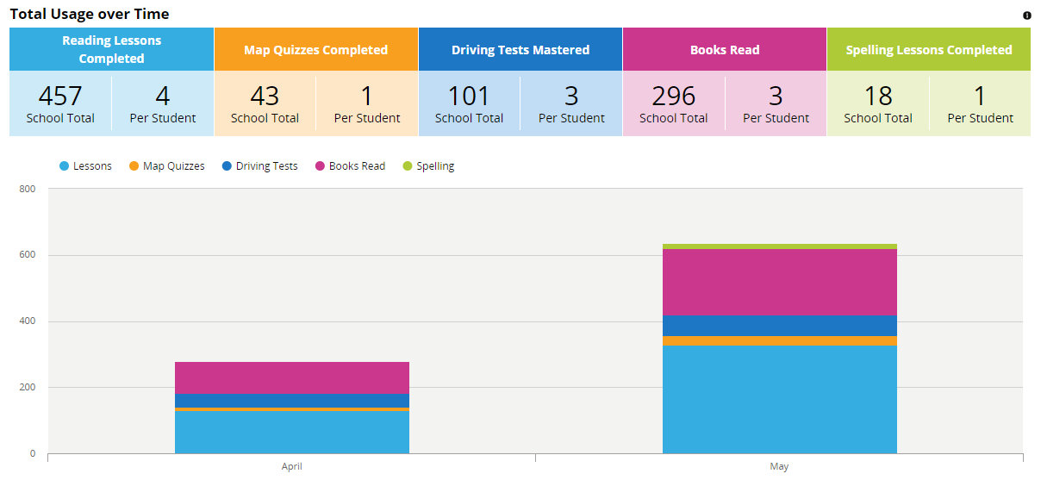
A huge well done to EYFS and Key Stage 1 for increasing the amount of time and activities on Reading Eggs during Term 5. What a big increase in books read and lessons completed over the course of the term. 457 lessons completed and 296 books read.
“I just wanted to say how amazing Reading Eggs is. It has helped my child so much and she really enjoys doing all the tasks. As a parent of a child that has needs, it makes life so much easier to teach and we have so much fun.”
Parental quote

May
April
Reading Eggspress (KS2) Summary for Term 5
A great job to children in Key stage 2 for also increasing how many activities they complete on Reading Eggspress and enjoying some of the books and activities. 143 lessons completed and 83 books read. KS2, can you beat KS1 and EYFS next term?
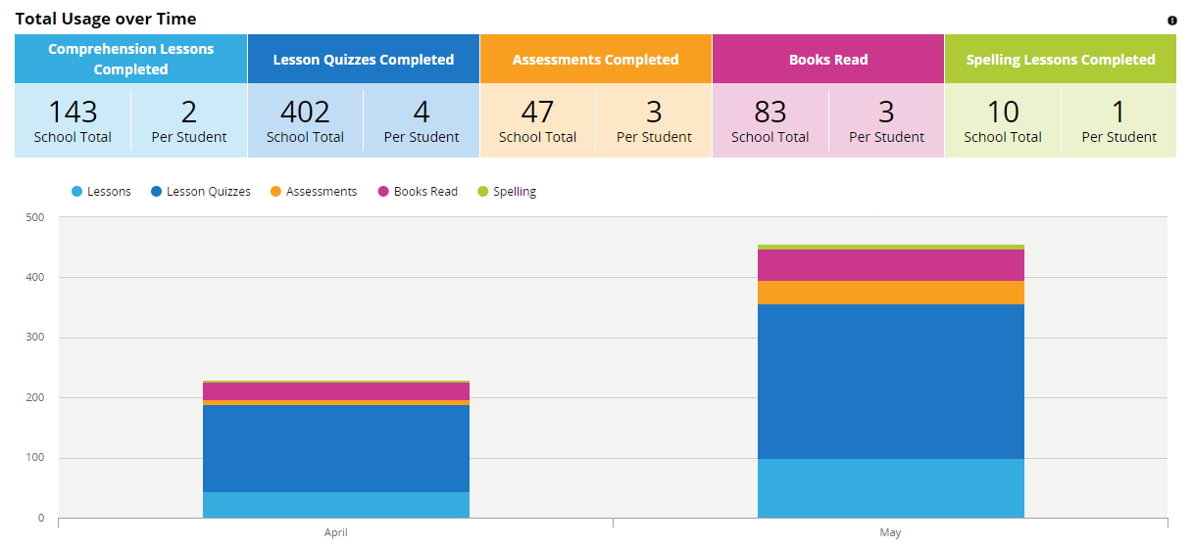
“I am so impressed with Fast Phonics for my younger child and Reading Eggspress for my child in Year 5. They are both absorbed with their reading and love the different activities. Thank you for purchasing this.” Parental quote

April
May
What books are we studying in Summer Term 2?
Each phase has set text(s) for reading and writing which develop core objectives and key skills. This is what each year group will be studying during Summer 2.
 | Focused Reading Text(s) |  |  | Writing Stimulus
Pugwash | 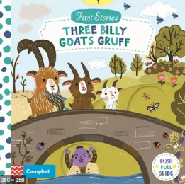  “The Three Billy Goats gruff”
EYFS | 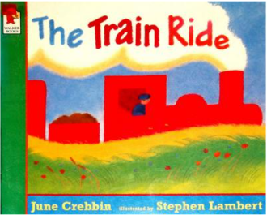  “The Train Ride” by June Crebbin | 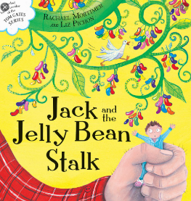  ” Jack and the Jelly Bean Stalk” by Rachael Mortimer |  |  |  |  | 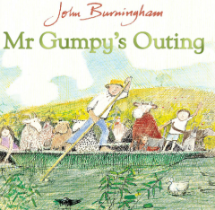  ”Mr Gumpy’s Outing” by John Burningham
Year 1/2 | 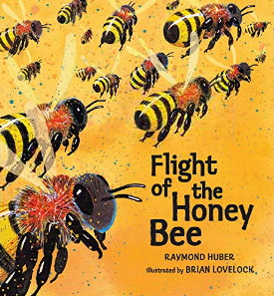  “Flight of the Honey Bee” by Raymond Huber |  |  |  |  | 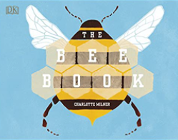  “The Bee Book” by Charlotte Milner
Year 3/4 | 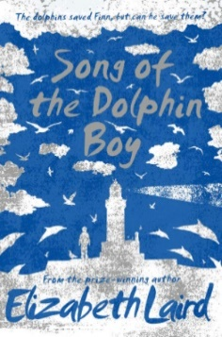  “Song of the Dolphin Boy” by Elizabeth Laird  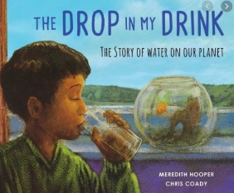  “The Drop in My Drink” by Meredith Cooper |  |  |  | 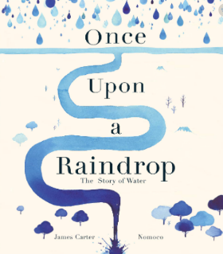  “Once Upon a Raindrop” by James Carter.
Year 5/6 | 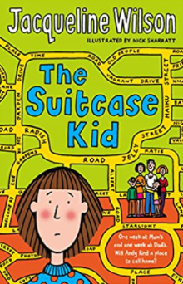  “The Suitcase Kid” by Jacqueline Wilson |  |  |  | 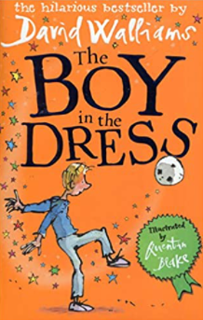  “The Boy in a Dress” by David Walliams
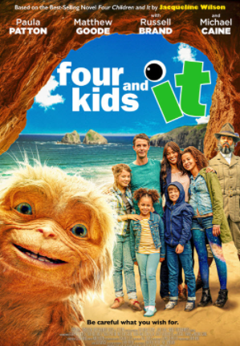
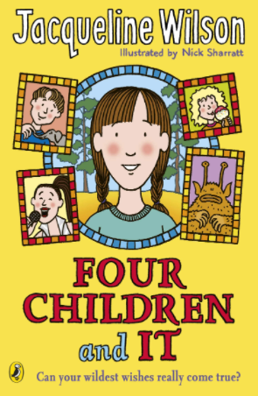
Will you read it or watch it?

4 Kids and It/Four Children and It

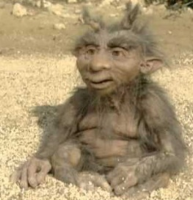
Based on the 2012 book by award winning author Jacqueline Wilson (which was itself an update of E Nesbit’s classic Five Children and It) Four Kids and It is the story of a blended family who have gone on holiday to the seaside. The children, rebellious Smash and her sister Maudie, and their step siblings Ros and Robbie are all very grumpy with each other at first until they make an amazing discovery one day on the beach! The Psammead has the power to grant them a wish – one a day, anything they want, but lasting only until sunset…what could possibly go wrong!
4 Kids and It is only available on Sky Cinema and Now TV but should be available to watch more widely later in the year.
Make Reading Your Favourite Piece of Homework
From Term 5, all children will have a weekly piece of reading set on Reading Eggs (if you’re in EYFS or KS1) and Reading Eggspress (if you’re in KS2).
The class teacher will set work individually for each child based on their own individual level, which suits their ability and will provide them with fun and challenge.
If your child can’t complete their reading at home, they will be given opportunities to complete their learning during the school day.

Each month, I will now be focusing on a different reading genre. This month, the reading genre is…Humour! Yes, anything funny brightens up our day. Therefore…Miss Brassleay Recommends for Summer 2…
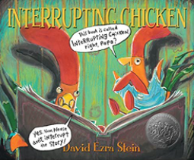
“Interrupting Chicken” by David Ezra Stein
Aimed at Reception and Year 1
It’s time for the little red chicken’s bedtime story—and a reminder from Papa to try not to interrupt. But the chicken can’t help herself! Whether the tale is Hansel and Gretel or Little Red Riding Hood or even Chicken Little, she jumps into the story to save its hapless characters from doing some dangerous or silly thing.
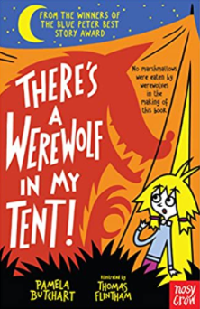  Year 2 and 3: “There’s a Werewolf in my Tent” by Pamela Butchart  Izzy and her friends are SO EXCITED about their school trip. They're going camping and there'll be marshmallows and no washing and everything. But then WEIRD things start happening! There are howling sounds at night, and some sausages have gone missing, and it's nearly a full moon...But it's when they see their new teacher's hairy legs that they KNOW! There's a werewolf on the school trip and they're all DOOMED!! |  |  | 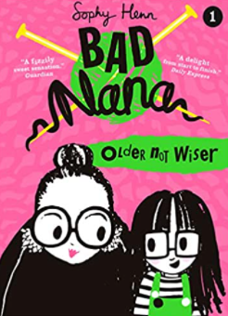  Year 3 and 4: “Bad Nana” by Sophy Henn  Jeanie’s Grandma is BAD. Not bad like a vampire or a gangster or anything, more like . . . up to no good. Sometimes she can be a bit embarrassing but most of the time she’s REALLY fun, especially when she gets Jeanie involved in her mischievous schemes. Everyone says she’s old enough to know better . . . but she doesn’t seem to care one bit. In fact, Jeanie thinks she might quite like it!  Bad Nana is a deliciously wicked new series for ages six and up, told through the eyes of 7 3/4-year-old Jeanie. Gorgeously illustrated throughout with vibrantly coloured spreads, Bad Nana’s naughty exploits will shock and make you snort with laughter!
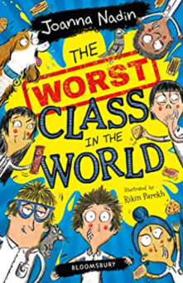  Years 5 & 6: “The Worst Class in the World” by Joanna Nadin  According to head teacher Mrs Bottomley-Blunt, 4B is the WORST CLASS IN THE WORLD. She says school is not about footling or fiddle-faddling or FUN. It is about LEARNING and it is high time 4B tried harder to EXCEL at it.  But Stanley and Manjit didn't LITERALLY mean to make their whole class sick with homemade biscuits. And they definitely didn't LITERALLY mean for Manjit's dog, Killer, to eat their teacher's shoes or for Bruce Bingley's rat to escape. These things just happened even though they had a FOOLPROOF plan.  You see, 4B may be the WORST CLASS IN THE WORLD. But you wouldn't want to be anywhere else. |  |  | 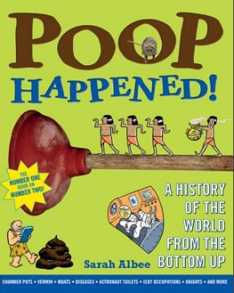  Humorous NON – FICTION for all ages: “Poop Happened” by Sarah Albee.  "Did lead pipes cause the fall of the Roman Empire?"  "How many toilets were in the average Egyptian pyramid? "  "How did a knight wearing fifty pounds of armour go to the bathroom?"  "How do astronauts go in space?"  History finally comes out of the water-closet in this exploration of how people's need to relieve themselves shaped human development from ancient times to the present.

