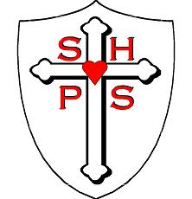

Science Sequence
Sacred Heart Catholic Primary School

 | Autumn 1 | Autumn 2 | Spring 1 | Spring 2 | Summer 1 | Summer 2
Nursery | Our Bodies – All about me | Harvest -growing | Our bodies - moving | People who help us | Really Wild, minibeasts | The Seaside
Reception | All about me | Superheroes | Around the world - animals | Space | Minibeasts, life cycles | Plants and growing
Year 1 | Materials | Earth and Space  (Seasonal Changes) | Animals including humans |  | Plants | Forces
Year 2 | Living Things | Materials | Animals including humans |  | Plants | Electricity
Year 3 | Earth in Space  (Rocks and soils) | Light | Plants |  | Animals including humans | Forces
Year 4 | Materials  (States of Matter) | Living things | Electricity |  | Sound | Animals and Humans
Year 5 | Living Things | Materials | Earth and space | Animals including humans | Sound | Forces
Year 6 | Living Things | Light | Animals including humans | Electricity | Evolution and inheritance

