Parent / Carer Information Pack
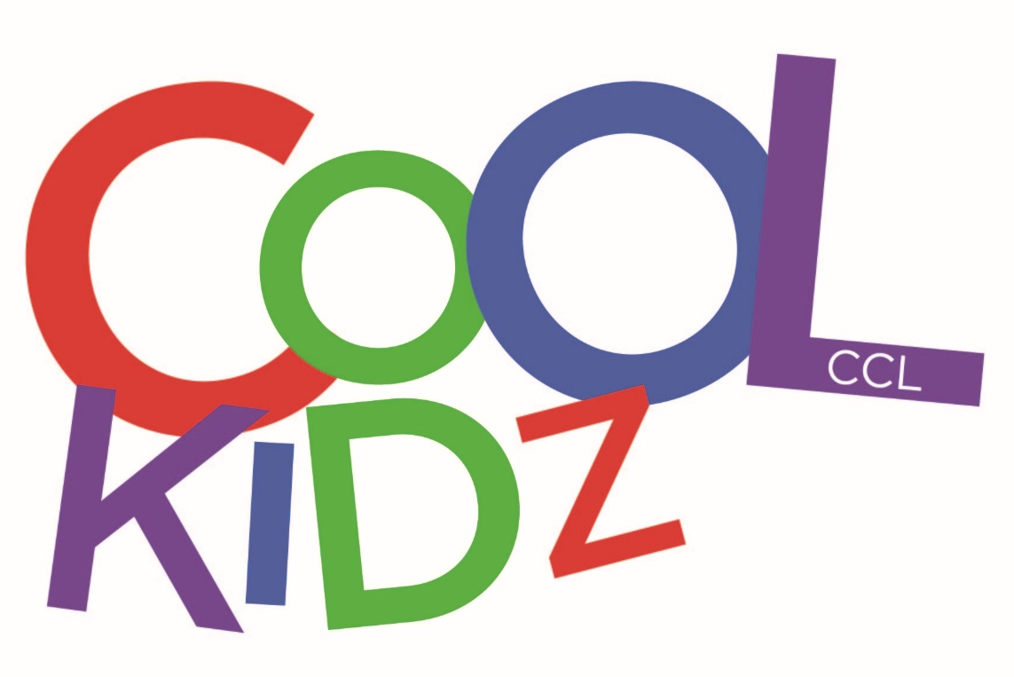
Cool Kidz @ Sacred Heart
Address: Sacred Heart Catholic Primary School
Poulton St
Ashton-on-Ribble
Preston
PR2 2SA
Phone us: 07928 325954
Email us: coolkidzsh@communityfutures.org.uk
Find us on Facebook: @coolkidzsacredheart
We value our relationship with you and are committed to working in partnership with you to provide top quality play and care for your children.

With this in mind we will:-

  - Welcome you at all times to discuss our work, have a chat or take part in our activities (if required);

  - Keep you informed of our opening times, fees and charges, programmes of activity, menus and procedures;

  - Be consistent and reliable to enable you to plan with confidence and peace of mind;

  - Share and discuss your child’s achievements, experiences, progress and friendships;

  - Be available to discuss decisions about the running of the club;

  - Ask your permission for outings and special events;

  - Listen to your views and concerns to ensure we continue to meet your needs.

Our Pledge to Parents and Carers
Cool Kidz @ Sacred Heart is a registered provider of childcare for children aged 4-11 years. It is open from 3:15pm until 5:45pm after school during term time. We are based in the primary school where we have snack and where we carry out a variety of activities including crafts, construction, cookery, creative and indoor sports play and read books. There is also an outdoor area for physical play, weather permitting.
About the Club
Aims
The club aims to provide a safe, secure and relaxed environment for the children in our care. We endeavour to provide an atmosphere and activities similar to those found at home.

What we offer
We offer a wide range of activities incorporating cookery, craft, needlework, board games, reading, imaginary play, construction, sport and much more. During their time at the club children choose activities that suit them best.
Snack and drinks are provided in the afternoon. This however is not intended to be a substitute for a main evening meal that the child will receive at home. We promote independence, by encouraging children to prepare their own snacks where possible and to clear away after themselves. We use fresh ingredients and follow statutory guidelines. Fresh drinking water is available at all times. Individual dietary requirements and parental preferences are met wherever possible. We recognise the importance of healthy nutrition for children delivered in a calm, friendly setting. We allow children to decide when they are ready to eat, but request that food be consumed whilst sitting at the snack table.
Staffing
Cool Kidz @ Sacred Heart is staffed by a Manager and play workers. In addition, there are occasionally some volunteers who also give their time to assist in the running of the provision as required. The aim is to provide a smooth transition between school and the out of school club. All our staff have significant experience of working with children and complies with the EYFS requirements for registered childcare. Staff are expected to undertake professional development training. All staff and volunteers are checked and cleared through DBS assessment. We maintain a staff/child ratio of 1:8 for children under 8 years of age in line with statutory requirements.

Organisation
It is our intention to make Cool Kidz @ Sacred Heart accessible to children and families from all sections of our local community. Admission to the club is organised by the Manager and a waiting list system is implemented when the need arises. The waiting list will be operated on a first come first served basis, with the exception of siblings who will have priority for the same day(s) as a sibling already attending.
Re-enrolment is required at the end of the summer term. Places will not be kept open for children unless a new membership form is completed.
Admission
Terms & Conditions
All policies and procedures are available from the Manager on request.
Policies and Procedures
Cool Kidz @ Sacred Heart is a project of Community Futures (registered charity 702233). We maintain a close working relationship with Sacred Heart Catholic Primary School in order to ensure continuity of care.

Payment of Fees
The current fee for permanent bookings is £11.40 per child for a full afternoon session. The fee for casual bookings is £11.70 per child.
Fees are payable in advance by cash, cheque or bank transfer. Cheques should be made payable to ‘Cool Kidz’. (Fees are reviewed annually in March)
The price per session per child applies to all children. This is payable for all sessions, including those when your child is sick or on holiday (regardless of the amount of notice given).
Bank holidays and professional days will not be charged for.
Non-payment for more than one half term will result in your place being terminated.
Cool Kidz @ Sacred Heart aims to keep fees to a minimum, whilst still raising enough income to cover our running costs. Please ensure that fees are paid promptly by cash, cheque, vouchers or BACS.
Please note that non-payment of fees will result in your child’s place being suspended until the debt is cleared.

At least 2 weeks’ notice of termination or of changes in attendance must be given. Requests for changes to days should be made in writing and will be accommodated where possible.
Changes to days or cancelling your place
Please remember that we need to know if your child/children will not be attending Cool Kidz @ Sacred Heart for any reason. Even if you have informed school, we still need to know.
If you know in advance of the days when your child/children will not be attending during the following week, please try to let the setting know by THURSDAY at the latest. In cases of illness or emergency when notice cannot be given, please call as soon as you can. Contact details can be found on the front page.
Temporary Changes

Arrival & Departure

All children will be collected and walked to the school hall for the After School Club. Staff members will be waiting to greet them. A register is taken each day of those attending and a signing out sheet must be completed by parents or guardians when collecting their child or children

If you are delayed for whatever reason, please telephone the club to let them know. A late payment fee of £10.00 will be charged for every 15 minute period your child is collected after 5:45pm.
Please note that your child is not insured after 6:00pm unless there is a planned event and the club can take no responsibility for any accidents or injuries which occur before or after these times.
Late Collections

General Information
Child Protection
We intend to create an environment in which children are safe from abuse and in which any suspicion of abuse is promptly and appropriately responded to. We aim to comply with local and national child protection procedures and ensure that all staff are appropriately trained.
Equal Opportunities
Cool Kidz @ Sacred Heart is committed to equal opportunities as stated in its Equality and Diversity policy. Strategies used to realise this goal include:
• Premises used by the club provide a high level of accessibility to the community at large;
• Menus include sufficient variability to provide for the cultural mix of the club’s children.
Special Needs
Cool Kidz @ Sacred Heart will make every effort to accommodate and welcome any child with special needs. We will work in liaison with parents/carers and relevant professionals to meet the child’s specific needs.
Our staff training programme includes specific elements relating to children with special needs.
We will endeavour to accommodate all children of all ability, whilst working within the club’s limitations. Each case will be assessed individually and risk assessed to ensure everyone’s safety.

Children and staff have created rules for behaviour whilst at the club. These are displayed for the children to see.
The club also operates a behaviour policy, summarised here. A full copy of this policy is distributed to all members of staff and children but includes the following:-
• Children and staff are expected to respect each other and visitors;
• Staff will encourage an atmosphere of care and consideration between all members of the club including children, staff and visitors;
• Cool Kidz @ Sacred Heart aims to encourage appropriate behaviour through praise for good behaviour, emphasis on co-operative play and sharing, talking to children with the courtesy we expect from them and engaging children in activities;
• Cool Kidz @ Sacred Heart will not tolerate bullying, aggressive, confrontational or threatening behaviour or behaviour intended to result in conflict.
The club has procedures for dealing with unacceptable behaviour. In the case of violence or behaviour that poses an immediate danger a child is required to be collected directly; as an ultimate sanction the child may be excluded from the club. Cool Kidz @ Sacred Heart recognises that poor behaviour can occur from time to time for reasons that are not always evident, or as a result of special needs. It will strive to be flexible in order to accommodate such cases.
We are unable to care for children who are unwell. Please contact the setting to inform them of any infectious illness your child may contract. If your child has sickness or diarrhoea, please do not send him/her to the club for 48 hours after the illness has ceased.
Illness
Behaviour
Cool Kidz @ Sacred Heart is run for the children. We value your opinions. If you have any queries, comments or concerns or simply want to discuss issues relating to your child please feel free to speak to the Setting Manager, or any other member of staff.
All written complaints will be acknowledged within the first 5 working days of its receipt and a full written response will be provided within 1 month of receipt of the complaint.
A full copy of our complaints procedure and policy is available on request.
Complaints will be dealt with professionally and promptly to ensure that any issues arising from these complaints are handled effectively and to ensure the welfare of all the children. To make a complaint please refer to the complaints procedure within our Policy and Procedure file. After following the procedure, if the matter cannot be resolved to your satisfaction, as a parent, you have the right to raise the matter with Ofsted.
Ofsted contact details:
Applications, Regulatory & Contact (ARC) Team
Ofsted
Piccadilly Gate
Store Street
Manchester
M1 2WD
Telephone: 03001 231231
Complaints Procedure
Please let the Manager know if your child is taking prescribed medicine. Please speak to the Supervisor if medication needs to be administered during club time (a form will require completion before medication can be dispensed).
Medication
Every precaution is taken to ensure the safety of the children in our care at all times. The club is fully insured. Several of our staff are trained in first aid and a first aid kit is available whilst on site. We operate an accident procedure and fire drills are regularly carried out.
Accidents / First Aid

