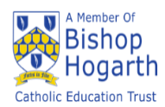
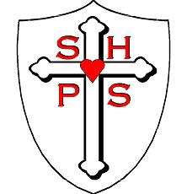
Sacred Heart Catholic Primary School Newsletter 11/11/2022

Website: https://sacredheart.bhcet.org.uk Email: admin@sacredheart.bhcet.org.uk Tel: 01429 272684

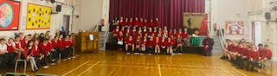
Thank you to everyone who joined us for our Remembrance Liturgical Service on Wednesday.
The Year 5 children and Year 4, 5 and 6 choir, led a very moving service and it was lovely to have Canon Paul join us. I would like to say a very special thank you to the soloists: Maisie, Beth and Lilly. Unfortunately, one was ill on the day and Lilly stepped in at the last moment.

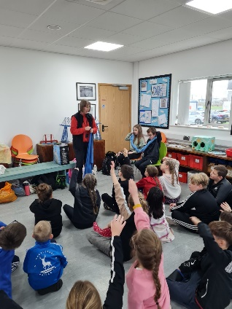
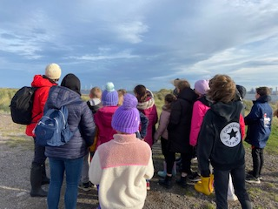
Our Year 5 have had a wonderful school trip to Teesmouth as part of their geography fieldwork. They were looking at the different aspects of a river and following the journey of the River Tees.
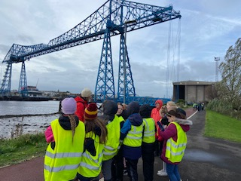
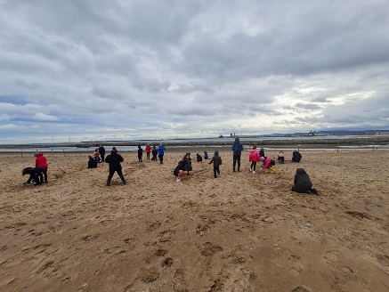

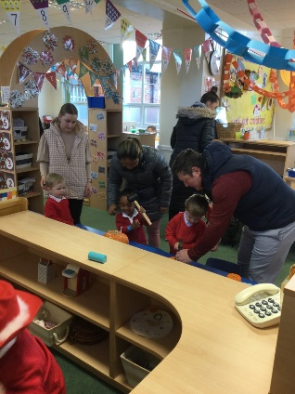
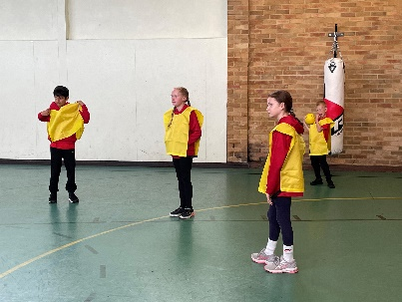
Nursery have held an Open Morning this week. Some of our Year 3 and Year 4 pupils attended a sports hall athletics event at English Martyrs and some of our boys’ football team played at High Tunstall on Tuesday as part of the Hartlepool United Community Sports Foundation, whilst some of our Year 5 Change4life children attended a conference at Brierton.

More photos are available on our website: https://sacredheart.bhcet.org.uk/latest-news/

Anti-Bullying Week
Next week is Anti-Bullying Week, to start off the week we would like children to come to school wearing odd socks.

IQ Christmas Cards
If you ordered and paid for Christmas cards that your child has designed, you should have received them this week. The only box that has not been received is the box of chocolate. (I know what you are going to say! No, it hasn’t made its way to my office! If it were a box of crisps, that would be a different story!) Any problems please inform the school office.

First Holy Communion and Holy Family Parish Bulletin
There is a meeting, in Church, this Sunday, for those children making their First Holy Communion.
St Patrick’s Mass at 9am followed by First Holy Communion preparation
St Joseph’s 9am First Holy Communion preparation and then Mass at 10am.
St John Vianney’s 10am First Holy Communion preparation followed by Mass at 11am.
Please keep these 29 children in your prayers. For further information about what is happening in the parish, please follow this link: 6th-November-2022.pdf (bhcet.org.uk) which can be found on the school website.
There is a lovely children’s section on the bulletin, which your child may want to complete.

Children in Need
Friday 18th November is Children in Need Day. Children are allowed to come into school out of uniform that day for a donation. This year that donation can be a bottle or a bar of chocolate (which will be used at the Christmas Fayre) or money, which will be sent off to Children in Need.

Youth Sunday
As part of their First Holy Communion preparation, the children are invited to a special Mass, at St Joseph’s Church on Sunday 20th November at 10am. Our choir will also be there to lead the singing.

Carols by Candlelight
On Thursday 8th December (5pm) we will be holding a Christmas Carol Concert, here in school. Tickets will be £1 and this will include a hot drink and a mince pie. Our choir and some musicians will be helping us to get into the Christmas spirit. Tickets will go on sale on Monday 21st November and will be available from the school office.

Christmas Fayre
We need your help! Our Christmas Fayre raffle is always full of wonderful prizes to be won. If you have anything that we can use as a raffle prize, please send them into school. Even better, if you own a business or work for a company who would be willing to donate something to be used as a prize in our raffle, please let us know.

Pantomime
Reception through to Year 6 will be going to Billingham Forum on Thursday 15th December. Children will be back at school between 4.30pm and 4.45pm and the cost is £14 per child. Payment for this can be made via Scopay, in small increments if you wish. Please note, there will not be any Munchkins that evening.

Attendance

Well done to Class 8 whose attendance was 99.3%.

Overall this week attendance was 94.7%. We are aiming to have attendance at 96% or above for each week, each class and each child. Attendance does matter so please ensure your child attends school everyday.

FORTHCOMING EVENTS

Sunday 13th November | First Holy Communion Preparation
Monday 14th November | Children come to school wearing odd socks.
Friday 18th November | Children in Need Day, children come out of uniform for a donation which could be a bottle or bar of chocolate for our Christmas Fayre or a donation of money to be sent to Children in Need.
Sunday 20th November | St Joseph’s Church 10am Mass. All are welcome but particularly choir and children making their First Holy Communion
Thursday 24th November | School Nurse – Drop in session for parents 2.00pm
Friday 25th November | School closed for PD Day
Tuesday 29th November | Year 5 and Year 6 Advent Service, St Joseph’s Church at 9.30am
Wednesday 30th November | Nursery Open Morning & Afternoon 8.30am-9.00am/2.30pm-3.00pm
w/b 5th December | Parent Consultation Evenings
Monday 5th December | Year 3 and Year 4 Advent Service. St Joseph’s Church at 9.30am
Tuesday 6th December | Performing Arts Christmas concert – invitation only.
Thursday 8th December | Carols by candlelight 5pm in the school hall. Tickets available Monday 21st November from the school office.
Wednesday 14th December | Christmas Fayre  Parish Carol Service 5pm St Joseph’s Church
Thursday 15th December | The Pantomime! Trip to Billingham Forum to see Beauty and the Beast
Saturday 17th December | Children, making their FHC will make their First Reconciliation
Tuesday 20th December | School closes for the Christmas holidays
Wednesday 4th January | School reopens at 8.30am
Items in red are new this week.

Thank you for your continued support.
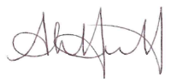
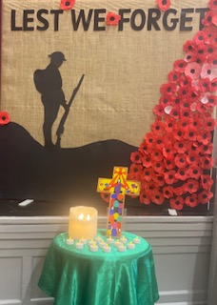
Headteacher

They shall grow not old, as we that are left grow old: Age shall not weary them, nor the years condemn. At the going down of the sun and in the morning, we will remember them.

