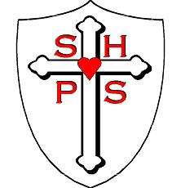
Sacred Heart Catholic Primary School Newsletter 4/11/2022

Website: https://sacredheart.bhcet.org.uk Email: admin@sacredheart.bhcet.org.uk Tel: 01429 272684

Welcome back! I hope you have all had a lovely, relaxing half term and are now ready for what always proves to be the busiest half term of the year! Parent consultation evenings, carol services, Christmas Fayre, nativities and that doesn’t even include the school trips for the Year 5 or the whole school trip to the panto! All this and only 6 weeks to fit it in!
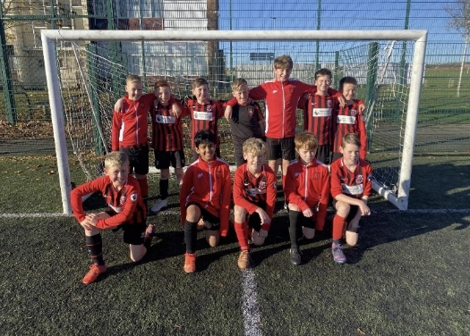

Well done to the boys football team. Out of the 7 games played this morning, they won 5 and drew 2. This means that they have won the Hartlepool Schools Premier League this season. Well done!

Service of Remembrance
On Wednesday children from Year 5 will be holding a Service of Remembrance to remember those who have died during the wars. All of our school community are invited to come and join us in the school hall at 9.15am. It will last approximately 30 minutes and Canon Paul will also be in attendance.

Children in Need
Friday 18th November is Children in Need Day. Children are allowed to come into school out of uniform that day for a donation. This year that donation can be a bottle or bar of chocolate (which will be used at the Christmas Fayre) or money, which will be sent off to Children in Need.

Carols by Candlelight
On Thursday 8th December (5pm) we will be holding a Christmas Carol Concert, here in school. Tickets will be £1 and this will include a hot drink and a mince pie. Our choir and some musicians will be helping us to get into the Christmas spirit. Tickets will go on sale on Monday 21st November and will be available from the school office.

Christmas Fayre
Our fayres have always proved very popular and we are hoping this one will not disappoint. If you own a business, or work for a business who would like to donate a prize for our raffle, however small, we would be very grateful. Please hand any donations to myself or Mrs Palmer, on the gate on a morning or into the school office. Anything that is donated means that the money we raise benefits all the children in our school.

Class Dojo
We use Class Dojo as our communication platform so that we can keep parents informed and you can message us with school related matters. Please remember that Dojos will not be responded to outside the hours of 5pm and 8am on weekdays or on weekends. If there is a safeguarding issue outside of school hours, please contact the police on 101 and report it to them.

Pantomime
Reception through to Year 6 will be going to Billingham Forum on Thursday 15th December. Children will be back at school between 4.30pm and 4.45pm and the cost is £14 per child. Payment for this can be made via Scopay, in small increments if you wish.

Virtue Wednesday
Well done to all the children who achieved the Respect Virtue Award this week, we are linking our virtues to British Values as well. If you want to find out more information about British Values please follow this link: https://sacredheart.bhcet.org.uk/wp-content/uploads/2022/11/British-Values.pdf

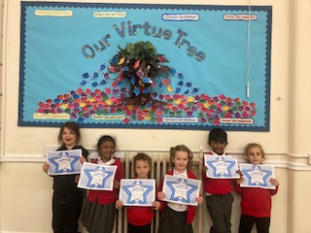

More photos are available on our website: https://sacredheart.bhcet.org.uk/latest-news/

First Holy Communion and Holy Family Parish Bulletin
The children making their First Holy Communion will first make their Reconciliation on Saturday 17th December. Please keep these 29 children in your prayers. For further information about what is happening in the parish, please follow this link: 6th-November-2022.pdf (bhcet.org.uk) which can be found on the school website.
There is a lovely children’s section on the bulletin, which your child may want to complete.

Attendance

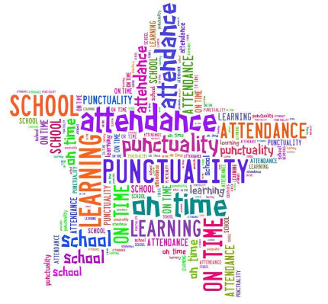 | Attendance this week is 95.3%. Better than previous weeks before half term but we are aiming for 100% each week.  For information: since September we have only had 7 classes who have had 100%. That is Class 2 (this week), Class 6, Class 11, Class 14 and Class 12 have had 100% two weeks in a row.  Well done to Mrs Scott and Class 2 who had 100% attendance this week.
Flu Immunisation
If you have not already registered your child online for their immunisation and wish to do so, you will need to ring the following number as the website is now locked: 03000 032554

Only children with parental consent in place will receive this.

Goodbye
Finally, today we wished Miss Chera goodbye. She is moving to Nottingham to be closer to family so we wish her well and hope that her new job goes well. We will miss you!

FORTHCOMING EVENTS

Monday 7th November | Y5 (Class 12) Trip to Teesmouth Field Centre –
Tuesday 8th November | Flu Immunisations
Wednesday 9th November | Remembrance Service 9.15am Year 5 children are leading it. All are welcome.
Thursday 10th November | Y5 (Class 11) Trip to Teesmouth Field Centre –
Sunday 13th November | First Holy Communion Preparation
Friday 18th November | Children in Need Day, children come out of uniform for a donation which could be a bottle, bar of chocolate or money.
Thursday 24th November | School Nurse – Drop in session for parents 2.00pm
Friday 25th November | School closed for PD Day
Wednesday 30th November | Nursery Open Morning & Afternoon 8.30am-9.00am/2.30pm-3.00pm
w/b 5th December | Parent Consultation Evenings
Tuesday 6th December | Performing Arts Christmas concert – invitation only.
Thursday 8th December | Carols by candlelight 5pm in the school hall.
Wednesday 14th December | Christmas Fayre  Parish Carol Service 5pm St Joseph’s Church
Thursday 15th December | The Pantomime! Trip to Billingham Forum to see Beauty and the Beast
Saturday 17th December | Children, making their FHC will make their First Reconciliation
Tuesday 20th December | School closes for the Christmas holidays
Wednesday 4th January | School reopens at 8.30am
Items in red are new this week.

Thank you for your continued support.
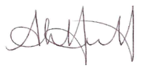
Headteacher

