Vocabulary
E-Safety | The safe and responsible use of technology.
Growth Mindset | Individuals who believe their talents can be developed through hard work and good strategies.
Twisted Traditional Tale | A traditional tale where we might change the character or setting.
Instructions | Detailed information about how something should be done or operated.
Place Value | The value of each digit in a number. For example, the 5 in 350 represents 5 tens, or 50.
Innovated Tale | rewritten story where characters, settings, or events are changed creatively
2D shapes | A flat, closed figure with length and width but no depth or thickness
3D shapes | A solid figure with three dimensions: length, width, and height or depth.
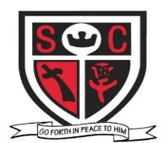
Maths Key Skills
Y1
Read o’clock and half past times
Identify and describe 2D and 3D shapes.
Solve one step problems involving missing
numbers
Identify and represent numbers using the
number line
Count on and back in 2s, 3s, 5s and 10s.
Compare and describe capacity and volume
Recall and use doubles of all numbers to 10 and
corresponding halves.
Y2
Read time to fine minute intervals
Identify 2D shapes on the surface of 3D shapes
Solve one step problems involving missing numbers
Identify and represent numbers using the number line
Count on and back in 2s, 3s, 5s and 10s.
Measure capacity and volume in l and ml
Compare and order numbers ≤≥

Spelling and Grammar
Y1- We will use the prefix un– for words and the suffixes –ing, –ed, –er and –est
Y2- We will add suffixes ful or less to create adjectives e.g. playful, careful, careless, hopeless. We will use suffixes er and est to create adjectives e.g. faster, fastest, smaller, smallest. We will use suffix ly to turn adjectives into adverbs e.g. slowly, gently, carefully

English Key Skills
We will write own innovated tale based on a model.
We write instructions using time connectives and imperative verbs.
We will write and punctuate simple sentences
Y1- We will use and, because within our writing.
Y1-We will make predictions based on what we have read.
Y1- We will make basic inferences about what is being said and done
Y2- We will make predictions using evidence from the text. We will make inferences about characters and events using evidence from the text e.g. what is a character thinking, saying and feeling?
Y2- We will use and, but, so, because within our writing.

We are reading
Traditional tales linked to our topic - Rapunzel.
Instructional texts to inform our own instructions on how to build a castle.
Physical Health – PE – Gymnastics
Mental Health – HRSE – Growing in Love for family, friends, faith and community.
Topic Based Key Skills for the lead subjects this half term
DT:
Y1 We will explore construction kits to make structures and then plan and make our own drawbridge.
Y2 We will explore existing products and investigate how they have been made. We will decide how existing products do/do not achieve their purpose. We will then plan and make our own drawbridge.
Science:
Y1-We will identify and name a variety of common wild and garden plants, including deciduous and evergreen trees. Identify and describe the basic structure of a variety of common flowering plants, including trees.
Y1-We will Observe and describe changes across the four seasons. Observe and describe weather associated with the seasons and how day length and temperature varies.

Y2- We will observe and describe how seeds and bulbs grow into mature plants. Find out and describe how plants need water, light and a suitable temperature to grow and stay healthy.
Y2-We will learn about the sun and the 8 different planets. We will learn about the movement of the different planets.
History
Y1-We will learn about some similarities and differences between ways of life in Norman times and present day.
Y2-We will begin to understand the reasons why people in the Norman period acted as they did from a range of sources.
Computing
Y1 and Y2- We will learn about how to play safely online. We will also learn about algorithms using the Maze Explorer Unit.

Religious Education
This half term, we will focus on the journey from Galilee to Jerusalem, exploring the Presentation in the Temple, Finding Jesus in the Temple, Jesus announcing His mission, choosing His disciples, welcoming children, His encounter with Zacchaeus, and celebrating Jesus as the Light of all nations.
School and Parish Events
- Meet the Teacher Spring Term
• Whole School welcome back Mass
• Visit to the Church Crib
• Online Safety Day
Saint Clare’s Catholic Primary School Hazel Class Castles:

Year 1 Recommended Reading
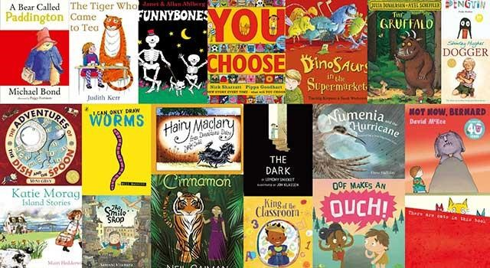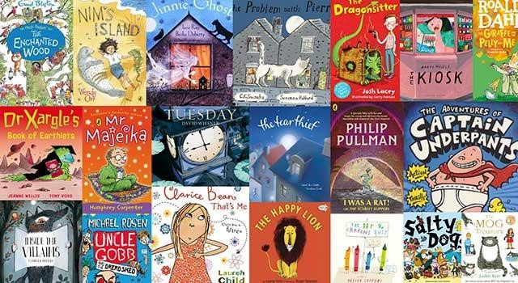

Year 1
- The Enormous Turnip.
- The Tale of Peter Rabbit by Beatrix Potter.
- Jack and the Beanstalk.
- Oliver’s Vegetables by Vivian French.
- Instructions for making cress heads from the CBeebies website (here).
- Instructions for growing a bean plant from The Great Grub Club website (here).
- Recipes from the CBeebies website (here).
- A range of instruction texts suitable to Year One.
Useful Links

https://www.booktrust.org.uk/book
s
-
d
an
-
reading/ou
r
-
0
recommendations/10
-
t
bes
-
/
books

https://schoolreadinglist.co.uk/readin
g
-
list
s
-
fo
r
-
ks
1
-
schoo
l
-
pupils/suggeste
d
-
readin
g
-
lis
t
-
r
yea
-
1
-
pupil
s
-
1
ks
-
ag
e
-
5
-
6
/

https://schoolreadinglist.co.uk/readin
g
-
list
s
-
r
fo
-
ks
1
-
schoo
l
-
pupils/suggeste
d
-
readin
g
-
lis
t
-
yea
r
-
2
-
pupil
s
-
ks
1
-
ag
e
-
6
-
7
/

https://www.waterstones.com/category/children
s
-
teenag
e

https://www.whsmith.co.uk/books/children
s
-
bo
o
s
k
-
d
an
-
e
pictur
-
books/bks00080
/

s
https://www.amazon.co.uk/children
-
9
books/b?ie=UTF8&node=6

