Talk Homework
At St. Clare’s we recognise the importance of speaking and listening skills therefore we set talking homework for you and your family to complete with your child. Please discuss these talking points and complete the activities with your child. You don’t need to return this homework to school.

Can you retell the story of The Stinky Cheese Man? Can you name all of the different characters within the story? Can you describe all of the different settings in the story?
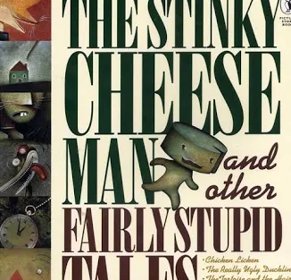
What story is it based on? What are the similarities and differences between the
stories?

Can you tell a member of your family what an adjective, noun and a verb is?

Can you tell you compose a sentence from the story using an adjective, a noun and a verb?

