Talk Homework
At St. Clare’s we recognise the importance of speaking and listening skills therefore we set talking homework for you and your family to complete with your child. Please discuss these talking points and complete the activities with your child. You don’t need to return this homework to school.

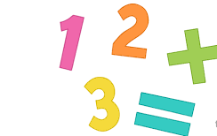
Can a member of your family say a number and you say what one more or less would be? Can a member of your family say a number and you say what ten more or ten less would be?

What do these symbols mean - =?

Can you tell your family how you would answer 10 - 2 = ? Can you tell your family how you would answer difficult subtraction questions like 12 -5 =?

Can you recite all of your subtraction number bonds (numbers that are subtracted and are the reverse of addition bonds such as 10-2=8) to 10?

