Vocabulary
Annunciation | The announcement of the Incarnation by the angel  Gabriel to Mary (Luke 1:26–38).
Properties | How they behave in use to make informed selections when designing products.
E-Safety | The safe and responsible use of technology.
Growth Mindset | Individuals who believe their talents can be developed through hard work and good  strategies.
Twisted Traditional  Tale | A traditional tale where we might change the character or  setting.
Non- Chronological  Report | A text that is not written in time order.
Algorithm | A process or set of rules to be followed.

English Key Skills
Y1
-To be able to make prediction about characters.
-To be able to write and punctuate simple and compound sentences using ‘and’.
-To be able to make inferences about characters and events using evidence from the text.
-To be able to retell a story orally.
-To be able to write their own twisted traditional tale
-To be able to gather information from a variety of sources.
-To be able to construct their own non- chronological report.
Y2
- Use past tense for narrative, recount historical reports.
- Say, write and punctuate simple and compound sentences using the connectives and, but and or
- Proofread to check for errors in spelling, grammar and punctuation.
We are reading
The Stinky Cheese Man by Jon Scieszka.

Nonfiction texts to inform our non- chronological reports.
Maths Key Skills
Y1
-Read, write interpret mathematical statements involving - =
-Subtract one digit and two digit numbers
-Understand fractions can describe part of a whole
-Understand that a unit fraction represents on equal part of a whole
-Recognise, find and name a half as one of two equal parts of an object, shape or quantity
-Recognise, find and name a quarter as one of four equal parts of an object shape of quantity
-recognise and know the value of different denominations of coins and notes
-Recognise days of the week, months of the year
Y2
-Subtract numbers using concrete objects, pictorial representation and mentally strategies.
-Understand and use the term numerator and denominator
-Understand that a fraction can describe part of a set
-Recognise, find, name and write fractions one third, all quarters of a length, shape, set of objects or quantity
-recognise and use symbols for pounds (£) and pence (p);
-combine amounts to make a particular value -find different combinations of coins that equal the same.
-Compare and sequence intervals of time
-Tell and write the time to 5 mins, including quarter to/past the hour and draw the hands on the clock
-Know the number of minutes in an hour and hours in a day.

Physical Health – PE – Fundamental Movement Skills and Dance
Mental Health – HRSE – How to take care of ourselves.
Religious Education
This half term we will look at the Annunciation, Mary visiting Elizabeth, Mary is our Mother, the birth of Jesus and the visit of the Shepherds.
School and Parish Events
- School Advent Service
- KS1 Nativity
- Christmas Celebrations
Materials
Hazel Class Materials
Topic Based Key Skills for the lead subjects this half term

History: Children will be able to learn about and experience what is was like to live and learn in the Victorian times. We will explore Victorian classrooms and even have our own Victorian day.
Science: To learn about properties of different materials and how they can change. Children will have the opportunity to perform simple tests and gather and record data using simple equipment.
Computing: Children will learn about how to stay safe online. We will also look at algorithms and when and how they are used.

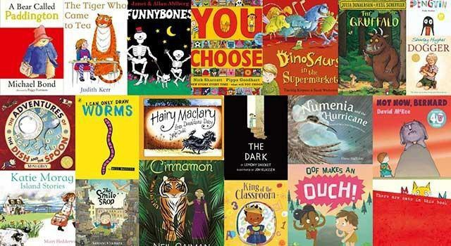
Year 1 suggested reading
Zog by Julia Donaldson.
The Princess and the Dragon by Audrey Wood. George and the Dragon by Christopher Wormell. The Snow Dragon – BBC Learning Zone (here). Princess and the Dragon – YouTube clip (here).
The Stinky Cheeseman and other Fairystupid Tales by Jon Scieszka and Lane Smith

