Saint Clare’s Catholic Primary School Progression towards a ‘Written Method for Multiplication’

In developing a written method for multiplication, it is important that children understand the concept of multiplication, in that it is:
- repeated addition
They should also be familiar with the fact that it can be represented as an array They also need to understand and work with certain principles, i.e. that it is:
- the inverse of division
- commutative i.e. 5 x 3 is the same as 3 x 5
- associative i.e. 2 x 3 x 5 is the same as 2 x (3 x 5)

YR
Early Learning Goal:
Children solve problems, including doubling.

Children are encouraged to develop a mental picture of the number system in their heads to use for calculation. They should experience practical calculation opportunities using a wide variety of equipment, including small world play, role play, counters, cubes etc.

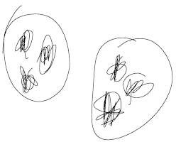
They may develop ways of recording calculations using pictures, paintings, role play, stories etc.

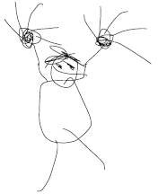
A child’s jotting showing the fingers on each hand as a double.

Y1

A child’s jotting showing double three as three cookies on each plate.

End of Year Objective:
Solve one-step problems involving multiplication by calculating the answer using concrete objects, pictorial representations and arrays with the support of the teacher.
In year one, children will continue to solve multiplication problems using practical equipment and jottings. They may use the equipment to make groups of objects. Children should see everyday versions of arrays and use this in their learning, answering questions.

Children will begin to learn doubles through practical activities and number stories. Children will start to record their number sentences.
Children will count on and back in multiples of 2, 5 and 10 to support their multiplication knowledge and calculations.

Y2
End of Year Objective:
Calculate mathematical statements for multiplication (using repeated addition) and write them using the multiplication (x) and equals (=) signs.
Children should understand and be able to calculate multiplication as repeated addition, supported by the use of practical apparatus such as counters or cubes. e.g.






5 x 3 can be shown as five groups of three with counters, either grouped in a random pattern, as below:



or in a more ordered pattern, with the groups of three indicated by the border outline:

Children should then develop this knowledge to show how multiplication calculations can be represented by an array, (this knowledge will support with the development of the grid method in the future). Again, children should be encouraged to use practical apparatus and jottings to support their understanding, e.g.
5 x 3 can be represented as an array in two forms (as it has commutativity):




5 + 5 + 5 = 15

3 + 3 + 3 + 3 + 3 = 15

Due to using terms such as ‘groups of’ or ‘lots of’, children are more familiar with the initial notation
above.

Y3
End of Year Objective:
Write and calculate mathematical statements for multiplication using the multiplication tables that they know, including for two-digit numbers times one-digit numbers, progressing to formal written methods.*

Initially, children will continue to use arrays where appropriate linked to the multiplication tables that they know (2, 3, 4, 5, 8 and 10), e.g.

3 x 8

They may show this using practical equipment:


3 x 8 = 8 + 8 + 8 = 24

or by jottings using squared paper:
 | x | x | x | x | x | x | x | x
 | x | x | x | x | x | x | x | x
 | x | x | x | x | x | x | x | x

3 x 8 = 8 + 8 + 8 = 24

As they progress to multiplying a two-digit number by a single digit number, children should use their knowledge of partitioning two digit numbers into tens and units/ones to help them. For example, when calculating 14 x 6, children should set out the array, then partition the array so that one array has ten columns and the other four.
10 4

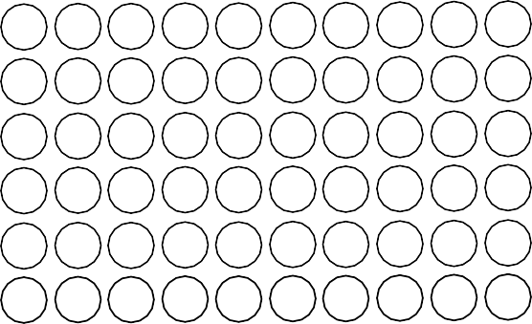

Partitioning in this way, allows children to identify that the first array shows 10 x 6 and the second array shows 4 x 6. These can then be added to calculate the answer:

(6 x 10) + (6 x 4)
NB There is no requirement for children to record in this way, but it could be used as a jotting to support development if needed.

= 60 + 24

= 84

This method is the precursor step to the grid method. Using a two-digit by single digit array, they can partition as above, identifying the number of rows and the number of columns each side of the partition line.
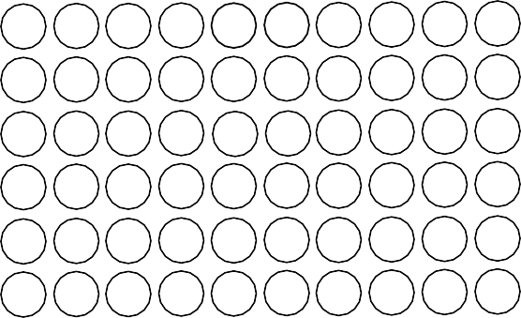
10 4

6 60 24

By placing a box around the array, as in the example below, and by removing the array, the grid method can be seen.

x | 10 | 4
6 | 60 | 24
It is really important that children are confident with representing multiplication statements as arrays and understand the rows and columns structure before they develop the written method of recording.
From this, children can use the grid method to calculate two-digit by one-digit multiplication calculations, initially with two digit numbers less than 20. Children should be encouraged to set out their addition in a column at the side to ensure the place value is maintained. When children are working with numbers where they can confidently and correctly calculate the addition mentally, they may do so.

13 x 8
x | 10 | 3
8 | 80 | 24

80
+ 24
104
When children are ready, they can then progress to using this method with other two-digit numbers.

37 x 6
x | 30 | 7
6 | 180 | 42

180
+ 42
222

Children should also be using this method to solve problems and multiply numbers in the context of money or measures.

Y4
End of Year Objective:
Multiply two-digit and three-digit numbers by a one-digit number using formal written layout.

Children will move to year 4 using whichever method they were using as they transitioned from year 3. They will further develop their knowledge of the grid method to multiply any two-digit by any single- digit number, e.g.

79 x 8
x | 70 | 9
8 | 560 | 72

560
+ 72
632

To support the grid method, children should develop their understanding of place value and facts that are linked to their knowledge of tables. For example, in the calculation above, children should use their knowledge that 7 x 8 = 56 to know that 70 x 8 = 560.

By the end of the year, they will extend their use of the grid method to be able to multiply three-digit numbers by a single digit number, e.g.

346 x 8
2400
x | 300 | 40 | 6
8 | 2400 | 320 | 48

+ 320
+ 48
2768
When children are working with numbers where they can confidently and correctly calculate the addition (or parts of the addition) mentally, they may do so.

Children should also be using this method to solve problems and multiply numbers in the context of money or measures.

Y5
End of Year Objective:
Multiply numbers up to 4 digits by a one- or two-digit number using a formal written method, including long multiplication for two-digit numbers.
Children should continue to use the grid method and extend it to multiplying numbers with up to four digits by a single digit number, e.g.

4346 x 8 |  | 32000
 | + | 2400
 | + | 320
 | + | 48
 |  | 34768
and numbers with up to four digits by a two-digit number, e.g.
2693 x 24
 |  | 40000
 | + | 8000
 | + | 12000
 | + | 2400
 | + | 1800
 | + | 360
 | + | 60
 | + | 12
 |  | 64632
1 1 1
x | 4 000 | 300 | 40 | 6
8 | 32 000 | 2400 | 320 | 48

x | 2000 | 600 | 90 | 3
20 | 40000 | 12000 | 1800 | 60
4 | 8000 | 2400 | 360 | 12

The long list of numbers in the addition part can be used to check that all of the answers from the grid have been included, however, when children are working with numbers where they can confidently and correctly calculate the addition (or parts of the addition) mentally, they should be encouraged to do so. For example,
x | 2000 | 600 | 90 | 3 | = 53 860  = 10 772 +
20 | 40000 | 12000 | 1800 | 60 | = 53 860  = 10 772 +
4 | 8000 | 2400 | 360 | 12 | = 53 860  = 10 772 +
64 632
1 1

Adding across mentally, leads children to finding the separate answers to: 2 693 x 20
2 693 x 4

Children should also be using this method to solve problems and multiply numbers in the context of money or measures.

During Year 5, the transition from the grid method into the formal vertical method for multiplication should take place. The traditional vertical compact method of written multiplication is a highly efficient way to calculate, but it has a very condensed form and needs to be introduced carefully.
It is most effective to begin with the grid method, moving to an expanded vertical layout, before introducing the compact form. This allows children to see, and understand, how the processes relate to each other and where the individual multiplication answers come from e.g.

368 x 6

Th H T U
3 6 8
x 6
4 8 (8 x 6)

1800
+ 360
x | 300 | 60 | 8
6 | 1 800 | 360 | 48

+ 48
2208
1 1

becomes

Th H T U
3 6 8
x 6
2 2 0 8

Th H T U
3 6 8
x 6
4 8 (8 x 6)
3 6 0 (60 x 6)
+ 1 8 0 0 (300 x 6)
2 2 0 8
1 1

3 6 0 (60 x 6) ₄ ₄
+ 1 8 0 0 (300 x 6)
2 2 0 8
1 1
The place value columns are labelled to ensure children understand the size of the partitioned digits in the original number(s) and in the answer.
It is vital that the teacher models the correct language when explaining the process of the compact method.
The example shown should be explained as:
“Starting with the least significant digit… 8 multiplied by 6 is 48, put 8 in the units and carry 4 tens (40).
6 tens multiplied by 6 are 36 tens. Add the 4 tens carried over to give 40 tens (which is the same as 4 hundreds and 0 tens). Put 0 in the tens place of the answer and carry 4 hundreds.
3 hundreds multiplied by 6 are 18 hundreds. Add the 4 hundreds carried over to give 22 hundreds (which is the same as 2 thousands and 2 hundreds). Write 2 in the hundreds place of the answer and 2 in the thousands place of the answer.”

Children should recognise that the answer is close to an estimated answer of 400 x 6 = 2 400

Long multiplication could also be introduced by comparing the grid method with the compact vertical method. Mentally totalling each row of answers is an important step in children making the link between the grid method and the compact method.

x | 600 | 90 | 3
20 | 12000 | 1800 | 60 | = | 13 860
4 | 2400 | 360 | 12 | = | 2 772 | +
16 632
1 1

Children should only be expected to move towards this next method if they have a secure understanding of place value. It is difficult to explain the compact method without a deep understanding of place value.

Step 1
TTh Th H T U
6 9 3
x 2 4
2 7 7 2 (693 x 4)
The example shown should be explained as:
“Starting with the least significant digit… 3 multiplied by 4 is 12; put 2 in the units
and carry 1 ten (10).
9 tens multiplied by 4 are 36 tens. Add the 1 ten carried over to give 37 tens (which is the same as 3 hundreds and 7 tens). Put 7 in the tens place of the answer and carry 3 hundreds.
6 hundreds multiplied by 4 are 24 hundreds. Add the 3 hundreds carried over to give 27 hundreds (which is the same as 2 thousands and 7 hundreds). Write 7 in

3 1 the hundreds place of the answer and 2 in the thousands place of the answer. We have now found the answer to 693 x 4. Step 1 is complete so to avoid confusion later, we will cross out the carried digits 3 and 1.”
Notice this answer can clearly be seen in the grid method example.

Step 2
TTh Th H T U
6 9 3
x 2 4
7
2 72 (693 x 4)
3
1
+ 1 3 8 6 0 (693 x 20)
1 1

Step 3
TTh Th H T U
6 9 3
x 2 4
2 7 7 2 (693 x 4)
Now we are multiplying 693 by 20. Starting with the least significant digit of the
top number… 3 multiplied by 20 is 60. Write this answer in.
90 multiplied by 20 is 1 800. There are no units and no tens in this answer, so write 8 in the hundreds place and carry 1 in the thousands.
600 multiplied by 20 is 12 000. Add the 1 (thousand) that was carried to give 13 000. There are no units, no tens and no hundreds in this answer, so write 3 in the thousands place and 1 in the ten thousands place.

The final step is to total both answers using efficient columnar addition.

3 1
+ 1 3 8 6 0 (693 x 20)

11 61
1
6 3 2
1

When using the compact method for long multiplication, all carried digits should be placed below the line of that answer e.g. 3 x 4 is 12, so the 2 is written in the units column and the 10 is carried as a small 1 in the tens column.
This carrying below the answer is in line with the written addition policy in which carried digits are always written below the answer/line.

Y6
End of Year Objective:
Multiply multi-digit numbers up to 4 digits by a two-digit whole number using the formal written method of long multiplication.
Multiply one-digit numbers with up to two decimal places by whole numbers.
By the end of year 6, children should be able to use the grid method and the compact method to multiply any number by a two-digit number. They could also develop the method to be able to multiply decimal numbers with up to two decimal places, but having been introduced to expanded and compact vertical methods in Year 5, it may be appropriate to use the expanded vertical method when introducing multiplication involving decimals.

4.92 x 3
T U . t h 4 . 9 2
x 3
0 . 0 6 (0.02 x 3)
2 . 7 (0.9 x 3)
+ 1 2 (4 x 3)
1 4 . 7 6

becomes

T U . t h 4 . 9 2
x 3
1 4 . 7 6
2

Children should also be using this method to solve problems and multiply numbers, including those with decimals, in the context of money or measures, e.g. to calculate the cost of 7 items at £8.63 each, or the total length of six pieces of ribbon of 2.28m each.

