Saint Clare’s Catholic Primary School Progression towards a ‘Written Method for Subtraction’

In developing a written method for subtraction, it is important that children understand the concept of subtraction, in that it is:
- Removal of an amount from a larger group (take away)
- Comparison of two amounts (difference)

They also need to understand and work with certain principles, i.e. that it is:
- the inverse of addition
- not commutative i.e. 5 - 3 is not the same as 3 - 5
- not associative i.e. 10 - 3 - 2 is not the same as 10 - (3 - 2)

YR
Early Learning Goal:
Using quantities and objects, children subtract two single-digit numbers and count on or back to find the answer.

Children are encouraged to develop a mental picture of the number system in their heads to use for calculation. They should experience practical calculation opportunities using a wide variety of practical equipment, including small world play, role play, counters, cubes etc.

Taking away
Children will begin to develop their ability to subtract by using practical equipment to count out the first number and then remove or take away the second number to find the solution by counting how many are left e.g. 9 – 4.

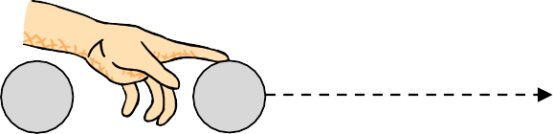
For illustration purposes, the amount being taken away are show crossed out. Children would be encouraged to physically remove these using touch counting.
2
3
4
1

By touch counting and dragging in this way, it allows children to keep track of how many they are removing so they don’t have to keep re-counting. They will then touch count the amount that are left to find the answer.

Those who are ready:

- record their own calculations/number sentences using a number story
- use a number line to count backwards and cubes to further support their understanding of subtraction

Y1
End of Year Objective:
Subtract one-digit and two-digit numbers to 20, including zero (using concrete objects and pictorial representations).
Children will continue to use practical equipment and taking away strategies. To avoid the need to exchange for subtraction at this stage, it is advisable to continue to use equipment such as counters, cubes (on the number line) and the Base 10 equipment.

Touch count and remove the number to be taken away, in this case 4.
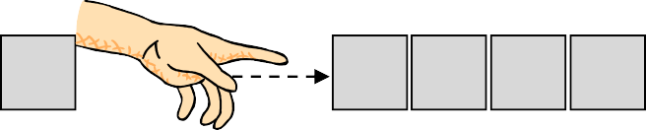
4
3
2
1

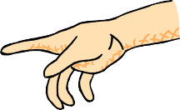
Touch count to find the number that remains.
9

1 | 2 | 3 | 4 | 5 | 6 | 7 | 8

Those who are ready:
- create number sentences using number stories to support their understanding
- use number lines to further develop their knowledge of subtraction

Y2
End of Year Objective:
Subtract numbers using concrete objects, pictorial representations, and mentally, including: a two-digit number and ones; a two-digit number and tens; two two-digit numbers.
Children will use the Base 10 equipment to support their calculations, still using a take away, or removal, method. They need to understand that the number being subtracted does not appear as an amount on its own, but rather as part of the larger amount. For example, to calculate 54 - 23, children would count out 54 using the Base 10 equipment (partitioning - 5 tens and 4 units). They need to consider whether there are enough units/ones to remove 3, in this case there are, so they would remove 3 units and then two tens, counting up the answer of 3 tens and 1 unit to give 31. Children will record written horizontal number sentences.

which leaves so 54 – 23 = 31

Children can also record the calculations using their own drawings of the Base 10 equipment (as slanted lines for the 10 rods and dots for the unit blocks), e.g. to calculate 39 – 17 children would draw 39 as 3 tens (lines) and 4 units (dots) and would cross out 7 units and then one ten, counting up the answer of 2 tens and 2 units to give 22.

Once the children are confident in using base 10 they move on to written methods of calculation. They begin by partitioning the tens and units without bridging the 10.

78-25=53
T | U
70-20= 50 | 8-5=3
50+5=53

Towards the end of the year the children will keep the first number whole and partition the second number only. This allows them to subtract any two 2-digit numbers.

82-37=45
82-7=75
75-30=45

Y3
End of Year Objective:
Subtract numbers with up to three digits, using formal written method of columnar subtraction.*
Children will build on their knowledge of using Base 10 equipment from year 2 and continue to use the idea of exchange. This process should be demonstrated using arrow cards to show the partitioning and Base 10 materials to represent the first number, removing the units and tens as appropriate (as with the more informal method in year 2).
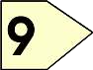
Step 1 Step 2
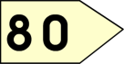
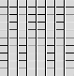
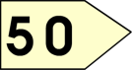
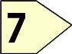

Step 3

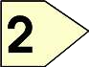
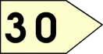
This will be recorded by the children as:
Emphasise that the second (bottom) number is being subtracted from the first (top) number rather than the lesser number from the greater.
80 → 9
- 50 → 7
30 → 2 = 32

Children can also use jottings of the Base 10 materials (as in year 2) to support with their calculation, as in the example below.

80 → 9
- 50 → 7
30 → 2 = 32

From this the children will begin to solve problems which involve exchange. Children need to consider whether there are enough units/ones to remove 6. In this case there are not (Step 1) so they need to exchange a ten into ten ones to make sure that there are enough, as they have been doing in the method for year 2 (Step 2). They should be able to see that the number is just partitioned in a different way, but the amount remains the same (71 = 70 + 1 = 60 + 11).
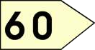
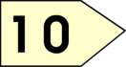
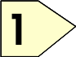
Step 1 Step 2
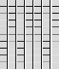
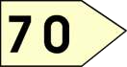
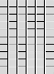
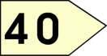
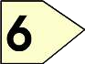

Step 3 Step 4

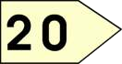
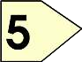
This will be recorded by the children as:

60
70 → ¹1
- 40 → 6
20 → 5 = 25
By the end of year 3, children should also extend this method for three digit numbers.

Y4
End of Year Objective:
Subtract numbers with up to 4 digits and decimals with one decimal place using the formal written method of columnar subtraction where appropriate.

Children will move to year 4 using whichever method they were using as they transitioned from year 3. Some children will continue to use the practical methods seen above.
Step 1 Step 2 (exchanging from tens to units)

700 → 50 → 4
- 200 → 80 → 6
40
700 → 50 → ¹4
- 200 → 80 → 6

Step 3 (exchanging from hundreds to tens) Step 4

600 140
700 → 50 → ¹4
- 200 → 80 → 6

600 140
700 → 50 → ¹4
- 200 → 80 → 6
400 → 60 → 8 = 468

This would be recorded by the children as:

600 140
700 → 50 → ¹4
- 200 → 80 → 6
400 → 60 → 8 = 468

When children are ready, this leads on to the compact method of decomposition:

6 14
4 7 5 ¹4
- 3 2 8 6
1 4 6 8

By the end of year 4, children should be using the written method confidently and with understanding. They will also be subtracting:

- numbers with different numbers of digits, understanding the place value;
- decimals with one decimal place, knowing that the decimal points line up under one another.

Y5
End of Year Objective:
Subtract whole numbers with more than 4 digits and decimals with two decimal places, including formal written methods (columnar subtraction).
Children should continue to use the decomposition method (both formally and practically) to solve calculations such as:

6 6
7 ¹0 7 ¹2
- 3 2 2 6

3 8 4 6
2 13
3 . 4 ¹2
- 1 . 7 6

1 . 6 6

They will also be subtracting:

- numbers with different numbers of digits, understanding the place value;
- decimals with up to two decimal places (with each number having the same number of decimal places), knowing that the decimal points line up under one another.
- amounts of money and measures, including those where they have to initially convert from one unit to another

Y6
End of Year Objective:
Subtract whole numbers and decimals using formal written methods (columnar subtraction).

Children should extend the decomposition method and use it to subtract whole numbers and decimals with any number of digits.

5 13
1
3 6 11
1 1

6 4 3 2
- 4 6 8 1
1 7 5 1
4 1 7 . 2 0
- 3 4 . 7 1
3 8 2 . 4 9

When subtracting decimals with different numbers of decimal places, children should be taught and encouraged to make them the same through identification that 2 tenths is the same as 20 hundredths, therefore,
0.2 is the same value as 0.20.
PLACE HOLDER

They will also be subtracting:

- numbers with different numbers of digits, understanding the place value;
- decimals with up to three decimal places (with mixed numbers of decimal places), knowing that the decimal points line up under one another.
- amounts of money and measures, including those where they have to initially convert from one unit to another.

