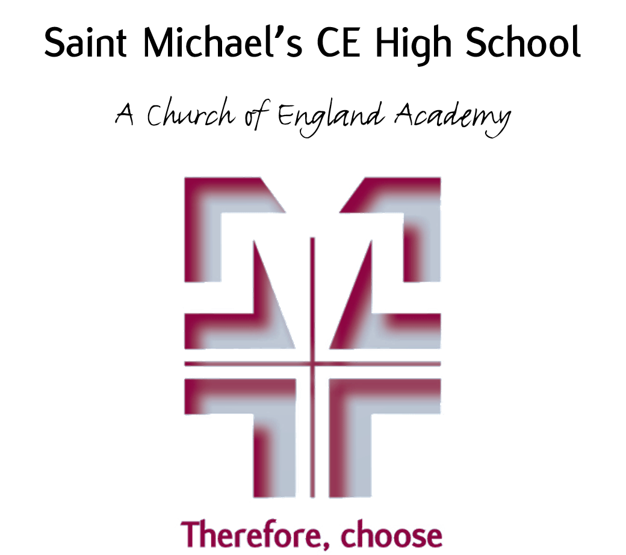

Uniform & Appearance Policy

September 2022

Uniform and Appearance Policy
At St Michael’s we believe that school uniform plays an important part in establishing the ethos and high standards of the school in a number of ways:
- It encourages pupils to identify with the school and nurtures the notion of community
- It protects children from social pressures to dress in a particular way
- It supports discipline and our policy of ‘choose excellent behaviour’
- It instils a sense of pride in the school
- It promotes more effective learning and teaching
The appearance of pupils is also an important factor at St Michael’s in promoting good behaviour and ensuring the health and safety of pupils and staff.
Aims

This policy aims to:

- Set out our approach to requiring a uniform that is of reasonable cost and offers the best value for money for parents and carers
- Explain how we will avoid discrimination in line with our legal duties under the Equality Act 2010
- Clarify our expectations for school uniform

Our school’s legal duties under the Equality Act 2010

The Equality Act 2010 prohibits discrimination against an individual based on the protected characteristics, which include sex, race, religion or belief, and gender reassignment.

To avoid discrimination, St Michael’s will:

- Avoid listing uniform items based on sex, to give all pupils the opportunity to wear the uniform they feel most comfortable in or that most reflects their self-identified gender
- Make sure that our uniform costs the same for all pupils
- Consider adaptations to our policy on the grounds of religion or equality by asking pupils or their parents to get in touch with the child’s Pupil Manager, who can answer questions about the policy and respond to any requests

Limiting the cost of school uniform

Our school has a duty to make sure that the uniform we require is affordable, in line with statutory guidance from the Department for Education on the cost of school uniform.

We understand that items with distinctive characteristics (such as branded items, or items that have to have a school logo or a unique fabric/colour/design) cannot be purchased from a wide range of retailers and that requiring many such items limits parents’ ability to ‘shop around’ for a low price.

We will make sure our uniform:
- Is available at a reasonable cost
- Is of a high quality and provides the best value for money for parents/carers*

We will do this by:
- carefully considering items with distinctive characteristics
- limiting the amount of distinctive characteristics
- consider limiting distinctive characteristic items to low-cost or long-lasting items
- avoid specific requirements for items students could wear on non-school days, such as coats, bags and shoes
- keeping the number of optional branded items to a minimum
- avoiding different uniform requirements for different years and extra-curricular activities
- ensuring that second-hand uniform is available to be acquired at either the school or our uniform suppliers
- consulting with all stakeholders on any proposed significant changes to the uniform policy

* The issue of best value has been demonstrated by:
- Comparing our prices with those of other local schools.
- Ensuring the quality of uniform garments so that they wash well and maintain a good appearance over time. The school’s preferred suppliers provides such items of uniform.
- Reviewing costings annually to maintain good value for money.
- The school will look at offering financial help for families in need.
Uniform and Appearance for a St Michael’s Pupil

Outdoor Clothing

Coats: Plain black coat or fleece with no exterior markings or logo (except for reflectors). Hip length at least. (No denim, suede or leather material)

Scarves: Only plain black. (No football scarves or hats)

Indoor Clothing
Blazers: | Maroon badged blazer as supplied by the school preferred suppliers.
Jumper: | Strongly recommended in colder months. Lower School Years 7 – 9 Maroon ‘V’ neck with school crest. Upper School Years 10 & 11 Black ‘V’ neck with school crest.
Tie: | School crested clip-on tie only. Years 7-9 Maroon. Years 10 & 11 Black.  Please note that when the school year moves forward in July Y9 pupils may choose to wear a black jumper and tie from this date but this is compulsory from the September.
Shirt: | White, traditional style, good quality with stiff collar. Shirts must have top buttons fastened and be tucked in to waistbands at all times.
Skirts: | Regulation badged skirt supplied by the school preferred suppliers. Length of skirt no more than 3 inches from the knee. Skirt waistbands must not be rolled over. Shorts should not be worn under a skirt.
Trousers: | Regulation badged trousers supplied by the school preferred suppliers, with plain black socks.
Tights/socks: | When worn with skirts – black opaque (minimum 40 denier) preferred throughout winter. In summer, white ankle socks or white knee length socks may be worn.  Over the knee socks or trainer socks are not permitted.
Shoes: | Black, traditional style. No boots, trainers or ‘trainer style’, pumps, suede or canvas material. Black laces if lace-ups. Heels no higher than 3”. No logos/colour flashes, coloured tasels/heels. Brands such as Vans, Converse etc. are not permitted. If you are unsure on the suitability of a shoe please feel free to contact school before purchasing or alternatively you can see images of suitable footwear on the school website.
Hair: | This must be of a naturally occurring shade. No shaven heads (no shorter than a number 2 sides and back). No lines cut into the hair or extreme fashion styles. Plain hair bands/slides/bobbles - black only.  Pupils are expected to be clean shaven for school. (Where appropriate we shall be sensitive to the needs of different cultures, races and religions.)
Jewellery: | Must not be worn apart from a wristwatch (No smartwatches).
Make Up: | Make-up is not permitted in Year 7-10. (Discreet use only in Year 11). Fake tan, nail varnish, false nails, cosmetic eyebrows, false eyelashes etc. are not permitted for all year groups. Tattoo’s are not permitted.
Catering Apron: Plain white.

PE all years
- Maroon Shorts (printed initials optional)
- Plain Black joggers (Also used for dance. Leggings can also be used for dance only)
- Maroon Rugby Shirt or Sweatshirt (printed initials optional)
- Maroon PE socks
- Football boots
- Shin Pads
- Maroon Polo (printed initials optional)
- Trainers
- Gum shield

The school will be the final arbiter regarding suitability of dress and appearance.

Where to purchase our uniform

St Michael’s school uniform is stocked at two different suppliers.

JADA Embroidery and Print, 213 Eaves Ln, Chorley PR6 0AG
St Michael’s CE High School – JADA Embroidery & Print Ltd. 01257 271592 (jadauniforms.co.uk)

Nu Uniforms, 83 Market St, Chorley PR7 2SF
Nu:uniforms (nuuniforms.com)

Expectations and Sanctions
The uniform and appearance policy is strictly enforced. Every opportunity will be given for pupils to conform to the uniform policy and rectify any identified issues.
Minor breaches of uniform or appearance will result in an appropriate sanction being applied. This sanction will be increased for persistent offenders and parents/carers will be asked to support their child in meeting the uniform and appearance code.
The school may ask a parent/carer if they are able to bring an item of uniform in so to rectify any breach of the uniform regulations. If this is not possible, the pupils may be required to continue their learning in the Personal Guidance Unit until such time as they conform to the policy.
Schools can refuse to allow a pupil to come into school for failing to wear the uniform or maintain the appearance required by the school. Persistent breach of the uniform regulations could result in a suspension from school.
Governors
The governing body will review this policy and ensure that it:
- Is appropriate for our school
- Is implemented fairly
- Offers uniform that is appropriate, practical and safe for all pupils
- Gives the highest priority to cost and value for money

Updated September 2022

