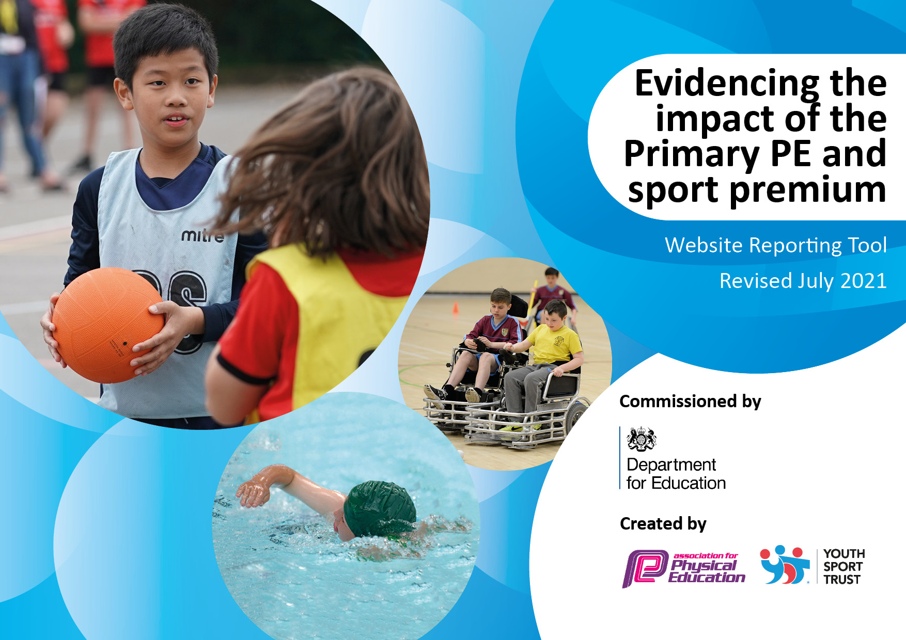
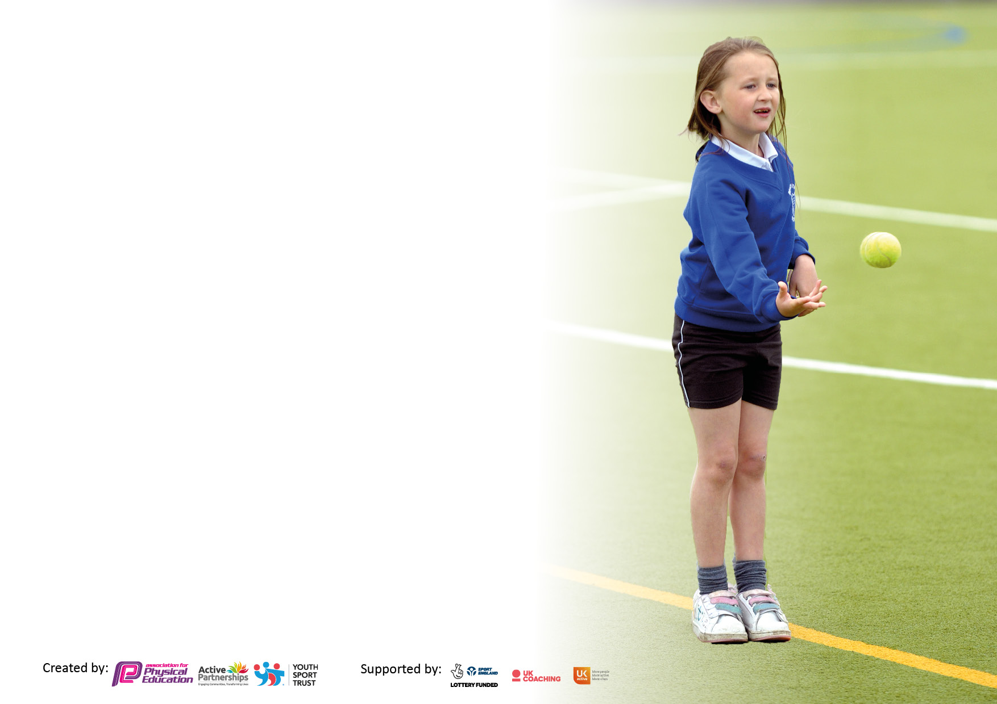

It is important that your grant is used effectively and based on school need. The Education Inspection Framework makes clear there will be a focus on ‘whether leaders and those responsible for governors all understand their respective roles and perform these in a way that enhances the effectiveness of the school’.

Under the Quality of Education Ofsted inspectors consider:
Intent - Curriculum design, coverage and appropriateness
Implementation - Curriculum delivery, Teaching (pedagogy) and Assessment
Impact - Attainment and progress

To assist schools with common transferable language this template has been developed to utilise the same three headings which should make your plans easily transferable between working documents.

Schools must use the funding to make additional and sustainable improvements to the quality of Physical Education, School Sport and Physical Activity (PESSPA) they offer. This means that you should use the Primary PE and sport premium to:

- Develop or add to the PESSPA activities that your school already offer
- Build capacity and capability within the school to ensure that improvements made now will benefit pupils joining the school in future years
- The Primary PE and sport premium should not be used to fund capital spend projects; the school’s budget should fund these.

Pleasevisitgov.ukfortherevisedDfEguidanceincludingthe5keyindicatorsacrosswhichschoolsshoulddemonstrate animprovement.Thisdocumentwillhelpyoutoreviewyourprovisionandtoreportyourspend.DfEencouragesschools to use this template as an effective way of meeting the reporting requirements of the Primary PE and sport premium.

We recommend you start by reflecting on the impact of current provision and reviewing the previous spend.

Schools are required to publish details of how they spend this funding, including any under-spend from 2019/2020, as well as on the impact it has on pupils’ PE and sport participation and attainment. All funding must be spent by 31st July 2022.

We recommend regularly updating the table and publishing it on your website throughout the year. This evidences your ongoing self-evaluation of how you are using the funding to secure maximum, sustainable impact. Final copy must be posted on your website by the end of the academic year and no later than the 31st July 2021. To see an example of how to complete the table please click HERE.

Details with regard to funding
Please complete the table below.

Total amount carried over from 2019/20 | £4195.25
Total amount allocated for 2020/21 | £16,574.75
How much (if any) do you intend to carry over from this total fund into 2021/22? | £5479.44
Total amount allocated for 2021/22 | £17,682.56
Total amount of funding for 2021/22. To be spent and reported on by 31st July 2022. | £23162.00
Swimming Data
Please report on your Swimming Data below.

Meeting national curriculum requirements for swimming and water safety.  N.B. Complete this section to your best ability. For example you might have practised safe self-rescue techniques on dry land which you can then transfer to the pool when school swimming restarts.  Due to exceptional circumstances priority should be given to ensuring that pupils can perform safe self rescue even if they do not fully meet the first two requirements of the NC programme of study | 100%
What percentage of your current Year 6 cohort swim competently, confidently and proficiently over a distance of at least 25 metres?  N.B. Even though your pupils may swim in another year please report on their attainment on leaving primary school at the end of the summer term 2020.  Please see note above | 78%
What percentage of your current Year 6 cohort use a range of strokes effectively [for example, front crawl, backstroke and breaststroke]?  Please see note above | 100%
What percentage of your current Year 6 cohort perform safe self-rescue in different water-based situations? | 100%
Schools can choose to use the Primary PE and sport premium to provide additional provision for swimming but this must be for activity over and above the national curriculum requirements. Have you used it in this way? | Yes/No

Action Plan and Budget Tracking
Capture your intended annual spend against the 5 key indicators. Clarify the success criteria and evidence of impact that you intend to measure to evaluate for pupils today and for the future.

Academic Year: 2021/22 | Total fund allocated: £17,682.56 | Date Updated: Sep 2021
Key indicator 1: The engagement of all pupils in regular physical activity – Chief Medical Officers guidelines recommend that primary school pupils undertake at least 30 minutes of physical activity a day in school |  |  |  | Percentage of total allocation:
 |  |  |  | 17 %
Intent | Implementation |  | Impact
Your school focus should be clear what you want the pupils to know and be able to do and about  what they need to learn and to  consolidate through practice: | Make sure your actions to achieve are linked to your intentions: | Funding allocated: | Evidence of impact: what do pupils now know and what can they now do? What has changed?: | Sustainability and suggested next steps:
To continue to encourage daily mile across all classes to support children achieving a healthy and active lifestyle  To develop the role of Sports Leaders within school life to help encourage more active lifestyle for all children. | Consider new initiatives that can keep the active sessions fresh for children and not a chore. Develop class challenges and achievements based on amount of distance run/walked.  Renew playtime resources in Autumn term to ensure children stay engaged with playtime games.  New outdoor shed which can be accessible by children and keeps resources better protected for longevity.  Develop the new role of Sports Leaders to impact on children’s engagement levels across school:  - Help set up ad lead Y5/6 playtime clubs  - Meet with PE Lead to discuss ideas to improve sports and active lifestyles at Samlesbury  Budget to be used to set up Y5 play leaders – Active school program  Use children’s wellbeing questionnaire as a basis to support child voice for active lifestyle in school. | £300 for renewed resources  £500 for new shed to keep outdoor resources in  £500 for storage boxes and hooks in the store cupboard  £75 Young Leaders course  Total = £1375
Key indicator 2: The profile of PESSPA (Physical Education, School Sports & Physical Activity) being raised across the school as a tool for whole school improvement |  |  |  | Percentage of total allocation:
 |  |  |  | 29%
Intent | Implementation |  | Impact
Your school focus should be clear what you want the pupils to know and be able to do and about  what they need to learn and to  consolidate through practice: | Make sure your actions to achieve are linked to your intentions: | Funding allocated: | Evidence of impact: what do pupils now know and what can they now do? What has changed?: | Sustainability and suggested next steps:
To ensure that all staff are trained up on using the PE APP, even if not directly teaching PE.  To develop whole school involvement in various activities that offer further skill alongside their curriculum sessions.  .  To ensure all sports have appropriate resources to have greater impact on children’s progress across the curriculum | Consider other APPs which maybe purchased to support PE sessions this further.  All staff to access assessment data, monitor class progress and add experiences from extra-curricular activities to the assessments to generate more detailed picture of each child’s achievements and progress.  Develop self/peer assessment whilst using the APP during PE sessions to aid children with greater understanding of their progress and that of other peers.  Set up Taekwondo taster session with the aim to book in an after school club for whole year.  Offer an eclectic choice of opportunities to create interest in active lifestyles for all pupils (within the limits of small school settings and budgets)  Use Year 5 PE leads and Sports Leads to set up sports clubs during the day. “Let’s Get Active” Tuesday Clubs run by Year 5  Offer variety in sports club. Possible link with Taekwondo club/golf/dance/fitness/bike ability/tots on tyres/scootability  Take part I Lancashire’s “Dance from the Heart” roadshow. Y5/6 pupils to lead dancing sessions to teach whole school dance to e performed in Summer 2.  Due to changes in playground, renew markings to match sports taught – smaller netball court, tennis squares  Audit all sports resources and order appropriate sets to ensure that whole classes can complete lessons. Gymnastics tables, basket ball hoops, tennis rackets, athletics resources etc. | £855 (3 year subscription)  £50 for other APPs  (£4 per child per session – paid by parents)  Active Travel Program £750  Dance From the Heart – Leadership Training £75  Cost of playground markings tbc (around £3000)  £2000  Total = £6730

Key indicator 3: Increased confidence, knowledge and skills of all staff in teaching PE and sport |  |  |  | Percentage of total allocation:
 |  |  |  | 24%
Intent | Implementation |  | Impact
Your school focus should be clear | Make sure your actions to | Funding | Evidence of impact: what do | Sustainability and suggested
what you want the pupils to know | achieve are linked to your | allocated: | pupils now know and what | next steps:
and be able to do and about | intentions: |  | can they now do? What has
what they need to learn and to |  |  | changed?:
consolidate through practice:
To ensure that high quality PE is taught across all key stages to support the development of PE skills and any catchup needed due to gaps in learning from lockdowns. | PE lead to continue cover KS2 PE in a whole afternoon PE session including swimming opportunity for all KS2 children. PE lead to support KS1 and EYFS teaching.  PE lead to attend cluster meetings to stay up-to-date and current.  Arranged CPD staff training:  Wellbeing of Staff – Whole School  Holistic PE – PE Lead  PE Topic (Potentially gymnastics - TBC) – Staff who require | Cost for PE lead to run afternoons: £5500  £75  £10  £75  Total: £5660
Key indicator 4: Broader experience of a range of sports and activities offered to all pupils |  |  |  | Percentage of total allocation:
 |  |  |  | 17%
Intent | Implementation |  | Impact
Your school focus should be clear | Make sure your actions to | Funding | Evidence of impact: what do | Sustainability and suggested
what you want the pupils to know | achieve are linked to your | allocated: | pupils now know and what | next steps:
and be able to do and about | intentions: |  | can they now do? What has
what they need to learn and to |  |  | changed?:
consolidate through practice:
To explore various approaches to sports ad active lifestyle to give pupils a clear idea of ways they can be more involved.  To increase the offer of swimming to whole KS2 children to support the acquisition of life saving skills and increase percentage of children becoming competent swimmers.  To develop Forest School provision across all key stages.  To use PE funding to support pupil wellbeing | Visit from GB Paralympian (Sports For School) to talk with whole school about being a Paralympian and then complete a sponsored event with children.  Take part in Whole school festivals (South Ribble School Games):  Paralympics Fesitval  Athletics Festival  Full term swimming for Year 6  Full term swimming for Year 5  Half term swimming for Year 4  Half term swimming for Year 3  Maintain current EYFS/KS1 Forest school provision and set up regular Forest schools sessions for KS2 children (Initially KS2)  Wellbeing Wednesday clubs to roll out across year groups over the year. Children to take part in various activities and practises to support their own wellbeing (South Ribble School Games link) | Sponsored event  £195  £195  £2250 swimming sessions with Nick’s Swim School  Travel costs £1440  Free  Total = £4080

Key indicator 5: Increased participation in competitive sport |  |  |  | Percentage of total allocation:
 |  |  |  | 2%
Intent | Implementation |  | Impact
Your school focus should be clear | Make sure your actions to | Funding | Evidence of impact: what do | Sustainability and suggested
what you want the pupils to know | achieve are linked to your | allocated: | pupils now know and what | next steps:
and be able to do and about | intentions: |  | can they now do? What has
what they need to learn and to |  |  | changed?:
consolidate through practice:
To increase involvement in cluster competitions to support children’s application of taught skills and build appropriate sportsmanship | Through South Ribble School Games partnership, compete in set cluster competitions alongside other schools. 6 in total across the year. | £75 x 6 = £450  Total = £450

Signed off by
Head Teacher: | Lucy Sutton
Date: | 5th September 2021
Subject Leader: | L Greenbank
Date: | 5th September 2021
Governor: | SEC Committee
Date: | 29th September 2021

