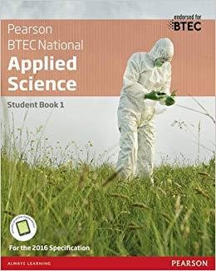
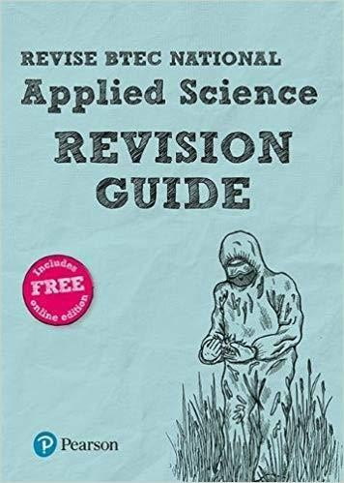

Welcome to BTEC Applied Science. The purpose of this summer mailing is to prepare you to start your study of BTEC Level 3 National Diploma in Applied Science at The Samworth Church Academy in September 2020.
As you make the transition from GCSE to Level 3 studies you may find that you are expected to do much more independent reading, revision and research outside of lessons. This task will help you to make a start.

There are THREE tasks for you to complete
Task 1:
Report writing task

Your Challenge
The BTEC Level 3 Applied Science course includes units that are assignment-based. In preparing these assignments, you will need to write/produce a number of reports. To do this, you will need to successfully research, find and extract relevant information from a number of sources both internet-sourced and non-internet sourced (e.g. books, journals or personal contacts for example).

You will need to structure and summarise this information and produce a coherent and logical
report avoiding any plagiarism or copy and paste!
Please visit & go through the following websites for guidance on summarising and avoiding plagiarism:
http://www.buowl.boun.edu.tr/students/avoidingplagiarism.htm https://qualifications.pearson.com/content/dam/pdf/Support/Quality%20Assurance/Plagiarism- Factsheet.pdf

Prepare a 250-word written report based on one of the following questions. You will carry out your own research and then hand your work in during the first lesson back in September. Your work can be presented in any format of your choice. Remember, you are demonstrating your ability to work independently and produce work to the standard required at post 16. Choose from:

Biology:
- The history of the microscope
- The differences between light and electron microscopes

Physics:
- The application of fibre optics in medicine (to include endoscopes).
- The application of fibre optics in communication (to include analogue-to-digital conversion and broadband).

TIPS:
A good strategy in summarising a text you have read is:
  - Read the text several times but do not make any notes. During your first reading you may be tempted to take extensive notes, but later you may find out that you do not need them. Therefore, read without making notes but interacting with the author. That is, familiarise yourself with the text, the author, the main ideas and arguments, etc.

  - List the key ideas and supporting arguments

  - Rank them in order of importance before writing them up

Please include a word count at the end (to show how many words are in your report). The word count should be within 10% of the recommended 250 words.

Remember to list the websites that you have used in preparing your report. Microsoft Word has a ‘references’ menu. In this, is a drop down menu for ‘citations and bibliography’ – this is a good way to insert reference citations in the text and produces a bibliography that can be inserted at the end of the report – give it a go!

Task 2:

Exam practice questions

Chemistry questions:

Q1 – Atomic structure
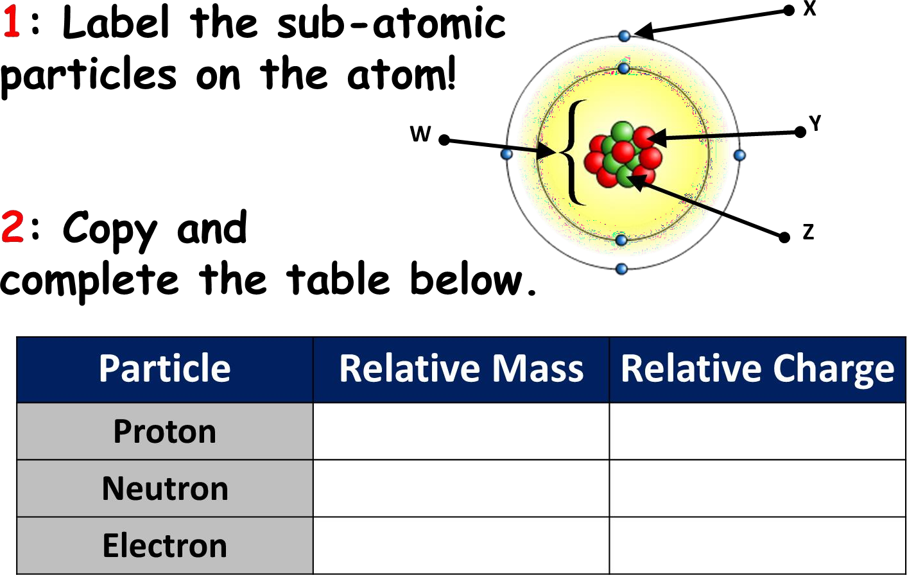

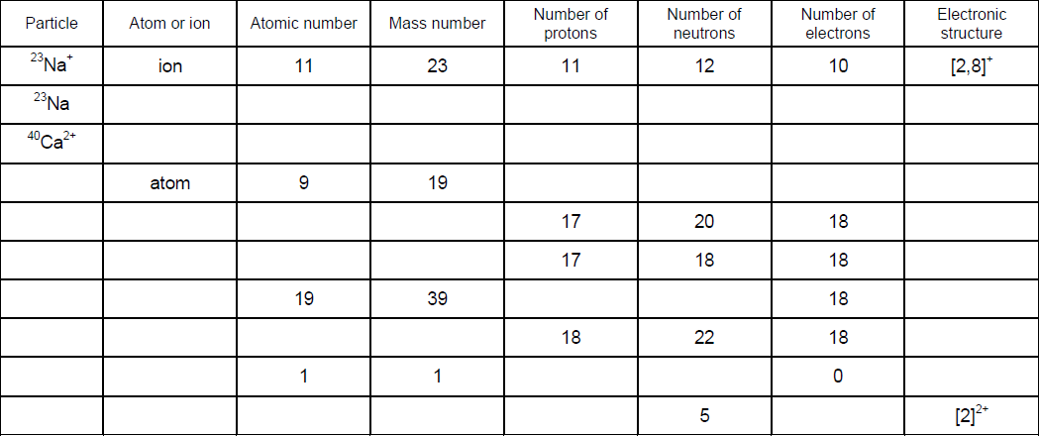

Atoms are the basic building blocks of matter. They are not the smallest of particles, and within Chemistry, we are interested in the sub-atomic particles especially the electron.

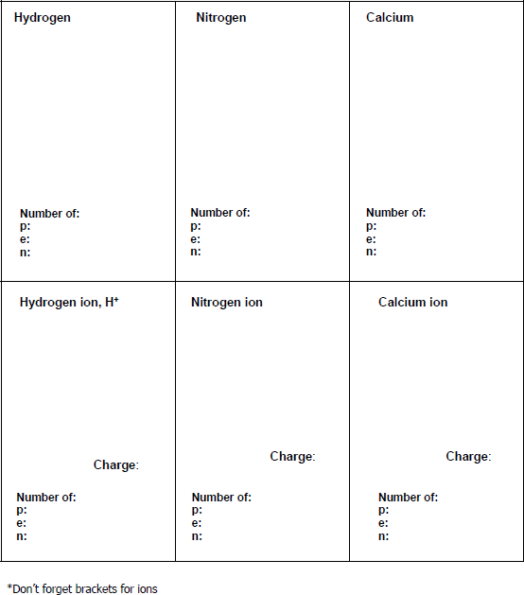
Using a periodic table, draw the electronic configuration, as well as identifying how many sub-atomic particles there are for the following atoms and its corresponding ions:

Q2 – Bonding and Dot cross diagrams

You would have covered ionic and covalent bonding in your GCSE. Using your knowledge:
- Draw the dot cross diagrams for the following compounds, showing only outer electrons.
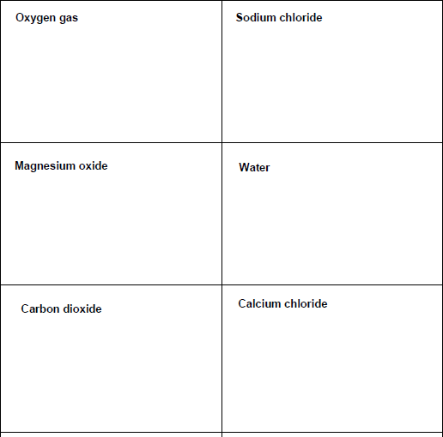
- State the type of bonding involved (ionic, covalent, metallic)

Q3 - Rearranging Formulae
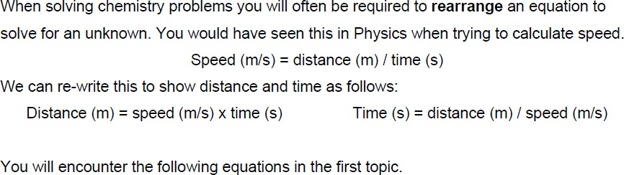
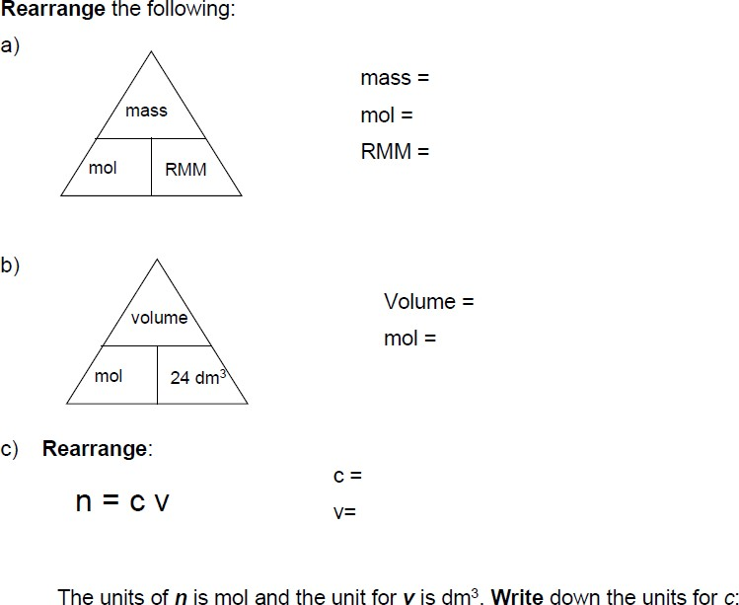

Q4 – Balancing equations
Fill in the boxes with the numbers you need to balance the equation. Note: Some boxes can be left blank.

H₂ + O₂ → H₂O
H₂ + N₂ → NH₃
Cr + O₂ → Cr₂O₃
Al₂O₃ → Al + O₂
P₄ + O₂ → P₂O₅

Q5 - Relative formula mass

Use a Periodic Table to work out the relative formula mass of the following compounds:

e.g. NaOH : Na + O + H = 23 + 16 + 1 = 40

Biology questions:
Q1 - Cell Structure
Watch the video from the link below
Video: https://www.youtube.com/watch?v=cj8dDTHGJBY

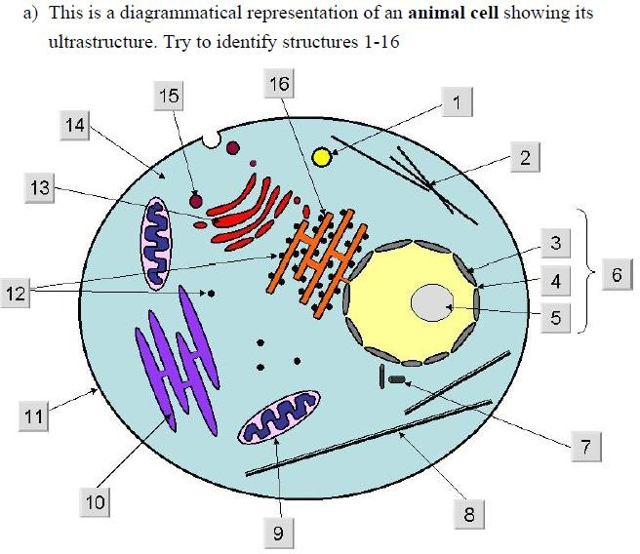

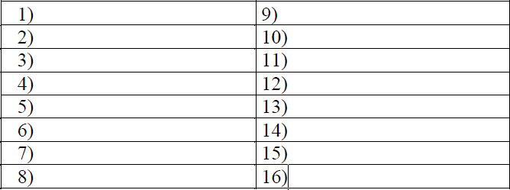

b) This is a diagrammatical representation of a plant cell showing its ultrastructure. Try to identify strictures A-I

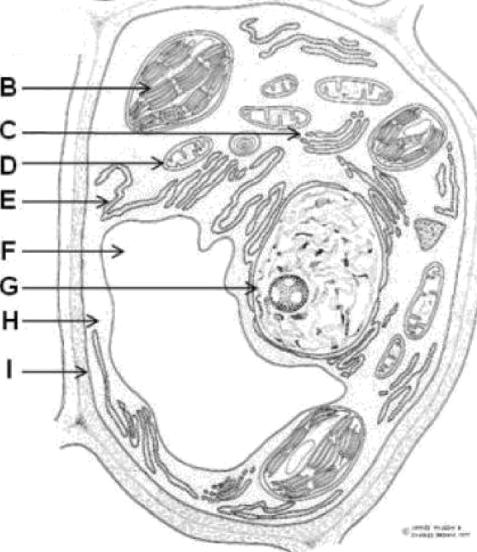
A
B
C
D
E
F
G
H
I

Q2 – Organelle structure and function
Match the cell structure with its function in the table below. Record your answers in the table below.

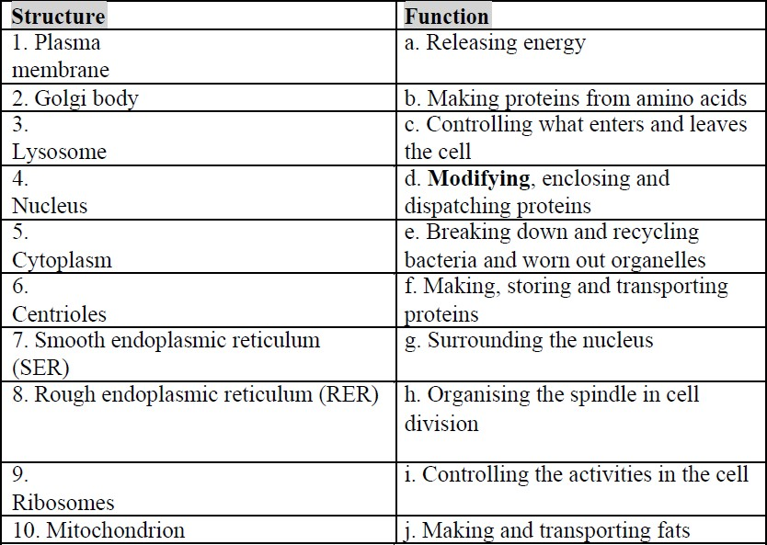

Answers: Write the correct letter (function) next to the corresponding number (structure)
1 | 2 | 3 | 4 | 5
6 | 7 | 8 | 9 | 10

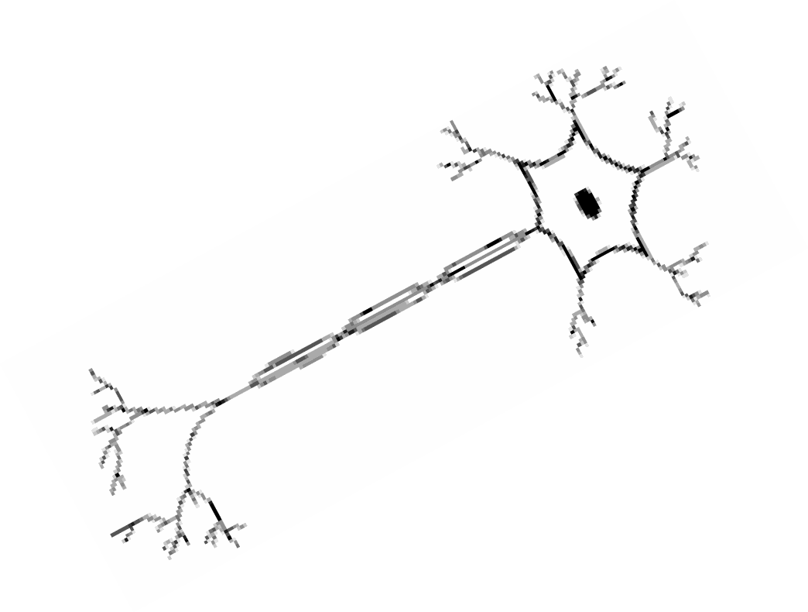
Q3 – Specialised cells – complete the table about the cells below:

Picture | Plant/Animal? | Function (it’s job) & features
Red blood cell |  | Contains haemoglobin to carry oxygen to the cells.
Sperm cell

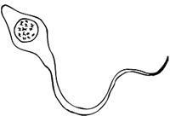
Egg cell
Nerve cell
Epithelial cell
Root hair cell

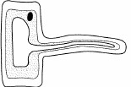

Palisade cell  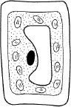 |  | These cells are packed with…
White blood cell

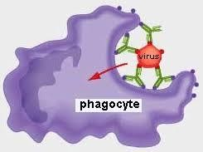

Physics questions:

Q1 – Wave features
A transverse wave has five key terms you need to know and be able to label on a diagram.
  - Wavelength – This is the distance of one complete wave.
  - Wave direction – This is the direction the wave is travelling.
  - Peak – The top of the wave.
  - Trough – The lowest part of the wave.
  - Amplitude – The height of the peak, or the depth of the trough from the middle.

Task: Label the main features of a wave below on the diagram.

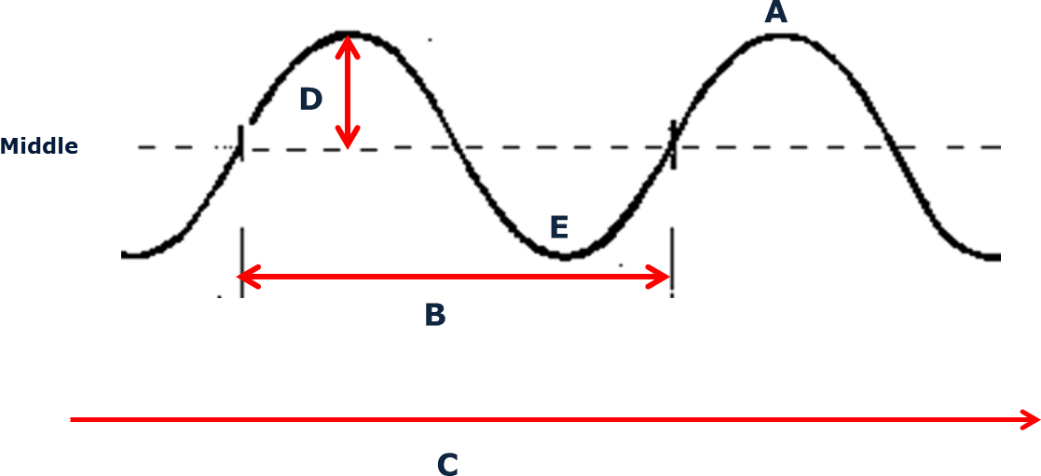

Q2 – Types of Waves
Waves may be longitudinal or transverse.

Describe the differences between longitudinal waves and transverse waves.

(3)
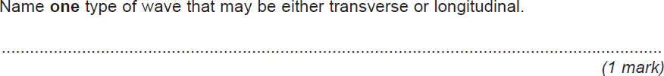
Q3 – The Wave equation
The wave equation is:
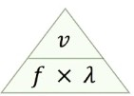
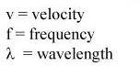

Rearrange the following:

v = f =
ג =

What are the units for each symbol?

Task 3:

Explain how a diffraction grating produces an emission spectrum. You can use a labelled diagram to help your explanation

Please bring the work with you to your first lesson in Applied Science!
AND remember to bring pen, pencil, ruler, eraser, calculator and paper too!

See you there…..
☺

