Task 2
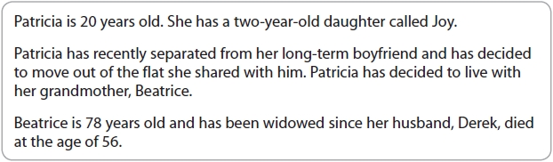
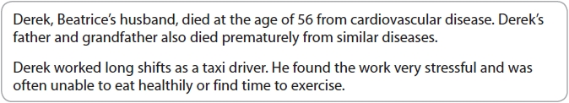
Describe two genetic diseases that may impact on an individual's development.
1 ...........................................................................................................................................
.............................................................................................................................................
.............................................................................................................................................
.............................................................................................................................................
.............................................................................................................................................
.............................................................................................................................................
2 ...........................................................................................................................................
.............................................................................................................................................
.............................................................................................................................................
.............................................................................................................................................
.............................................................................................................................................
.............................................................................................................................................

(Total for question = 4 marks)

3

Explain the effects of foetal alcohol syndrome on Nita's intellectual development.
(Total for question = 6 marks)

4
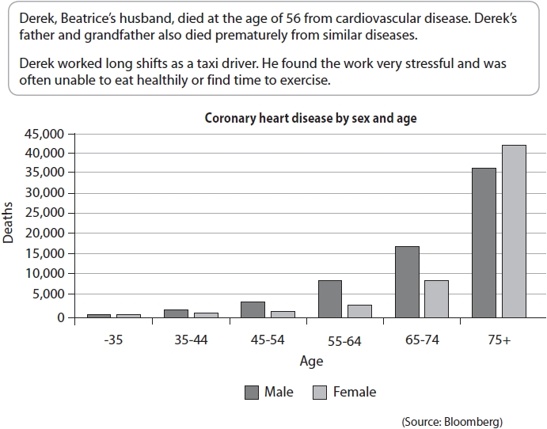
Using the data from the graph, identify:
(i) at which age do more women than men die from heart disease?
(ii) at which age do the least number of men and women die from heart disease?
(i) ........................................................................................................................................
(ii) ........................................................................................................................................

(Total for question = 2 marks)

5
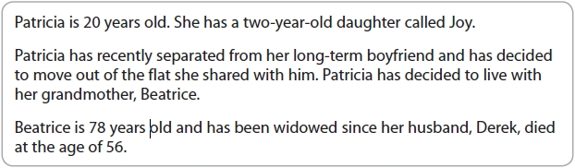
To what extent do genetic factors determine health and wellbeing?

(Total for question = 10 marks)

