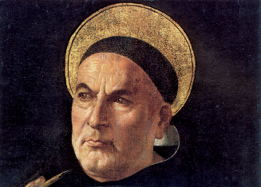
Introduction to
Ethics

One third of the A Level RS course focuses on Ethics. The word ethics comes from the Greek ’ethike’, which means habit or behaviour. Many situations in life will have pros and cons, and sometimes it’s not easy to decide which route is the better outcome. The study of ethics is the consideration of guiding principles that direct our actions. You will need to understand the arguments and also critically evaluate how convincing they are as proofs a situation right or wrong. Some ethical theories are based on religion (e.g. Natural Law) and some are entirely secular (e.g. Utilitarianism)

The following activities will give you an understanding of the ethical issues surrounding ‘euthanasia.’ You will have to decide if in the following situations, euthanasia should be accepted.

As always, feel free to complete additional research. You can present your answers however you wish: written answers, pictures / storyboard, PowerPoint…

Activity 1:

Read the information on the pages that follow about what euthanasia is, what the different types are and what the law says in the UK about euthanasia. Use the information to complete the following tasks:-

A. Explain what euthanasia is
B. Explain what the UK law says about euthanasia
C. Explain the different types of euthanasia
D. Explain and evaluate the arguments for making euthanasia legal rather than keeping it illegal
Stretch: Include religious scripture that may support different points of view
Activity 2:

Read the information on the pages that follow about different case studies concerning euthanasia that have been in the news in recent years.

A. For each case study, make a list / spider diagram of different examples and reasons why euthanasia would be acceptable in this case and reasons why euthanasia would not be acceptable. Try and do this without using your own thoughts and emotions—try and look at each case study from a neutral perspective.

B. Explain why you think the following groups should or should not have the right to decide when people die:-
I) Law makers (e.g. Parliament and the Law courts)
II) Society (e.g. voters, pressure groups)
III) Parents/ Families
IV) Doctors

Stretch: Include religious scripture that may support different points of view.

Voluntary Euthanasia and the UK Law
This is the term used to refer to a painless and dignified death. It is commonly held to refer to the practice of assisting a patient who is suffering from some terminal and painful disease.
- The aim is to ensure that the patient is given the opportunity to take some control of their final days, and to allow them to die in as pain-free dignified managed a way as possible.
euthanasia’ is derived from ‘eu’ - good and ‘thanatos’ - death
A popular expression would be ‘mercy killing’.

The legal position in the UK
- Suicide is not illegal in the UK (this was made law in the Suicide Act of 1961).
- Assisting suicide is illegal and is a criminal offence.
- Any person who carries out actions that are deliberately intended to bring about the death of a persons is culpable under the Homicide Act of 1957. Where it can be shown that the actions were carried out for compassionate reasons, the charge could be reduced to manslaughter on the grounds of diminished responsibility.
- Anyone found guilty of ‘aiding, abetting, counselling or procuring’ the suicide of another person can be imprisoned for up to 14 years. However, in practice, where a person has assisted suicide for compassionate reasons, a suspended sentence has often been handed down.

Voluntary euthanasia
This is the term used for euthanasia at the request of the patient concerned. The patient is able to give full informed consent.
Usually the patient is suffering from a terminal and debilitating disease. Death is preferable to continued but painful life.
The pain being experience can also be the pain felt by close friends and relatives who have to watch the patient die.
Euthanasia is therefore based on anticipated results. The decision to seek euthanasia is based on the anticipated benefits for the patient and for the relatives.
It is this form of euthanasia that is the popular concept held in debates and in the public perception of euthanasia.
The principle of voluntary euthanasia is usually rooted in the idea that a human being has the right to die in dignity and free from pain. Patients who seek euthanasia as a solution to their condition suffer from a wide variety of diseases, including multiple sclerosis, cancer or some other disease that leaves them lucid (i.e. capable of rational thought) but in very great physical discomfort.
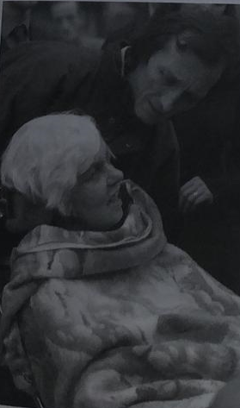
Diane Pretty (d. 11 May 2002) – a motor neurone disease sufferer who wanted to end her life with dignity – see BBC News article below.

Euthanasia Definitions
Non-voluntary euthanasia
- When a patient is unable to request euthanasia, their relatives, friends or doctor may seek to end their life – usually because the patient is in considerable suffering or is in PVS (permanent vegetative state).
- In the case of PVS there have been considerable legal and ethical difficulties. A person can be kept alive on a respirator indefinitely, despite considerable brain damage. In such cases, it may be that the patient regains consciousness (eventually – some textbooks cite cases of patients who exist in such a state for over 20 years before reviving!), or it may be that they do not. The patient’s relatives presumably consider this condition to be undignified. There is also considerable suffering on the part of the relatives, who have to maintain some kind of vigil at the bedside – their relative is to all intents and purposes dead, but they cannot begin to grieve.

In such cases, death is often defined as the cessation of certain fundamental brain functions:
Whole brain death  This is the definition of death based on the entire brain ceasing to function. | Upper brain death  This is the absence of consciousness, thought and emotion – the qualities usually associated with personhood. | Brain stem death  The brain stem is the part of the brain that controls physiological and anatomical function. Death is therefore the cessation of function that part of the brain, the person ceases to be the person that they were.

Involuntary euthanasia
- This is the term used when someone is killed in order to prevent their further suffering, but their consent is not sought (even though they are capable of expressing their opinion).
- It may be that they have expressed an opinion, but it is judged to be in the patient’s best interest that their life is ended in a humane way.
- The people who carry out the actions that end the patient’s life have motives associated with preventing unnecessary suffering.
The difference between involuntary euthanasia and murder would appear to be a matter of motive alone!

Active euthanasia
- Something ‘positive’ is done to bring about the end of a person’s life – popularly referred to as a ‘mercy killing’.
- This could be the injection of a drug, or the administration of sleeping pills or a pillow.

Passive euthanasia
- Treatment is withdrawn or not administered in the first place – thereby bringing about the death of the patient. This would include turning off a life-support machine.

Suicide
In the United Kingdom, there is no law that deals directly with voluntary euthanasia. Cases where a person helped someone to die are prosecuted either under the law dealing with murder, or under the law on suicide.

Murder
The Homicide Act 1957 states that murder is punishable with life imprisonment. However, the court can reduce this punishment for compassionate reasons. The sentence can be reduced, or the charged reduced from murder to manslaughter through diminished responsibility.
Diminished responsibility
s.2 (1): Where a person kills or is party to the killing of another, he shall not be convicted of murder if he was suffering from such abnormality of mind … as substantially to impair his mental responsibility for acts and omissions in doing or being party to the killing.
s.2 (3): A person who but for this section would be liable, whether as principal or as accessory, to be convicted of murder shall be liable instead to be convicted of manslaughter.

Suicide pacts
s.4 (1): It shall be manslaughter and shall not be murder for a person acting in pursuance of a suicide pact between him and another to kill the other or to be a party to the other being killed by a third party.
This means that, while it is not a criminal offence for a person to commit suicide, it is a criminal offence either to assist in a suicide, or to provide the means for a person to commit suicide.

Ethics and euthanasia
Euthanasia is usually seen as a utilitarian act – an action carried out on the basis of perceived outcomes. However, it may also be regarded as a response to suffering and terminal illness embedded in the principles of compassion – in this way it may be justified under the principles of situation ethics.
However, the action that brings about the end of a person’s life would appear to be directly against the Biblical principle ‘You shall not kill’. This verse is variously translated ‘kill’ or ‘murder’ – the debate hinges on this!
The practice of euthanasia radically changes the relationship between doctor and patient.
The Roman Catholic view was summed up by Pope John Paul II in Evangelium Vitae. In it, he states clearly that euthanasia is a violation of the law of God. Life is an extraordinary gift from God.
On a practical (and perhaps cynical) level, there are concerns about euthanasia, particularly over the possibility of unscrupulous relatives seeking the early demise of a rich aunt by arguing for mercy killing – when we say ‘put her out of her misery’, do we really mean ‘put her out of her misery’?
Emotive arguments against euthanasia have included references to the Nazi’s attempt to ‘deal’ with a variety of groups of people in pre-war Germany.
From society’s point of view, euthanasia poses awkward questions regarding the value of individual persons – is human dignity based solely on a person’s usefulness to society?

Ethical theories and euthanasia
A situationist might argue that ‘rules’ about the sanctity of life should not apply. The most important consideration is the suffering of the patient. Situation ethics argues that the ‘correct’ response is the most compassionate.
However, deontological arguments, such as the categorical imperative, take the position that euthanasia could never be a universalisable principle. Killing can never be right, and it can certainly never be made into law applicable to everyone.

Christianity and euthanasia
In Augustine of Hippo’s The City of God, Chapter 20 is titled ‘That Christians Have no Authority for Committing Suicide in Any Circumstances Whatever’.
Thomas Aquinas wrote:
- Everything naturally loves itself – suicide is contrary to this.
- Suicide injures the community.
- Life is God’s gift to Man – only God has the right to take this life away.
Aquinas, T. Summa Theologica, 1271, part II, Q64, A5
Rowan Williams (Archbishop of Canterbury) argued that assisted suicide would be wrong because of the sin it brought on the assister.
The Roman Catholic Catechism (a book stating Roman Catholic beliefs) is absolutely opposed to euthanasia except where it is the ‘withdrawal of burdensome, dangerous, extraordinary or disproportionate to the expected outcome’.
http://www.vatican.va/archive/catechism/p3s2c2a5.htm#brief

BBC News

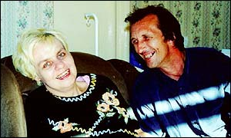
Sunday, 12 May, 2002, 22:38 GMT 23:38 UK Diane Pretty dies

“Diane had to go through the one thing she had foreseen and was afraid of - and there was nothing I could do to help” – Brian Pretty
Diane Pretty's husband Brian was at her bedside A terminally ill British woman who lost a legal battle to allow her husband to help her commit suicide has died, her family have said.
Diane Pretty, who was in the advanced stages of motor neurone disease, died at a hospice near her home on Saturday, aged 43. The mother-of-two had begun experiencing breathing difficulties 10 days ago, three days after she lost her right-to-die court challenge in the European Court of Human Rights. Her husband Brian said "I was with Diane most of the day and was about to come home when I was stopped and told it was time. "And then for Diane it was over, free at last." He was "very proud" of her, Mr Pretty added. His wife always said she wanted her husband to help her commit suicide because she feared the choking and asphyxia often caused by her disease.
'Staff wonderful'
Mr Pretty was at his wife's bedside when she died. In a statement issued on Sunday by the Voluntary Euthanasia Society (VES), which supported the couple in their legal fight, he said she had slipped into a coma after suffering breathing difficulties. "On Thursday 2 May, Diane asked me to call the doctor as she was having trouble with her breathing," he said. "She had no chest infection and her airways were clear. "The next day she went into the hospice and started having breathing problems again. The doctors and nurses managed to get her stable for a few days but she was still in pain. "The staff were wonderful at their job and there was always someone there with her.
Historic ruling
"They had trouble getting her comfortable and pain-free until Thursday evening, after which she started to slip into a coma-like state and eventually died. "Diane had to go through the one thing she had foreseen and was afraid of - and there was nothing I could do to help." In an historic ruling last month, European judges dismissed Mrs Pretty's claim that the British courts were contravening her human rights by refusing to allow her husband to help her commit suicide. The ruling marked the end of the legal road for Mrs Pretty, who criticised the decision. After it was announced, she told a news conference in London: "The law has taken all my rights away." After Mrs Pretty's death on Sunday, Dr Ryszard Bietzk, head of medical services at the Pasque Hospice, Luton, where Mrs Pretty was cared for, said her death was "perfectly normal, natural and peaceful". George Levvy, chief executive of the Motor Neurone Disease Association, said: "Diane showed great courage and determination, both in her battle against motor neurone disease and in her campaign through the courts. "Her story has highlighted the devastating nature of MND and the need for people with the disease to have the best in palliative and terminal care." But campaigners who had fought to block her case stood by their decision. Rachel Hurst, director of Disability Awareness in Action, said it would be "very wrong for justice to say in certain circumstances people can die". "It would be a slippery slope and many people who did not want to die could be affected," she said.

BBC News
Tony Bland 1992: Hillsborough Victim allowed to die
Doctors treating Hillsborough victim Tony Bland can disconnect feeding tubes keeping him alive, a judge at the High Court in London has ruled. The president of the Family Division, Sir Stephen Brown, said there was no "reasonable possibility" that after three years Mr Bland would emerge from a coma known as a "persistent vegetative state" or PVS. Mr Bland's parents, Allan and Barbara, supported the doctors' court action and said they were "relieved" at the ruling. Tony Bland, 22, suffered severe brain damage when he and hundreds of other football supporters were crushed in an overcrowded stand at Hillsborough stadium in April 1989. Ninety-five fans died in the disaster.
In the High Court Mr Bland's doctors at Airedale General Hospital, near Keighley in Yorkshire and other experts in the field said he could survive for up to five years but he would never recover. If food were withdrawn he would die within days. Sir Stephen ruled, for the first time in an English court, that artificial feeding through a tube is medical treatment and that to discontinue treatment would be in accordance with good medical practice.
The true cause of Mr Bland's death would be the Hillsborough disaster, Sir Stephen added. But the lawyer appointed by the Official Solicitor to act on Mr Bland's behalf argued that to withdraw food from him would be tantamount to murder and said he would be appealing against the decision. Doctors have agreed to continue feeding Mr Bland until after the appeal is heard on 30 November. A spokesman for an anti-euthanasia group, Keith Davies, also announced its intention to contest the ruling. Mr Davies from Life said: "We believe this decision is unsafe and unsatisfactory and we will be using every legal, legitimate and democratic means to oppose it."
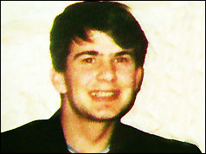
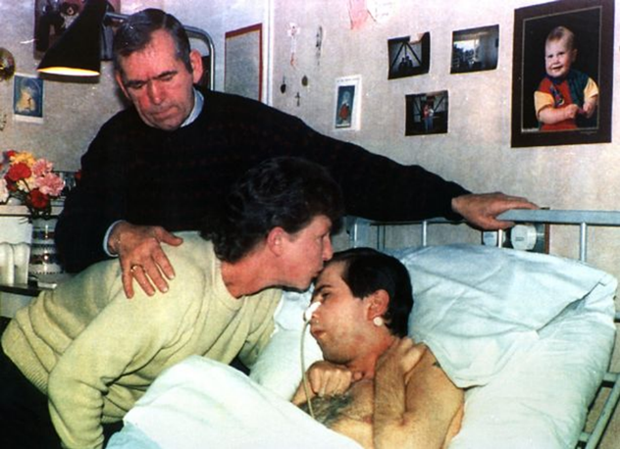

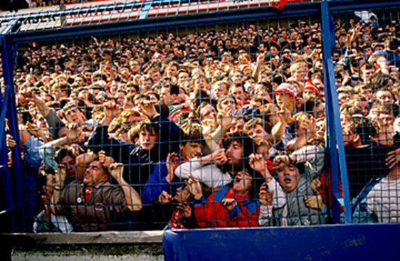
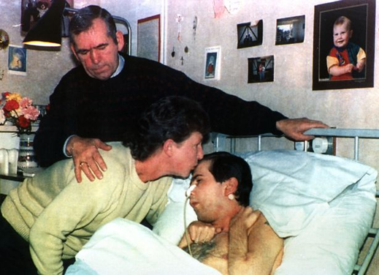

Court Case
Airedale NHS Trust vs Tony Bland
The tragedy
On the 15th of April 1989 Liverpool was playing Nottingham Forest for an FA Cup semi-final at Sheffield Wednesday's Hillsborough football ground. Traffic delays had led to many Liverpool fans arriving late and in the moments prior to kick off there were several thousand fans outside the turnstiles. As a bottleneck developed outside the ground, police, fearing a crush, opened a set of gates leading in to a narrow tunnel at the rear of the terrace. Fans streamed down the tunnel into the already crowded central section of the terrace. At the front of the terrace fans were pushed and crushed against steel fencing installed to prevent hooliganism. 96 people died as a result of the crush at Hillsborough with 766 injured.
Tony’s case – a Persistent Vegetative State
Tony Bland, an 18 year old Liverpool supporter, suffered crushed ribs and two punctured lungs. This interrupted the supply of oxygen to his brain which caused catastrophic and irreversible damage, and left him in a Persistent Vegetative State. He could not see, hear or feel anything. However, the brain stem, which controls the reflexive functions of the body like heartbeat, breathing and digestion, continued to operate. In the eyes of the medical world and of the law a person is not clinically dead so long as the brain stem is still functioning. In order to keep Tony Bland alive in his present condition, he had to be fed with a tube. All medical opinion agreed that Tony Bland would never recover from his present condition, but that he would continue to live for many years as long as he was provided with medical treatment. The doctors in charge of Tony Bland formed the view, which was supported by his parents, that no useful purpose was to be served by continuing that medical care. They decided that it was appropriate to stop the artificial feeding and other measures aimed at prolonging his existence. In short – there was no benefit to Tony Bland in keeping him alive. Since, however, there were doubts as to whether this might constitute a criminal offence, the Airedale NHS Trust, who were responsible for Bland, asked the High Courts of Justice for advice.
The Ruling
The judges debated the moral and ethical issues raised by the case but in the end they agreed that given the circumstances: “ it is perfectly reasonable for the responsible doctors to conclude that there is no affirmative benefit to Anthony Bland in continuing the invasive medical procedures necessary to sustain his life. Having so concluded, they are neither entitled nor under a duty to continue such medical care. Therefore, they will not be guilty of murder if they discontinue such care.” Treatment was stopped, and Tony Bland died on March 3rd 1993. The Hillsborough disaster and the following enquiry resulted in the conversion of many football stadiums to all-seater and the removal of barriers at the front of stands.
TONY BLAND, the 22-year-old Hillsborough stadium disaster victim, died from kidney failure after medical treatment was withdrawn, an inquest was told yesterday. The coroner, James Turnbull, said the Liverpool football supporter suffered traumatic asphyxia and brain damage during the crush at the Leppings Lane end stand at Sheffield Wednesday's ground on 15 April 1989 when 95 other people died. Adjourning the Bradford inquest to a date to be fixed, he paid tribute to staff at the Airedale General Hospital in Keighley, West Yorkshire, where Mr Bland was treated for almost four years. 'What they have done was quite superlative,' he said. The coroner said Tony Bland died at Airedale hospital at 9.15pm on Wednesday. Dr Jim Howe, the consultant physician who has been caring for Mr Bland and who authorised the ending of his hospital treatment, said yesterday he felt sure most people supported the action taken by the Blands to cease feeding their son and allow him to die peacefully. He said he was not concerned about the chance of a private civil action being taken against himself, the Blands or the hospital.

