Preparing for Adulthood Next Steps



Building on the Success of Saxon Hill

Specialist Provisions, Care Settings and Colleges
Information for Families

Updated 2026



In this booklet, we have collated information about available providers of education and support to enable you to make an informed choice about what would be the best, appropriate option for your child.














We would advise all families to visit or contact some settings, look for further information on setting websites and talk to your child’s teacher about what options to consider if you feel unsure. At each annual review from Year 9, we will also have focused discussions about next steps to ensure that at each stage, you have the right information and support.

Please contact school if you need any further information about the transition process.

Please note that this information has been gathered to help you with a starting point to know what is available. There are other settings that may also be appropriate. These are not our recommendations.

Any decisions about placement will be made by the local authority in Year 14.


Burton and South Derbyshire College

Location: Burton on Trent
Contact Number: 01283 494400
Contact Email: enquiries@bsdc.ac.uk
Website: https://www.bsdc.ac.uk
Provision: day college provision (up to 5 days per week)

Hours: variable between 9-4:30pm

About this provision:

“We believe that education is important for everyone and we offer a range of courses to support learners with disabilities and/or learning difficulties, as well as those who have few or no qualifications.

Our foundation learning courses will help to prepare you for other courses in the College and/or employment by developing your skills and confidence, so you feel ready to take the next step. You will learn in a safe and friendly environment and will be supported every step of the way by your tutors and other students on the course.

You will focus on key areas of employability such as presentation skills, effective communication, interview skills, working as part of a team and safe learning in the workplace. You will gain skills in independent living, working with the community, personal and social development and achieving individual learning and social targets.

We are committed to ensuring all of our learners feel valued and supported in reaching their goals, be that further education, employment, supported living or supported internships.

We also cater for young adults with complex learning difficulties and/or disabilities with Education and Health Care Plans. Our courses are designed to provide a progression route from school or residential college.”

Care First: Further Education

Location: Head Office – Great Barr (sites in Walsall and Tamworth)
Contact Number: 0121 308 6555
Contact Email: debbiet@carefirstltd.co.uk
Website: www.optionsautism.co.uk/carefirst/

Provision: 48 weeks of the year
Hours: Monday to Friday 9:30-3:30pm

About this provision:

"Care First: Further Education is a specialist education provider for young people aged 16-25 with Education, Health and Care Plans (EHCPs). Programmes are designed to support learners to develop independence, confidence, qualifications and employability skills." [optionsautism.co.uk]
"Learners access personalised study programmes including English and maths, vocational learning, employability training, life skills, personal development and wellbeing support. Learning is tailored to individual needs and aspirations, with a focus on preparing young people for adulthood." [optionsautism.co.uk]
"Opportunities include work experience, community-based learning and supported internships, enabling learners to develop skills for employment, independent living and participation in their local community."

Catherine Care

Location: Great Wyrley and Cannock
Contact Number: 01543 271000
Contact Email: enquiries@catherinecare.com
Website: https://catherinecare.com
Provision: Community access, day opportunities and
residential care
Hours: variable

About this provision:

“At Catherine Care, we offer a wide range of services for adults with learning difficulties to help them live life to the fullest.

• Day activities and opportunities
• Community access and participation
• Shared supported housing and independent living
• Residential care

We put together full, flexible and personal packages of support. These help us meet individual needs and help people stretch and grow towards their goals.
Our well-trained staff and specialist sites in Cannock and Great Wyrley in the West Midlands offer the care, activities, and opportunities that we know make a positive difference to people with learning difficulties, at every stage of their adult lives.

Run by people who understand the challenges and joy of sharing a life with someone with additional needs, we’re proud to have grown from a small, family idea into a thriving, busy community.”


CJB Care
Location: Burton
Contact Number: 01283 530 416
Contact Email: info@cjbcare.co.uk
Website: www.cjbcare.co.uk
Provision: Day opportunities, respite and fulltime accommodation
Hours: variable

About this provision:

“CJB Care is dedicated to the enrichment of people’s lives under our care. Our belief that every life should always be healthy and fulfilled, drives us to be better. Everyone in our organisation is passionate about individuals and their needs – It’s what makes us unique.

Our services are tailored to provide a high quality, individualistic service, which enables every person to have the maximum choice and control over how they spend their day. Those we support will be surrounded by a safe and warm environment that promotes independence, participation and integration using an approach that places the individual first.

Leigh house offers 5 bedrooms, a spacious lounge, kitchen and a dining room. The house also has a sensory/activity areas. There are three bathrooms which can cater for individuals with physical disabilities. Outside there is a large garden and a large drive. The home is situated in Burton on Trent, close to the town centre, public transport and usual community facilities. The home has a wheelchair accessible vehicle that is used for transport to activities.”


Derwen College
Location: Oswestry, Shropshire
Contact Number: 01691 661234
Contact Email: enquiries@derwen.ac.uk
Website: https://www.derwen.ac.uk
Provision: Day and residential placements
Hours: 5 days a week (day placements)

About this provision:

“Derwen College works with young people with learning difficulties and disabilities, providing inspirational learning, development and care to enable the achievement of aspirations which transforms lives.

Derwen College offers residential and day placements to students aged 16-25 with learning difficulties and disabilities. With two satellite sites in Shropshire and the main campus in Gobowen, near Oswestry, students have many opportunities to experience real work settings.

Students at Derwen College have a choice of pathway areas for their learning programme: Hospitality and Housekeeping, Horticulture, Retail, Performing Arts and Work Skills.

Having a unique opportunity to work in our restaurant, cafe, print shop or garden centre, students learn work skills needed for the world beyond college.

Outside work, residential students live in the on-site student accommodation, working with staff and other students to learn independence and social skills. Leisure activities are on offer in the evenings and at weekends. There are many clubs, sports activities and trips that happen every week at Derwen College.”

Friends 2 Friends

Location: Lichfield
Contact Number: 07800576645
Contact Email: f2friendscharity@gmail.com
Website: https://www.friends2friends.org
Provision: Support services (signposting and groups)
Hours: variable depending upon service

About this provision:

“A relaxing, friendly environment in which adults with learning disabilities can come to if they need any help or advice with problems they may have, big or small.

Encourages users to participate in training to learn skills and help in gaining employment, living independently and confidence building.

The age group for friends 2 friends is 18 +

F2F is a member led charity that supports adults with learning disabilities and others. .
Since opening members have put on community events, gained qualifications, worked with local companies to improve the services they offer, supported Civic events, run a community breakfast club, moved into independent living and employment; one member has even done a skydive!

Our members run other groups open to the community e.g. Drama, living healthy group and Street dance.

F2F will help with form filling, signposting to other organisations and any other help needed.’


Futures@SSC
Location: Rodbaston and Tamworth
Contact Number: 01785 710575
Contact Email: enquiries@southstaffs.ac.uk
Website: Futures@SSC – South Staffordshire College (southstaffs.ac.uk)
Provision: day college provision (up to 5 days per week)

Hours: variable between 9am and 4:30pm

About this provision:

“Futures@SSC is designed to help people with complex learning needs achieve their full potential. This purpose-built facility opened its doors in 2015 and enables young people aged 16-25 with complex learning needs to access specialist education and training within Staffordshire.

Home to a sensory space, independent skills suite, preparation for work area and giant interactive tablet computer, the centre was designed to cater for learners with a range of complex learning needs including Autism spectrum disorders, Down’s Syndrome, William’s Syndrome, Fragile X Syndrome and sensory impairments. Learners benefit from individualised study programmes that are tailored to their specific needs, developing their personal and social development through a range of vocational opportunities.

We have expert staff with extensive knowledge and experience to guide learners in their journey to prepare them for adulthood, whilst working closely with parents, carers and other agencies.”

Heart of Birmingham Vocational College 
(HBVC)

Location: North Birmingham

Contact Number: 0121 809 0666

Contact Email: info@hbvc.ac.uk

Website: www.hbvc.ac.uk

Provision: day college provision including Supported Internships

Hours: Variable

About this provision:

‘At HBVC, our Curriculum is personalised to support students to make progress and achieve short and long term targets. Students can expect to learn new skills which support them in the Preparation for Adulthood, targets are linked to key themes linked to student’s aspirations so may include communication, independent living and/or employment outcomes’

‘Our Supported Internships are structured learning programmes based mainly at an employer.
They will equip you with the skills you need for employment through learning in the workplace’

The college also has;
- A sports and education programme from Entry Level 1 upwards based at Redditch United Football Club
- Work placements
- Horticulture and Education programme



Hereward College
Location: Coventry
Contact Number: 02476426173
Contact Email: admissions@hereward.ac.uk
Website: www.hereward.ac.uk
Provision: Distance learning, day placements, residential
and employment support
Hours: variable depending upon placement

About this provision:

“Hereward College provides study programmes, learning experiences, and award winning work placement opportunities for young people (age 16-25) with complex disabilities and learning difficulties. We specialise in supporting day and residential learners who have a range of needs including autism, physical difficulties, profound and multiple learning difficulties, and complex disabilities.

The study programme at Hereward College is outcome focussed, designed to meet individual needs and support progression. Learners can choose from a range of subject areas and qualifications that are supported by work experience, enterprise projects, taster sessions, and placements related to their study as well as developing the skills needed for independent living.

A pathway approach to learning ensures that all levels are catered for, from Pre-Entry up to Level 3. There is also a Learning for Life sensory group specifically aimed at students with profound and multiple learning difficulties. An individualised and targeted programme of study is available which provides intensive support for learners with more complex needs.”

HIVE College 

Location: North Birmingham
Contact Number: 0121 306 4800
Contact Email: r.martin@hivecollege.org.uk
Website: https://www.hivecollege.org.uk/contact-us/
Provision: Variety of curriculum offers including work placements
Hours: variable depending upon placement
‘Our adopted college motto is ‘Believing is achieving’ which resonates through everything we do at the Hive and it’s at the heart of what we want our students to aspire to.
We’re dedicated to ensuring that every single student enjoys their time here and they are given every opportunity to develop the important qualities they need to aid their transition into adult life.
Our exciting and inclusive curriculum features what we call the Live, Strive and Thrive programmes, with each being expertly designed to meet the diverse needs of all students at the Hive College. More information can be found on the Courses section of the website.
It’s important to highlight that we do set high expectations because learning and developing has to be a two way process, so we need students to be willing to work hard and do the best they can. In return, students will be encouraged to believe in themselves, take pride in everything they do and know that they can reach their full potential.
Without doubt, our partnership with University College Birmingham has enabled us to be where we are today. As a world renowned university they share the same vision as us for their own students – work and live to be the best you can be. This sentiment carries us forward day to day.
We’re also incredibly proud of the strong links we have established with a range of employers, organisations, charities and volunteer groups who continue to offer valuable and life changing experiences for our students. Our grateful thanks go to them’
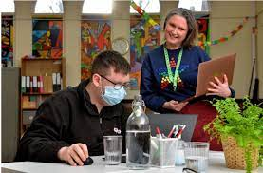


Home 2 Home With Care
Location: Swadlincote
Contact Number: 01283 310734
Contact Email: liz@home2homewithcare.co.uk
Website: www.home2homewithcare.co.uk
Provision: Respite, short breaks and supported living
Hours: variable

About this provision:

“Home 2 Home with Care are passionate about supporting you to continue living as independently as possible in your own home. That’s why we provide a range of home care services – also referred to as Domiciliary care services – that can be entirely tailored to your unique needs, including companionship and full time live –in care. We understand everybody’s needs are different, so the service we provide will be tailored to your specific requirement to allow our service users to lead more fulfilling lives, whatever their health and social care needs are. We are committed to supporting people safely to retain their skills and independence as far as possible, whilst enjoying well-being and a good quality of life.

Home2Home offers a spacious 5 bedroom house, 3 are for residential and 2 for respite. Our caring home comprises of 2 large bathroom that can cater for individuals with physical disabilities. We also have a large communal living area and a modern kitchen.
At the front of the house there is private parking for residential and visitors. We have accessible paths leading around the house to a enclosed private garden. We provide a beautiful summer house for individuals to relax and enjoy. We all so have a fully equipped sensory room designed with special lighting, music and soft play objects this can be used as a therapy room with individuals with limited communication skills. We offer a safe environment that allows the person to explore and interact without risk. The home also has its own wheelchair accessible vehicle that is used to transport to activities..”

Liberty Staffordshire CIC
Location: In and around Staffordshire
Contact Number: 0777 2749661
Contact Email: maggi@liberty-staffordshire.co.uk
Website: www.libertystaffordshire.co.uk
Provision: Youth clubs, day provision and targeted projects
Hours: variable

About this provision:

“Liberty Staffordshire CIC was founded in 2015 by Maggi Huckfield and Natalie Pearce. Both are professional youth workers with over 25 years experience in the field of youth and community work. The drive to establish Liberty was born out of a passion to offer young people with SEND equal opportunities to experience life from a starting point as a Young Person. Liberty strive to develop programmes which enable these young people similar or the same experiences as any other young person.

Over the past 5 years Liberty have established a working relationship with the University of Derby, offering professional work placements and paid employment to students on the Community and Youth work programmes. This has resulted in developing a professional staff team of Youth and Community workers, Professional SEND teachers and HLTA and professional coaches in related sports.

We work with young people and young adults who live with physical or learning disabilities offering social and emotional development opportunities in and around Staffordshire.”

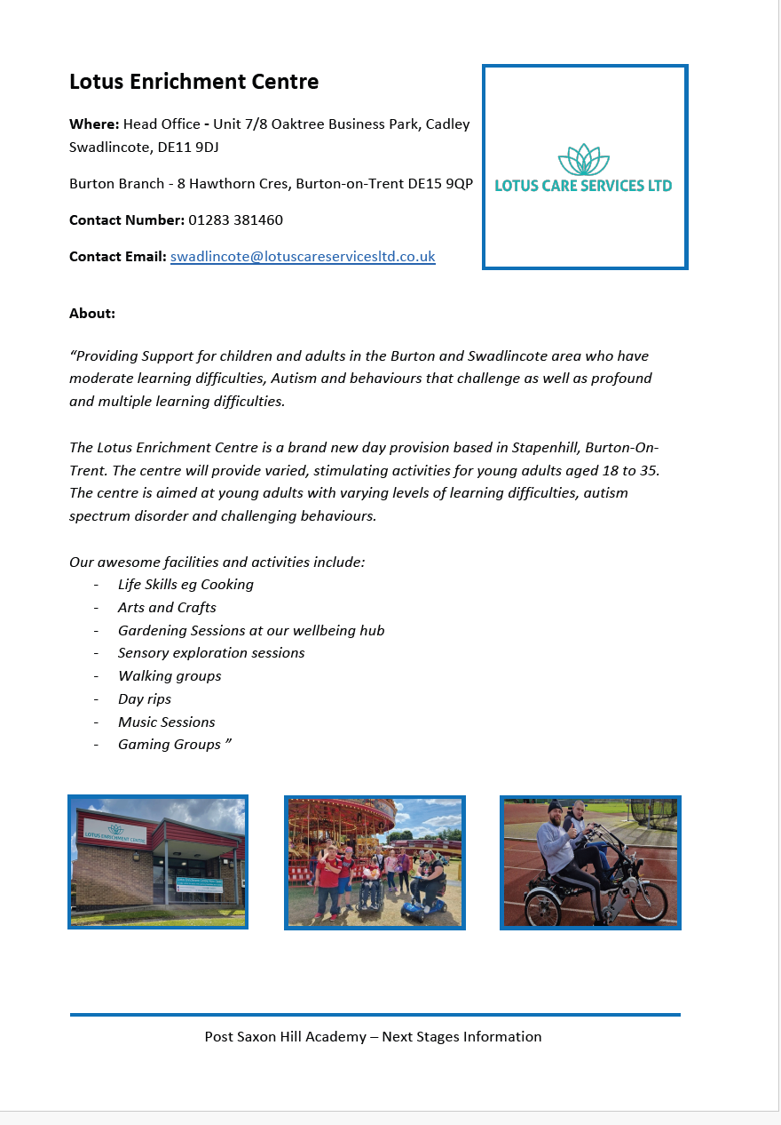

MENCAP 
Supported Internship Programme

Location: Lichfield and Stafford
Contact Number: 08088081111
Contact email: helpline@mencap.org.uk
Website: mencap.org.uk/internships
Provision: Supported Internship

About this provision:
Interns and Outcomes | Mencap
Interns and Outcomes – supports young people with a learning disability, aged between 16 and 24 years old, to make the important step from education into employment: helping them get ahead as they move into adulthood.

Why is the scheme important?
We believe that everyone with a learning disability has the right to work. We also believe that most people with a learning disability can work if they have the right support and the right opportunities.
We have been supporting people with a learning disability into work for more than 40 years and we have an exciting new programme that we think will help us to help more people. Over the next 3 years we hope to expand this programme to as many areas as possible.

Do you have a learning disability and are you interested in taking part?
If you are a young person aged 16-24 and you have an Education, Health and Care plan, and you would like to learn the skills you need to get a job then Interns and Outcomes might be for you.
It is a one-year programme that you will do instead of going to college. Most of the programme will be doing work experience with an employer that can offer the opportunity for you to learn the skills you want to learn to help get a job.
We will:
- Help you to find the right employer
- Provide a member of staff to help you to learn new skills during your placement
- Help you to secure you a job at the end of the programme.
We have lots of great links to employers already, such as The Financial Times, Barratt Homes, McDonald’s, Sainsbury’s Wetherspoon’s, Asda, South West Trains and The Co-op, and we can also help find others locally if you’d prefer.

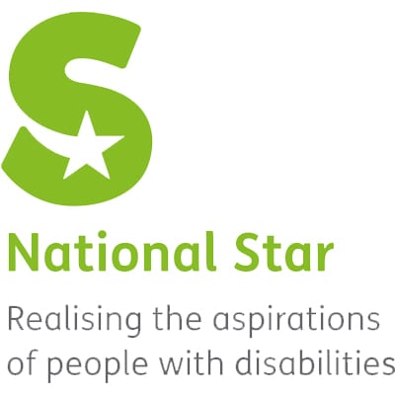
National Star College
Location: Cheltenham
Contact Number: 01242 527631
Contact Email: enquiries@nationalstar.org
Website: www.nationalstar.org
Provision: Full and part-time, residential and day courses
Hours: dependent upon programme

About this provision:

“At National Star, we’re driven by our vision for a world in which people with disabilities are able to realise their potential as equal and active citizens in control of their lives. This sits at the heart of everything we do, from the personalised and world-class learning we provide via National Star College to training, specialist services and our work in the wider community. All of this is underpinned by both our passion to enrich people’s lives and by our moral and statutory responsibilities.

We offer full and part-time, residential and day courses at our main site in Ullenwood, Cheltenham. You can also stay with us in college holidays.

We offer day courses across the UK – working in partnership with general further education colleges, schools and employers.

We will work with you to build an individual programme based on your interests, aspirations and requirements. tutors, personal learning coordinators, facilitators and therapy staff will work together to enable you to achieve your goals.

We also provide a range of college accommodation for students across three locations: Ullenwood, Cheltenham and Gloucester. A huge amount of consideration goes into matching students to the most appropriate environment for them, and takes into account both their personal and social needs.”

New Directions
Location: Rugby
Contact Number: 01788 573318
Contact Email: admin@newdirectionsrugby.org.uk
Website: www.newdirectionsrugby.org.uk
Provision: short breaks, independent living skills,
residential support, leisure groups and day activities
Hours: variable

About this provision:

“New Directions is an inspiring, vibrant, local charity that supports people with learning disabilities and their families and carers to lead a full and valued life and works in a real partnership with them.

We support each individual in a person centred way with flexible, responsive, tailored plans designed to empower people to reach their potential and achieve their goals and wishes. We are regulated and registered by the Care Quality Commission and we offer the highest quality of service.

Services range from supporting a person in their own home and in other community settings to providing our own range of accommodation options. We offer short breaks, independent living skills training, residential support, day activities, leisure groups and support with managing personal budgets, transport services, volunteering, finding work or a place to live.

Our work is grounded in the belief that everyone has the right to a good and full life, living in a home that they like, with a network of family and friends, to be involved in activities, volunteering or work within their community that is important to them.”

Newfriars College
Location: Stoke-on-Trent
Number: 01782 987180
Contact Email: helpline@newfriarscollege.org.uk
Website: www.newfriarscollege.org.uk
Provision: Day placements
Hours: variable

About this provision:

“Newfriars provides an outstanding education for pupils aged 16-19, and also for those aged 19-21 in partnership with Stoke-on-Trent College.

We provide a highly differentiated programme of study for pupils with a range of physical, learning, medical and sensory needs.

The Academy offers access for all and we provide the best resources and specialist facilities for all our young people. Ours is a safe, caring and friendly community with an emphasis on academic success alongside personal and social development. The curriculum is tailored and personalised to the interests and abilities of each individual person.

Our dynamic and highly skilled staff team support all students towards their next steps and their transition from school to the outside world.

Our pupils are proud to go to the Academy, enjoying the college atmosphere and responsibilities for organising themselves and being more independent. They particularly enjoy their contributions through the enterprise and charity work they do.”

Portland College
Location: Mansfield
Contact Number: 01623 499111
Contact Email: college@portland.ac.uk
Website: www.portland.ac.uk
Admissions Email: admissions@portland.ac.uk
Provision: Day and residential placements

About this provision:

“Portland College is a vibrant national college for people with a wide range of disabilities. The Portland College offer includes Further Education, as well as Employment Support and Personal Care.

We strive to develop every learner’s unimagined potential with a personalised programme. For those learners attending the Portland College campus in Sherwood Forest, such a programme can include work experience and volunteering. The personal curriculum is underpinned by a broad range of accredited qualifications in independence, literacy, numeracy, sport, arts, business studies, computing, small animal care and horticulture.

With such a wide range of qualifications available - from pre-entry level to level 3, we will tailor a programme to suit your individual disability or needs.

Depending on your interests you will access one of our three vocational study programmes which focus on a wide variety of subjects, within that programme you will then be streamed on an individualised route depending on your assessed level.

Functional skills Maths, English and ICT are embedded within a learner’s study programmes through bespoke individualised approaches and targets as well as through discreet group sessions.”

Queen Alexandra College (QAC)
Location: Harborne, Birmingham
Contact Number: 0121 428 5050
Contact Email: info@qac.ac.uk
Website: www.qac.ac.uk
Provision: Day and residential placements, supported
Internships
Hours: variable depending upon programme

About this provision:

“Queen Alexandra College (QAC) is a Specialist College based in Birmingham.

The College has been at its current location since 1903. Our original purpose was to provide education for young people who were blind or visually impaired. Today, in addition to supporting people who have a visual impairment, we now offer support and guidance for students on the Autistic Spectrum (including individuals with Asperger’s syndrome), those with moderate to severe learning difficulties, students with physical disabilities and those with other needs. Ultimately, we have a great mix of students which adds to the wonderful atmosphere here in College.

The reason why so many students choose QAC is because it offers a great variety of academic and employment focused courses. This combination with excellent learning and leisure facilities and friendly staff is a winner.

During their time at QAC learners are able to develop their academic as well as their social skills, make new friends and enjoy being independent and responsible for their own decisions and actions.”


Sherratts Wood
SHERRATTS WOOD BURTON
Address: Byrkley Street, Burton-On-Trent, DE14 2EG
Contact Number: 01283 565909
SHERRATTS WOOD THE FARM
Address: Middleton Green, Stoke-On-Trent, ST10 4PQ
Contact Number: 01889 502662
Website: https://www.sherrattswood.com/

About:

“Superbly located in Burton-on-Trent the centre promotes a social feeling with a large hall situated just inside the door of this purpose built centre. Like the Lichfield site Burton enables attending customers to extend their skills with IT suites, independent living suite, life skills facilities, craft room and customer designed and decorated music room. Private disabled accessible garden with polytunnel and a changing place ‘style’ facilities with hoist, changing bed and shower.

At our 20 acre Staffordshire farm venue, customers can explore all aspects of farm life throughout the seasons as well as getting involved in our extensive range of indoor and outdoor activities including sports, art, cooking, life skills, IT skills, gardening and horticulture. With a range of high-quality indoor spaces including commercial kitchen and learning hub, the farm venue offers an unrivalled opportunity to develop skills for life in a unique way. We have now started to build our new education centre, working with local specialist colleges.”

Transition2
Location: Derby
Contact Number: 01332 370978
Contact Email: info@transition2.co.uk
Website: www.transition2.co.uk
Provision: Day and residential placements
Hours: variable depending upon programme

About this provision:

“Transition 2 (T2) opened its doors in September 2012 with the aim of providing bespoke and genuine transition programmes that allow young learning disabled people to segue into meaningful opportunities in adult life.

Colleagues at Transition2 are committed to supporting young adults aged 18 to 25 with Severe Learning Difficulties, Learning Disabilities and/or Autism as they move on to opportunities in adult life, helping them to release their potential and achieve purposeful life outcomes in their local community. By continuing their education within the familiarity of their local community, learners are able to consolidate their skills and build upon prior achievements to become increasingly assured and confident when facing familiar or new activities.

At this important stage of transition to adult life, we think it is crucial to strengthen partnerships across education, health, social care and the community, believing that together we can achieve more.”

Trinity Specialist College

Location: Sutton Coldfield

Contact Number: 0121 378 3242

Contact Email: info@trinityspecialistcollege.co.uk

Website: https://trinityspecialistcollege.co.uk

Provision: 36 weeks per year - day placements

Hours: variable

About this provision:

“Trinity Specialist College is a Post 19 Further Education College and day placement centre providing up to a 36-week provision for students with learning differences and behaviours that challenge, disabilities and Autism.

The College was opened in 2011. It was started and is run by two sets of working parents who had struggled to find appropriate provision for their own young adults with disabilities. The building is light, spacious and airy with three large classrooms, each accommodating up to eight students. There is space for group sessions, individual workstations, ICT work stations, relaxation areas and ‘safe spaces’ where students are encouraged to self-manage their anxieties.

Trinity Specialist College is small and friendly and currently caters for 39 students at ‘The Lindridge’, which is a converted and much extended farmhouse located in a beautiful rural setting surrounded by farmland and 10 students that are located at a satellite setting. There are wet rooms for personal care, a large garden with picnic benches and sporting facilities, a sensory cabin, an additional classroom cabin and a domestic kitchen and laundry where students can develop their independence skills.

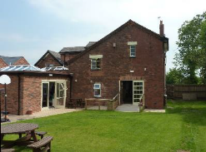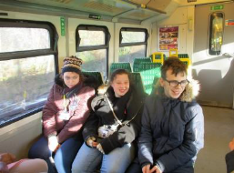


Voyage Care – Rugeley Day Service
Where: Rugeley Youth & Community Centre,
Burnthill Lane, Rugeley, Staffordshire, WS15 2HX
Contact Number: 0800 328 6091
Website: www.voyagecare.com/service/rugeley-day-service/

About:

“We provide high quality support to adults with a learning disability and other complex needs. We offer individualised care packages that incorporate social, vocational, leisure and educational activities and increase their presence in the community. Activity plans are tailored to each person’s aspirations, needs and interests and are designed to help individuals to pursue a more independent lifestyle. All activities are fully risk assessed.

A dedicated group of key workers are available to work with each individual to ensure a consistent approach with clear support plans in place. We can provide services for people with varying support needs, including physical disabilities, sensory impairments, communication difficulties, cerebral palsy, brain injuries, epilepsy, pica, challenging behaviour and Down’s syndrome. We will provide the necessary staffing ratio for each individual. We aim to:

- Provide work opportunities – paid and unpaid
- Teach enabling skills so that people gain the confidence to use public transport and local facilities
- Promote future goals and aspirations of independence
- Support people to develop relationships
- Use local facilities
- Empower people to look after their own health needs by using local primary care facilities”

We hope that you have found this document useful. All of the information we have shared has been gathered from the provisions’ own online published information and therefore it should be accurate and up to date.

School will review and amend all information we share on an annual basis and this will include more provisions if we have received information of others to add.

Saxon Hill Academy

