Dear Parents and Carers,
Re: Secondary Uniform Update – Pupil-Initiated Change
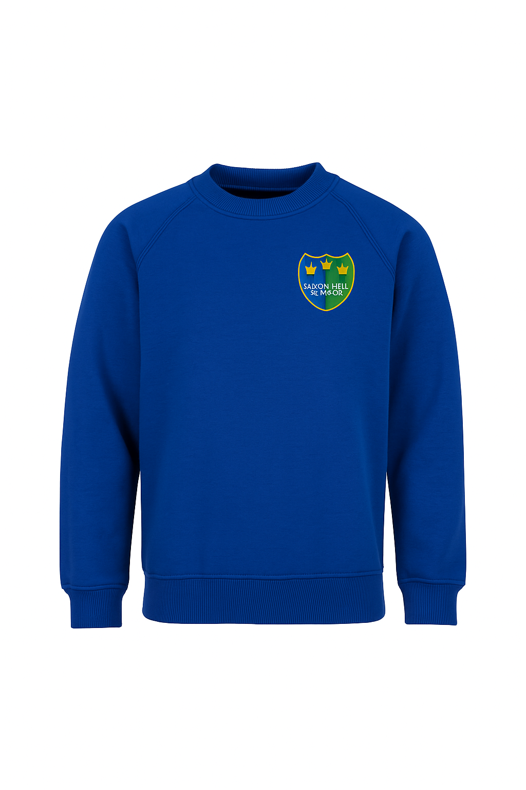
Following recent feedback from our pupils, we’re pleased to share a change that celebrates the transition into secondary education. Many of our secondary students expressed a desire to wear something that reflects their more grown-up status and marks this important phase of their school journey.
In response, the leadership team has decided to introduce a new optional uniform colour for our secondary classes. From September 2025, pupils in secondary classes are invited to wear a blue version of the school uniform, rather than the traditional green. We feel that introducing our school blue is a positive way to mark their progression and support their sense of identity as older members of our school community.
However, we are also mindful that change can be difficult for some of our pupils. This uniform update is optional, and we fully support families and students who feel more comfortable continuing to wear the green uniform. The aim of this change is to celebrate, not to create pressure or discomfort. If the change could negatively impact your child, they are very welcome to continue wearing green.
If you have any questions or wish to discuss how this might affect your child, please don’t hesitate to get in touch with your child’s class teacher or a member of the leadership team.
Thank you, as always, for your continued support.
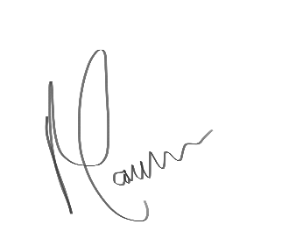
Maggie Candlish
Headteacher

