Scotforth St Paul’s Church of England Primary School

PROPOSED DETERMINED ADMISSION ARRANGEMENTS

For September 2028

Making an application
Applications for admission to the school for September 2028 should be made on the home Local Authority’s common application form between 1st September 2027 and 15th January 2028. It is not normally possible to change the order of your preferences for schools after the closing date.

Parents must complete their home Local Authority application form, stating three preferences. Residents can apply online at https://www.lancashire.gov.uk/children-education-families/schools/apply-for-a-school-place/ For families who are unable to apply online, application forms can be requested from, and returned to, the school or appropriate area office, the address of which is available at the school. All parents returning application forms to school must receive a receipt of submission.

Parents who wish their application to this Church school to be considered against the faith criteria must also complete the Supplementary Form. If the school is oversubscribed, a failure to complete the Supplementary Form will result in your application for a place in this school being considered against lower priority criteria as the Governing Board will have no information upon which to assess the worship attendance.

The Supplementary Information Form must be completed at the time of application and is available from the school or online at https://www.scotforth-st-pauls.lancs.sch.uk

The Supplementary Information Form must be returned directly to the school by 15th January 2028 if parents wish their application to be considered against faith criteria

Emails informing parents of whether or not their child has been allocated a place will be sent out by the Local Authority on 18th April 2028. Parents of children not admitted will be informed of the reason and offered an alternative place by the Authority. Parents applying by hard copy forms will be informed by letter.

Admission procedures
Arrangements for admission have been agreed following consultation between the Governing Board, the Diocesan Board of Education, Local Authorities and other admission authorities in the area.

The number of places available for admission to the Reception class in the year 2028 will be a maximum of 30

The Governing Board will not place any restrictions on admissions to the reception class unless the number of children for whom admission is sought exceeds their admission number. By law, no infant class may contain more than thirty children.

The Governing Board operates a system of equal preferences under which they consider all preferences equally and the Local Authority notifies parents of the result. In the event that there are more applicants than places, after admitting all children with an Education Health and Care Plan naming the school, the Governing Board will allocate places using the criteria below, which are listed in order of priority.

1. (a) Looked After Children and Previously Looked After Children
This means a ‘looked after child’ or a child who was previously ‘looked after’ but ceased to be looked after because they were adopted or became subject to a child arrangements or special guardianship order, including those who appear (to the admission authority) to have been in state care outside of England and ceased to be in state care as a result of being adopted (please see definitions below). A ‘looked after child’ is a child who is (a) in the care of the local authority or (b) being provided with accommodation by a local authority in exercise of their social services functions (see the definition in Section 22(1) of the Children Act 1989) at the time of making an application to the school.

An adoption order is an order under the Adoption Act 1976 (see Section 12 adoption orders) and children who are adopted under the Adoption and Children Act 2002 (see Section 46 adoption orders). A ‘child arrangements order’ is an order settling the arrangements to be made as to the person with whom the child is to live under Section 8 of the Children Act 1989 as amended by Section 14 of the Children and Families Act 2014. Section 14A of the of the Children Act 1989 defines a ‘special guardianship order’ as an order appointing one or more individual’s to be a child’s special guardian (or special guardians). A child is regarded as having been in state care outside of England if they were in the care of or were accommodated by a public authority, a religious organisation, or any other provider of care whose sole or main purpose is to benefit society.

(b) Children with special medical or social circumstances affecting the child where these needs can only be met at this school.
Professional supporting evidence from a professional, e.g. a doctor, psychologist, social worker, is essential if admission is to be made under the criterion for special medical or social circumstances, and such evidence must set out the particular reasons why the school in question is the only school where these needs can be met and the difficulties which would be caused if the child had to attend another school. Parents must submit this evidence to the school by 15th January 2028, if they wish their application to be considered under this criterion..

2. Siblings
Children who have a sibling attending the school on the date of application and on the date of admission. Siblings include full, step, half, foster, adopted brothers and sisters and children of parent or carer’s partner. In all cases both children should be living in the same family unit at the same address

3. Children with a parent/guardian worshipping in a church in full membership of Churches Together in England or the Evangelical Alliance or the North West Partnership or the Global Horizons network to a maximum of 10. Once these 10 places have been allocated, criteria 4 will be applied (children with parent/guardian who live in the parish).
"Parental worshipping" is normally taken to mean a minimum of 18 times a year attendance at church at public worship for over at least 1 year leading up to the 1st September 2026. The governors will request confirmation of this from the relevant member of the clergy or church officer. The lists of Churches can be found on the Churches Together in England website at cte.org.uk, and for the Evangelical Alliance at eauk.org, for Global Horizons at global-horizons.org and for North West Partnership at northwestpartnership.com; lists are taken as on 1st September 2026. Churches in membership of the equivalent bodies to CTE in Northern Ireland, Scotland and Wales are equally accepted.

In the event that during the period specified for attendance at worship the church has been closed for public worship and has not provided alternative premises for that worship, the requirements of these arrangements in relation to attendance will only apply to the period when the church or alternative premises have been available for public worship.

4. Children with parent/guardian who lives in the ecclesiastical parish of Scotforth St. Paul’s or civil parish of Scotforth.
A map showing the boundaries is included at the end of this document, is available in school or on our website.

5. Other children

Tie break
Where there are more applicants for the available places within a category, then the distance between the Ordnance Survey address points for the school and the home measured in a straight line will be used as the final determining factor, nearer addresses having priority over more distant ones. This address point is within the body of the property and usually located at its centre. Where two addresses have the same distance, or the cut-off point is for addresses within the same building, then the Local Authority's system of a random draw will determine which address(es) receive the offer(s).

Admissions information:

In 2027, there were TBC applications for 30 places

Twins and Multiple Births
Where there are twins, etc wanting admission and there is only a single place left within the admission number, then the Governing Board will exercise as much flexibility as possible within the requirements of infant class sizes. In exceptional circumstances we may be able to offer places for both twins and all triplets, even when this means breaching infant class size limits.

Late applications for admission
Where there are extenuating circumstances for an application being received after the closing date for applications (15th January 2028), and it is before the Governing Board have established their list of pupils to be admitted then it will be considered alongside all the others.

Otherwise, applications which are received after closing date will be considered after all the others, and placed on the waiting list in order according to the criteria.

Waiting list
Where we have more applications than places, the admissions criteria will be used. Children who are not admitted will have their name placed on a waiting list. The names on this waiting list will be in the order resulting from the application of the admissions criteria. Since the date of application cannot be a criterion for the order of names on the waiting list, late applicants for the school will be slotted into the order according to the extent to which they meet the criteria. Thus it is possible for a child who moves into the area later to have a higher priority than one who has been on the waiting list for some time. If a place becomes available within the admission number, the child whose name is at the top of the list will be offered a place. This is not dependent on whether an appeal has been submitted. Looked after children, previously looked after children and those allocated a place at the school in accordance with a Fair Access Protocol will take precedence over those on a waiting list.

This waiting list will operate until 31st December 2028.

Address of pupil
The address used on the school’s admission form must be the current one at the time of application, i.e. the family’s main residence. If the address changes subsequently, the parents should notify the school. Where the parents live at different addresses, and there is shared parenting, the address used will normally be the one where the child wakes up for the majority of Monday to Friday mornings. If there is any doubt about this, then the address of the Child Benefit recipient will be used. Parents may be asked to show evidence of the claim that is being made for the address, e.g. identity cards of various sorts showing the child’s address as the one claimed. Where there is dispute about the correct address to use, the Governing Board reserve the right to make enquiries of any relevant third parties, e.g. the child’s GP, Council Tax Office, Electoral Registration Officer, utilities provider. For children of UK Service personnel and other Crown Servants returning to the area proof of the posting is all that is required.

Non-routine and In-Year Admissions
It sometimes happens that a child needs to change school other than at the “normal” time; such admissions are known as non-routine or in-year admissions. Parents wishing their child to attend this school can arrange to visit the school to discuss this should they wish. You must submit an “In Year Application Form” to the school Admissions | Scotforth St Paul's C of E Primary & Nursery School. If there is a place in the appropriate class, then your child will be admitted. If there is no place, then the governing body will have to refuse the application, but information will be provided about how to appeal against this refusal.

If your family is moving house, your application (both for routine and non-routine applications) and any appeal will be considered as being made from your old address until you provide suitable evidence of a permanent change of address, e.g. exchange of contracts on your house purchase or the signed tenancy agreement and rent book for your new address.

Where Lancashire County Council administers the appeals process on behalf of the school. Parents can complete the school’s appeal form on Lancashire County Council’s website.

Appeals for routine admissions
Appeals
Where the governors are unable to offer a place because the school is oversubscribed, parents have the right to appeal to an independent admission appeal panel, set up under the School Standards and Framework Act, 1998, as amended by the Education Act, 2002. Parents/guardians should request an appeal form from the Clerk to the Governors at the school and return it within 20 school days of receiving the letter refusing a place. Parents will have the opportunity to submit their case to the panel in writing and also to attend in order to present their case. You will normally receive 14 days’ notice of the place and time of the hearing.

Appeals which are received after the deadline will be slotted into the schedule where this is possible. There is no guarantee that this will happen and late appeals may be heard after the stipulated date at a second round of hearings. The schedule is subject to change depending upon the availability of appeal panel members, clerks, venues and the number of appeals for each school (which will vary year on year).

Please note that this right of appeal against the Governing Board’s decision does not prevent you from making an application or an appeal in respect of any other school. However, parents do not have the right to a second appeal in respect of the same year group at this school unless, in exceptional circumstances, the school has considered a second application from the parents in the same academic year because of a significant and material change in the circumstances of the parents, child or school but the child was still refused admission.

Fraudulent applications
Where the Governing Board discovers that a child has been awarded a place as the result of an intentionally misleading application from a parent (for example a false claim to residence in the catchment area or of involvement in a place of worship) which effectively denies a place to a child with a stronger claim, then the Governing Board is required to withdraw the offer of a place. The application will be considered afresh and a right of appeal offered if a place is refused.

Deferred admission and part-time provision
If your child is due to start school during the next academic year, it is important that you apply for a place for September. If your child’s fifth birthday is between the months of September and December, then if you wish it, admission may be deferred until January: if it is between January and August, then admission may be deferred until the start of the summer term though it is unlikely to be in your child’s interest to start any later than January. Please note that if your child does not take up the place during the summer term, it will be withdrawn, and you will have to apply again for admission.
You may also request that your child attends school part time until he/she reaches ‘compulsory school age’. A child reaches compulsory school age on the prescribed day following his/her fifth birthday (or on his/her fifth birthday if it falls on the prescribed day). The prescribed days are 31 December, 31 March and 31 August.

Admission of children outside of their normal age group
Parent(s)/carer(s) may seek a place for their child outside of the normal age group, for example, if a child is gifted and talented or has experienced problems such as ill health. In addition, the parent/carer of a summer born child (i.e. a child born between 1 April and 31 August) may choose not to send that child to school until the September following their fifth birthday and may request that they are admitted outside of their normal age group – to reception rather than year 1.

In-year applications (i.e. children who are already of school age)
Parent(s)/carer(s) must submit their written request for admission out of the normal age group to the Governing Board. If their request is agreed and a place is available in the requested year group, the child will be admitted.

Children seeking admission to reception in the September after their fifth birthday
Parent(s)/carer(s) will need to submit a normal Common Application Form (CAF) to the Local Authority (in writing or online) for admission into the normal age group at the same time as they submit a written request to the Governing Board for their child to be admitted out of the normal age group.

Please note: This Governing Board will not honour a decision made by another admission authority on admission out of the normal age group. Parent(s)/carer(s), therefore, should consider whether to request admission out of the normal year group at all their preference schools, rather than just their first preference school.

The Governing Board will make a decision on the request before the Primary national offer date if at all possible.

If the request is agreed, the parent(s)/carer(s) must make a new application for the next main admission round the following year, and their current application for the normal age group should be withdrawn before a place is offered. The following year the new application will be considered on the base of the determined admission arrangements only, including the application of oversubscription criteria where applicable. The application will not be given lower priority on the basis that the child is being admitted out of their normal age group.

If their request for admission outside their normal age group is refused, parent(s)/carer(s) must decide whether to accept the offer of a place for the normal age group that they receive from the Local Authority, or to refuse it and make an in-year application to the Governing Board for admission to year one for the September following their child’s fifth birthday.

More information is available at: https://www.gov.uk/government/publications/summer-born-children-school-admission

Making the decision
Parent(s)/carer(s) seeking admission of their child outside their normal age group must send their written request to the Governing Board. It is the responsibility of the parent(s)/carer(s) to provide the Governing Board with all relevant information relating to this request, including the parent(s)/carer(s) views; information about the child’s academic, social and emotional development; where relevant, their medical history and the views of the medical professional; whether the child may naturally have fallen into a lower age group if it were not for being born prematurely; and whether the child has previously been educated out of their normal age group.

The Governing Board is required to take into account the views of the Head Teacher on the application as well as the information from the parent(s)/carer(s). The Governing Board will make their decision on the basis of the circumstances of each individual case, and in the best interests of the child concerned.

The Governing Board will then inform the parent(s)/carer(s) of their decision on the year group the child should be admitted to and will provide the reasons for their decision.

Parent(s)/carer(s) have a statutory right to appeal to an independent admission appeal panel against the refusal of a place at a school for which they have applied. As the purpose of the appeals process is to consider whether a child should be admitted to a particular school, the right of appeal does not apply if they are offered a place at the school but it is not in their preferred year group. However, they may make a complaint about an admission authority’s decision not to admit their child outside their normal school age group.

Ecclesiastical Parish Boundary for Lancaster St Paul’s Scotforth

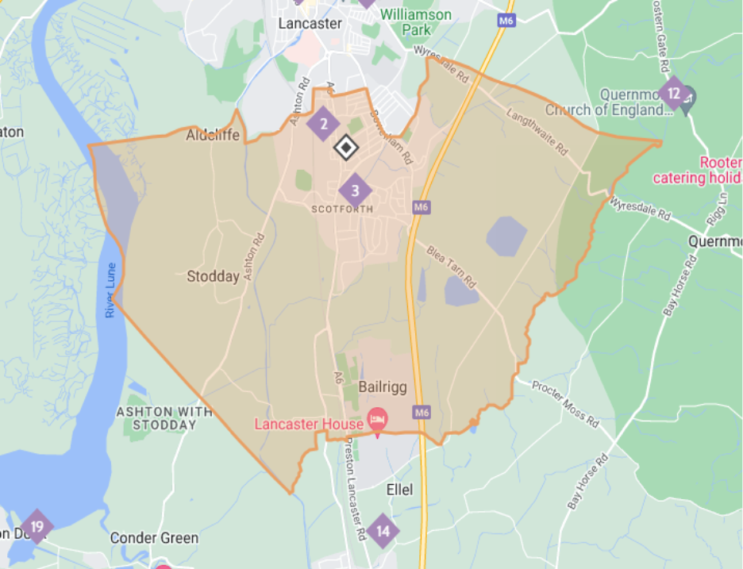
IMPORTANT: This form must be returned directly to school before 15th January 2028 either to Scotforth St Paul’s or bursar@scotforth-st-pauls.lancs.sch.uk if parent(s)/carer(s) wish their application to be considered against faith criteria

Diocesan Supplementary Information Form

Admission to Primary School, 2028

Scotforth St Paul’s Church of England Primary School

Name of child:
Surname . . . . . . . . . . . . . . . . . . . . .Christian names . . . . . . . . . . . . . . . . . . . . . . . .
Date of birth . . . . . . . . . . . . . . . . . . . .

Name of parent/guardian . . . . . . . . . . . . . . . . . . . . . . . . . . . . . . . . . . . . . . . . . . . .
Address . . . . . . . . . . . . . . . . . . . . . . . . . . . . . . . . . . . . . . . . . . . . . . . . . . . . . . . . . . .
. . . . . . . . . . . . . . . . . . . . . . . . . . . . . . . . . . . . . . . . . . . . . . . . . . . . . . . . . . . . . . . . . . . . . . . . . . . . . . . . . . . . . . . . . . . . . . . . . . . . . . . . . . . . . . . . . . . . . . . . . . . . . . . . .
Post code . . . . . . . . . . . . . . . . . . . . . . . . . . . . . . . . .
Contact telephone number . . . . . . . . . . . . . . . . . . . . . . . . . . . .

If you are applying to this school on faith grounds, please complete the following sections:
Place of worship one of parents / guardians regularly attends:
Name of place of worship . . . . . . . . . . . . . . . . . . . . . . . . . . . . . . . . . . . . . . . . . . . . . .
Address . . . . . . . . . . . . . . . . . . . . . . . . . . . . . . . . . . . . . . . . . . . . . . . . . . . . . . . . . . .
. . . . . . . . . . . . . . . . . . . . . . . . . . . . . . . . . . . . . . . . . . . . . . . . . . . . . . . . . . . . . . . . .

Name of vicar / priest / minister / faith leader / church officer:
. . . . . . . . . . . . . . . . . . . . . . . . . . . . . . . . . . . . . . . . . . . . . . . . . . . . . . . . . .
Address . . . . . . . . . . . . . . . . . . . . . . . . . . . . . . . . . . . . . . . . . . . . . . . . . . . . . . . . . . .
. . . . . . . . . . . . . . . . . . . . . . . . . . . . . . . . . . . . . . . . . . . . . . . . . . . . . . . . . . . . . . . . .
. . . . . . . . . . . . . . . . . . . . . . . . . . . . . . . . . . . . . . . . . . . . . . . . . . . . . . . . . . . . . . . . .
Post code . . . . . . . . . . . . . . . . . . . . . . . . . . . . . Telephone . . . . . . . . . . . . . . . . . . .

Your faith leader will be contacted in order to provide the information.
This form is for use by the School; it will be sent to the appropriate faith leader, to be returned directly to the school.
Clergy Reference Form: Admission to Primary School, 2028

Scotforth St Paul’s Church of England Primary School
Name of child:
Surname . . . . . . . . . . . . . . . . . . . . .Christian names . . . . . . . . . . . . . . . . . . . . . . . .
Date of birth . . . . . . . . . . . . . . . . . . . . .
Name of parent/guardian . . . . . . . . . . . . . . . . . . . . . . . . . . . . . . . . . . . . . . . . . . . .
Address . . . . . . . . . . . . . . . . . . . . . . . . . . . . . . . . . . . . . . . . . . . . . . . . . . . . . . . . . . .
. . . . . . . . . . . . . . . . . . . . . . . . . . . . . . . . . . . . . . . . . . . . . . . . . . . . . . . . . . . . . . . . . . . . . . . . . . . . . . . . . . . . . . . . . . . . . . . . . . . . . . . . . . . . . . . . . . . . . . . . . . . . . . . . .
Post code . . . . . . . . . . . . . . . . . . . . . . . . . . . . . . . . .
Contact Telephone . . . . . . . . . . . . . . . . . . . . . . . . . . . .
This parent has given your name as a reference for his/her commitment to the church/place of worship. Our criteria require the parent to have attended there 18 times a year for at least 1 year prior to 1st September 2027.

Has this been the pattern for this parent? YES / NO
If NO, has your church building been closed for fully-accessible and non-restricted worship during the qualifying period? YES / NO.

IF YES, please give the dates of when fully-accessible and non-restricted worship was not possible in the church building……………………………………………………………………………………

Signed . . . . . . . . . . . . . . . . . . . . . . . . . . . . . . . . . . . . . . . . . . . . . . . . . . .
Name . . . . . . . . . . . . . . . . . . . . . . . . . . . . . . . . . . . . . . . . Date: . . . . . . . . . . . . . . . .
Position . . . . . . . . . . . . . . . . . . . . . . . . . . . . . . . . . . . . . . . . . . . . . . . . . .
Church . . . . . . . . . . . . . . . . . . . . . . . . . . . . . . . . . . . . . . . . . . . . . . . . . .
This church is a part of (please tick):
Churches Together in England Evangelical Alliance North West Gospel Partnership

Global Horizons

Please return this form to Scotforth St Paul’s Church of England Primary and Nursery School, Scotforth Road, Lancaster, Lancashire LA1 4SE or via email to bursar@scotforth-st-pauls.lancs.sch.uk

By . . . . . . . . . . . . . . . . . . . . . . . . . . . . . . . . . . . . . . . . . . . . . . . . . .

For a definition of what qualifies as accessible and non-restricted worship contact admissions@blackburn.anglican.org

