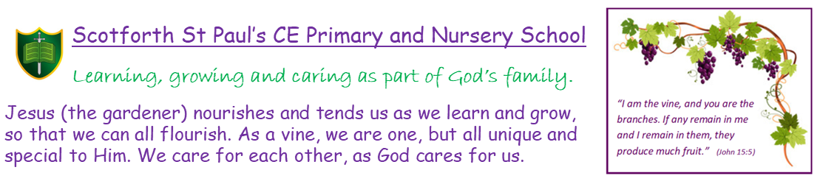

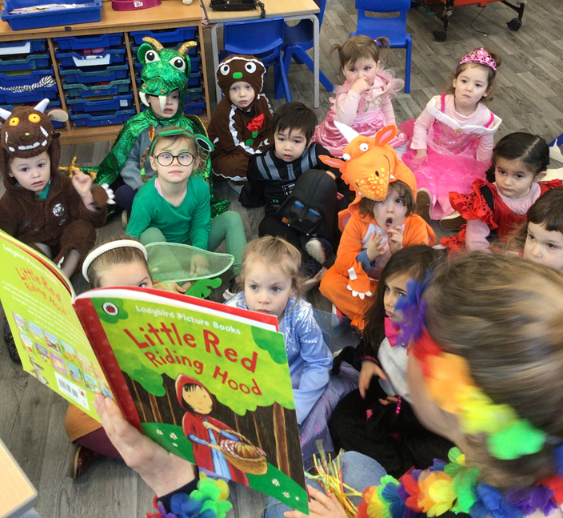

Nursery Prospectus September 2026

Nursery Prospectus
Aims
Our primary focus is to provide a high quality nursery education for children aged 3-4 in a purpose built EYFS unit which is part of Scotforth St Paul’s School. We will serve local families and the wider area. We intend to do this by
: Creating a happy, secure environment that is child centred, stimulating and safe.
:Establishing a partnership with parents, supporting them and acknowledging them as the primary carers and educators of their children.
:Planning experiences in the nursery that are fun and appropriate to individual children.
:Employing a trained teacher who is experienced in the Early Years.

Application forms and the terms and conditions are on our website at
www.scotforth-st-pauls.lancs.sch.uk Please ask if you need any help filling in the application.
Safeguarding
To ensure all children are protected from abuse and harm, and to promote their right to be strong, resilient and listened to, we are committed to responding promptly and appropriately to all incidents or concerns of abuse and to work with the statutory agencies. We follow the Local Safeguarding Children’s Boards flowchart for referrals; these will be recorded in accordance with school’s Child Protection procedures.
Our Safeguarding and Child Protection policies are freely available on request.
Location
We are located on the A6 on Scotforth Road.
Staff
To offer the best care and education for your child we believe it is vital to employ staff with a good balance of skills, experience and specialisms.
Mrs Atkinson is a qualified teacher with over 20 years experience working in the Early years in both reception and school nursery classes. She is St. Paul’s School’s Foundation Stage co-ordinator.
Mrs Atkinson is supported by Mrs Todd-Bryce who is a Level 3 qualified teaching assistant. We will be based in the EYFS unit alongside a second teacher and Teaching Assistant.
There is always at least 1 member of staff in the unit who is trained in paediatric first aid.
Settling in Procedure
We attach great importance to settling your child into nursery. We recommend up to 3 visits of at least an hour in which we ask you to leave your child to begin to get to know us. If you want to know more about visits we would be delighted to help you, please telephone with any further questions or to arrange an appointment to view the nursery. Children can have up to 3 free settling in sessions.
Each child will have a key worker-we will get together with the children in our key groups daily. If you would like to talk with your child’s key worker please ring school on 01524 65379 to make an appointment. You could also send us an email:
Mrs Atkinson r.atkinson@scotforth-st-pauls.lancs.sch.uk
Curriculum
We follow the statutory framework for the Early Years. The Early years foundation stage has 7 areas of learning and development. The nursery staff plan together each half term to provide purposeful activities based around each child’s needs and interests. Staff observe the children and use these observations to plan for the next steps in children’s learning.
Many of the activities are planned around the 3 prime areas of
: communication and language-speaking, listening and understanding.
: physical development-health and self-care, small and large scale movements and using tools including pencils.
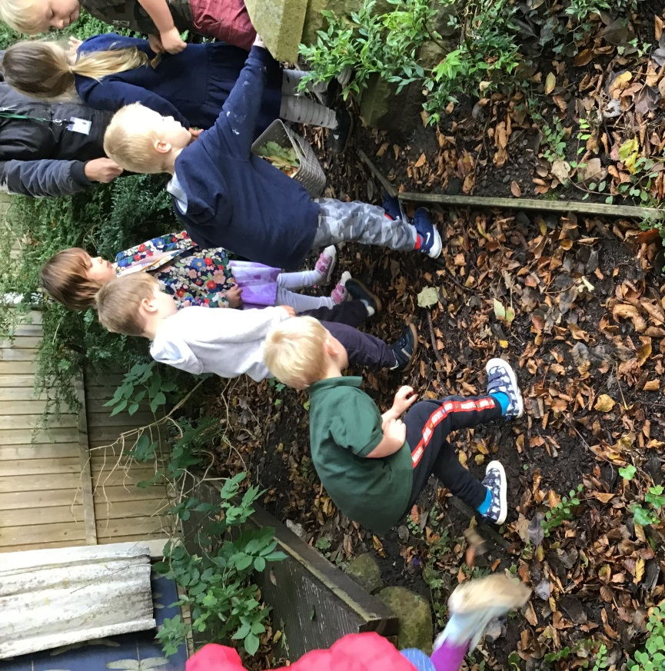

:personal, social and emotional development-self confidence, making relationships and managing behaviour.

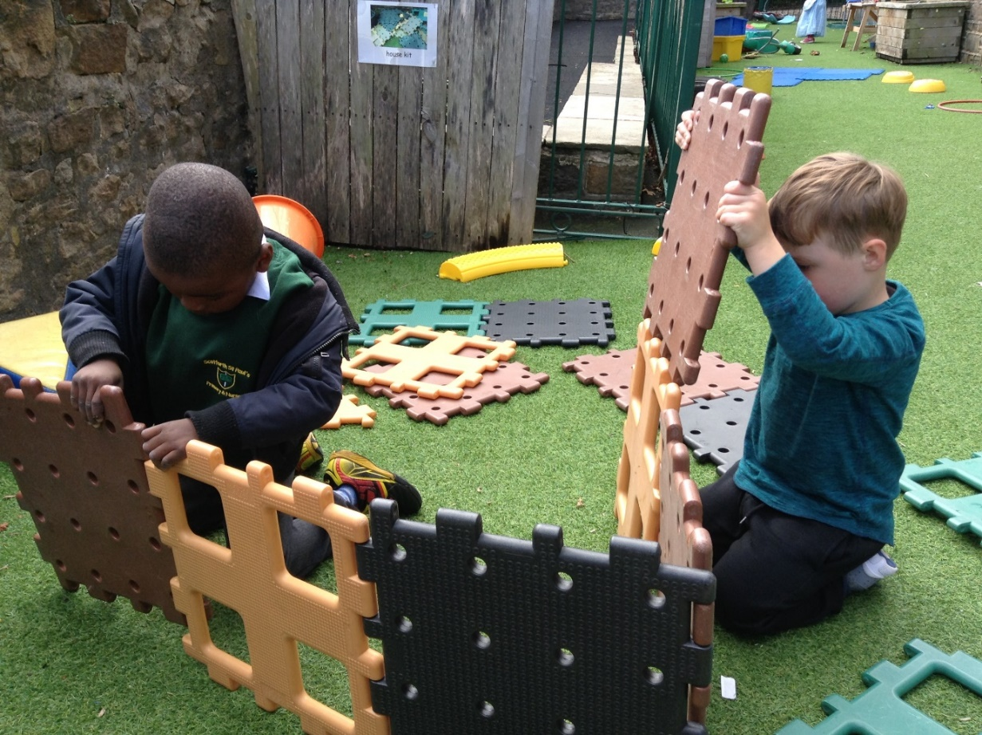
Without the skills in these areas, children would struggle to access the 4 specific areas of:
literacy-including reading, listening to and joining in with songs, rhymes and stories and mark making that will develop into writing.
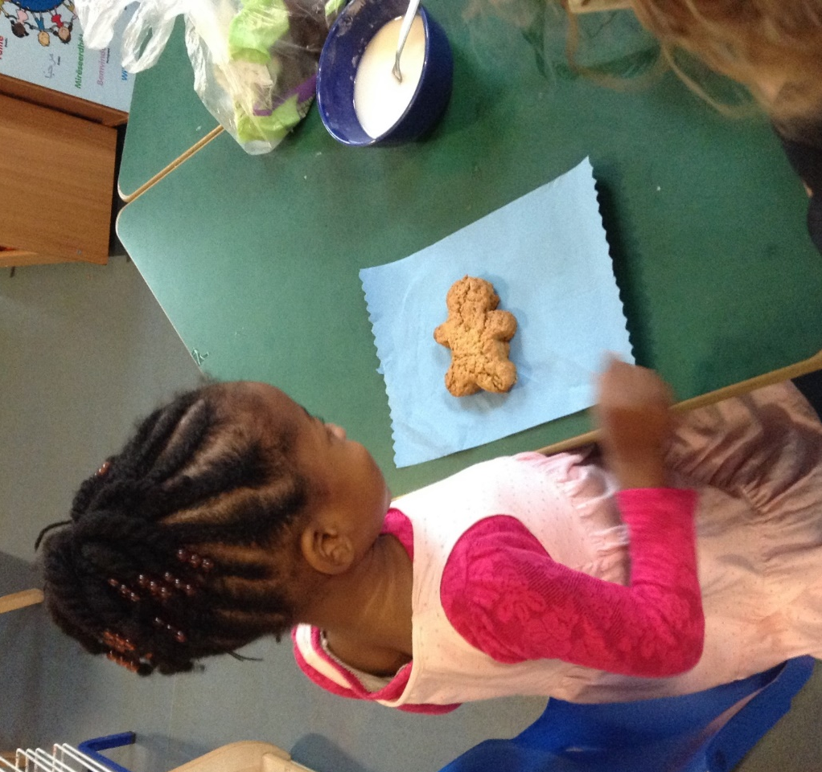

:mathematics-including numbers, shape and measures.
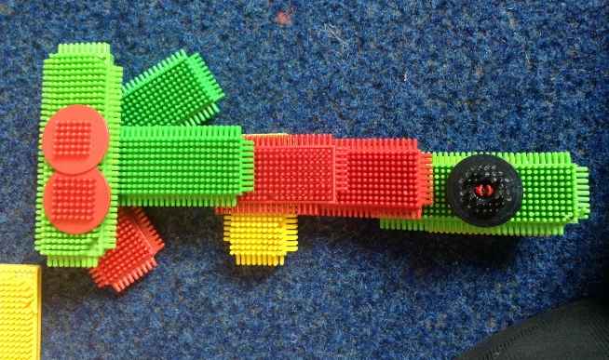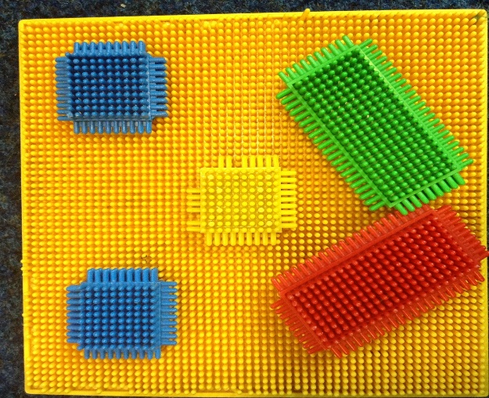

:understanding the world-including animals, plants and the local area.

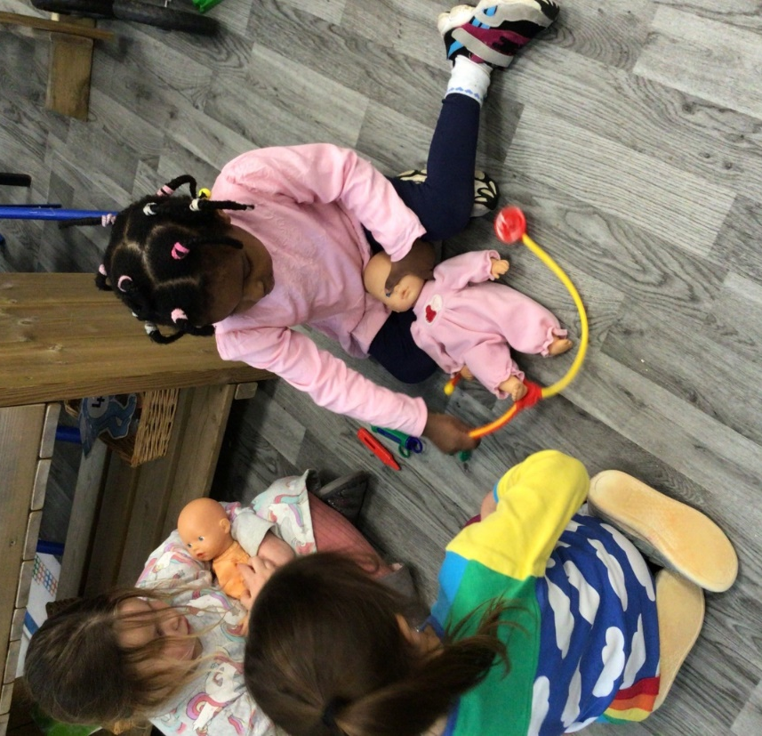

:expressive arts and design-including making, joining construction toys, art, music, dance and role-play.
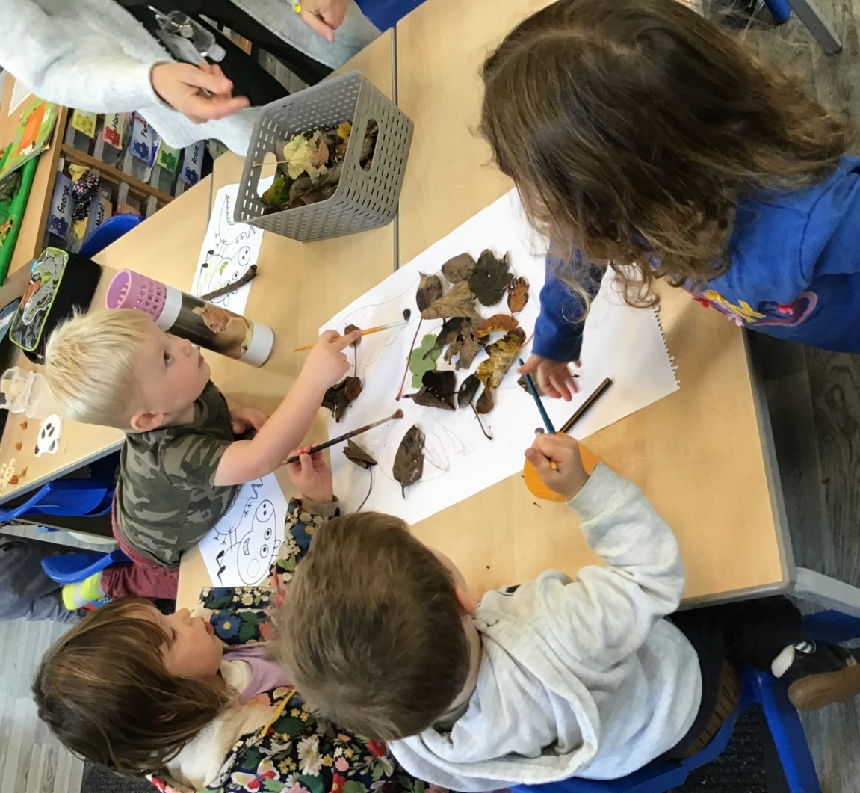

Children will have the opportunity to use the hall, playgrounds and PE facilities. Children will use the outdoor areas every day and are encouraged to bring a pair of wellies to keep at nursery.
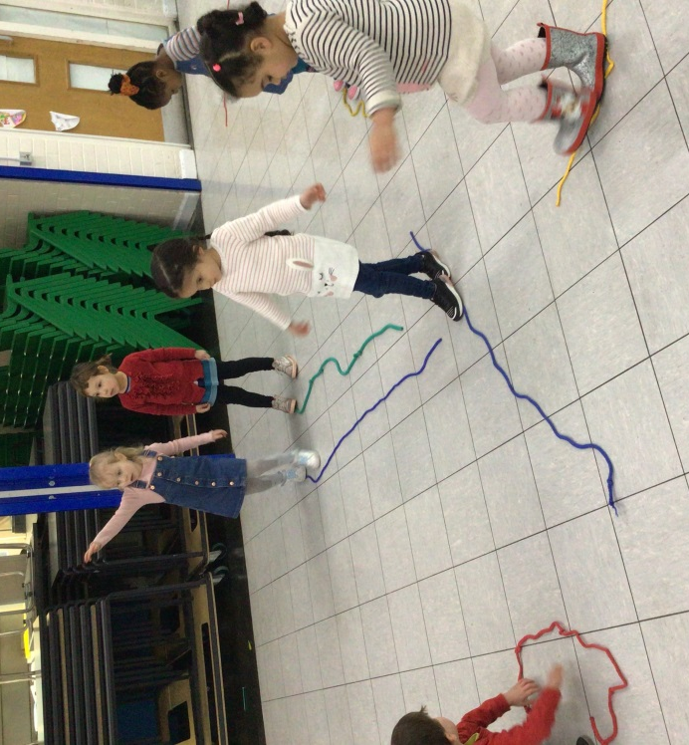
Children will have the opportunity to attend shows, special assemblies and sports days with the school children especially in the 2 terms before they go to school.
Please remember that parents must apply for a place at their chosen primary school in the October before your child starts school. Attending St. Paul’s nursery class does not mean children will receive a place in the reception class.

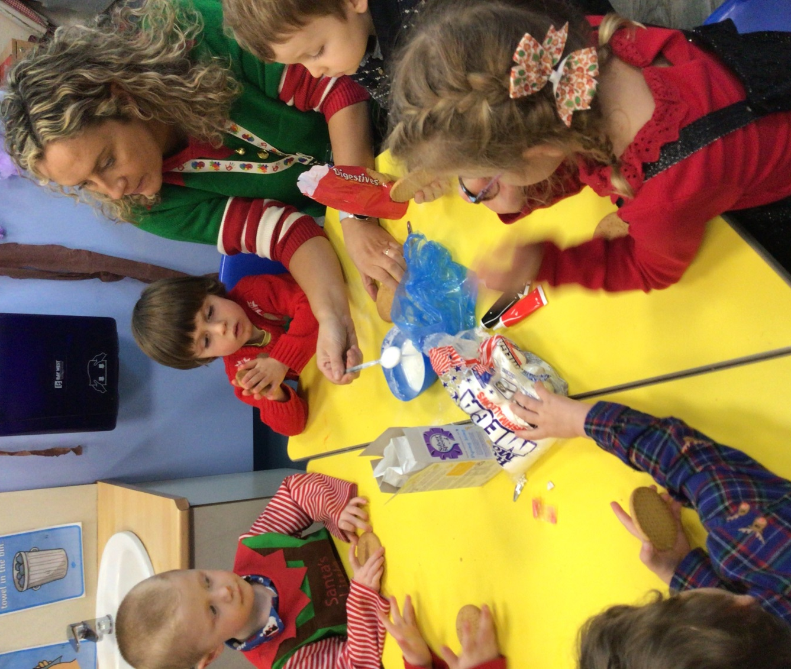

Sessions and fees
Nursery is open for 38 weeks of the year (term time) It is possible to book nursery aged children into the holiday play scheme at school which operates for a further 8 weeks a year. Please see Scotforth After School Club EYFS prospectus for details of their terms and conditions. This is available on the school website.
Morning sessions are 8:55am to 11:55am (doors open in a morning at 8:45am)
Lunch sessions are 11:55am-12:25pm
Afternoon sessions are 12:25pm to 3:25pm.
Children can attend from the term after their third birthday for up to 15 hours per week using the governments free universal 15 hours of childcare. You may choose to take up to 5 mornings, 5 afternoons or 2 full days and a part session. We can be flexible if you need a different pattern. Some families are entitled to 30 free hours.
Children who will turn 3 in a term are known as “rising 3’s” and can start Nursery with a fee-paying place or using the Government 30 hours for children of working parents.
Parents can check if they are eligible for this extra funding by going on the new “Childcare choices” website. Both parents must be working and earning under £49,999 each.
There is the option to pay for further sessions or use your free hours at before school care and after school care.
Sometimes an extra session is needed in a week. If we have the space, we will try to accommodate requests.
Breakfast club runs from 7:30am-8:45am (In the school hall but run by Scotforth ASC)
After School Club runs from 3:25pm-6:00pm
Morning or afternoon session at Nursery £5.50 per hour.
After school club from 3:25pm until 6:00pm (Please enquire about current prices)
Full day 8:45 am to 3:00pm £36.25
Invoices are sent the first week of each term and should be paid within 14 days. Invoices can be paid by cash or cheque. Ask us about paying online.
On accepting a place, you will be asked to sign permissions for the taking and displaying of photographs of your child, emergency treatment, first aid, application of sun cream and outings from nursery in the local area.
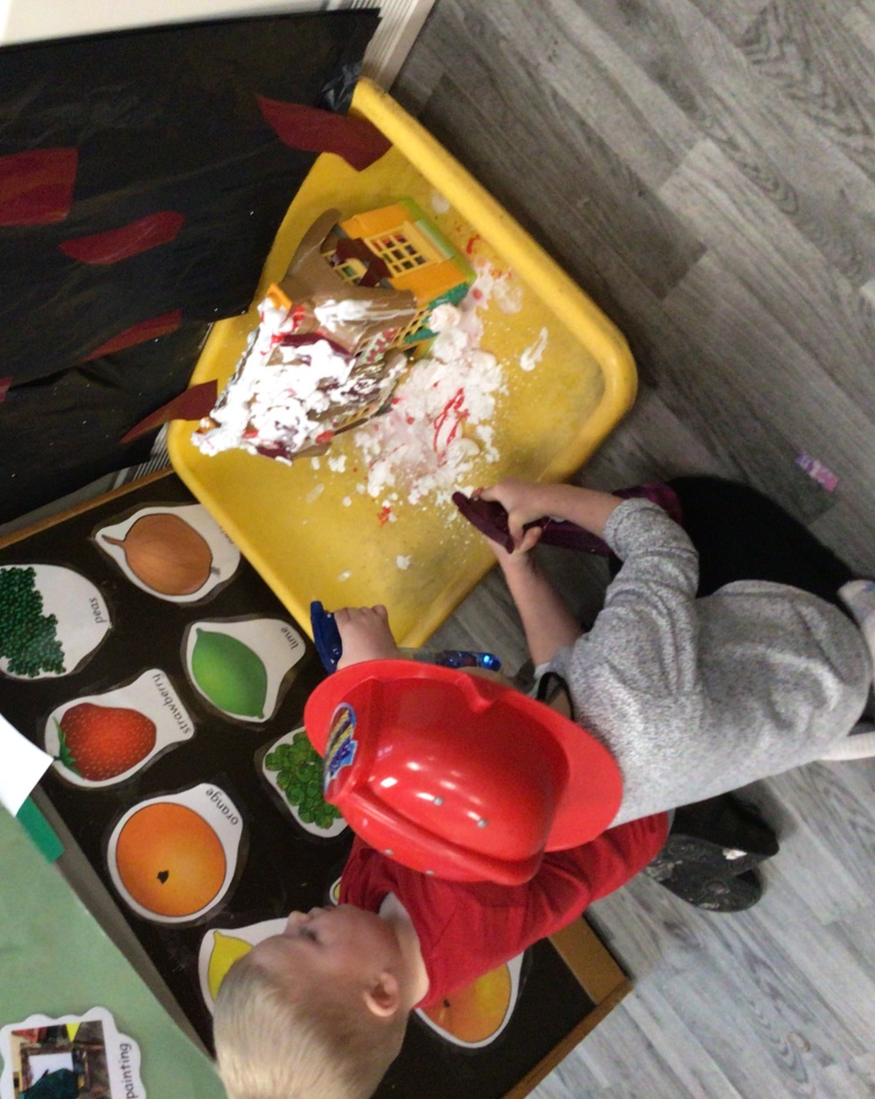

Help with childcare costs
The government funds 15 hours of education per week for 38 weeks of the year beginning the term following your child’s third birthday. This is known as “Universal” funding. Most working parents will be able to access a further 15 hours a week which can be split between up to 2 providers a day. This “extra” funding can be used at Breakfast clubs and after school clubs and for holiday childcare. Parents apply for this funding online and will receive an 11 digit code to bring into Nursery.
Child tax credit-This is paid into the bank account of the main person in your family who is responsible for looking after the children. Child tax credit is available to families with an income up to £43,000 whether or not they are working.
Working tax credit-Help is available for parents who work through the Working Tax Credit, part of which helps with the costs of childcare. You can get more information on either credit online at www.inlandrevenue.gov.uk/taxcreditsor ring the helpline on 0845 300 3900.
Food/snacks/drinks
Drinks of water are available on demand throughout the day. Children are encouraged to drink plenty of water, especially in warm weather. Children have access to milk at snack time and lunch time. Children do not need their own water bottle unless they bring a packed lunch.
To safeguard your child’s teeth, we aim to limit the consumption of sugar. Our snacks include lots of fresh fruit and vegetables. Children are not allowed to bring sweets or chocolate to eat at nursery as a snack. Children may have biscuits etc. in their packed lunch. Please talk to us about your child’s allergies or any special dietary needs.
Sometimes we have other food in school e.g. to celebrate Chinese New Year. You will be informed of these occasions.
Children who are staying for lunch can bring a packed lunch which will be eaten in the dining hall at 11:55am with the other classes. The nursery children sit together with a familiar adult.
Children can have a hot dinner (currently £3.00 per day.) Parents on certain benefits can apply for 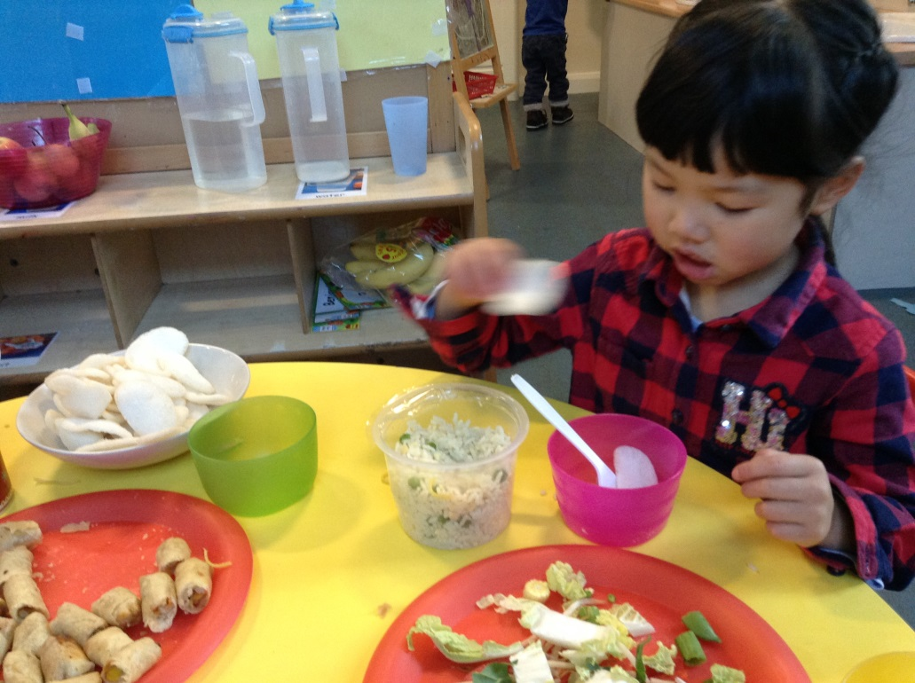
Pupil premium which can support with the costs of having a hot lunch.

Security of children
For the safety of all the children in our care the EYFS access gate is open until 8:55am before being shut by a member of staff. The gate reopens at 11:55am for parents collecting children from the morning session and for parents bringing children to the lunch session. The gate unlocks again at 3:00pm for parents picking up children from reception/nursery and will stay unlocked until 3:45 pm.
In the morning a member of staff will stay at the classroom door and there is a further member of staff by the gate. At the end of the day a member of staff will let parents in through the classroom door and will stay at the door until all children are collected. During the day when the external gate is locked children will have access to the outdoors with a member of staff.
Under no circumstances will we allow your child to be collected by anyone not authorised by you. Proof of identity or a password will be required from anyone unfamiliar to us. We will not allow anyone under the age of 16 to collect your child.
If you are later than 8:55am in the morning, please can you enter school through the office.

Clothing and nappies
Most children at 3 years old are already using a toilet. Within the nursery class are infant sized toilets. It is expected that children will attempt to wipe their own bottoms. If your child still wears nappies please inform us before they start nursery and we will work together on toilet training.
Children can keep a bag with a change of clothing on their peg in case of accidents or getting wet outside. A member of staff will assist children in getting changed where needed.
We encourage children to wear clothing that they can remove and dress themselves in including their socks and shoes. A coat must be brought each day. In summer a sun hat must be provided that can be left in school. All clothes should be named. If you have signed the consent form we will support children in applying sun cream on arms, legs and faces.

Illness and infection
Due to the risks of cross-infection in a nursery environment, if your child is suffering from an infectious illness, including Measles, German Measles, Chicken Pox, Thrush, Impetigo, Scarlet fever etc. he or she must not attend nursery until the infection has cleared. Please ask for latest health service advice. If your child is suffering from sickness or diarrhoea, then they must not return to nursery for 48 hours after beginning to feel well again.
Please make sure all contact details are up to date in case we need to ring you in case of an accident or illness.

Prescribed Medication
We will only give your child medication that is prescribed by a GP. Please fill in a form from the school office if your child needs medication during the day including inhalers. Medicine will only be given if it is in its original container with the child’s name on.

First Aid and Emergency treatment
When your child starts nursery we will ask you for written permission to administer first aid treatment if necessary, and for permission to take your child to hospital, by car or ambulance in an emergency.

Access to records
Parents are welcome to see any written records we hold on their child. Children’s learning journeys are now all online using the “evidence me” app. Let me know if you need support in setting this up. You can look at children’s observations and achievements as often as you like. We encourage parents to send us photos on and achievements on the app.
We also have paper assessments including tracking grids/speech and language and phonics. You will be shown these at parent’s evening.
News
The nursery has its own area on the school website under “classes.” We also have a blog.
www.scotforth-st-pauls.lancs.sch.uk
You are welcome to come to school functions and are automatically a member of Scot4all our PTA.
Scot4all have their own facebook group that you can request to join.
We no longer send out paper copies of the weekly newsletter. Newsletters are now automatically sent by email to all parents. Please contact school if you do not wish to receive it.

Application for a Nursery Class place
Child’s Full Name: | Child’s Date of Birth:  Child’s Gender:

Parent / Guardian’s Full Name:
Parent D.O.B:
Parents national insurance number (if using the extra 15 hours)
11 digit code for extended 15 hours if known:
Address:

Postcode:
Home Telephone: Work Telephone:
Mobile: Email:
All languages spoken at home:

Intended Start Date September 2026 January 2027 April 2027
Other start date:
Criteria* under which the place is being applied for
□Child in public care □Medical/social need □Faith □Sibling □Distance
*Please refer to the Nursery Class Admissions Policy and tick as appropriate. These criteria will be applied if the nursery is over subscribed. A supplementary form must also be completed if applying under the faith criteria (criteria 2).

Free Entitlement Vouchers for Preschool Children (aged 2 to 4 years)
Would you like to use your Universal free 15 hours: Yes / No

Are you eligible for the extra 15 hours Yes/No

Will use be using a Tax free childcare account?

Will you be splitting your hours with another provider Yes/No
Please tell us here how many hours you will be using with each provider………………

Is there anything you think we should know about your child? (You can tell us about anything your child is good at or needs extra support with.)

Do you think your child might be entitled to pupil premium funding? Yes/No

Please ask Nursery staff if you are not sure.

Is your child in receipt of DLA? Yes/No

If yes this funding gives Nursery £1000 a year to support your child e.g. with specialist equipment.
Please indicate on the form below, which sessions you would like your child to attend.
Free Entitlement vouchers
Government universal funded places are available for a total of 15 hours. You could choose either:
- 5 morning sessions/week
- 5 afternoon sessions/week
- 2 full days and a part day.
We will try to accommodate other session patterns, subject to availability.
Please indicate these on the form by inserting a U on the appropriate sessions.
Working parents extra 15 hours funding may be spread between nursery, breakfast club and after school club. Please indicate these with an E on the form
Top-up sessions
Should you require more hours, you have the option to apply for top-up sessions, which will be charged at the following rates and will be subject to availability:
- Morning session (8:55am-11:55am) £16.50
- Afternoon session (12:25pm-3:25pm) £16:50
- Whole day (8:55am-3:25pm) £35.75 (including lunchtime care)
Please indicate these on the form by inserting a T on the appropriate sessions.
There is no charge this year for consumables including snacks/drinks.
 | Monday | Tuesday | Wednesday | Thursday | Friday
Breakfast Club*
7:45am-8:45am
Morning session
8:45am-11:55am
Lunchtime session
11:55am-12:25pm
Afternoon session
12:25pm-3:25pm
After-school Club*
3:25pm-6pm
Breakfast Club and After-school Club are provided by Scotforth After School Club under the leadership of Marie Smith (whose Ofsted registration includes 3 and 4 year olds). Please see their prospectus for further information.
If we are unable to offer you the requested sessions can we offer you alternatives? Yes/No
Details:

Signature of Parent / Guardian Date: Date:
You will receive an email to acknowledge receipt of your application form. You will then receive an email the term before the start date to ask you to confirm you want to take up a place.

