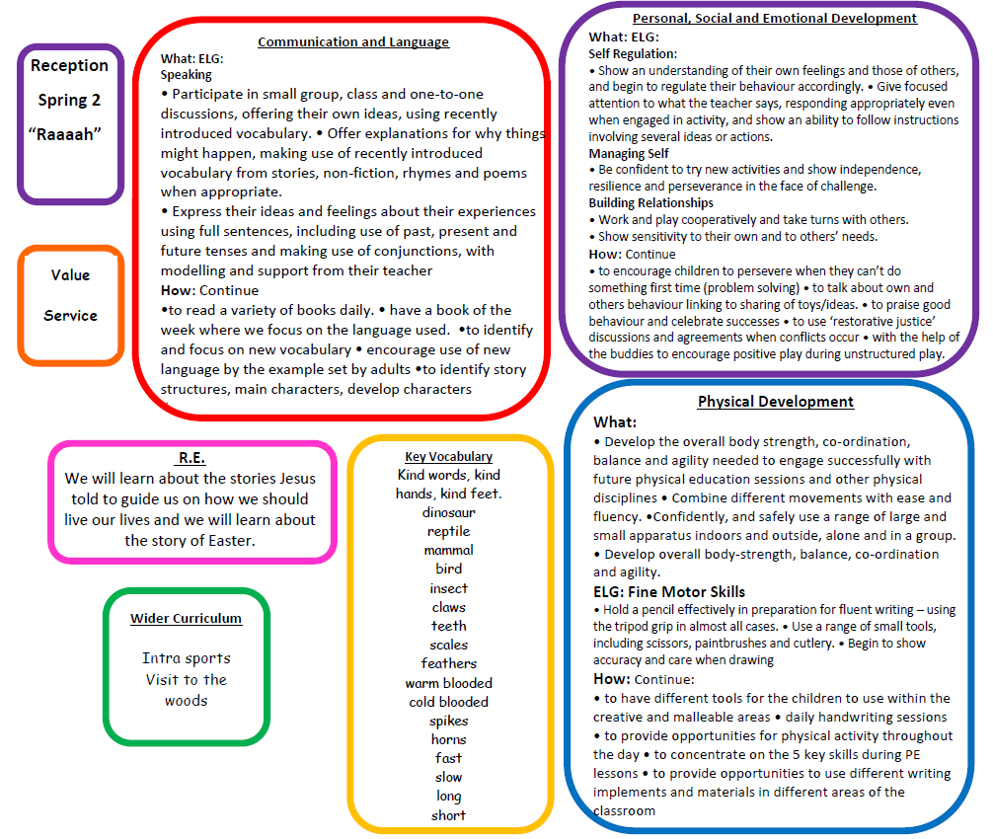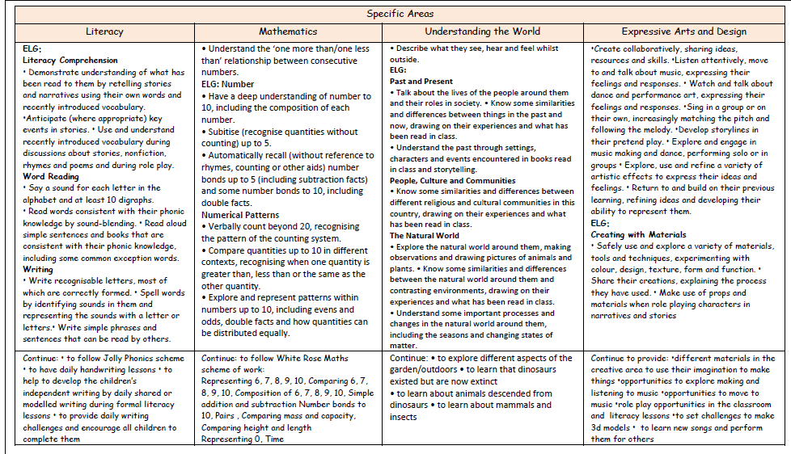

**Wider curriculum**

This half term we will be comparing animals, dinosaurs and talking about where they live.

We will be walking to Dorrington Woods.

Intra sports

**Compassion**