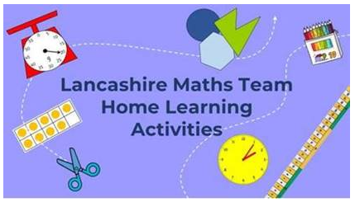
The Lancashire Maths Team have put together free resources on their website:
http://www.lancsngfl.ac.uk/curriculum/primarymaths/index.php?category_id=1211
There is a timetable on the page of activities across the week including games, puzzles and skill sharpening activities, some for specific year groups, some for either EYFS/KS1 or KS2 and some which can be adapted for any year group.

It is not part of the password protected site so can be accessed by all families.

