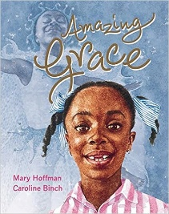
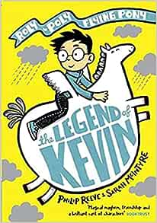
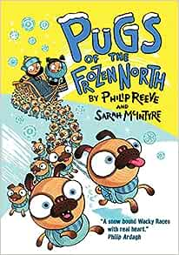
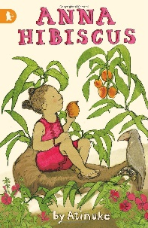
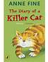
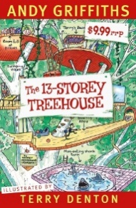
Scotforth School - Year 3 Recommended Reading List 2023-24. How many can you read?
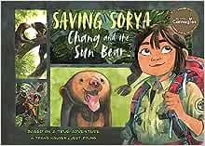

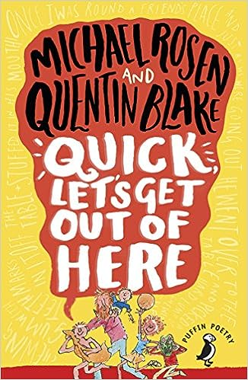
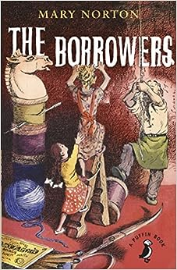
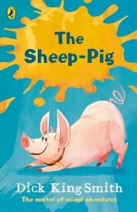
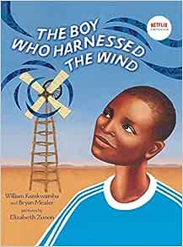
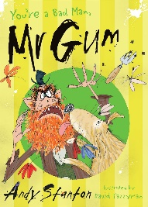
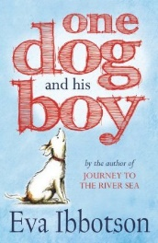
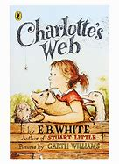
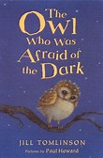
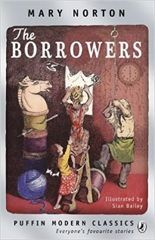
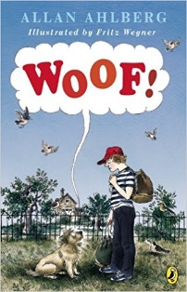
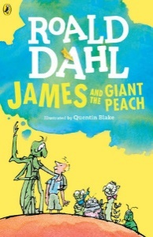
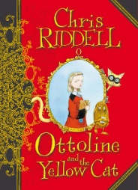
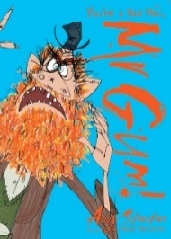
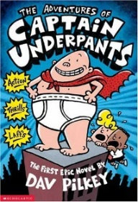
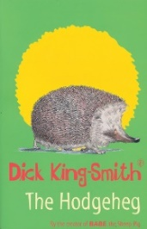
 | Tick and date when read. (This includes sharing it with an adult.)
The Accidental Prime Minister | Tom McLaughlin
Willa and Old Miss Annie | Berlie Doherty
Ottoline and the Yellow Cat | Chris Riddell
The 13-Storey Treehouse (series) | Andy Griffiths
Pugs of the Frozen North | Philip Reeve and Sarah McIntyre
Cliffhanger | Jacqueline Wilson
The Legend of Kevin | Philip Reeve & Sarah McIntyre
You’re a Bad Man Mr Gum! (series) | Andy Stanton
The Enchanted Horse | Magdalen Nabb
Anna Hibiscus (series) | Atinuke
Tales of Wisdom and Wonder | High Lupton
The Hodgeheg | Dick King Smith
The Owl Who was Afraid of the Dark | Jill Tomlinson
The Diary of a Killer Cat | Anne Fine
The Miraculous Journey of Edward Tulane* | Kate DiCamillo
One Dog and His Boy* | Eva Ibbotson
The Abominables* | Eva Ibbotson
Saving Sorya – Chang and the Sun Bear | Trang Nguyen & Jeet Zdung
Ruby’s Worry | Tom Percival
Charlotte’s Web* | E.B. White
The Sheep Pig | Dick King Smith
The Great Hamster Massacre | Katie Davies
The Battle of Bubble and Squeak* | Philippa Pearce
Harry the Poisonous Centipede (series) | Lynne Reid Banks
Woof! | Allan Ahlberg
It was a Dark and Stormy Night | Janet Ahlberg
Amazing Grace (series) | Mary Hoffman & Caroline Birch
Lubna and the Pebble | Wendy Meddour & Daniel Egneus
Mr Majeika | Humphrey Carpenter
The True Story of the Three Little Pigs | Jon Scieszka
The BFG* | Roald Dahl
James and the Giant Peach | Roald Dahl
Ice Palace | Robert Swindells
The Magic Finger | Roald Dahl
Meerkat Mail | Emily Gravett
The Borrowers* | Mary Norton
The Boy Who Harnessed the Wind (picture book edition) | William Kamkwamba
Flat Stanley series | Jeff Brown
Six Dinner Sid | Inga Moore
Please Mrs Butler (poetry) | Allan Ahlberg
Quick, Let’s Get Out of Here (poetry) | Michael Rosen & Quentin Blake
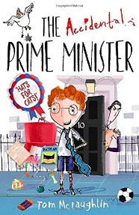
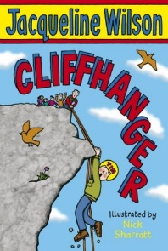
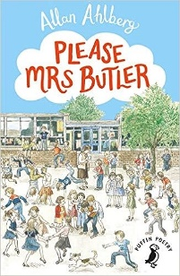
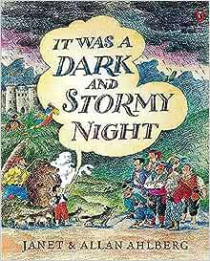
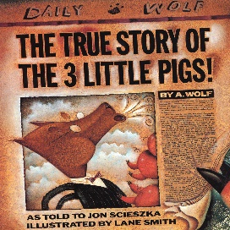

*These books are longer and more demanding so probably need to be read to/shared with your child

Year 3 Recommended Reading List 2023-24
Dear Parents/Carers,
We are sometimes asked to recommend books suitable for different aged children and over the page is a list of possible fiction books for Year 3 aged children. The list over the page is purely a suggested reading list and by no means compulsory or exhaustive (please feel free to suggest to us any other texts you know that are suitable). We would also recommend that you read the synopsis of the book before deciding whether it would be suitable for, or of interest to, your child.
Please remember that there is an expectation for children to be reading every night at home and to be filling in their reading record regularly (at least 5 times a week). Whilst the children are at a stage where they may be starting to read independently, many of these books are particularly good to share with your child (especially the books with asterisks which are quite long and demanding). This helps them hear good reading and expression being modelled and also allows for you to discuss any themes or vocabulary arising from the books. We have recently bought many of the books on the list and so they are available in school if your child would like to borrow them.
It would be lovely if your child could keep this sheet, filling it in as they go along, and return it to their teacher at the end of the school year. Team points will be awarded! Feel free to attach a list of any other books which your child has read and enjoyed.

J. Redmayne (Literacy subject-leader)

