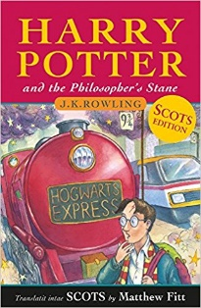
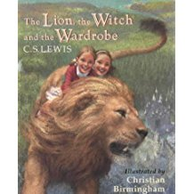
Scotforth School - Year 5 Recommended Reading List. How many can you read?!
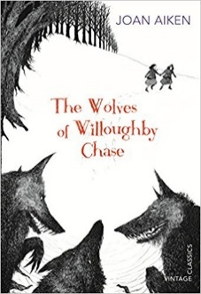
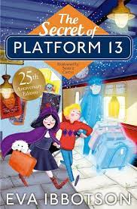
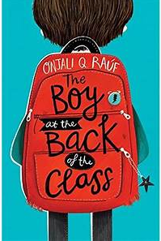
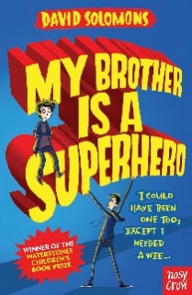

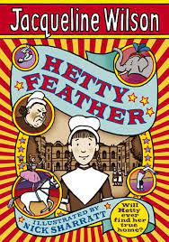
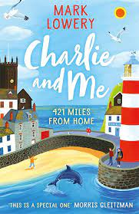
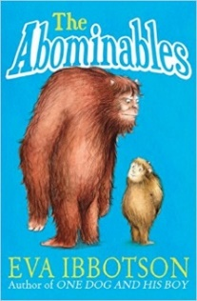
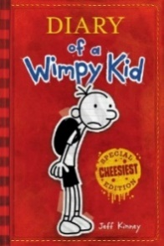
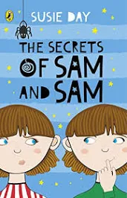
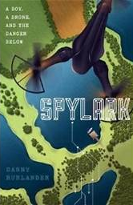
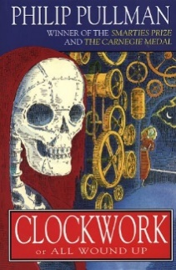
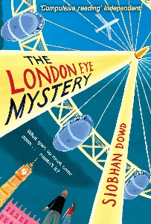
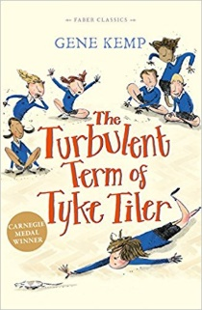
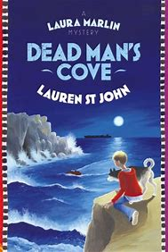
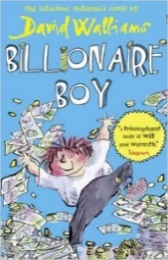
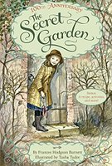
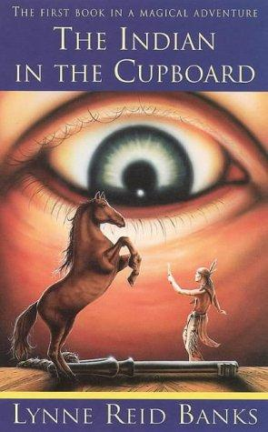
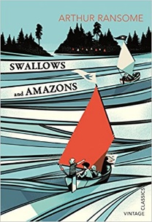
 | Tick and date when read. (This includes sharing it with an adult.) Feel free to awards stars out of 5!
Harry Potter and the Philosopher’s Stone (and others in the series) | J.K. Rowling
The Secrets of Sam and Sam | Susie Day
My Brother is a Superhero (series) | David Solomons
The Lion, the Witch and the Wardrobe | C.S. Lewis
Kaspar : Prince of Cats | Michael Morpurgo
The Wolves of Willoughby Chase | Joan Aiken
Charlie and Me | Mark Lowery
The Last Bear | Hannah Gold
The Abominables | Eva Ibbotson
Diary of a Wimpy Kid (series) | Jeff Kinney
Boy | Roald Dahl
Danny Chung Does Not Do Maths | Maisie Chan
Cosmic | Frank Cottrell-Boyce
Has Anyone Seen Archie Ebbs? | Simon Packham
The London Eye Mystery | Siobhan Dowd
Clockwork | Phillip Pullman
I was a Rat | Phillip Pullman
Spylark | Danny Rurlander (local author)
Dead Man’s Cove | Lauren St. John
The Secret Garden | Frances Hodgson Burnett
The Secret of Platform 13 | Eva Ibbotson
The Boy at the Back of the Class | Onjali Q. Rauf
Hetty Feather | Jacqueline Wilson
The Amazing Edie Eckhart | Rosie Jones
Secret Friends | Elizabeth Laird
One Dog and His Boy | Eva Ibbotson
The Turbulent Term of Tyke Tiler (some bad language) | Gene Kemp
The Miraculous Journey of Edward Tulane | Kate DiCamillo
Bernard’s Watch | Andrew Norris
Give Peas A Chance (short stories) | Maurice Gleitzman
Rooftoppers | Katherine Rundell
The Children of Castle Rock | Natasha Farrant
Matilda | Roald Dahl
Danny the Champion of the World | Roald Dahl
The Secret Garden | Frances Hodgson Burnett
Quick, Let’s Get out of Here (poetry) | Michael Rosen and Quentin Blake
Talking Turkeys (poetry) | Benjamin Zephaniah
Don’t Tell the Teacher (poetry) | Gervaise Phinn
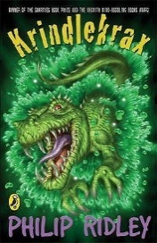
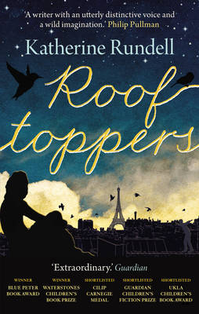
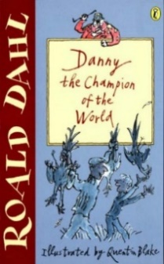
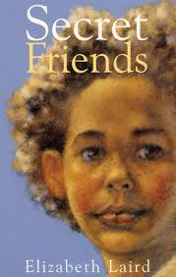

Year 5 Recommended Reading List
Dear Parents/Carers,
We are sometimes asked to recommend books suitable for different aged children and over the page is a list of possible fiction books for Year 5 aged children. The list over the page is purely a suggested reading list and by no means compulsory or exhaustive (please feel free to suggest to us any other texts you know that are suitable). We would also recommend that you read the synopsis of the book before deciding whether it would be suitable for, or of interest to, your child as sometimes the subject matter can be quite demanding.
Please remember that there is an expectation for children to be reading every night at home and to be filling in their reading record regularly (at least 5 times a week). Whilst the children are at a stage where they can read independently, many of these books are particularly good to share with your child. This helps them hear good reading and expression being modelled and also allows for you to discuss any themes or vocabulary arising from the books. We have recently bought many of these books and so they are available in school if your child would like to borrow them.
It would be lovely if your child could keep this sheet, filling it in as they go along, and return it to their teacher at the end of the school year. Team points will be awarded! Feel free to attach a list of any other books which your child has read and enjoyed.
J. Redmayne (English subject-leader)

