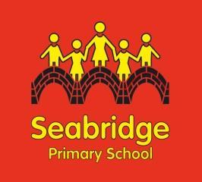

**Science**

**Intent**

At Seabridge we want our children to be naturally curious about the world around them. We want to embrace their sense of wonder about natural phenomena and to guide them into becoming enquiry-based learners. We provide children with a broad and ambitious science education that provides the foundations needed to recognise the importance of science in every aspect of their daily life. In an ever-changing world where our children’s future jobs may not even exist yet, it is vital that our children understand how science has already changed their lives and how it may shape their future.

**Implementation**

At Seabridge Primary School science is taught weekly. The Early Years Framework and the National Curriculum Science programme of study are used to ensure that teaching and learning shows coverage and progression across all key stages. The acquisition of key scientific knowledge is an integral part of our science lessons. Children are given the opportunity to reflect on previous learning and cross curricular links are made where possible. Working scientifically skills are embedded into lessons to ensure these skills are being developed throughout the children’s school career and new vocabulary and challenging concepts are introduced through direct teaching. Teachers demonstrate how to use scientific equipment and the working scientifically skills to embed scientific learning. Science teaching at Seabridge involves adapting and extending the curriculum to match all pupils’ needs to ensure they are challenged and achieve success, regardless of their starting point. Where possible, science is linked to class topics. Headstart is used as an assessment tool to allow teachers to assess pupils at the end of each science unit. The outcome of the assessments and subsequent data, along with ongoing teacher assessment, allows judgements to be made on the attainment and progress of pupils and guides future teaching and learning.

**Impact**

Science at Seabridge ensures our children progress to secondary school with the enthusiasm to want to know more about the world and the skills to enable them to work scientifically at a deeper level. We provide children with the foundations and knowledge for understanding the world, aiming to ignite their interest in a range of science-based subjects, promoting STEM subjects so that children learn about the possibilities for future careers in science. We further develop the profile of Science through enrichment activities including science week, Goblin Car STEM projects and school trips.