LONG TERM OVERVIEW  YEAR 4  2024 / 2025 |  |  |  | 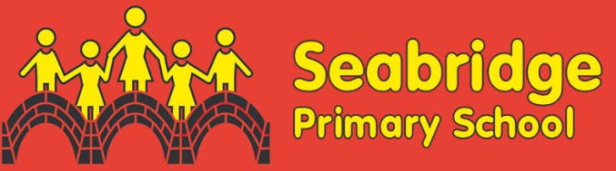
SUBJECT | AUTUMN 1 | AUTUMN 2 | SPRING 1 |  | SPRING 2 | SUMMER 1 | SUMMER 2
FOCUS | Anglo-Saxons |  | Ancient Egyptians/Rivers |  |  | Mountains and civilisations
  ENGLISH | Journey, Aaron Becker  Various Poems | Beowulf, Michael Morpurgo  The Little Match Girl, Hans Christian Andersen | Wisp, Zana Fraillon and Grahame Baker-Smith  Shakespeare- The Tempest |  | Alba the 100 Year Old Fish, Lara Hawthorne | Where the Rainforest Meets the Sea, Jeannie Baker
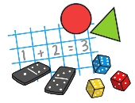  MATHS | Number- Place value  4-digit numbers  Addition and Subtraction | Addition and subtraction  Multiplication and Division  Area | Multiplication and division  Length and Perimeter |  | Fractions including decimals | Decimals  Money  Time | Geometry-shape, position and direction  Statistics
  SCIENCE | States of matter |  | Electricity |  | Living things and their habitats | Animals Including Humans | Sound
GEOGRAPHY  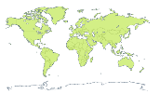 | North America | North America |  |  | Rivers | Mountains  Settlements | Agriculture
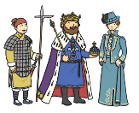  HISTORY | Anglo-Saxons | Anglo-Saxons | Anglo Saxons |  | Ancient Egyptians | Cradles of Civilisation  The Indus Valley | Persia and Greece
  COMPUTING | Online Safety | Computer systems | Computer science and programming |  |  | Photo editing  Audio editing | Data
  ART | Drawing and sketchbooks |  | Surface and Colour- Famous artist- Paul Cezanne  Still Life |  |  | Working in 3D
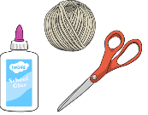  DT |  | Seasonal stockings |  |  | Light up signs | Light up Sign continued
  PE | Tennis | Handball | Gymnastics |  | Dance  OAA | Athletics | Swimming  Rounders
  MUSIC | Interesting time  signatures | Combining elements to make music | Developing pulse and grove through  improvisation |  | Creating simple melodies together | Connecting notes and feelings | Purpose, identity and expression in music
 | Recorders run throughout the Autumn and Spring Term and the other elements of music are taught throughout the lesson. |  |  |  |  | Connecting notes and feelings | Purpose, identity and expression in music
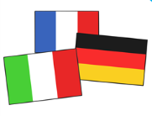  MFL | Phonics lesson- La Phonetic  Je Me presente |  | Culture lesson- La Galette des rois  Quel Temps Fait-il? |  |  | Chez moi (My home)
  RE | What is the best way for a Jew to lead a good life? | What is the most significant part of the nativity story for Christians today? | How do Jewish beliefs, teachings and stories impact on daily life? |  | Is forgiveness always possible for Christians? | How does celebrating Shavuot help Jewish children feel closer to God? | Do people need to go to church to show they are Christians?
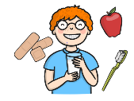  PSHE | Online relationships | Respectful relationships  Being safe | Families and people who care for me |  | Health and wellbeing | Mental wellbeing | Risks

