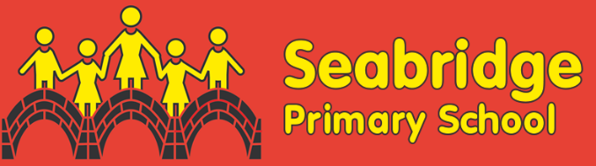SCIENCE

LONG TERM OVERVIEW

2025 / 2026

|  |  |  |  |  |  |  |
| --- | --- | --- | --- | --- | --- | --- |
|  | Autumn 1  (8 Weeks) | Autumn 2  (7 Weeks) | Spring 1- Science week  (6 weeks) | Spring 2  (5 Weeks) | Summer 1  (6 Weeks) | Summer 2  (7 Weeks) |
| Year 1 | Animals including Humans - Humans | Everyday materials 1 | Everyday Materials 2 | Seasonal Change | Animals including humans – Animals | Plants |
| Year 2 | Living things and their habitats | Living things and their habitats – around the word | Everyday materials | Plants | Animals including Humans – growth | Animals including Humans – Lifecycles |
| Year 3 | Scientific enquiry | Rocks | Animals including Humans | Forces and magnets | Plants | Light |
| Year 4 | States of matter | Electricity | Living things and their habitats | Living things and their habitats – conservation | Animals including humans | Sound |
| Year 5 | Forces | Earth and Space | Properties of materials | Changes of materials | Animals including humans | Living things and their habitats |
| Year 6 | Living things and their habitats | Light | Electricity | Animals including Humans | Evolution and inheritance | Looking after our environment |