When reading a book I take on various reading roles.
Seabridge reading roles

At Seabridge. reciprocal reading roles are used to develop reading comprehension, confidence in reading and inference through the use of specific reading strategies: predicting, questioning, clarifying and summarising. Our reading strategy encourages children to ask questions about the text they are reading and to discuss the text with others; asking questions and group discussion about a text requires a higher level of understanding and engagement.
At home, we would like you to use these roles with your child and record their reading activities in their home school link diaries. Whilst at home reading, your child will only need to focus on one of the below roles and these roles will be modelled in their partner reading session that day.

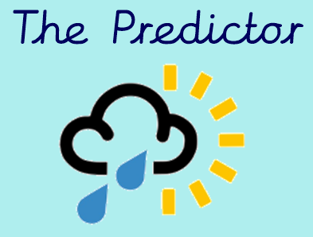
A predictor uses the information to form an idea about what will happen next. During this session, your child will make a prediction at the beginning of a story using clues from the front cover. As your child progresses throughout the week, they can continue to review and alter their prediction.

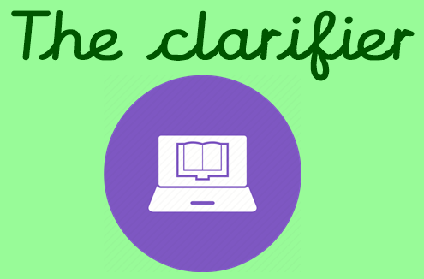
In this role, it is important for your child to remember that they will not know or understand every word or phrase in a text. As a clarifier, your child will aim to explore the meaning of words/phrases in relation to their text in order to improve their understanding.

The reader role takes place once the Predictor and Clarifier roles have been completed. Before each session, your child can be supported by going over their prediction, recapping unfamiliar words and summarising what they have read so far. We encourage your child to complete their text within three or four reading sessions before moving on to the others roles.
The Reader

As the summariser, your child will find the more important pieces of information in a text. This role can be done at the end of each paragraph/page or once they have finished the book depending on their age and reading ability. You child should then be able to summarise the main ideas in a limited amount of sentences.

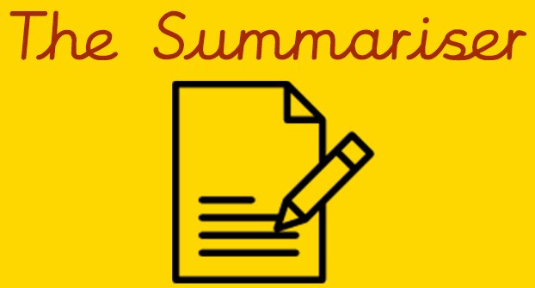

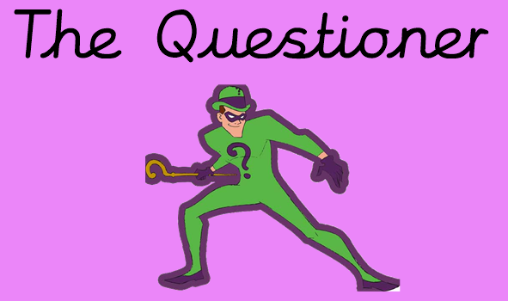
Parents/guardian be prepared for it’s your child’s turn to question you. To embed their understanding of a text further, your child will ask you questions about the text they are reading. Encourage and model with your child questions where you can quickly locate the answer within the text and questions which provide thought and challenge.

This task is the final task to be completed.
As a comprehension champion, your child will take on the role of a detective looking for the answers to questions within a text. To support your child you could ask them a range of questions linking to the text such as: How do you know the character is happy? What is the colour of ___? Why do you think X is hurt? What does the word X mean?
Comprehension questions can also be found online and at the back of your child’s reading book.

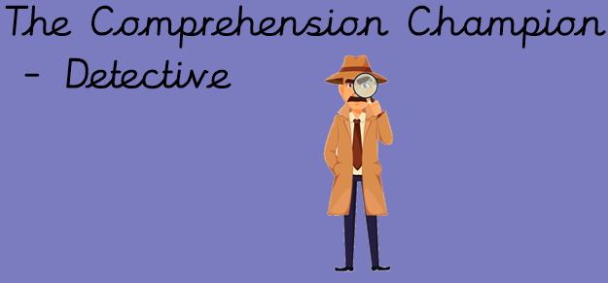

How does it work as a free reader?
When becoming a free reader, your child will still be required to use our school reading roles. However, they may begin to use two or more reading roles at the same time. The use of multiply roles when reading will allow for your child think in more detail about the skills they are using in order to gain a stronger understanding of the text.

Example week
Monday | Predictor role will be used to create connection linked to predicted vocabulary.
Tuesday  P 1 - 35 | Your child will need to flick between the Clarifier, Reader and Summariser when reading a larger passage to ensure they have a good understanding of the text.
Wednesday  P 36 - 54 | Your child will need to flick between the Clarifier, Reader and Summariser when reading a larger passage to ensure they have a good understanding of the text.
Thursday  P 55 - 90 | Your child will need to flick between the Clarifier, Reader and Summariser when reading a larger passage to ensure they have a good understanding of the text.
Friday  P 91 - 120 | Your child will need to flick between the Clarifier, Reader and Summariser when reading a larger passage to ensure they have a good understanding of the text.

Although your child will be a free reader, we still encourage that your child takes how a range of fiction and non-fiction texts from a variety of authors to ensure a breadth of reading.

How can I support my child at home?
Please use the below questions to support your free reading child.
Predictor Role:
Who is on the front cover? What is in the background? How might these details give us clues about the content of the book?
Based on what you know about the character/event, how do you think the
story will develop next?
Think about the author’s other stories. Are there any familiar themes/ characters/settings to the story we are reading? How did the story end? How might this story end?
Do you think the character will change his/her behaviour in the future? Give evidence for your ideas.

Clarifier Role:
What does this word tell us about the character/setting/atmosphere?
Look at that sentence/passage and circle a word/phrase that means the same as .
Which words/phrase in this text give us the impression that the main character is ?
Which words/phrase in this text give us the impression that the setting is ?
Which words/phrase in this text give us the impression that the atmosphere is ?

Summariser Role:
What is the main theme/argument in this paragraph? What is the main message in this paragraph?
Can you describe what has happened in this paragraph/chapter? Using less than 20 words, could you write a new blurb for this book? Which is the most important message in this book?
Can you describe what happened in three sentences? Why do you think that might be important?
Is there anything you know now which you didn’t know before?

Comprehender Role:
Why did the author choose the verb/adjective/adverb ?
Why did the author describe ______ like this?
How does the author imply the ____ is feeling ______?
Look for an example of a simile in the text. How does this add meaning?
Look at chapter ___. Why has this been in included in this text?
Explain how the character’s behaviour/appearance has changed throughout the book.
In what way is ____ like ____?
In what way do the diagrams/illustrations/photographs help support the reader?

