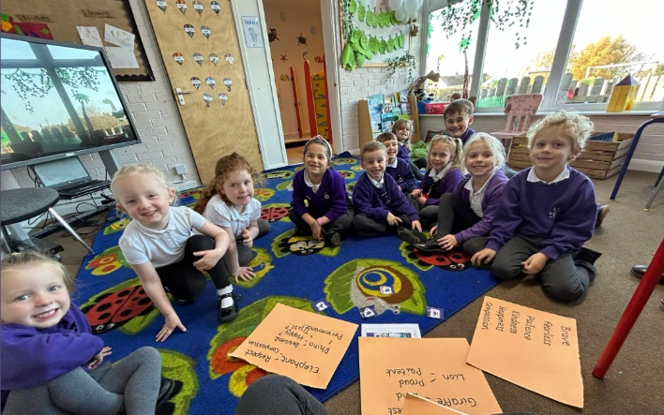**8.11.23**

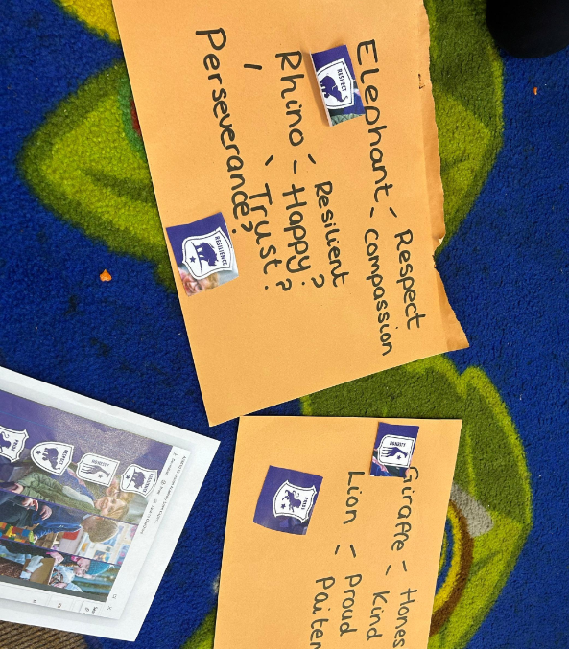Following our previous meeting. We have decided on 4 animals that we think would be great to represent a ‘house’.  
A rhino 🦏  
Elephant 🐘  
Giraffe 🦒  
And a Lion 🦁  
We have also thought of some fantastic words to describe these animals that we could use as values in our school, such as honestly, resilience etc.  
We can not wait to share our final designs with you!

11.10.23

Today the School Council and Green Team got together for our first meeting!  
We discussed our roles and talked about things we would like to see in school.  
Discussions soon turned to some of the children’s interests of Harry Potter and the houses that the children are placed in.  
We researched the meaning of each house and found that:  
  
Gryffindor - bravery and helping others  
Hufflepuff - patience and loyalty  
Ravenclaw - intelligence and knowledge  
Slytherin - ambition and cunningness  
  
We discussed the meanings and what it means to us alongside our classroom rules. We discussed other meanings such as honesty and resilience.  
  
It was mentioned that a lion is proud and we then moved onto discussing different animals. Linking the animals to our classroom rules.  
The children thought it would be a great idea to create houses of our own and are excited to discuss this further in future meetings.

