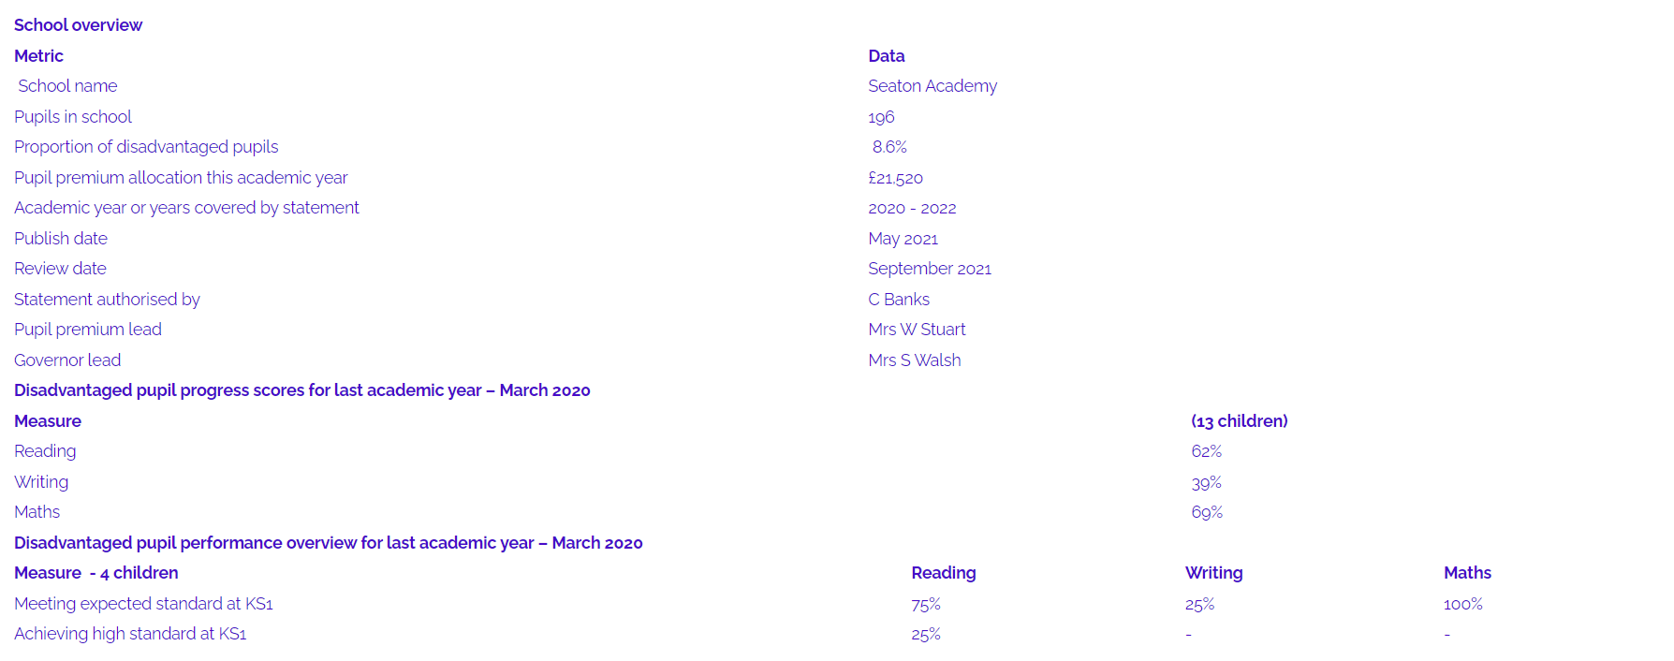**Pupil Premium May 2021**

Signed by:

Headteacher: Name: _____________________ Signature: ______________________

Date:

Trustee (s) Name: _____________________ Signature: ______________________

Name: _____________________ Signature: ______________________

