Grades 6-9 Y11 Independent Revision Plan
Week starting |  | Maths genie
13 Feb | Trigonometry: SOHCAHTOA  Sine and cosine rule  Area of a triangle 1/2absinC  Exact values  3D Pythagoras and Trigonometry
Half Term | Changing the Subject  Transformations of Graphs  Sequences  Bounds
27 Feb | Simplifying surds and rationalising the denominator  Indices  Algebraic fractions  Expanding Triple Brackets
6 March | Factorising quadratics  Completing the Square  Quadratic Formula
13 March | Histograms  Venn diagrams  Probability  Standard Form
20 March | Similarity and congruence  Cumulative frequency and box plots  Ratio and Proportion
27 March | Circle Theorems  Area of sectors and segments, arc length  Equation of a circle  Compound Measures
EASTER | Iteration  Recognising and sketching graphs  Real Life Graphs  Reverse Percentages
EASTER | Simultaneous equations (including with 1 quadratic)  Converting recurring decimals to fractions  Functions
17 April | Vectors  Volume and surface area  Similar shapes
24 April | Reflections, rotation, enlargement, translation  Sampling - capture recapture  Algebraic proof
1 May | Straight line graphs and geometry  Gradient of curves  Trapezium rule for area
8 May | Solving inequalities  Graphing inequalities  Quadratic inequalities
HIGHER - Grades 5 – 9
Algebra
I can do this | Grade | Title |  | I can do this | Grade | Title
 | 9 | Approximate solutions to equations using iteration. |  |  | 6 | Quadratic equations (factorisation)
 | 9 | Equation of a circle |  |  | 6 | Quadratic equations (graphical methods)
 | 9 | Equation of a tangent |  |  | 6 | Represent linear inequalities
 | 8 | Algebra and Proof |  |  | 6 | Simultaneous equations (linear)
 | 8 | Gradients and area under a graph |  |  | 5 | Algebraic argument
 | 8 | Graphs of trigonometric functions |  |  | 5 | Algebraic terminology
 | 8 | Quadratic equations (completing the square) |  |  | 5 | Cubic and Reciprocal graphs
 | 7 | Composite functions |  |  | 5 | Deduce quadratic roots algebraically
 | 7 | Expand the product of two or more binomials |  |  | 5 | Derive an equation
 | 7 | Factorising difficult quadratic expressions |  |  | 5 | Equation of a line
 | 7 | Geometric Sequences |  |  | 5 | Expand the product of two binomials
 | 7 | Graphs of exponential functions |  |  | 5 | Factorising quadratic expressions
 | 7 | Quadratic equations (needing re-arrangement) |  |  | 5 | Fibonacci, quadratic and simple geometric sequences
 | 7 | Quadratic equations (quadratic formula) |  |  | 5 | Graphical solution to equations
 | 7 | Real-life exponential graphs |  |  | 5 | Inequalities on number lines
 | 7 | Represent quadratic inequalities |  |  | 5 | Linear equations
 | 7 | Simultaneous equations (non-linear) |  |  | 5 | Quadratic graphs
 | 7 | Solve quadratic inequalities |  |  | 5 | Reciprocal real-life graphs
 | 7 | Translations and reflections of a function |  |  | 5 | Simplify indices
 | 7 | Turning points & completing the square |  |  | 5 | Simplify surds
 | 6 | Algebraic fractions |  |  | 5 | Solve linear inequalities in one variable
 | 6 | Identifying parallel lines |  |  | 5 | Writing formulae and expressions
 | 6 | Inverse functions
 | 6 | Linear inequalities in two variables
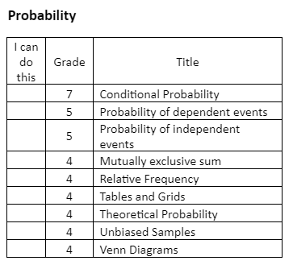
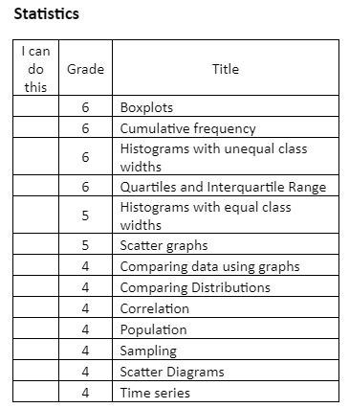
Geometry and Measures
I can do this | Grade | Title
 | 8 | Circle theorems
 | 8 | Vector arguments and proof
 | 7 | Area of a triangle
 | 7 | Cosine Rule
 | 7 | Pythagoras and trig 2D and 3D
 | 7 | Sine Rule
 | 6 | Combined transformations
 | 6 | Congruence and Similarity
 | 6 | Standard trigonometric ratios
 | 5 | Arc lengths and sectors
 | 5 | Derive triangle results
 | 5 | Enlargements and negative SF
 | 5 | Loci
 | 5 | Pythagoras
 | 5 | Similarity and Congruence
 | 5 | Standard constructions
 | 5 | Surface Area
 | 5 | Trigonometric ratios
 | 5 | Volume
 | 4 | Alternate and corresponding angles
 | 4 | Area of a circle
 | 4 | Areas of composite shapes
 | 4 | Areas of triangles, trapezia and parallelograms
 | 4 | Bearings
 | 4 | Circle terminology
 | 4 | Circumference of a circle
 | 4 | Congruent triangles
 | 4 | Enlargements and fractional SF
 | 4 | Perimeter of 2D shapes
 | 4 | Plans and elevations
 | 4 | Polygons
 | 4 | Solve geometrical problems
 | 4 | Vector arithmetic
 | 4 | Volume of prisms

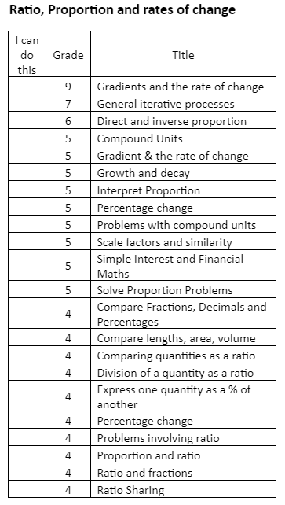
Number
I can do this | Grade | Title
 | 8 | Surds
 | 7 | Index Laws (negative and fractional)
 | 7 | Product rule
 | 7 | Recurring Decimals
 | 7 | Upper and lower bounds
 | 6 | Finance 1
 | 6 | Powers and Roots
 | 6 | Product of prime factors
 | 6 | Using Pi
 | 5 | Calculating with fractions
 | 5 | Error intervals
 | 5 | Index Laws
 | 5 | Limits of accuracy
 | 4 | Adding and subtracting fractions
 | 4 | Checking calculations
 | 4 | Compound measures
 | 4 | Converting metric units
 | 4 | Estimation
 | 4 | Fractions and percentages
 | 4 | Fractions and ratio problems
 | 4 | Interpret calculator displays
 | 4 | LCM and HCF
 | 4 | Multiples and factors
 | 4 | Multiplying fractions
 | 4 | Operations
 | 4 | Order of operations
 | 4 | Powers
 | 4 | Rounding
 | 4 | Standard Form
 | 4 | Terminating decimals and fractions
Exam details:
Edexcel GCSE Mathematics - Higher Exam Dates: All papers 90 mins each
Paper 1 (non-calc) - Friday 19th May 2023 AM
Paper 2 (calc) – Wednesday 7th June 2023 AM
Paper 3 (calc) –Wednesday 14th June 2023 AM

