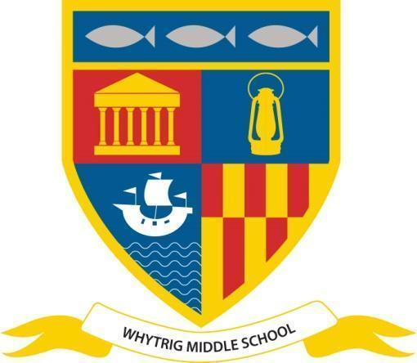  News release  www.svf.org.uk  For immediate release  Date: 17 August 2023  For further information please contact:  Adam Ironside  Phone 0191 237 1505  Email: reception@svf.org.uk | 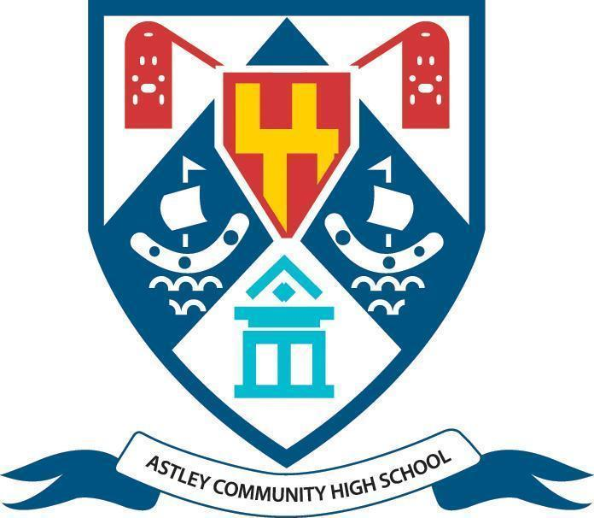
Amazing Post 16 Results at Astley High
A very proud day at Astley High School as students achieve fantastic results and secure places at top Universities including Oxford, Manchester and Newcastle.
Mackenzie Horton achieved top marks with four A* grades in Maths, Further Maths, Physics and Chemistry. He has accepted a place at Manchester University to read Physics.

Macy Reavley achieved excellent grades in English, Psychology and History and she is looking forward to reading English Literature at Oxford University.

Jack Steadman is delighted with an A* in Maths and A Grades in Further Maths, Physics and Chemistry and has a place at Newcastle University to read Mathematics for the next 4 years.

Rowan Dobbins achieved A Grades in Biology, Chemistry and Maths and is taking a year out to gain veterinary work experience before going on to study Veterinary Medicine at University.

Jodie Thompson is very pleased with A Grades in Geography and Maths a Distinction Star in Health and Social Care.

Executive Headteacher, John Barnes commented: “After the recent difficult years our students have experienced I am delighted and so pleased for them that they have achieved these outstanding results. I have no doubt they will go on to be great successes in their future endeavours and I wish them every success ."

Head of School, Richard Goodman stated: “It is great to see so many excellent results this year - this is testament to the hard work of the students and the dedication of our staff. These results open up a whole host of exciting destinations for our students and we wish them all the best for the future.”

Head of Sixth Form, Adam Ironside said: “We are so proud of the amazing results our young people have achieved this year with so many top grades and places at Universities across the country. We are thrilled that they are going on to study their chosen subjects and fulfil their future ambitions. We are very proud of their achievements, and look forward to hearing about their future successes.”

ENDS
Notes to editors
Astley Community High School
Astley Community High School is located in Seaton Delaval, south Northumberland, and is part of the Seaton Valley Federation.

Seaton Valley Federation
The Seaton Valley Federation is a collective of three schools with one governing body including; Seaton Sluice Middle School, Whytrig Middle School and Astley Community High School, under the leadership of one Executive Headteacher, Mr John Barnes.

