The digestive system
Do you know the body parts involved in the digestion process?
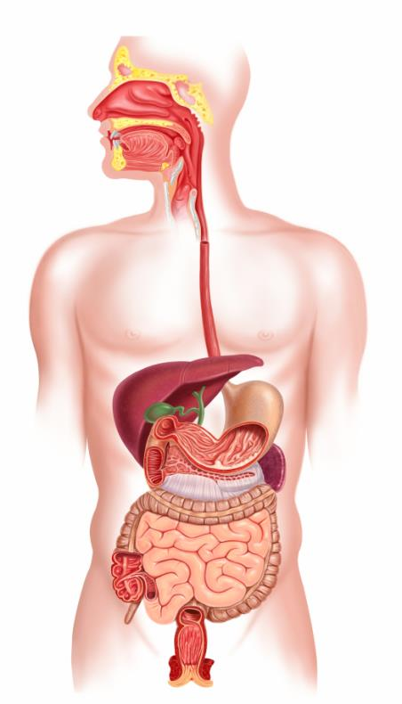
Link the body part name to the correct part of the body.
Mouth
Teeth
Small intestine
Drag and drop the labels to the correct part of the body and then save..
Stomach
Oesophagus

