This is a basic guide to Google classroom. For a comprehensive guide, check out the help section on the google support website here

Students Accessing Google Classroom

Open your Internet browser (Google Chrome works best!)

Go to: svf.org.uk > Click ‘School Email’ at the bottom of the page Depending on your school, email addresses are in the format:
ACHS: sv20jbrown@achs.svf.org.uk SSMS: sv19jbrown@ssms.svf.org.uk WMS: sv17jbrown@wms.svf.org.uk

Use the table below to see what your preﬁx is. Don’t use any symbols - For example, Sam O’Grady-Smith in Y7 will be: SV20SOGradySmith

If you are not sure what your username/password is, ask your teacher. On the home page you can select Classroom.
Correct for Academic Year 2026-2027

Year | Google Prefix
Y5 | sv22
Y6 | sv21
Y7 | sv20
Y8 | sv19
Y9 | sv18
Y10 | sv16
Y11 | sv15
Y12 | sv14
Y13 | sv13

Parents/Guardians Accessing Google Classroom

If you have been invited to a Google Classroom as a parent, accepting the invite means that you will receive summaries of your child’s classroom activity.

You do not gain access to your child’s Google classroom itself.

You can choose to get either daily or weekly summaries, which contain the below information:
- Missing work: Work not turned in when the summary was sent.
- Upcoming work: Work that’s due today and tomorrow (for daily emails) or that’s due in the upcoming week (for weekly emails).
- Class activities: Announcements, assignments, and questions recently posted by teachers.

You will not receive a summary if there is no activity to report, or you accept the invitation but chose not to receive summaries.

You can manage your settings within any of your Google Classroom Guardian Emails (at the bottom of the email under ‘Settings’) or (if you have a Google Account) by
going to: classroom.google.com/gs

Check out the comprehensive Google Classroom for Guardians Guide here.

Smartphones and tablets: download the free Google Classroom app

Android devices | iOS devices (iPhones, iPods, and iPads)
- Open the Play Store app  - Search for ‘Google Classroom’  - Tap ‘Google Classroom’  - Tap ‘Install’ | - Open the App Store app  - Search for ‘Google Classroom’  - Tap ‘Google Classroom’  - Tap ‘Get’

Join a Classroom

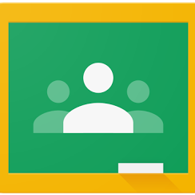
Most of the time, your classes will already be set up for you! Your classes will appear on your homepage and all you have to do is click on it to access each classroom.
Sometimes you might need to join an extra classroom. If you do, click the Plus
button on the classroom homepage and choose ‘Join Class’. Your teacher will give you a code to type in.

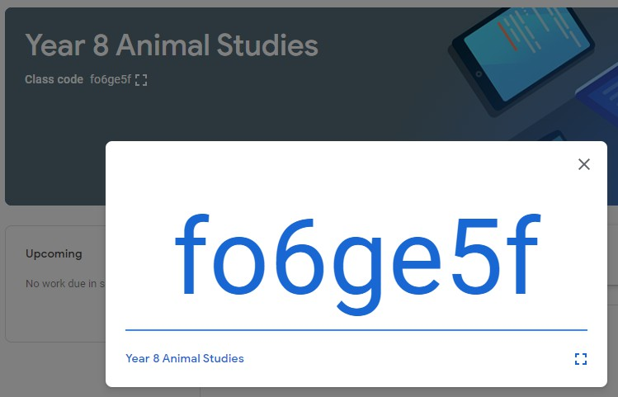

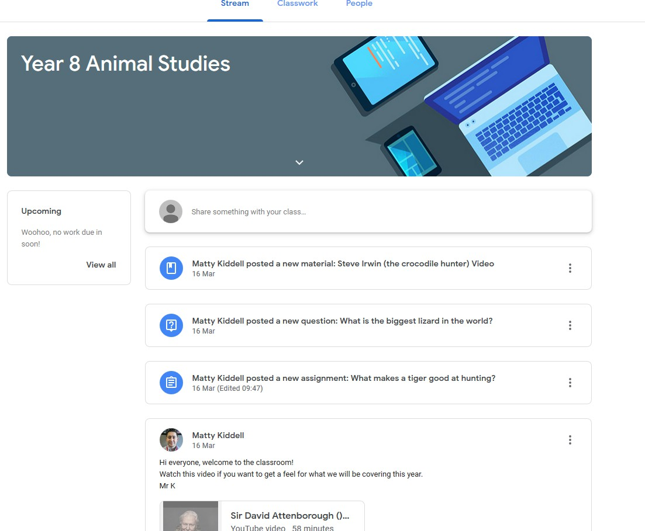
Using the Classroom

The classroom is split into 3 sections: Stream, Classwork and People.

Stream

Stream is the homepage of a classroom. When your teacher shares something like classwork or a message, it will appear here.

Classwork

- Classwork is where you can see the work your teacher has set. You can answer questions and see when work is due (if your teacher has set a due date). When you have completed an assignment or viewed material, the box will be greyed out.
- Here, I can see that my teacher has set an assignment. I can see that it needs to be returned by the 25th March at 11:00.
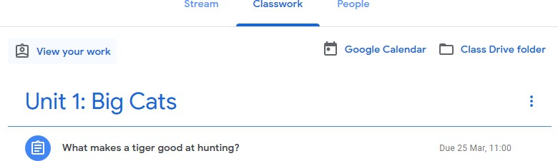

- If I click on the assignment, I can then click on ‘view assignment’ to take me to the work.
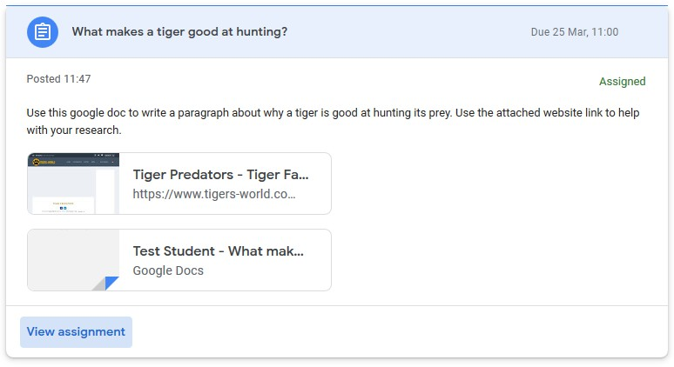

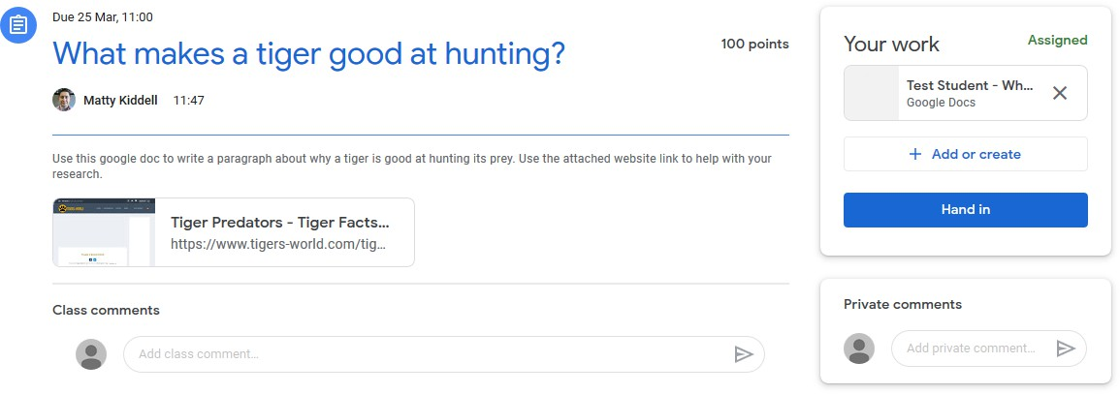
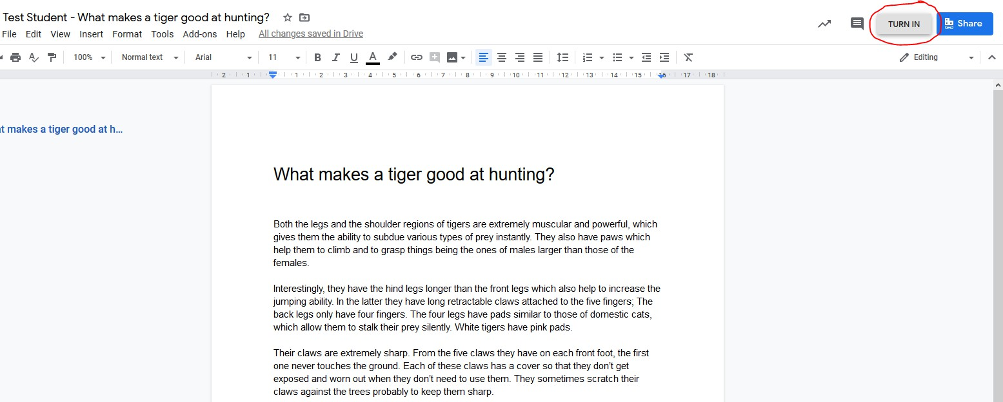
- From here, I can see the instructions and anything that has been attached to help me (like this website link). I can also send a private comment to my teacher (right side) in case I’m stuck or have any questions about the assignment.
- Under ‘Your work’ there is a ﬁle with my name on. Click it to start doing your work.

- I can use this template to do my work. When I’m happy with it, I need to click ‘Turn in’ at the top right corner.

- On the next screen I need to conﬁrm that I’m deﬁnitely happy to hand in this assignment.
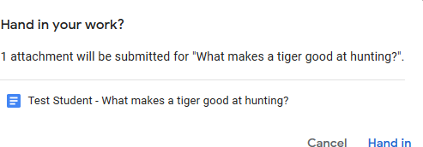

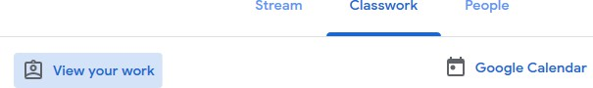
- In the classwork section, I can click ‘view my work’ to see a list of my work for this classroom.

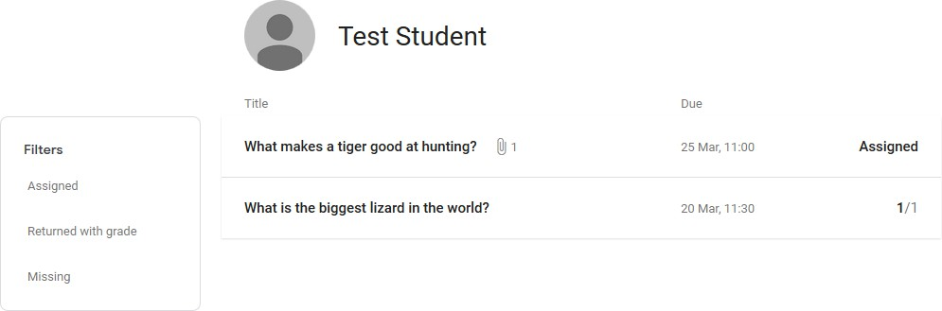
- Next to each assignment, I can see whether I still have to hand in the work (assigned) or if my teacher has marked it.

How to hand in work (mobile devices – Android or iOS)

  - Open the Google Classroom app
  - Tap on their class, then ‘Classwork’ (at the bottom)
  - Tap on an assignment, then the arrow at the bottom
  - Tap ‘Add attachment’. Follow their teacher’s instructions on how to complete their work
  - Once you’ve ﬁnished, tap ‘Hand in’, then ‘Hand in’ again to conﬁrm

Made a mistake? Tap ‘Unsubmit’ to return the work, then follow the last two steps to resubmit it.

Uploading Photos to Classroom

- Sometimes you will need to add photos to your assignments. To begin, take the picture on the device you will use to upload the picture.
- Go to Gmail and start a new email. Add your own email address in the ‘to’ box.
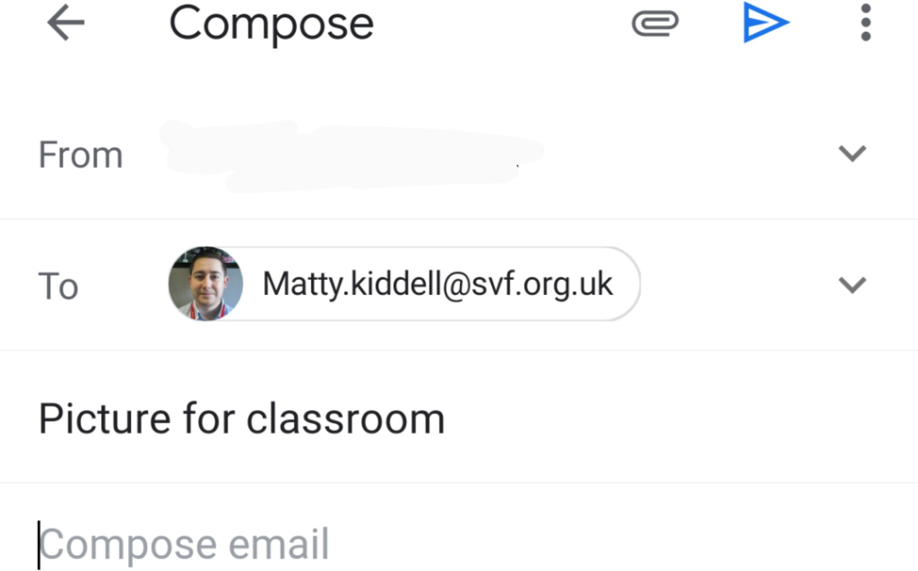

- Click the paperclip to add your picture(s).
- On the device that you use for classroom, go to Gmail and open the email you sent
yourself. Hover over your picture and click the Drive Icon. Choose where in drive you want it to be saved.
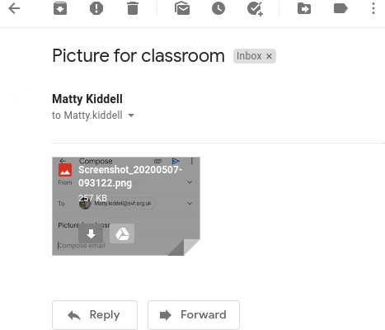

- Go to Google Classroom, ﬁnd the assignment you need to add your photo to. Click ‘add or create’. Then click ‘Google Drive’.
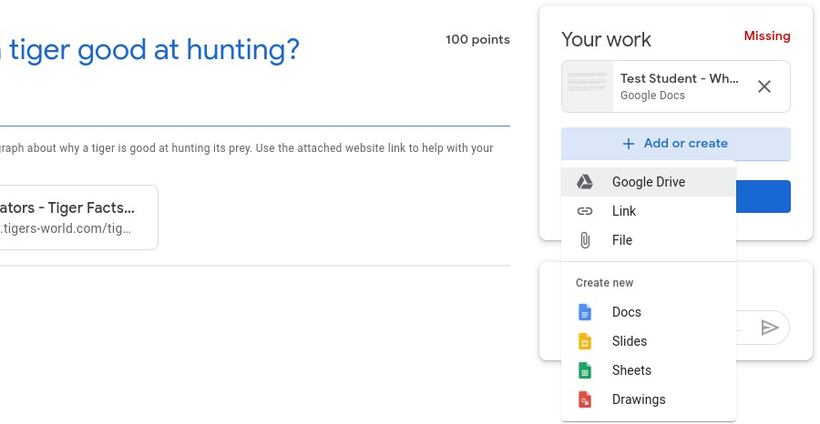
- Find the photo you uploaded and then click ‘add’. When you hand in your work, your teacher will be able to access your photo.

People

- The people section lists the teachers in my class.
- I can use the letter symbol to send an email to my teacher.
