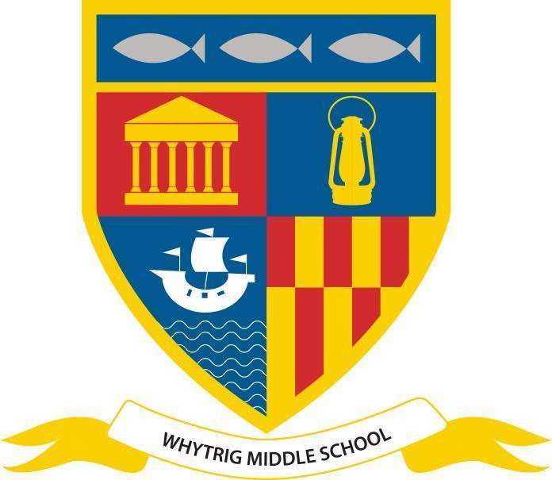
WHYTRIG MIDDLE SCHOOL
One of the Seaton Valley Federation of Schools

Elsdon Avenue, Seaton Delaval, Northumberland NE25 0BP
Tel: 0191 2371402
Email: wms@svf.org.uk
www.svf.org.uk

Executive Headteacher: John Barnes
Head of School: Jonathan Souter

Notices - Week Beginning 13th May 2024

Attendance

Please remember to call in or send a message via MCAS if your child is unwell and will not be attending school by 8:30am. It is important that we have evidence for each day your child is absent, even if they were sent home the previous day.

Please also send evidence of medical/dental appointments so we can attach these to your child’s profile on our system.
SATS Week - w/c 13th May 2024

Good luck to all of the children in Year 6 who will be sitting their SATs next week. After lots of hard work and preparation, they can now put into practice everything they have learned! However we must all remember that the SATs are just a snapshot in two subjects in one week of the school year. We have children who have talents in many different aspects of school life and they are not defined by the outcomes of next week. At the end of the day, we just want the children to do their best, show everyone what they can really do and not worry about things in the process! Here are ten top tips to ensure your child can do their best in the tests:

- Get a good night’s sleep.
- Eat some breakfast.
- Be on time.
- Have the right equipment with them.
- Breathe (don’t panic).
- Answer the question.
- Instructions are their friends!
- Watch the clock.
- Write neatly.
- Try to do their best!
Year 6 SAT Timetable

Monday 13th May Grammar, Punctuation and Spelling (am)
Tuesday 14th May Reading (am)
Wednesday 15th May Maths arithmetic and Maths Reasoning 1
Thursday 16th May Maths Reasoning 2
Year 6 Lilidorei Visit - Friday 17th May

If you are a Year 6 parent/carer, please remember to complete the permission slip for the trip to Lilidorei.
Mental Health Tip of the Week

We ALL have mental health! Here is a great little video to watch together and start a discussion at home; just right for kicking off Mental Health Week! https://youtube/DxIDKZHW3-E

PE Kit Reminder

Please remember that correct PE kit includes:

- trainers (not converse boots or similar)
- plain black shorts/leggings/joggers (no huge brand labels)
- white shirt with badge
- black jumper/hoodie with badge
- long hair must be tied back with bobble or equivalent
- all jewellery must be removed before the lesson- rings, necklace, watches etc
- if your child swims- swimming costume/shorts/trunks plus a towel

If your child is to be excused from PE, please add a note in their planner.

Lost & Found

We have a child who has lost a full PE kit in a black bag. Please can you check for any uniform/belongings that don't belong to your child and return items to school.

After School Sports Clubs

Mondays - KS3 Girls swimming
Tuesdays - Y6 swimming & Bike Club (Mr Edwards)
Wednesdays - KS2 Boys football & KS3 Boys swimming
Thursdays - Girls football
Fridays - KS3 Girls football (3:15-4pm) and Netball
Year 8 Boys Football

Congratulations to our Y8 Boys football team who won the Northumberland School Games competition on Friday. We played 5, won 4 and drew 1 to remain undefeated and claim. 1st place!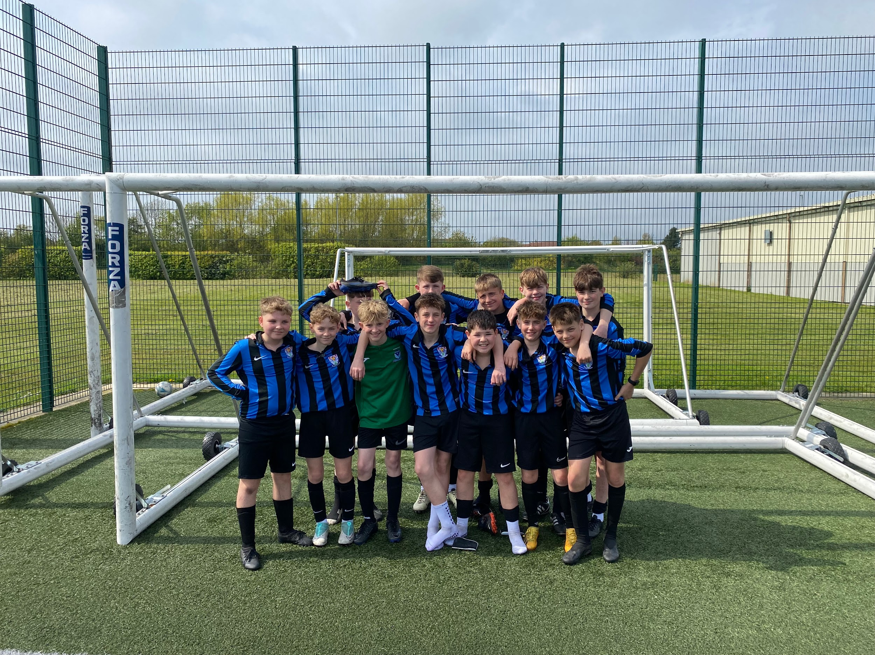
Football Friendlies

Well done to our Year 6 and Year 8 Boys football teams who both won their local derby friendlies against Seaton Sluice Middle School on Thursday 9th May, with some fine performances across both teams.
Stars of the Week

Our Stars of The Week are nominated each week by staff for a variety of reasons, which might be contribution to the school community, school work or something outstanding. Each week their success is shared in school in the Star of the Week video and they receive a certificate and chocolate bar.

Week ending 10/05/24:

5C: Alexandria W; 5K: Mia P; 5L: Brooke E;
6E: Kaycee L; 6F: Elsa B-B; 6L: Jack D;
7H: Oliver T; 7L: Stephanie V; 7T: Amelia S;
8M: Annalise H; 8Ro: Ava M; 8Ru: Savannah M;
Head of School SOTW: Liam S (6E)
Social Media Channels

Don’t forget to keep up to date with everything else on our social media channels
X - @WhytrigMS | Facebook - @Whytrig Middle School

