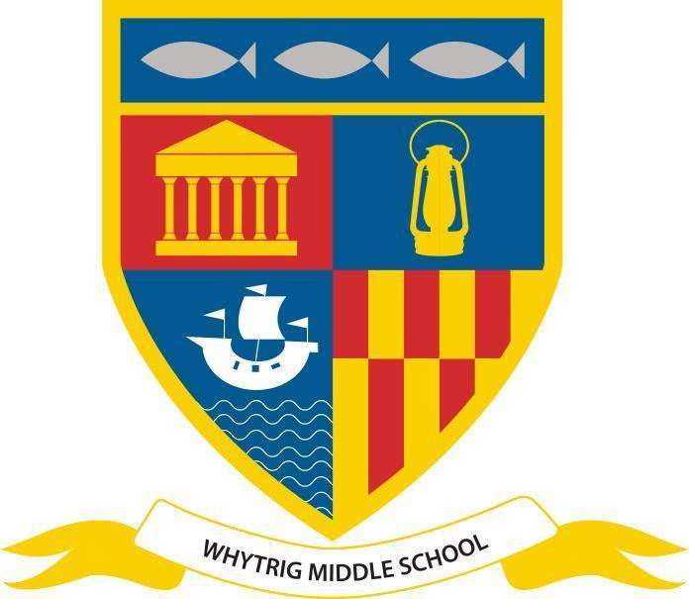
WHYTRIG MIDDLE SCHOOL
One of the Seaton Valley Federation of Schools

Elsdon Avenue, Seaton Delaval, Northumberland NE25 0BP
Tel: 0191 2371402
Email: wms@svf.org.uk
www.svf.org.uk

Executive Headteacher: John Barnes
Head of School: Jonathan Souter

Notices - Week Beginning 20th May 2024

Attendance

Please remember to call in or send a message via MCAS if your child is unwell and will not be attending school by 8:30am. It is important that we have evidence for each day your child is absent, even if they were sent home the previous day.

Please also send evidence of medical/dental appointments so we can attach these to your child’s profile on our system.
Mental Health Tip of the Week

Stress Management Tips for Kids and Teens!
Here is something to watch with your young people at home.
Interview with BAM Site Manager

Two of our students visited the new school site this week and interviewed the Site Manager, Craig Madge. They were very excited to see the plans in 3D and to look across the site from the offices. They were amazed at how big the site is and the facilities that the new school will have.
Free Half Term Holiday Camp

May half term funded holiday camp by Seaton Valley Town Council. Take a look here:

https://www.facebook.com/NCCSportsDevelopment/posts/pfbid029p2ExkJzSBnwudrYWMtxjCuKjhDTKC5K2gUvt87dBoaA1zRx3PuMsWXcQEVkLe7Cl

Boys Football Results
Year 6
WMS 4-1 SSMS
WMS 7-1 SSMS

Well done to our Y8 Boys “B” team who were undefeated at the School Games event at Blyth Academy on Thursday
WMS 0-0 Blyth
WMS 1-1 North Gosforth Academy
WMS 2-0 Dukes
WMS 0-0 Highfield MS
PE Kit Reminder

Please remember that correct PE kit includes:

- trainers (not converse boots or similar)
- plain black shorts/leggings/joggers (no huge brand labels)
- black socks
- white shirt with badge
- black jumper/hoodie with badge
- long hair must be tied back with bobble or equivalent
- all jewellery must be removed before the lesson- rings, necklace, watches etc
- if your child swims- swimming costume/shorts/trunks plus a towel

If your child is to be excused from PE, please add a note in their planner.

SCHOOL FOOTBALL KITS
If your child has a school football kit, please return to Mr Robinson as soon as possible:
Girls- Red/Black stripes
Y6 Boys- Blue Joma (full kit)
Y7 Boys- Red/Blue Prostar
Y7 Boys- Yellow Nike
Y8 Boys- Blue/White Adidas
Y8 Boys- Blue/Black stripes

Lost & Found

It’s the final week of the half term. It’s a good opportunity to check that your child has brought everything home that belongs to them. There are some items of Lost Property at Reception if you believe you are missing something.

After School Sports Clubs

Mondays - KS3 Girls swimming
Tuesdays - Y6 swimming & Bike Club (Mr Edwards)
Wednesdays - KS2 Boys football & KS3 Boys swimming
Thursdays - Girls football
Fridays - KS3 Girls football (3:15-4pm) and Netball
Stars of the Week

Our Stars of The Week are nominated each week by staff for a variety of reasons, which might be contribution to the school community, school work or something outstanding. Each week their success is shared in school in the Star of the Week video and they receive a certificate and chocolate bar.

Week ending 17/05/24:

5C:Josh R; 5K: Baker E; 5L: Alex F;
6E: Omar A; 6F: Harry T; 6L: Zoe F;
7H: Matthew C; 7L: Macey R; 7T: Sasha F;
8M: Leo H; 8Ro: Tamsin R; 8Ru: Ollie W;
Head of School SOTW: Jay M (7L)
Social Media Channels

Don’t forget to keep up to date with everything else on our social media channels
X - @WhytrigMS | Facebook - @Whytrig Middle School

